u

TE WHARE WANANGA O TE UPOKO O TE IKA A MAUI



VICTORIA

UNIVERSITY OF WELLINGTON



EXAMINATIONS — 2010  
MID-YEAR

SWEN 223

Software Engineering Analysis

Time Allowed: 120 Minutes

Instructions: There are 120 possible marks on the exam.

Answer all questions in the boxes provided.

Every box requires an answer.

If additional space is required you may use a separate answer booklet. Non-electronic Foreign language dictionaries are allowed.

Calculators ARE NOT ALLOWED (and not required).

No other reference material is allowed.

Achieved

|  |  |  |
| --- | --- | --- |
| Question | Topic | Marks |
| 1. | Software Engineering | 20 |
| 2. | Design Principles | 20 |
| 3. | UML | 20 |
| 4. | Interaction Diagrams | 20 |
| 5. | State Diagrams | 20 |
| 6. | Conceptual Modelling | 20 |

Total 120



Question 1. Software Engineering [20 marks]

1. [5 marks] Give a short summary of what constitutes “software engineering”. Include all properties you can think of that are typical of software engineering projects.
2. [4 marks] There are four factors of software development of which the client may pri­oritize three. By improving what property of the software development process can one gain an advantage regarding all of these? Briefly point out why this is the case for two of these factors.
3. [2 marks] Briefly explain why many regard the state of software development as a continuing “crisis”.
4. [2 marks] Why do you think 40 years of software engineering practice and research have not been able to lead software development out of the above mentioned crisis?
5. [4 marks] Briefly explain the terms “Correctness” and “Robustness” making sure the difference between them is clear.
6. [3 marks] Briefly explain what the term “maintenance” means in software engineering and what typical activities are performed in the maintenance phase.

[20 marks]

1. [4 marks] Why are classes with high coupling undesirable?
2. [2 marks] What countermeasures can you take when you encounter a class with low cohesion?
3. [6 marks] So-called control-objects orchestrate other, comparatively passive, objects. Dis­cuss the pros and cons of such “manager” objects.
4. [4 marks] Why should a system have “Modular Decomposability”?
5. [4 marks] Should a modular system have many or few interfaces and should they be small or large? Justify your answer.

[20 marks]

1. [3 marks] Briefly explain what a “use case” is. Include the ultimate criterion that deter­mines whether something really should be regarded as a use case.
2. [2 marks] Briefly explain the idea of an “essential use case” (as opposed to a “system use case”).
3. [6 marks] Describe two different kinds of situations when one would need OCL con­straints in modeling. Provide an example for each respectively.

Consider an ATM machine where customers may withdraw money by identifying them­selves using EFTPOS cards or through a fingerprint reader. It may occur that the ATM ma­chine has no online connection to a card verification service but is still expected to work, e.g., by trying to reconnect.

1. [4 marks] In what way can the potentially rich use case “Withdraw money” be factored into multiple smaller parts that are easier to deal with on their own? Base your factorization on the three UML use case relationships.
2. [5 marks] Draw the UML use case diagram for your design of question (d).

[20 marks]

1. [12 marks] Create a sequence diagram which contains at least the information of the following communication diagram:

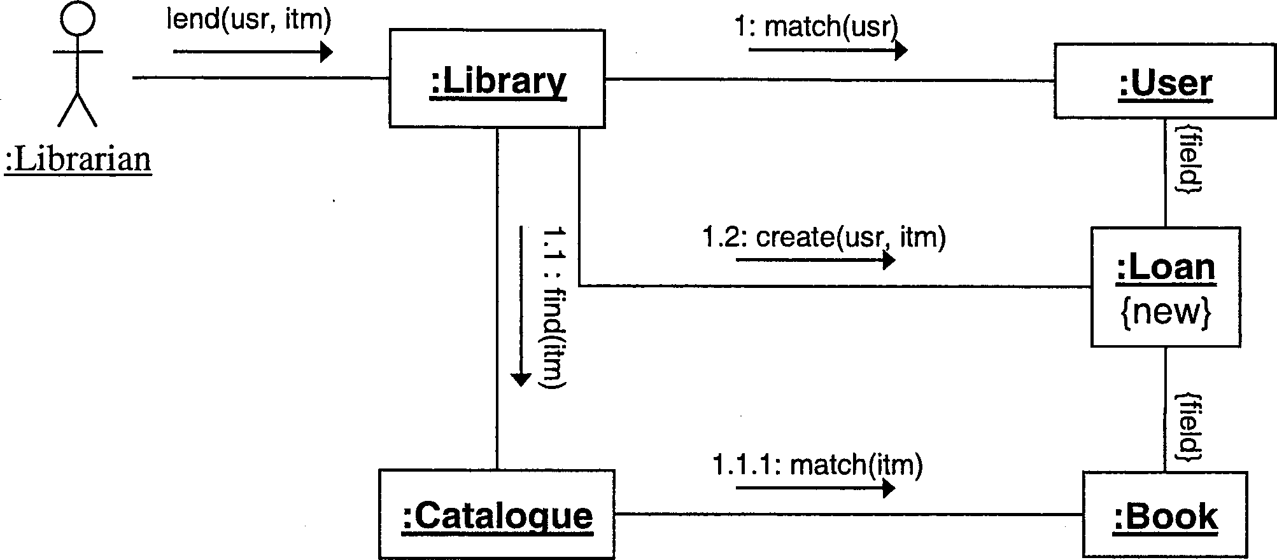

Your sequence diagram should show how values are returned even though this is not shown in the communication diagram.

1. [2 marks] In what way can you capture alternative execution paths in a communication diagram?
2. [2 marks] In what way can you capture alternative execution paths in a sequence dia­gram?
3. [4 marks] Briefly explain how you could use interaction diagrams in both implementa­tion and testing phases respectively

[20 marks]

(a) [15 marks] Create a state diagram that describes the high-level states and events of a chess game. There are two players referred to as the “white player” and “black player” respectively Your model should capture the following behaviour: The “white player” starts the game by moving a chess piece. Then the players alternate taking turns making “normal moves”. If a player “checks” the king of the other player, the latter has to make a “protective move”. The game terminates if either of the players wins by setting the other “checkmate” or if the game may ends in draw after a “stalemate” has occured.

SPARE PAGE FOR EXTRA ANSWERS

(b) [5 marks] Briefly explain what superstates are typically used for and why they are considered to be an important feature of state diagrams.

The following class diagram contains a number of errors/problems.

**this.**count < maxCount

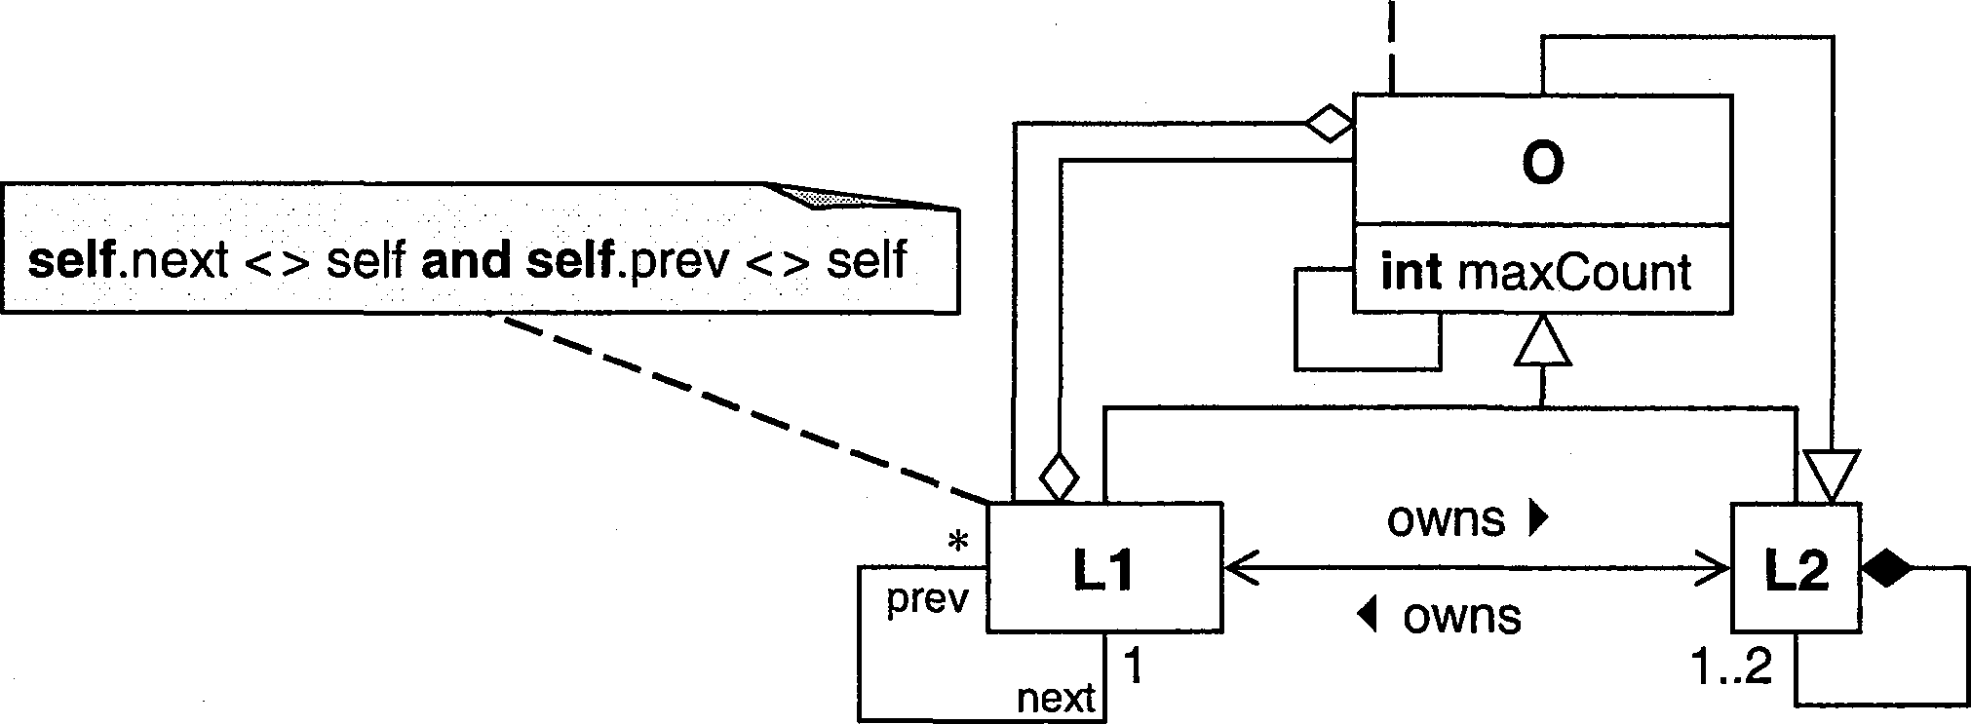

(a) [12 marks] List four errors/problems. For each, i) identify it with a numbered circle in the diagram, ii) briefly explain it, and iii) describe the least invasive way to correct it.

1)

2) 3) 4)

(b) [8 marks] A colleague asks you what the direction of the inheritance relationship be­tween the shape concepts “Square” and “Rectangle” should be. Advise your colleague of the options available and explain what principle you use to justify each option.

SPARE PAGE FOR EXTRA ANSWERS

********************************