EH

VICTORIA

UNIVERSITY OF WELLINGTON



EXAMINATIONS — 2011

MID-YEAR

SWEN 223

Software Engineering Analysis

Time Allowed: 120 Minutes

Instructions: There are 120 possible marks on the exam.

Answer all questions in the boxes provided.

Every box requires an answer.

If additional space is required you may use a separate answer booklet. Non-electronic Foreign language dictionaries are allowed.

Calculators ARE NOT ALLOWED (and not required).

No other reference material is allowed.

|  |  |  |  |  |
| --- | --- | --- | --- | --- |
| Question | Topic | Marks Achieved | | |
| 1. | Software Engineering | 20 |  |  |
| 2. | Design Principles | 20 |  |  |
| 3. | UML | 20 |  |  |
| 4. | Interaction Diagrams | 20 |  |  |
| 5. | State Diagrams | 20 |  |  |
| 6. | Conceptual Modelling | 20 |  |  |
|  | Total | 120 | | |

[20 marks]

1. [4 marks] Briefly discuss the meaning and significance of “maintenance” in software engineering.
2. [6 marks] The maintainability of a component correlates with the size of its interface. Briefly describe this correlation and mention two technical properties that components with the desirable interface size will typically exhibit.
3. [4 marks] Identify the core problems in software engineering today. What are the main issues that plague many software projects?
4. [6 marks] Discuss the challenges, potential benefits and dangers involved in reusing components.

[20 marks]

1. [4 marks] Briefly explain what “modular protection” is and what one may do to achieve it?
2. [4 marks] Briefly explain the relationship between coupling and information hiding.
3. [4 marks] Briefly explain which criteria - internal or external - of a software system matter the most and why? Why does one care about the other as well?
4. [4 marks] Explain why polymorphism and dynamic binding are so valuable for creating extensible software.
5. [4 marks] Briefly explain the relationship between “modular continuity” and “mainte­nance”.

[20 marks]

1. [3 marks] Briefly explain what a “use case” is. Include the ultimate criterion that deter­mines whether something really should be regarded as a use case.
2. [2 marks] Briefly explain the idea of an “essential use case” (as opposed to a “system use case”).
3. [6 marks] Why does modelling with the UML sometimes require the use of OCL? Ex­plain the need for OCL in general and provide two examples (not necessarily providing OCL code) for typical usage scenarios for OCL.

Consider an ATM machine where customers may withdraw money by identifying them­selves using EFTPOS cards or through a fingerprint reader. It may occur that the ATM ma­chine has no online connection to a card verification service but is still expected to work, e.g., by trying to reconnect.

1. [4 marks] In what way can the potentially rich use case “Withdraw money” be factored into multiple smaller parts that are easier to deal with on their own? Base your factorization on the three UML use case relationships.
2. [5 marks] Draw the UML use case diagram for your design of question (d).

[20 marks]

1. [12 marks] Create a sequence diagram which contains at least the information of the following communication diagram:

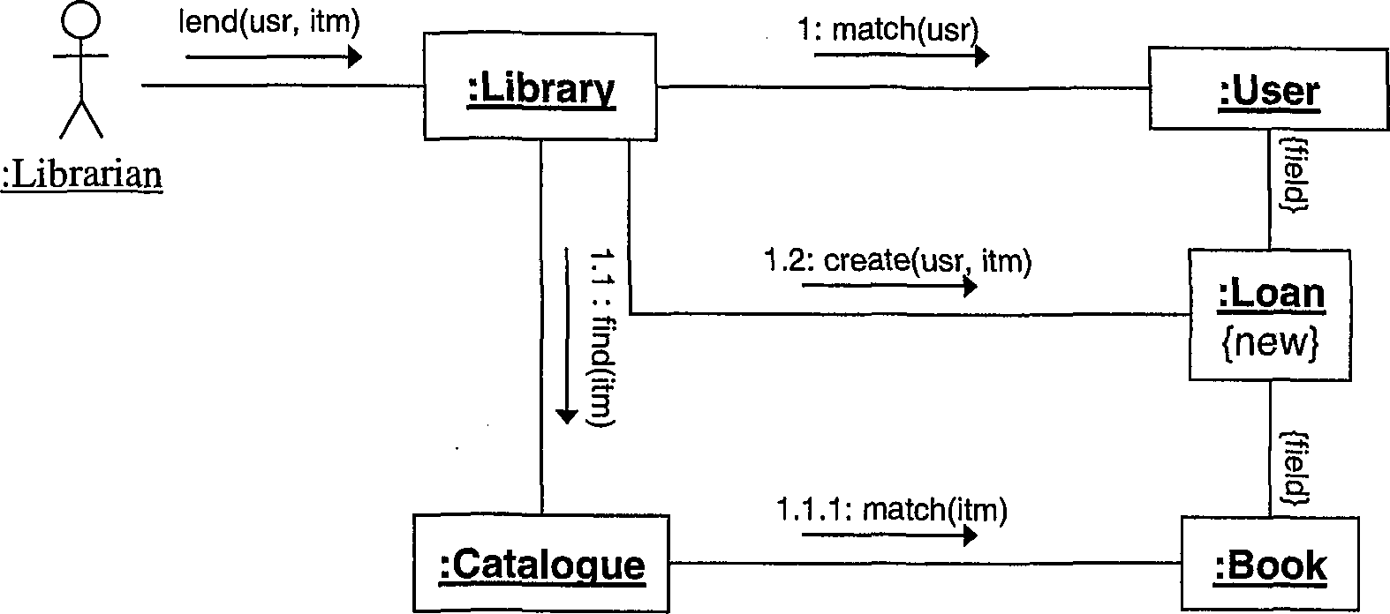

Your sequence diagram should show how values are returned even though this is not shown in the communication diagram.

1. [2 marks] In what way can you capture alternative execution paths in a communication diagram?
2. [2 marks] In what way can you capture alternative execution paths in a sequence dia­gram?
3. [4 marks] Briefly explain how you could use interaction diagrams in both implementa­tion and testing phases respectively.

[20 marks]

(a) [15 marks] Create a UML state diagram that describes the states and events of a phone with the following behaviour: Initially, the phone is idle. When an incoming call arrives, it keeps ringing until the user picks up or the caller aborts the call. In the former case the phone is connected to the calling party, in the latter case it becomes idle again. In the case of an outgoing call, when the user picks up the handle, the phone keeps accepting digits until a valid number has been dialled. In the latter case, it becomes connected to the called party. At any point during the dialling or while being connected, the user may hang up, causing the phone to become idle again. Marks are awarded for the appropriate use of advanced notation.

SPARE PAGE FOR EXTRA ANSWERS

(b) [5 marks] Briefly explain what superstates are typically used for and why they are considered to be an important feature of state diagrams.

[20 marks]

The following class diagram contains a number of errors/problems.

this.count < maxCount

i

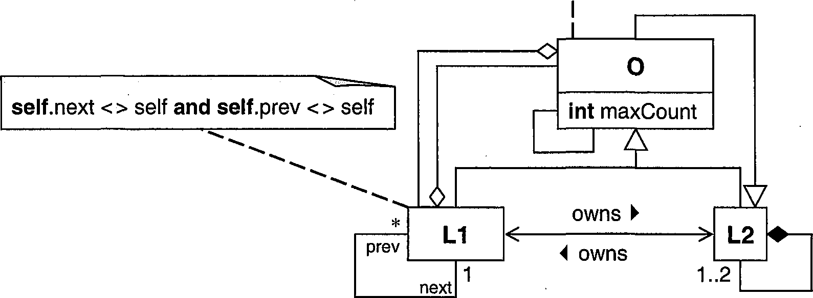

(a) [12 marks] List four errors/problems. For each, i) identify it with a numbered circle in the diagram, ii) briefly explain it, and iii) describe the least invasive way to correct it.

1)

2) 3) 4)

(b) [8 marks] A colleague asks you what the direction of the inheritance relationship be­tween the concepts “Circle” and “Ellipse ” should be. Advise your colleague of three alter­native options and briefly explain the rationale for each option.



SPARE PAGE FOR EXTRA ANSWERS