

VICTORIA

UNIVERSITY OF WELLINGTON



EXAMINATIONS — 2012

MID-YEAR

SWEN 223

Software Engineering Analysis

Time Allowed: 120 Minutes

Instructions: There are 120 possible marks on the exam.

Answer all questions in the boxes provided.

Every box requires an answer.

If additional space is required you may use a separate answer booklet. Non-electronic Foreign language dictionaries are allowed.

Calculators ARE NOT ALLOWED (and not required).

No other reference material is allowed.

|  |  |  |
| --- | --- | --- |
| Question | Topic | Marks |
| 1**.** | Software Engineering | 20 |
| 2. | Design Principles | 20 |
| 3. | UML | 20 |
| 4. | Interaction Diagrams | 20 |
| 5. | State Diagrams | 20 |
| 6. | Conceptual Modelling | 20 |
|  | Total | 120 |

Achieved

[20 marks]

1. [4 marks] Briefly discuss the meaning and significance of "maintenance" in software engineering.
2. [6 marks] The maintainability of a component correlates with the size of its interface. Briefly describe this correlation and mention two technical properties that components with the desirable interface size will typically exhibit.
3. [4 marks] If a software system is hard to change because any change may break the system in some way, what is the system suffering from and what system property could address the problem?
4. [6 marks] Briefly discuss the potential benefits and dangers involved in reusing soft­ware components.

[20 marks]

1. [2 marks] Why are classes with low coupling desirable?
2. [6 marks] Which - “layers” or “partitions” - are useful to address modular continuity? Explain your answer.
3. [4 marks] Which of the five modularity requirements that were discussed in lectures can help to improve robustness? Briefly explain your answer.
4. [4 marks] Briefly explain why even a correct implementation does not guarantee full customer satisfaction and why this circumstance is not used to change the traditional de­velopment process.
5. [4 marks] Briefly discuss whether pre-conditions or post-conditions are a better means to achieve modular protection.

[20 marks]

1. [3 marks] Briefly explain what a "use case" is. Include the ultimate criterion that deter­mines whether something really should be regarded as a use case.
2. [2 marks] Briefly explain the idea of an "essential use case" (as opposed to a "system use case").
3. [6 marks] Describe two different kinds of situations when one would need OCL con­straints in modeling. Provide an example for each respectively.

Consider a university library. When library users return items they need to identify them­selves through their library card or a staff card. In rare cases it may not be possible for the library staff to accept an item because the latter needs to be handled by a special staff member that is absent.

1. [4 marks] In what way can the potentially rich use case "Return Item" be factored into multiple smaller parts that are easier to deal with on their own? Base your factorization on the three UML use case relationships.
2. [5 marks] Draw the UML use case diagram for your design of question (d).

[20 marks]

1. [12 marks] Create a sequence diagram which contains at least the information of the following communication diagram:

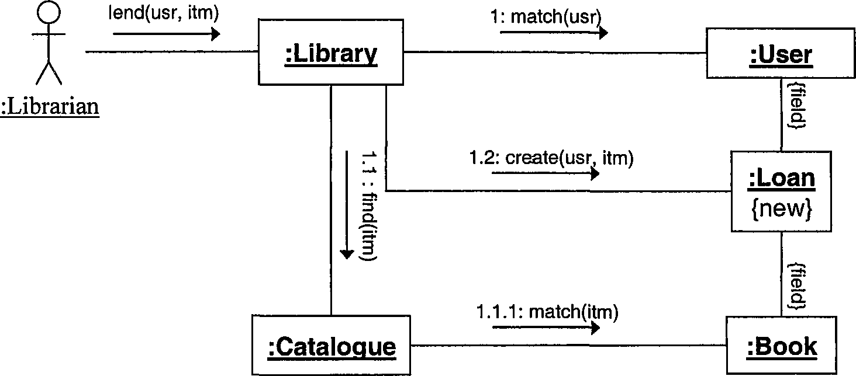

Your sequence diagram should show how values are returned even though this is not shown in the communication diagram.

1. [4 marks] Briefly explain how you could use interaction diagrams in both implementa­tion and testing phases respectively.
2. [2 marks] In what way can you capture alternative execution paths in a communication diagram?
3. [2 marks] In what way can you capture alternative execution paths in a sequence dia­grams?

[20 marks]

(a) [15 marks] Create a UML state diagram that describes the behaviour of an elevator. Ini­tially, the elevator waits on the first floor. When a “button press” event occurs, the elevator moves to the floor number specified by the event. It is important for the elevator to move in the correct direction (up or down). When the elevator reaches the target floor, an “arrived” event is generated. The elevator should then open its doors. The elevator should close the door before it moves and return to the first floor after 30 seconds of user inactivity (i.e., no button presses). At any point during the elevator’s operation, it is possible to press the “emergency button” which will cause the elevator to return to the first floor.

Marks are awarded for the appropriate use of advanced notation.

SPARE PAGE FOR EXTRA ANSWERS

(b) [5 marks] Briefly explain why substates, i.e., the ability to use concurrent lanes each specifying reactive behaviour that contributes to an overall combined behaviour, can be used to reduce the complexity of state diagrams.

[20 marks]

The following class diagram contains a number of errors/problems.

this.count < maxCount I

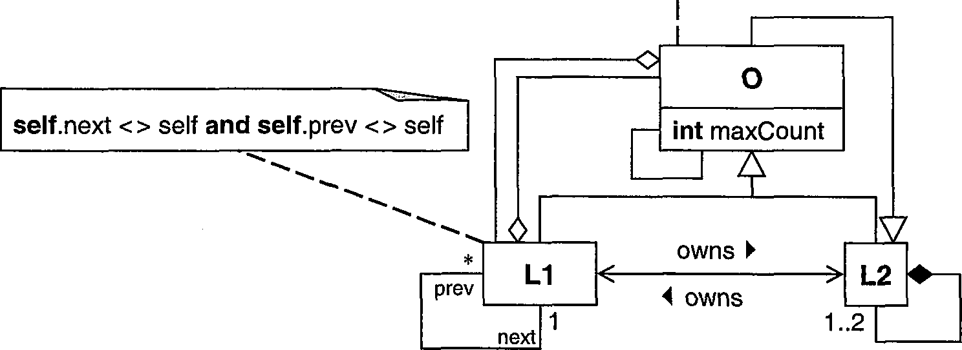

(a) [12 marks] List four errors/problems. For each, i) identify it with a numbered circle in the diagram, ii) briefly explain it, and iii) describe the least invasive way to correct it.

_

2) 3) 4)

(b) [8 marks] A colleague asks you what the direction of the inheritance relationship be­tween the concepts "Dictionary" and "Set " should be. Advise your colleague of three alternative options and briefly explain the rationale for each option.

SPARE PAGE FOR EXTRA ANSWERS