

TE WHARE WANANGA O TE tJPOKO O TE IKA A MAUI

Mara* VICTORIA

m



UNIVERSITY OF WELLINGTON

EXAMINATIONS — 2013  
Trimester 1

SWEN 223

SOFTWARE ENGINEERING ANALYSIS

Time Allowed: TWO HOURS

Instructions: Closed Book.

There are 120 possible marks on the exam.

Answer all questions in the boxes provided.

Calculators are not permitted.

Every box requires an answer.

If additional space is required you may use a separate answer booklet. Non-electronic Foreign language dictionaries are allowed.

No other reference material is allowed.

|  |  |  |
| --- | --- | --- |
| Question | Topic | Marks |
| 1**.** | Software Engineering | 20 |
| 2. | Design Principles | 20 |
| 3. | UML | 20 |
| 4. | Interaction Diagrams | 20 |
| 5. | State Diagrams | 20 |
| 6. | Conceptual Modelling | 20 |
|  | Total | 120 |

Achieved

Question 1. Software Engineering [20 marks]

1. Briefly discuss the meaning and significance of "maintenance" in software engineering.

[4 marks]

1. The maintainability of a component correlates with the size of its interface. Briefly describe this correlation and mention two technical properties that components with the desirable interface size will typically exhibit. [6 marks]
2. If a software system is hard to change because any change may break the system in some way, what is the system suffering from and what system property could address the problem? [4 marks]
3. Briefly discuss the potential benefits and dangers involved in reusing software compo­nents. [6 marks]

[20 marks]

1. Why are classes with high cohesion desirable? [3 marks]
2. Which - "layers" or "partitions" - are useful to address modular continuity? Explain your answer. [7 marks]
3. Which of the five modularity requirements that were discussed in lectures can help to improve continuity? Briefly explain your answer. [5 marks]
4. Briefly explain why even a correct implementation does not guarantee full customer satisfaction and why this circumstance is not used to change the traditional development process. [5 marks]

[20 marks]

1. Briefly explain what a "use case" is. Include the ultimate criterion that determines whether something really should be regarded as a use case. [3 marks]
2. Briefly explain the difference between a "system use case" and an "essential use case".

[2 marks]

1. Describe two different kinds of situations when one would need to add textual con­straints to a conceptual diagram. Provide an example for each respectively. [6 marks]

Consider a high security facility. Access is possibly only to individuals that can identify themselves with a staff card or per finger print reader. In rare "alert" situations, access is possible only for a subset of "VIP" users.



1. In what way can the potentially rich use case "Access Facility" be factored into multiple smaller parts that are easier to deal with on their own? Base your factorization on the three UML use case relationships. [4 marks]
2. Draw the UML use case diagram for your design of question (d). [5 marks]

[20 marks]

1. Create a sequence diagram which contains at least the information of the following communication diagram: [12 marks]

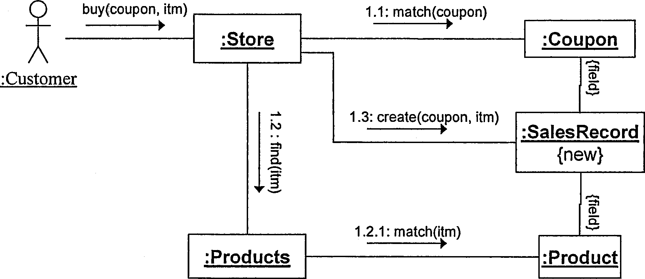

Your sequence diagram should show how values are returned even though this is not shown in the communication diagram.



1. Briefly explain how you could use interaction diagrams in both implementation and testing phases respectively [4 marks]
2. In what way can you capture alternative execution paths in a communication diagram?

[2 marks]

1. In what way can you capture alternative execution paths in a sequence diagram?

[2 marks]

[20 marks]

(a) Create a UML state diagram that describes the behaviour of a cleaning robot. Initially, the robot is idle. After 24 hours of inactivity or when the user presses the "clean" button on a remote control, the robot starts cleaning the floor and normally keeps moving forward until it has covered all of the floor or the user presses the "abort" button. The user can also set the speed to "fast" (noisier operation) or "slow" (quieter operation) at any time. If the robot encounters an obstacle, it turns by 25 degrees and then reverses direction - i.e., moves backwards if it has been moving forwards and moves forwards if it has been moving backwards. At any point in time an "error" condition may occur. If the "nature" of the error is "minor" the robot will self-repair and then continue. If the "nature" of the error is "fatal", the robot will terminate all activity immediately and indefinitely.

Marks are awarded for the appropriate use of advanced notation. [15 marks]

SPARE PAGE FOR EXTRA ANSWERS

Cross out rough working that you do not want marked.

Specify the question number for work that you do want marked.

(b) Briefly explain what superstates are typically used for and why they are considered to be an important feature of state diagrams. [5 marks]

[20 marks]

The following class diagram contains a number of errors/problems.

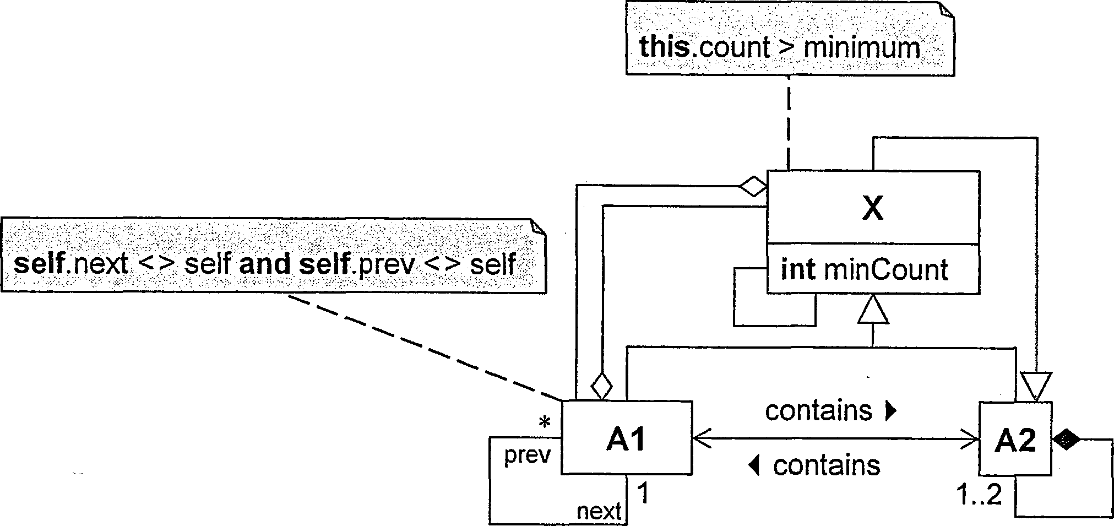

(a) List four errors/problems. For each, i) identify it with a numbered circle in the diagram, ii) briefly explain it, and iii) describe the least invasive way to correct it. [12 marks]

_

2) 3) 4)

(b) A colleague asks you what the direction of the inheritance relationship between the shape concepts "Square" and "Rectangle" should be. Advise your colleague of the options available and explain what principle you use to justify each option. [8 marks]

SPARE PAGE FOR EXTRA ANSWERS

Cross out rough working that you do not want marked.

Specify the question number for work that you do want marked.