VICTORIA

Jins

UNIVERSITY OF WELLINGTON

EXAMINATIONS — 2015  
TRIMESTER 1

SWEN 223

SOFTWARE ENGINEERING ANALYSIS

Time Allowed: TWO HOURS

CLOSED BOOK

Permitted materials: No Calculators permitted.

Instructions: There are six questions.

There are 120 possible marks.

Answer all questions in the boxes provided.

Every box requires an answer.

If additional space is required you may use a separate answer booklet. Non-electronic foreign to English dictionaries are allowed.

No other reference material is allowed.

|  |  |  |
| --- | --- | --- |
| Question | Topic | Marks |
| 1. | Software Engineering | 20 |
| 2. | Design Principles | 20 |
| 3. | UML | 20 |
| 4. | Interaction Diagrams | 20 |
| 5. | State Diagrams | 20 |
| 6. | Conceptual Modelling | 20 |

Total 120

[20 marks]

1. Briefly discuss the meaning and significance of "maintenance" in software engineering.

[4 marks]

1. What are symptoms of a software system that is hard to maintain? [5 marks]
2. Fewer interfaces are considered better than many interfaces in software engineering. Briefly explain why this does not imply that zero interfaces are optimal. [5 marks]
3. Briefly discuss the potential benefits and dangers involved in reusing software compo­nents. [6 marks]

[20 marks]

1. Briefly discuss which of "using pre-conditions" or "using post-conditions" is a better approach to achieving "modular protection". [5 marks]
2. Briefly explain the relationship between coupling and information hiding.

[4 marks]

1. Why do internal criteria for a software system matter, if the client is only concerned with external criteria? [4 marks]
2. What causes a software system to exhibit "rigidity"?

[3 marks]

(e) What causes a software system to exhibit "fragility"?

[4 marks]



[20 marks]

1. Name and very briefly describe three UML language/notation features designed to deal with complexity. [8 marks]
2. Briefly describe the UML's approach to characterising container types and write down how you would specify that a concept is used as i) an "Ordered Set" and ii) a "Sequence".

[7 marks]

1. Sally wrote the following OCL constraint in order express that if an employed person is a manager, the person's income must be at least $4000:

context Person inv appropriateSalary: if self.isEmployed then

self.isManager and self.income >= 4000 endif

What would you change and why? [5 marks]

[20 marks]

1. Create a sequence diagram which contains at least the information of the following communication diagram: [12 marks]

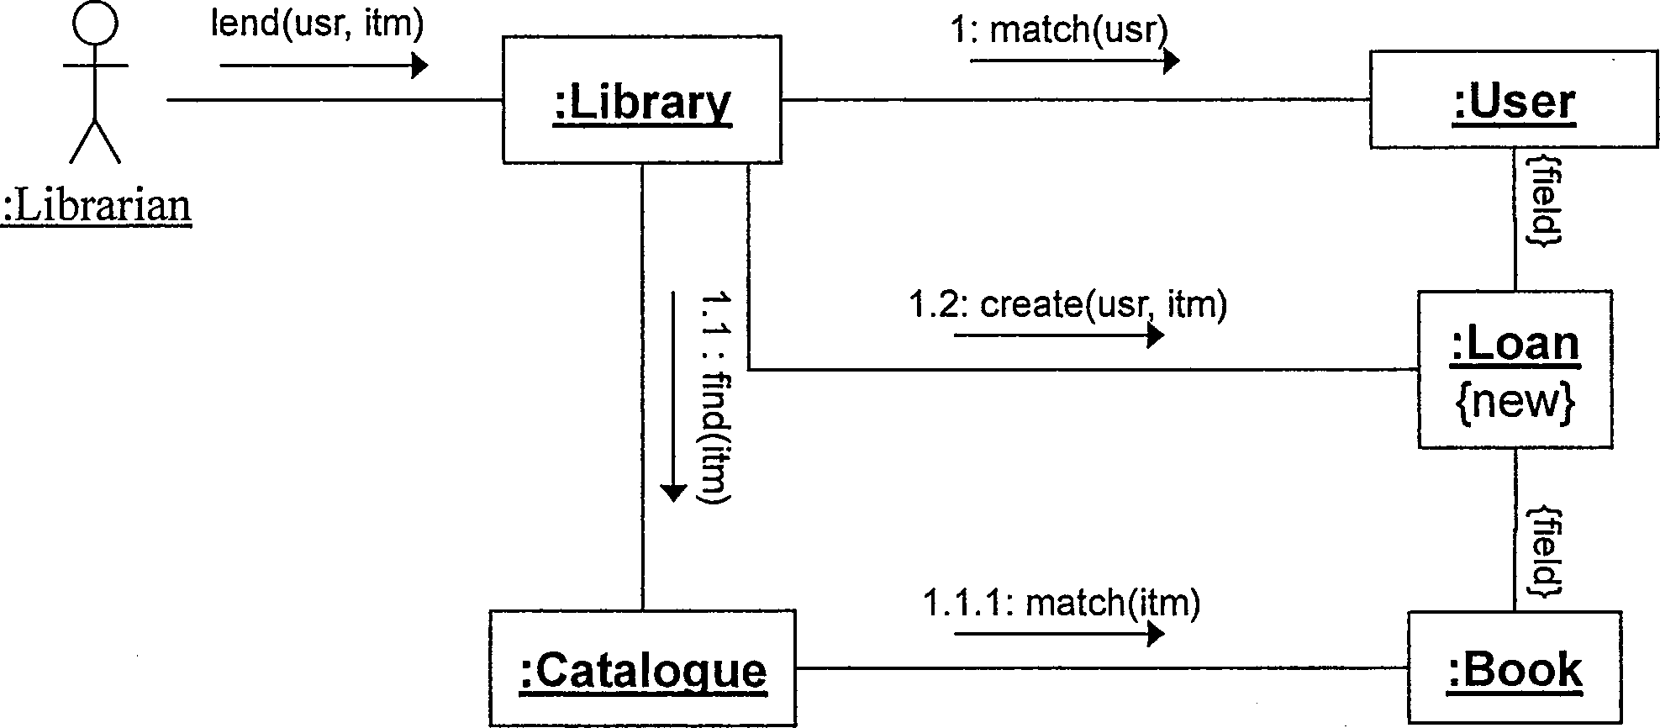

Your sequence diagram should show how values are returned even though this is not shown in the communication diagram.

1. In what way can you capture alternative execution paths in a communication diagram?

[3 marks]

1. Briefly explain for which purpose you would choose a . *S^aenc«.diagram over a communication diagram and vice versa. [5 marks]

[20 marks]

(a) Create a UML state diagram that describes the states and events of a phone with the following behaviour: Initially, the phone is idle. When an incoming call arrives, it keeps ringing until the user picks up or the caller aborts the call. In the former case the phone is connected to the calling party, in the latter case it becomes idle again. In the case of an outgoing call, when the user picks up the handle, the phone keeps accepting digits until a valid number has been dialled. In the latter case, it becomes connected to the called party. At any point during the dialling or while being connected, the user may hang up, causing the phone to become idle again. Marks are awarded for the appropriate use of advanced notation. [15 marks]

SPARE PAGE FOR EXTRA ANSWERS

Cross out rough working that you do not want marked.

Specify the question number for work that you do want marked.

(b) Briefly explain when and why one would use substates, i.e., the ability to use concurrent lanes each specifying reactive behaviour that contributes to an overall combined behaviour.

[5 marks]

[20 marks]

The following class diagram contains a number of errors/problems.

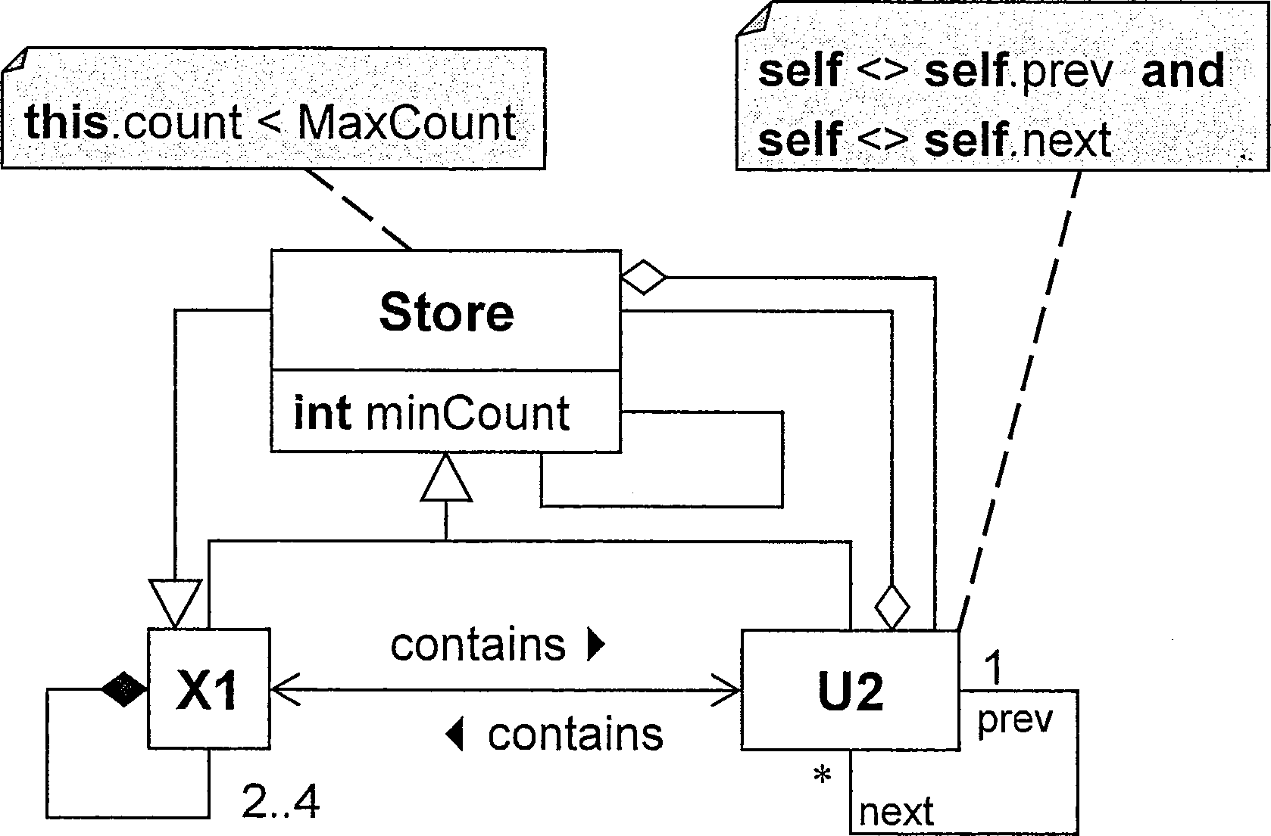

(a) List four errors/problems. For each, i) identify it with a numbered circle in the diagram, ii) briefly explain it, and iii) describe the least invasive way to correct it. [12 marks]

_

2) 3) 4)

(b) A colleague asks you what the direction of the inheritance relationship between the concepts "Circle" and "Ellipse " should be. Advise your colleague of three alternative options and briefly explain the rationale for each option. [8 marks]

SPARE PAGE FOR EXTRA ANSWERS

Cross out rough working that you do not want marked.

Specify the question number for work that you do want marked.

St*******************************