VICTORIA

UNIVERSITY OF WELLINGTON



EXAMINATIONS — 2016  
TRIMESTER 1

SWEN 223

SOFTWARE ENGINEERING ANALYSIS

Time Allowed: TWO HOURS

CLOSED BOOK

Permitted materials: No Calculators permitted.

Instructions: There are five questions.

There are 120 possible marks.

Answer all questions in the boxes provided.

Every box requires an answer.

If additional space is required you may use a separate answer booklet. Non-electronic foreign language dictionaries are allowed.

No other reference material is allowed.

|  |  |  |
| --- | --- | --- |
| Question | Topic | Marks |
| 1. | Software Engineering | 24 |
| 2. | Design Principles | 24 |
| 3. | Interaction Diagrams | 24 |
| 4. | State Diagrams | 24 |
| 5. | Modelling | 24 |
|  | Total | 120 |

[24 marks]

1. Not every code development counts as "software engineering". List three aspects that are characteristic of true "software engineering" projects. [6 marks]

There are four factors of software development of which the client may prioritize three,

1. By improving what property of the software development process can one gain an ad­vantage regarding all four factors? Briefly point out why this is the case for two of these factors. [6 marks]
2. Is there a difference between "building the right (desired) system" and "building the system right (properly)"? Briefly explain your answer using corresponding software engi­neering terminology. [6 marks]
3. Briefly explain what the term "maintenance" means in software engineering and what typical activities are performed in the maintenance phase. [6 marks]

[24 marks]

1. Why are classes with low coupling desirable? Tick only one box. [2 marks]

* They increase cohesion.
* They decrease cohesion.

EH They increase rigidity.

CH They decrease rigidity.

1. Assume module A has five components with six connections and module B has five components with 8 connections. Which module is more likely to contain components better suited for reuse? Briefly explain your answer? [4 marks]
2. Which - "layers" or "partitions" - are useful to address modular continuity? Explain your answer. [6 marks]
3. Assume an implementation has been verified to be correct with respect to the specifica­tion. What other properties of the implementation may the customer be interested in?

[6 marks]

1. Briefly list the pros and cons of pre-conditions and post-conditions for the purpose of achieving modular protection. [6 marks]
2. Create a sequence diagram which contains at least the information in the following communication diagram: [14 marks]

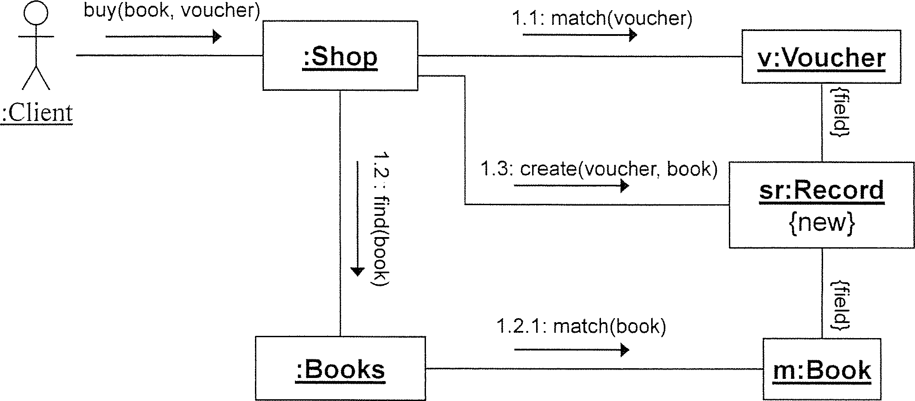

Your sequence diagram should show when values are returned even though this is not shown in the communication diagram.



Cross out rough working that you do not want marked.

Specify the question number for work that you do want marked.

1. In which development phases can one use interaction diagrams? Briefly describe the purpose of interaction diagrams for each phase you name. [6 marks]
2. In what way can you capture alternative execution paths in a communication diagram?

[2 marks]

1. In what way can you capture alternative execution paths in a sequence diagram?

[2 marks]

Cross out rough working that you do not want marked.

Specify the question number for work that you do want marked.

[24 marks]

1. Create a UML state diagram that describes the behaviour of a cleaning robot. Initially, the robot is idle. After 48 hours of inactivity or when the user presses the "go" button on a remote control, the robot starts cleaning the floor and normally keeps moving forward until it has covered all of the floor or the user presses the "cancel" button. The user can also set the speed to "fast" (noisier operation) or "slow" (quieter operation) at any time. If the robot encounters an obstacle, it turns by 15 degrees and then reverses direction - i.e., moves backwards if it has been moving forwards and moves forwards if it has been moving backwards. At any point in time an "error" condition may occur. If the "nature" of the error is "minor" the robot will self-repair and then continue. If the "nature" of the error is "fatal", the robot will terminate all activity immediately and indefinitely.

Marks are awarded for using advanced notation that goes beyond using only states and transitions. [18 marks]

Cross out rough working that you do not want marked.

Specify the question number for work that you do want marked.

1. Briefly explain what superstates are typically used for and why they are considered to be an important feature of state diagrams. [6 marks]

The following class diagram contains a number of errors/problems.

[24 marks]

|  |  |  |
| --- | --- | --- |
| this.minCount > |  | : k  self.next <> self and |
| minimum |  | self, prev <> self —,. 1 |

prev

next

int count

zr

B1

◄ supports ►

K

v

B2

2..4

(a) List four errors/problems. For each, i) identify it with a numbered circle in the diagram, ii) briefly explain it, and iii) describe the least invasive way to correct it. [12 marks]

__

2) 3) 4)

1. What is the defining characteristic of a "use case"? Tick only one box, [2 marks]

D It contains actors.

D It describes a concrete system usage.

0 It results in a value for the user.

EH It contains includes, extends, and specialisiation relationships.

1. An essential use case consist of what? Tick only one box. [2 marks]

EH Intentions and responsibilities.

EH System actions and responsibilities.

EH Intentions and system responses.

EH System actions and system responses.

1. A colleague asks you what the direction of the inheritance relationship between the

concepts "Rectangle" and "Square" should be. Advise your colleague of three alternative options and briefly explain the rationale for each option. [8 marks]

Cross out rough working that you do not want marked.

Specify the question number for work that you do want marked.

********************************