**LAB2_assignment**

Name: 신민선 Department: 미디어학과

Student ID: 201723307 Room_Number: 팔달관 333호

Due Date: 03/17

**Instructions of Task 1:**

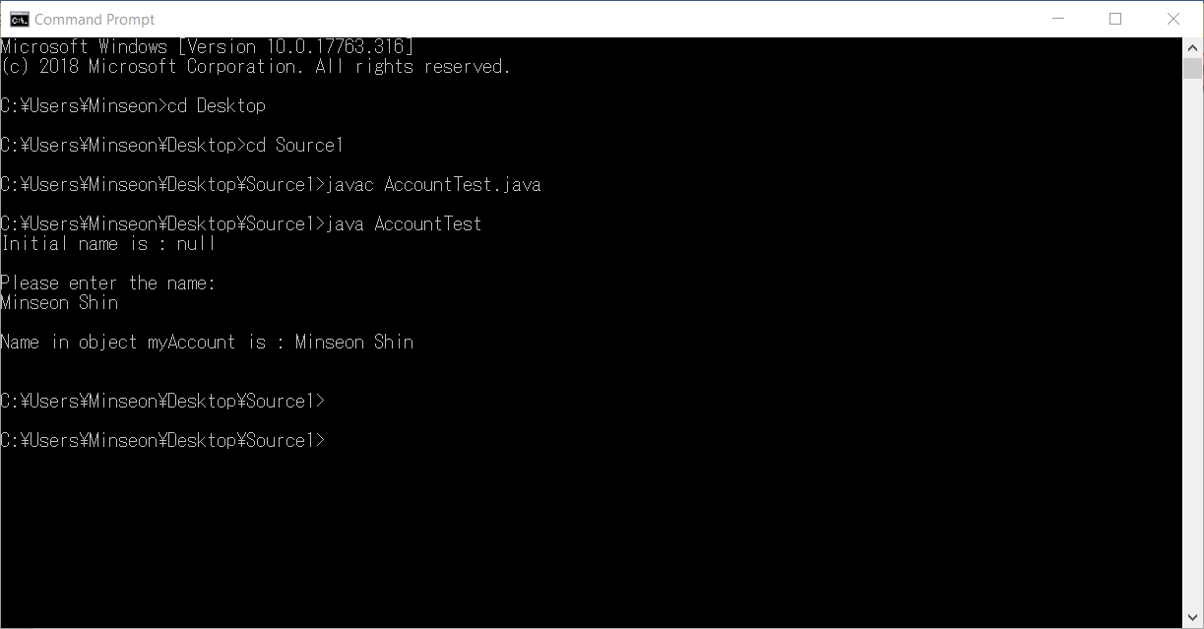

**Instructions of Task 2 (about class name and .java file name)**

In command prompt area, Compile the source codes.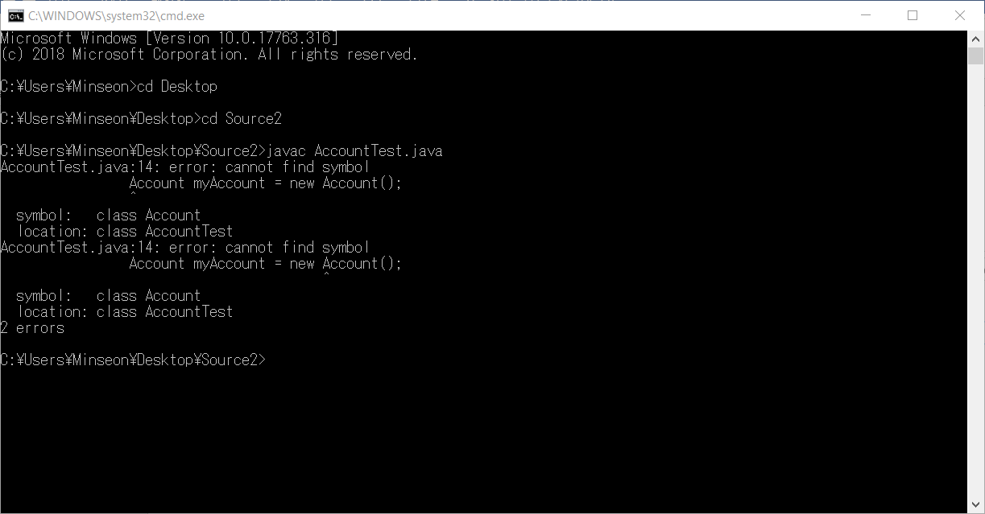

There is a completion error. Yes!

So, Fix the error = ACCOUNT.java is not same as class name.

(1) We have to fix the name from ACCOUNT.java to Account.java.

(class file name= class name)

Or

(2) We have to fix the name to “ACCOUNT.java” in AccountTest.java

Then, here is the result.

1. Revise only file name

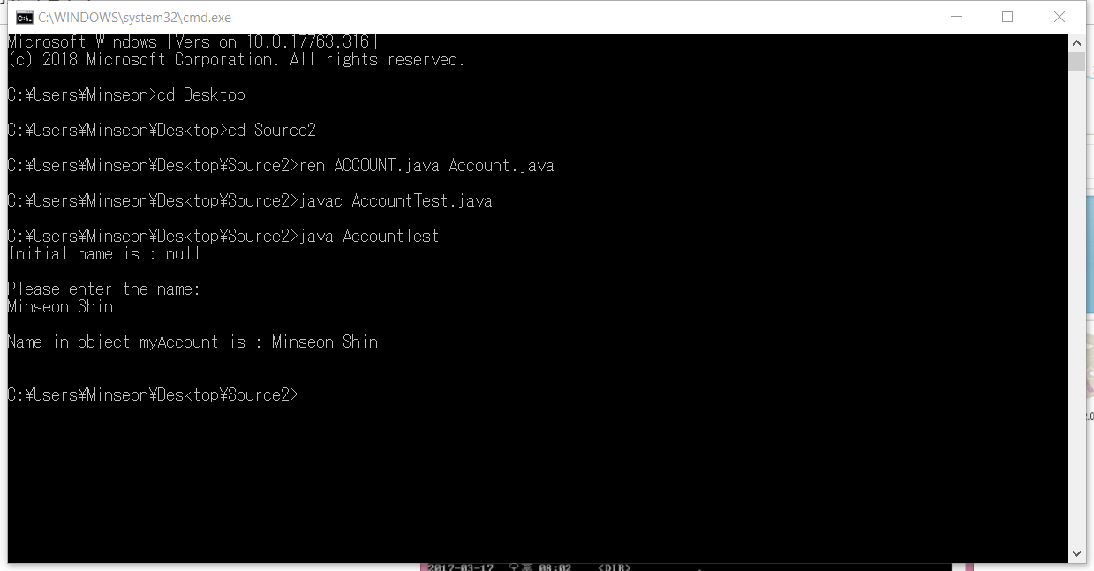

1. Revise class(code) name.

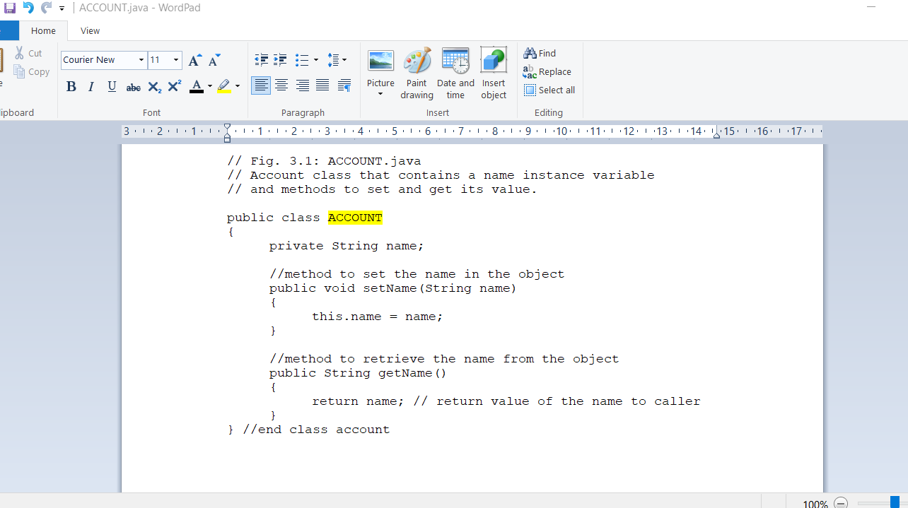

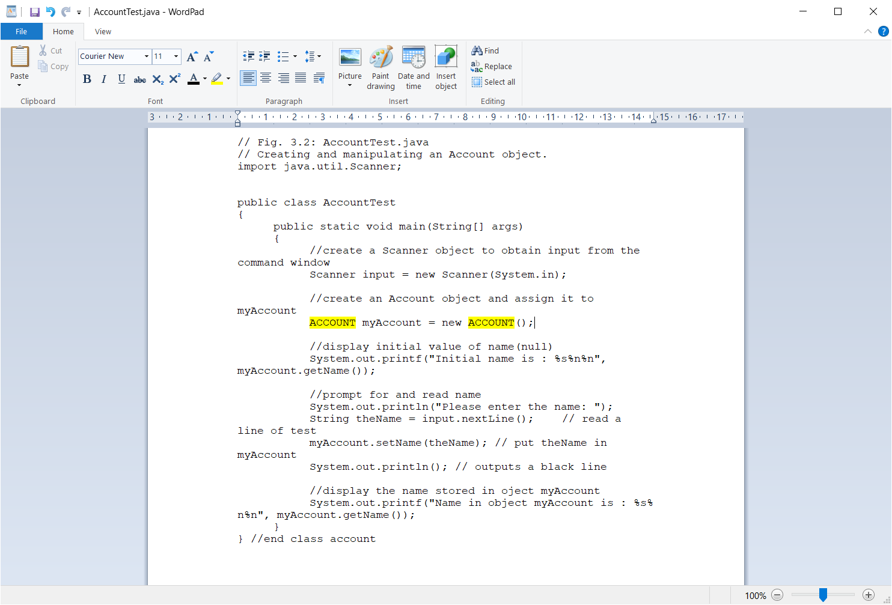

**Instructions of Task 3 (about class name and .class file name)**

There is no compilation error.

Because default is public as Access modifier(such as public, default).

So if we don’t write on access modifier, Computer automatically compile in public mode,

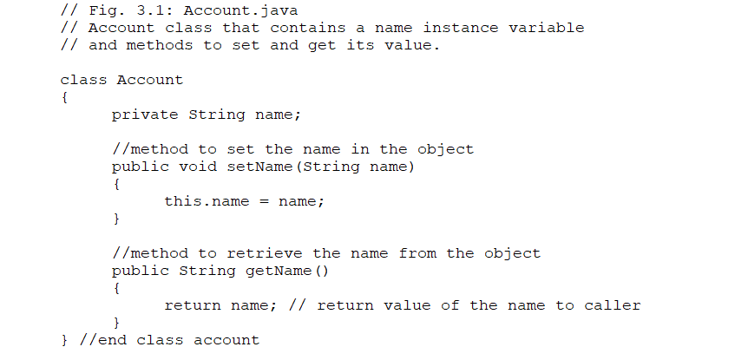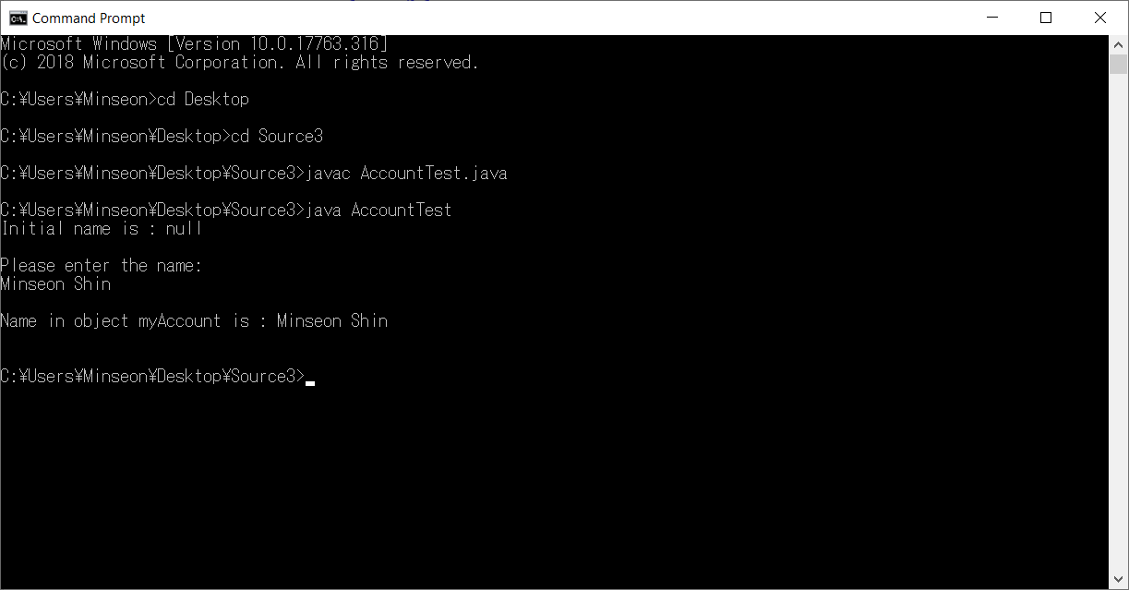

**Instructions of Task 4(about setting ClassPath)**

Yes, I got runtime error.

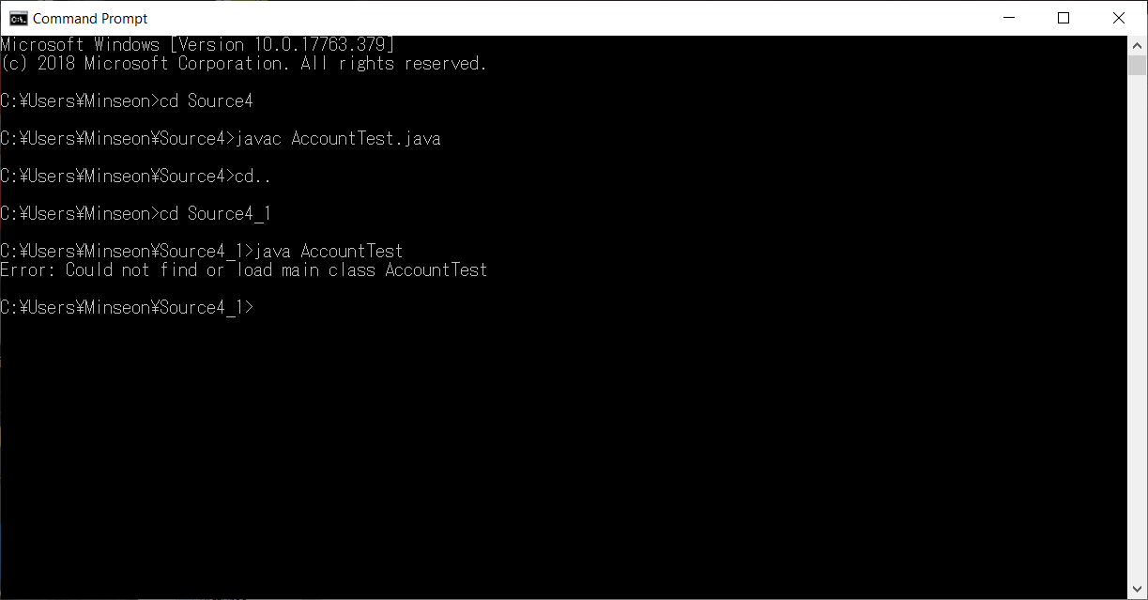

This error is because of classpath.

For fixing this error, we have to set classpath in command prompt.

In command prompt, enter the Source4_1 directory and then “set classpath = C:\Users\Minseon\Source4”

Then we can fix the error.

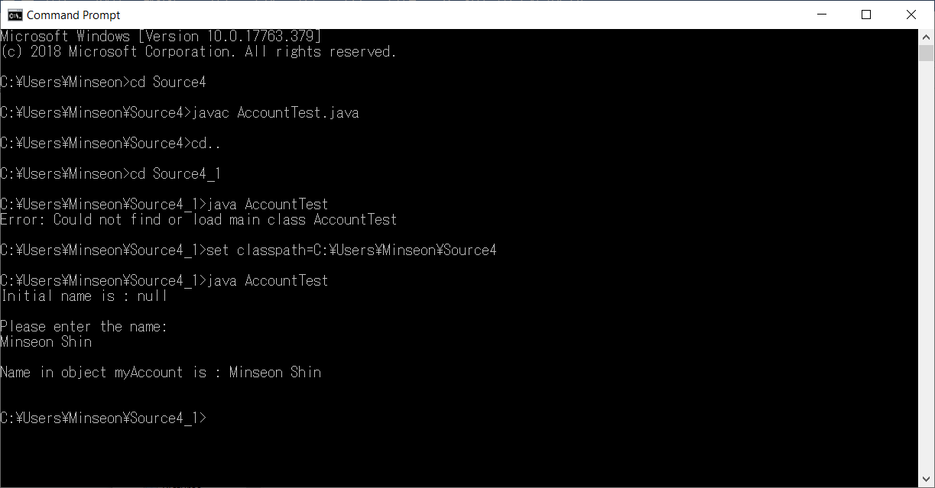

**Instructions of Task 5:(communication between a class in one default package and a public class in another non-default package)**

Yes, I got complie error.

First, similar to task 4, set the classpath like C:\Users\Minseon\Source5

Second, the reason is that default package can access only same default-package in same area.

For fixing the error, I have to make another package named “Source5”(non-default package.

Then, I move a class named “Source5”.

After that, I write on “**import Source5.Account;**” in AccountTest.java that has a main class.

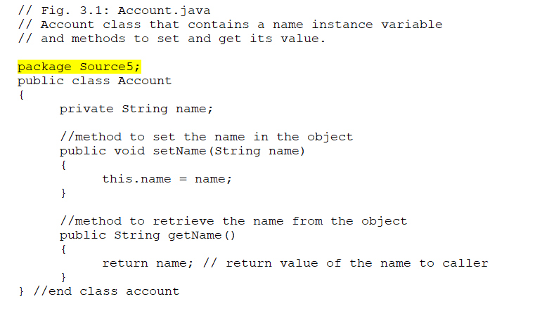

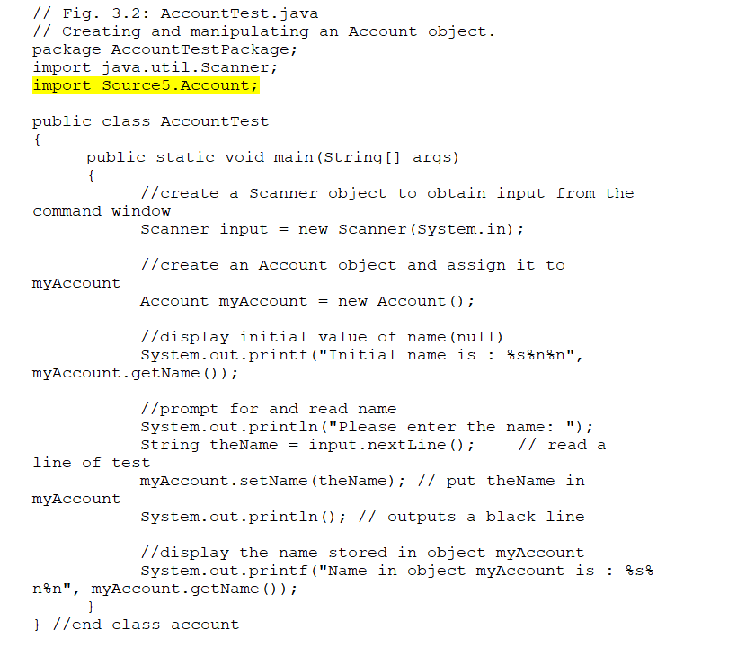

**Instructions of Task 6: (communication between a class in a non-default package and a public class in another non-default package)**

Did you get compile error? **Yes**.

First, similar to task 4, set the classpath like C:\Users\Minseon\Source6 in command prompt.

Second, like Task5, we got a error because we don’t add a line “**import**” part.

So, in AccountTest.java , Add “**import Accountpackage.Account;”** line.

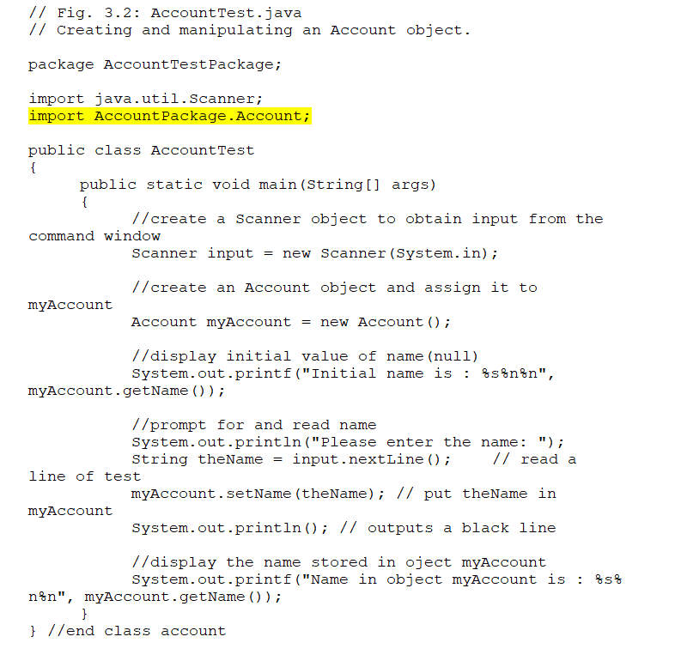

**Instructions of Task 7 :( communication between a class in a non-default package and a default class in another non-default package)**

Yes. I got a error.

First, similar to task 4, set the classpath like C:\Users\Minseon\Source7

Second, as definition of Access modifier, default class can’t access and import another class.

So, in order to access ‘Account’ class, we have to **change modifier** from default to public.

And add the code line “import AccountPackage. Account;” in AccountTest.java

Then Compiler can access both class and compile the code.

