**LAB10_assignment**

|  |  |  |  |
| --- | --- | --- | --- |
| Name: | 신민선 | Department: | 미디어학과 |
| Student ID: | 201723307 | Room Number: | 팔달관 333호 |
| Due Date: | **Saturday, May 18, 2019** | | |

* Submit your assignment using the following file format:

LabNumber_StudentName.zip (eg. Lab10_Hongkildong.zip).

* This zip file will contain two types of files, namely:

1. Report file with file format “**Report_Lab number**” (eg. report_10) to answer theory questions and to write the screen shot of your program.
2. Source code file that contains codes of classes to answer programming questions.

**Exercises**

1. Complete the given partial code (see the attached code).

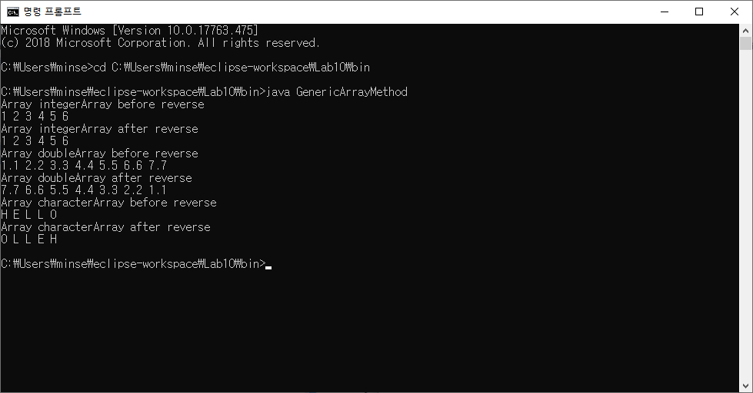

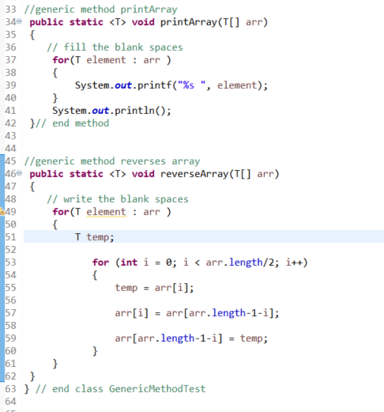

2.  **Complete the given partial code (see the attached code).**

Code is located in File folder.(Q2)

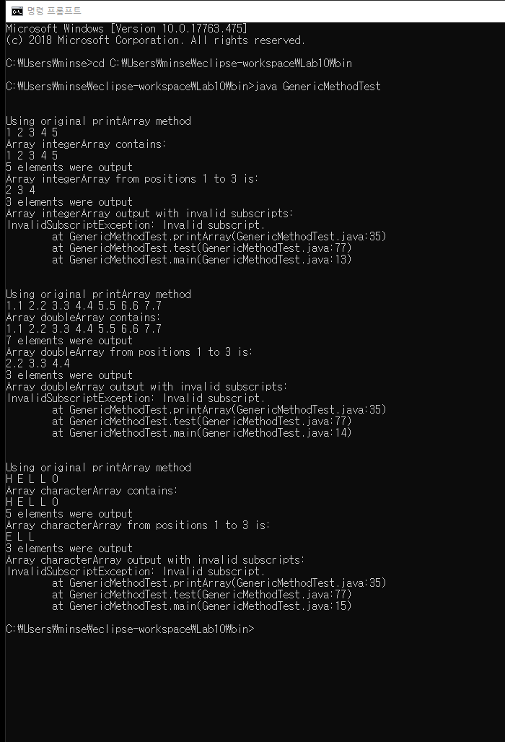

3. Complete the given partial code ( see the attached code).

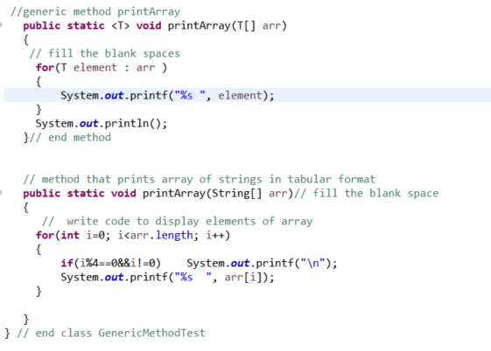

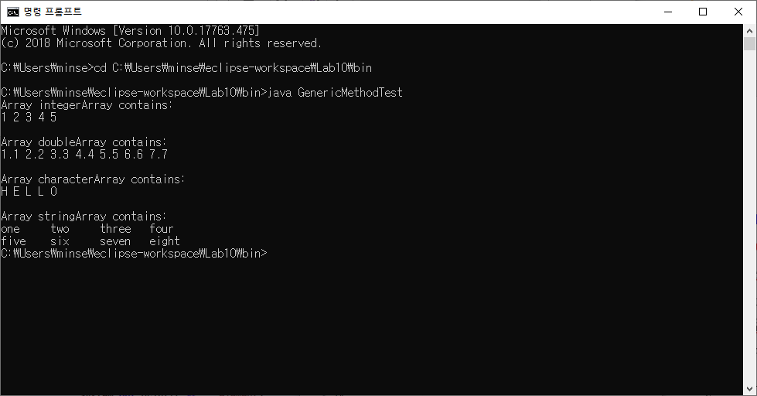

4. Complete the given partial code ( see the attached code).

a) **Complete the program by filling the missing parts of the given source code.**

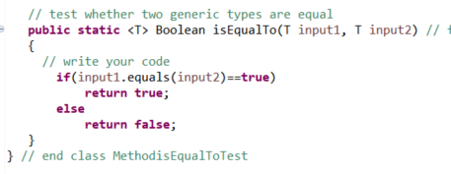

**b)**  What result do you get when you attempt to run this program?

**Include the result in your report file**

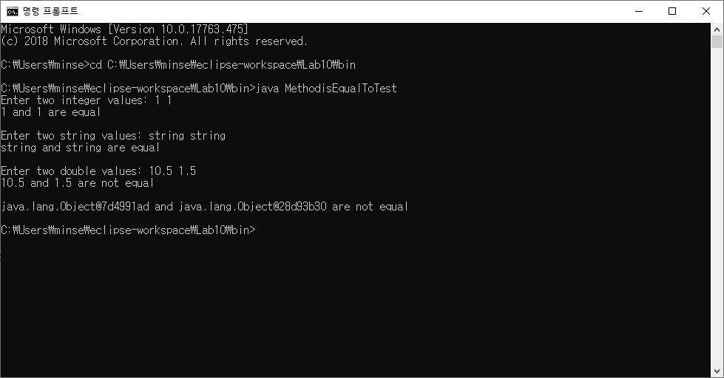

**c)**  Write your reason for question in **b**? **Include your reason in the report file.**

Every comparison without the last line(compare two objects) is perfectly activated. In the last line, they compare two individual objects. The objects initialize named g and h. They are the same type of object, but they are apparently different. Therefore, in the main method, It is printed "java.lang.Object@7d4991ad and java.lang.Object@28d93b30 are not equal". In printed line, next to Object, they print with @ and numbers. It is an object address converted hexadecimal address through toStirng() method.

5**. Write your own Program**

