**OOP Lab 11**

|  |  |  |  |
| --- | --- | --- | --- |
| Name: | 신민선 | Department: | 미디어학과 |
| Student ID: | 201723307 | Room Number: |  |
| Due Date: | June 1, 23 : 59 | | |

* Submit your assignment using the following file format:

LabNumber_StudentName.zip (eg. Lab11_Hongkildong.zip).

* This zip file will contain the source codes.

**Objectives**

* **How to use generic classes and interfaces that implements the basic data structures in computer Science**
* **Understand the advantage and disadvantage of each generic data structure classes**

**Exercises (7x5 =35%)**

1.

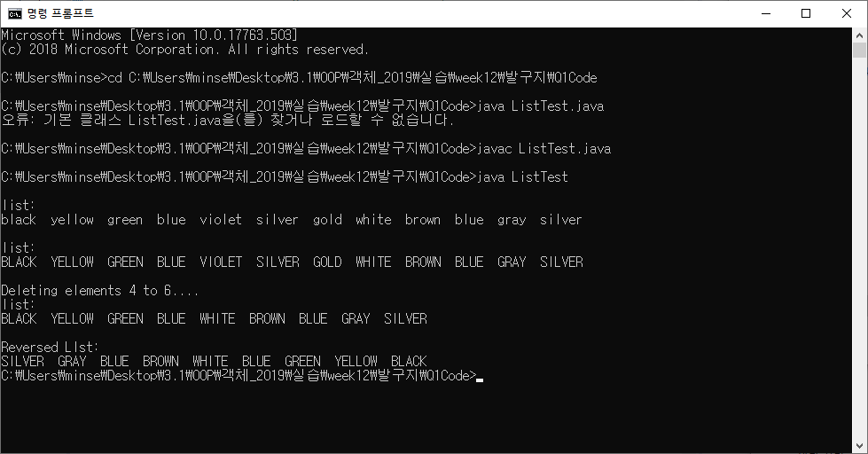

2.

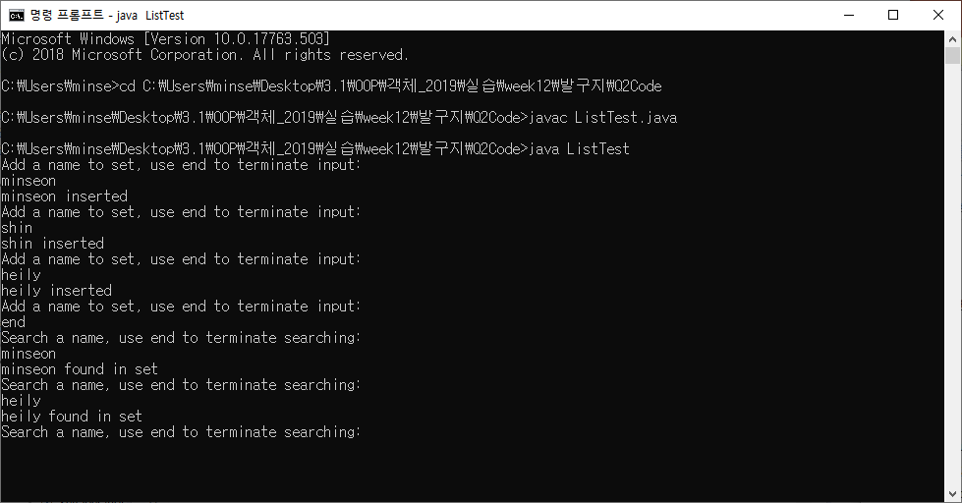

3.

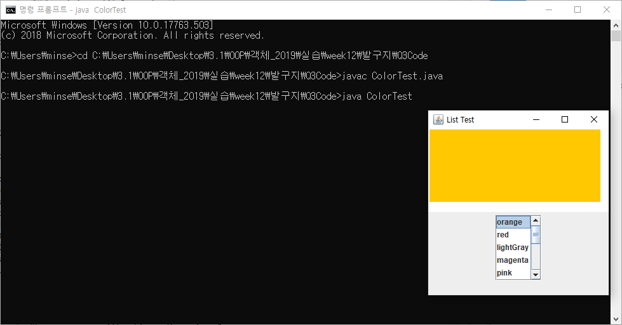

4.

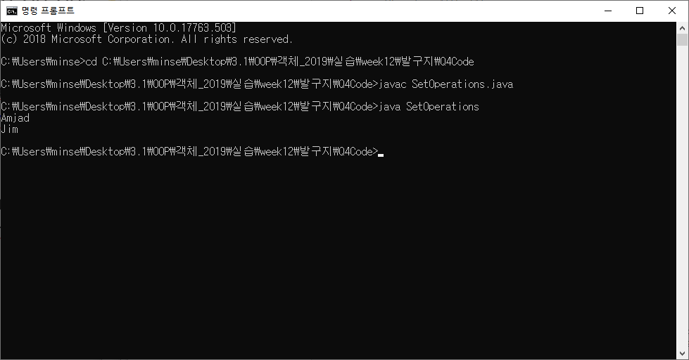

5.

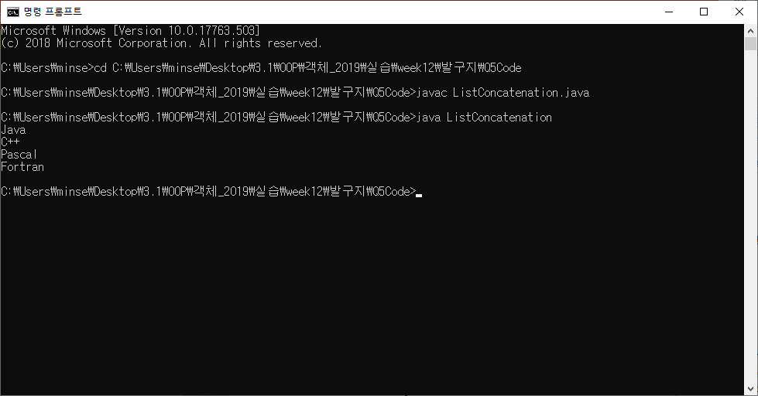

6.

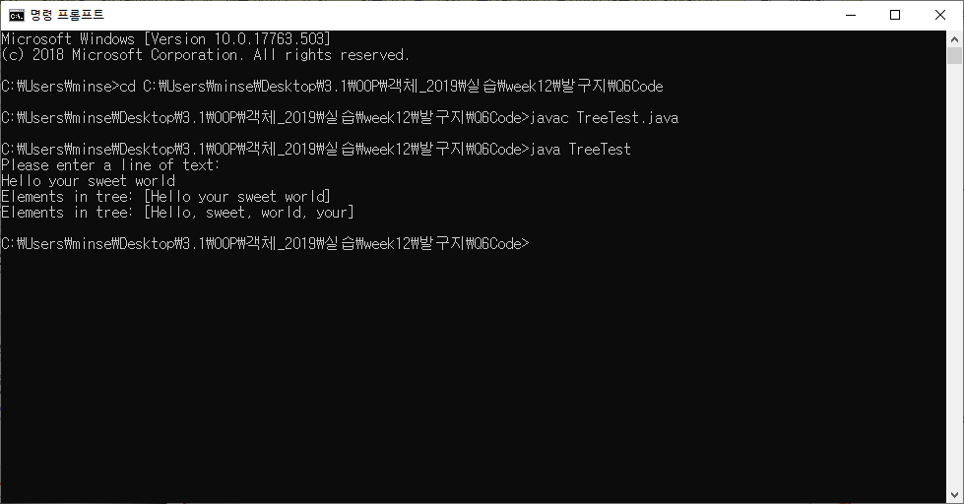

7.

