**OOP Lab 11**

|  |  |  |  |
| --- | --- | --- | --- |
| Name: | 신민선 | Department: | 미디어학과 |
| Student ID: | 201723307 | Room Number: |  |
| Due Date: | June 8, 23 : 59 | | |

**Q1**. The source code of an application that draws a series of eight concentric circles is given in the files “**CirclesJPanel.java” and** “**Circles.java”** in the folder “**CodeQ1”.** The circles are separated by 10 pixels. Hence, complete the partial source code in the file “Circles.java”. After your completed the code, the following figure should be displayed when you run the program.

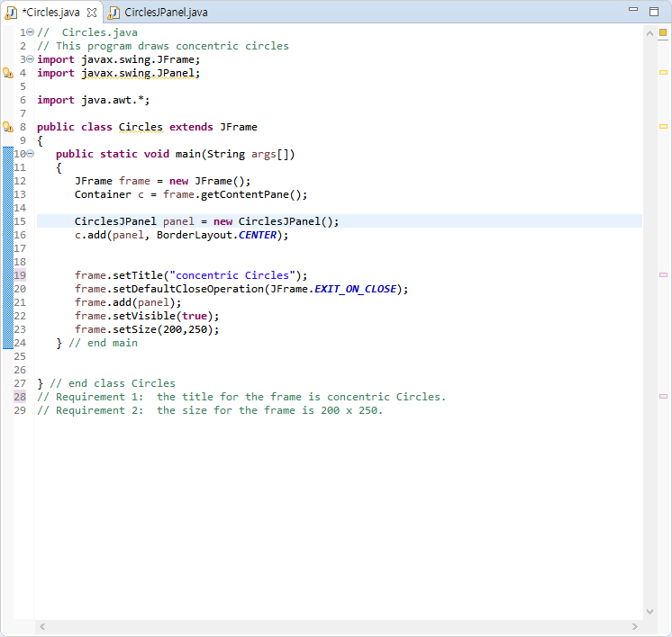

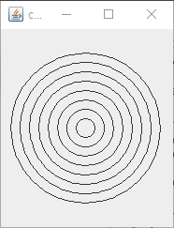

**Q2**. **Modify** your solution to **Q1** to draw the **ovals b**y using **Ellipse2D.Double** class and **draw** () method of

**Graphics2D** class. Hence, complete the codes in files “**Concentric.java**” and “CirclesJPanel.java” under the folder **CodeQ2**. When you run the code after completing the code, the following figure is displayed.

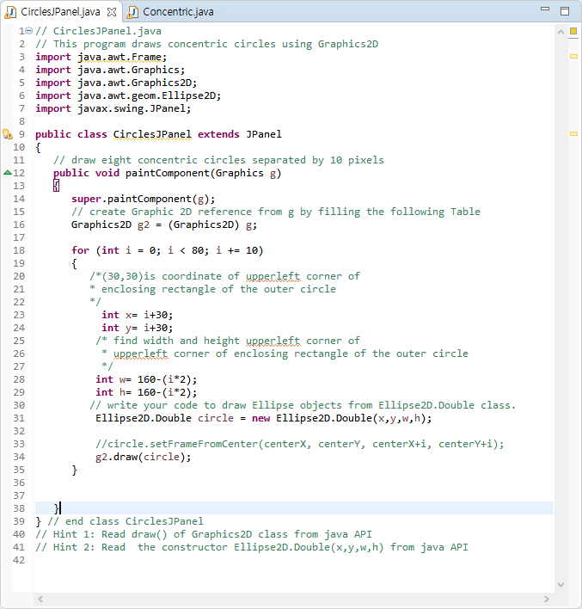

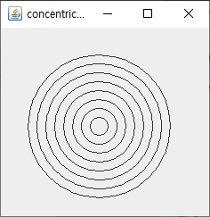

**Q3.**  The source code of an application that draws **ten** nested rectangles using **Rectangle2d.Double** class is given. The rectangles are separated by 10 pixels on all sides. Complete the partial source code in the files “DrawRectangles.java” and **“**RectanglesPanel.java” under the folder **CodeQ3.** When you run the code, the following figure is displayed.

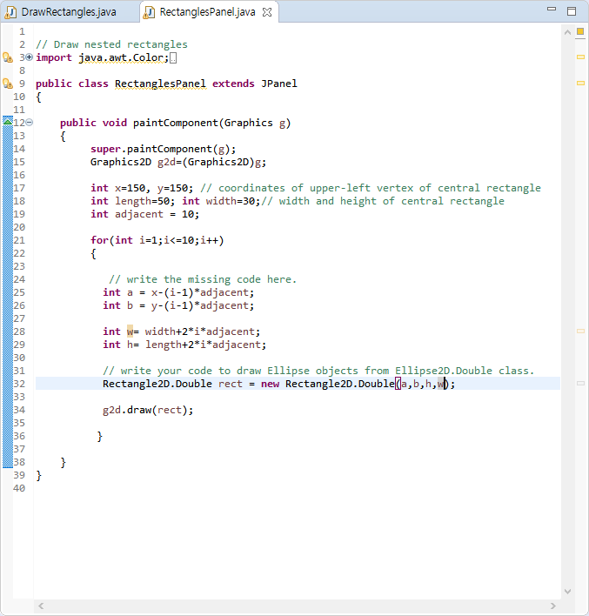

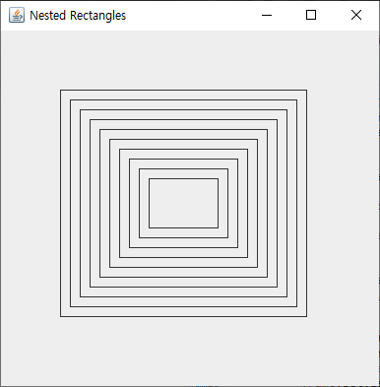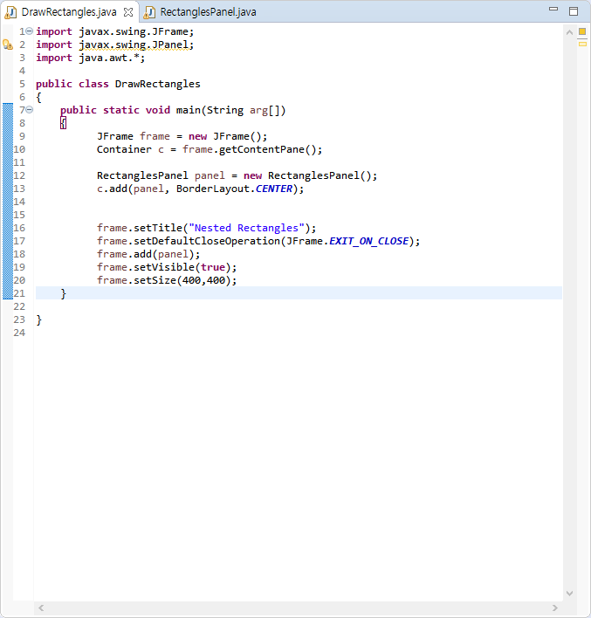

**Q4.** The source code of an application that asks the user to **input the radius** of a circle as a floating-point number and then display the values of the circle’s diameter, circumference and area. Use the value 3.14159 for **п**. Complete the partial source code in the file **“Circle.java” under CodeQ4.** When you run the code, the following 4 figures are displayed sequentially.

