**OOP Lab 13**

|  |  |  |  |
| --- | --- | --- | --- |
| Name: | 신민선 | Department: | 미디어학과 |
| Student ID: | 201723307 | Room Number: |  |
| Due Date: | **June 19, 23 : 59** | | |

**Q1.** The Skeleton code to create the following GUI without any functionality is given. Hence, complete the skeleton code in files “Align.java” and “AlignFrame.java” under the folder CodeQ1. After completing the code, when you run the program, the following window is displayed.

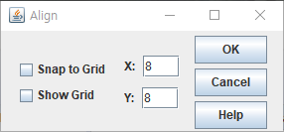

**Q2**.

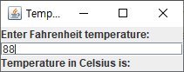

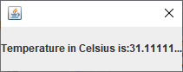

**Q3**. **Program with one Event Handler class that implements many types of Listener Interfaces.**

1. After **answering question a), answer the following questions.**
2. Select from **Combox** box and then add the screen shot in your file.

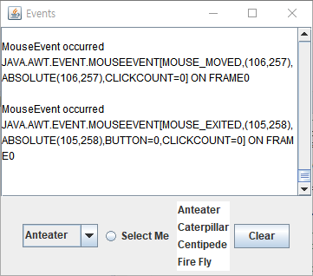

1. Click the “**clear”** button and then add the screen shot in your file.

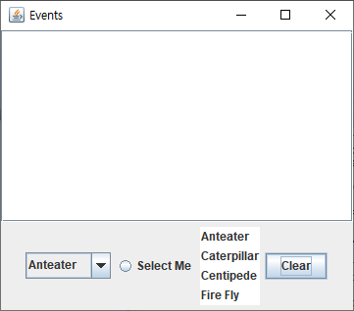

1. Click the ”**select me**” radio button and then add the **screen shot** in your file.

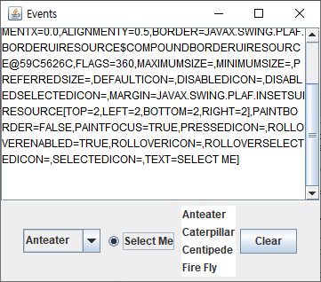

1. Select from “**list**” and then add the screen shot in your file. .

