**LAB3_assignment**

Name: 신민선 Department: 미디어학과

Student ID: 201723307 Room_Number: 팔달관 333호

Due Date: 03/23

**Exercises 1.**

**Case1) integer**

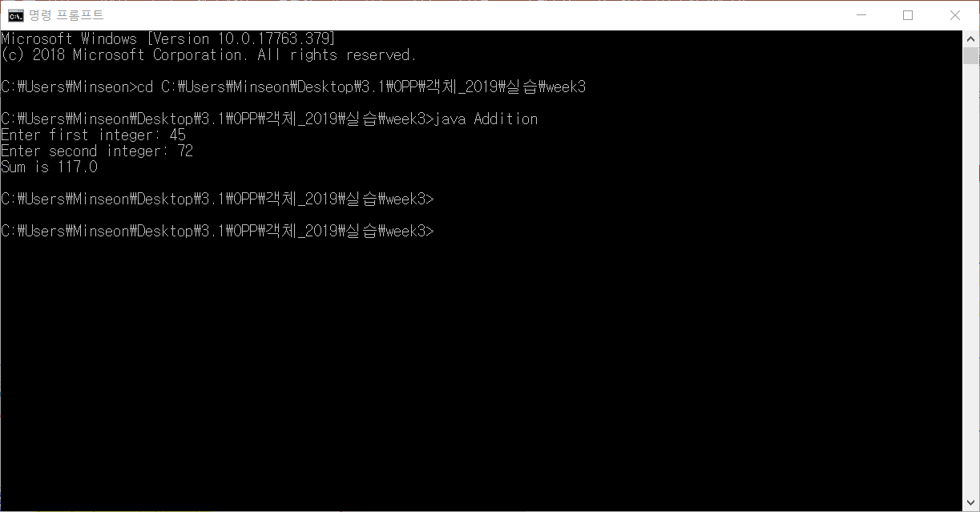

Case 2) double

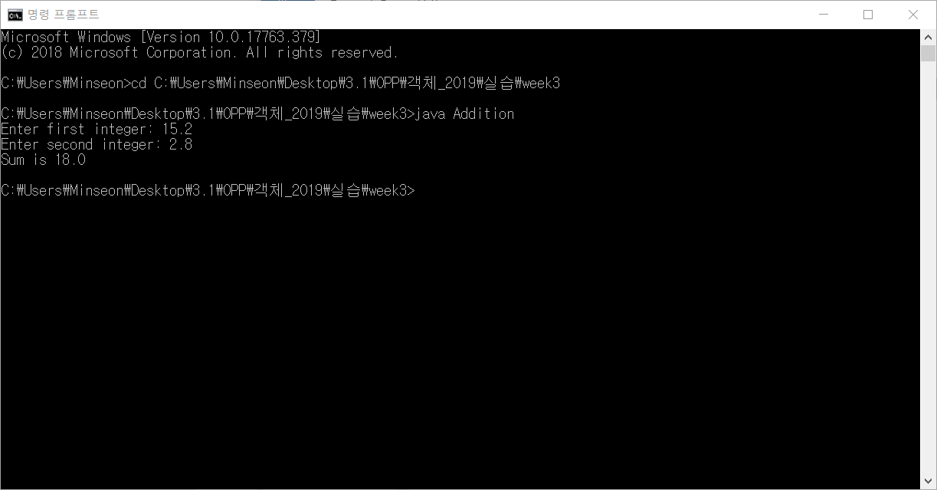

Exercise 2

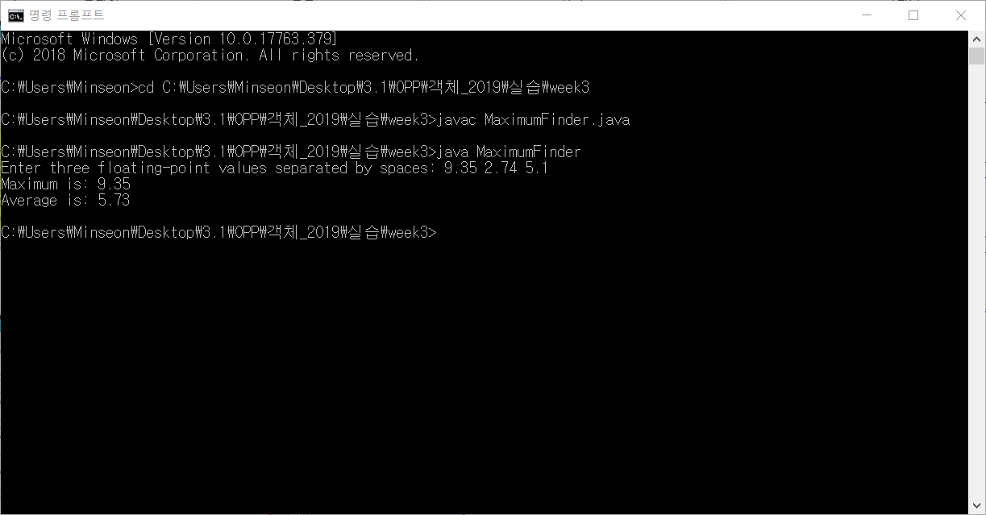

Practice

