**LAB8_assignment**

|  |  |  |  |
| --- | --- | --- | --- |
| Name: | 신민선 | Department: | 미디어학과 |
| Student ID: | 201723307 | Room Number: | 팔달관 333호 |
| Due Date: | **Saturday, May 4, 2019** | | |

**Q1. Write the following code and answer the following questions.**

1. **After compiling the above code, how many .class files are generated?**

2 .class file are generated.

1. **List the name of the . Class files.**

University$Department.class

University.class

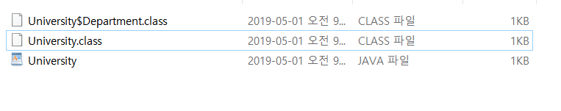**Q2. Write the following code and answer the following questions**

1. **When you compile and run the above program, you will get an error? Why this error is generated?**

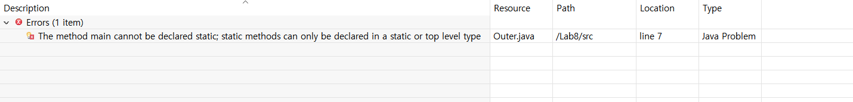

I got an Error.

The method main cannot be declared static; static methods can only be declared in a static or top level type.

Static method has to use in static inner class except top class. So, I have to change inner-class to static inner-class. Or I move main method from inner class to Outer class.

1. **Can a non-static inner class have a static method including main() ?**

Nope. As I said in above question, static method can create only in static class except top class. So We have to move to top class or change access modifier from default to static.

**Q3. The following code is a partial code. Complete the missing code to get the output.**

**Question**: To get this output from the above code, write the missing code.

*Hint: How* ***main()*** *method ( belongs to* ***outer*** *class) invoke method M1() (belongs to an inner class)*

**public** **static** **void** main(String[] args)

{

Outer outer = **new** Outer();

Outer.Inner i = outer.**new** Inner();

i.M1();

}

Attach1) code

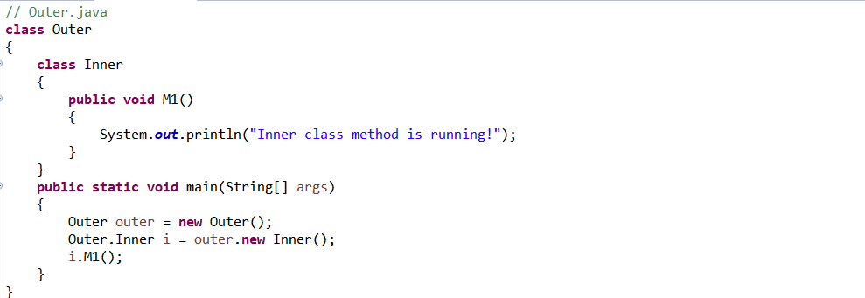

Attach2) cmd

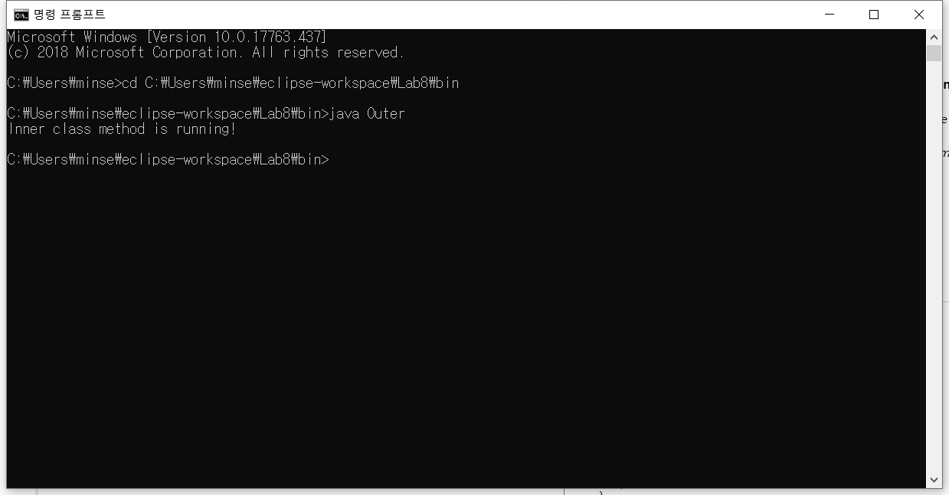

**Q4. The following code is a partial code. Complete the missing code to get the output.**

Hint: How M2( ) method (belongs to **outer** class) invoke method M1() (belongs to an inner class)

Attach1)

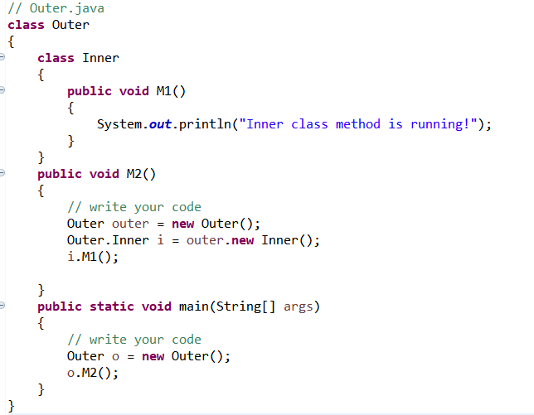

Attach2)

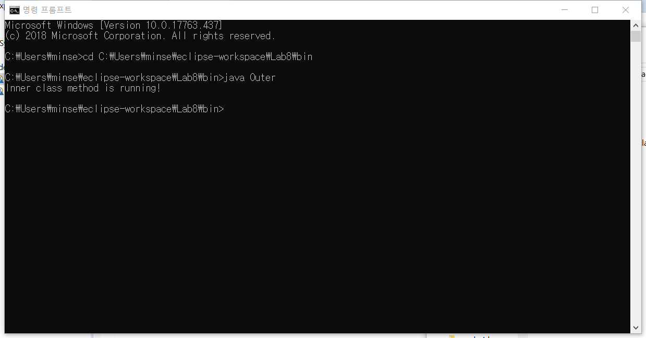

**Q5. The following code is a partial code. Complete the missing code to get the output.**

Hint: How the **main()** method (belongs **TestClass**) invoke method M1()

Attach1) code

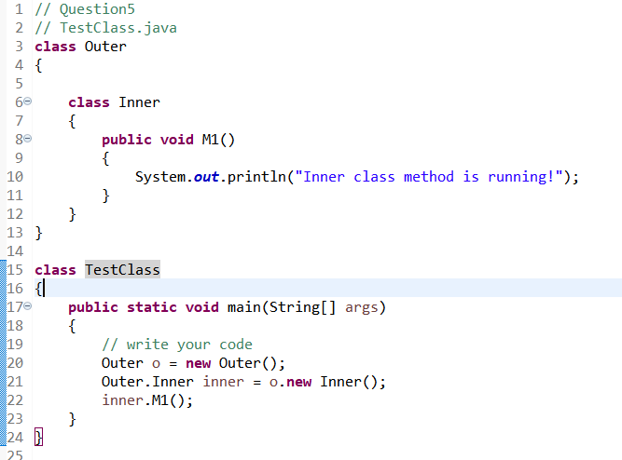

Attach 2)



**Q6. Write and run the following code**

**Question: from the output of the above code, a method (belongs to non-static inner class) can access fields of outer classes? Why ?**

Yes. They can access fields of outer classes.

The inner class is an instance class of Outer class. So they can access even if it is static.

And in the main method, Objectify the external class at first. after that, objectize the inner class.

So external class can be used by instantiating an inner class as an instance variable.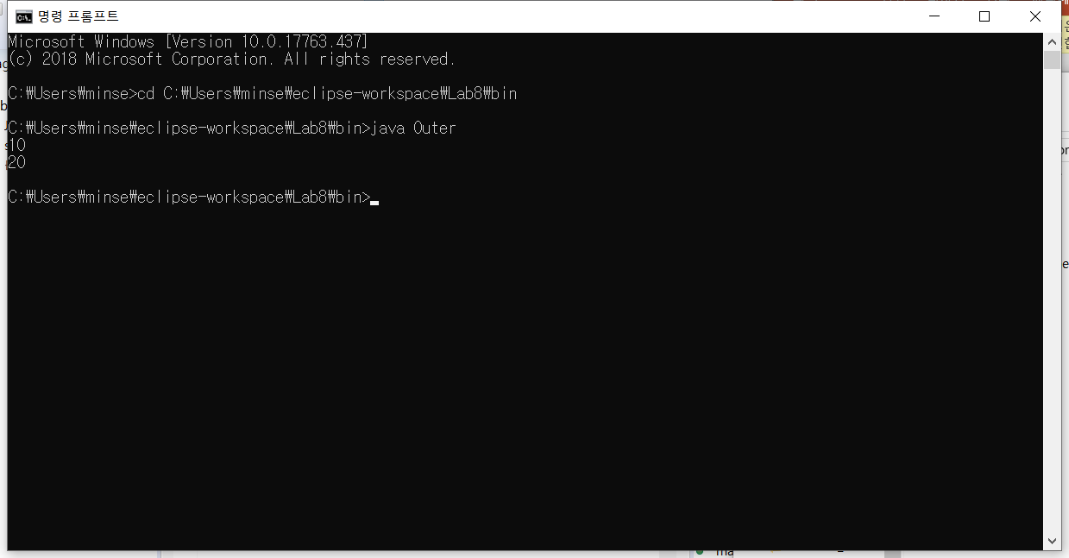

**Q7. The following code is a partial code. Complete the missing code to get the output.**

**Hint: How a method of inner class solve Shadowing effect?**

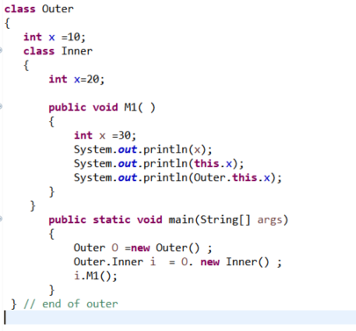

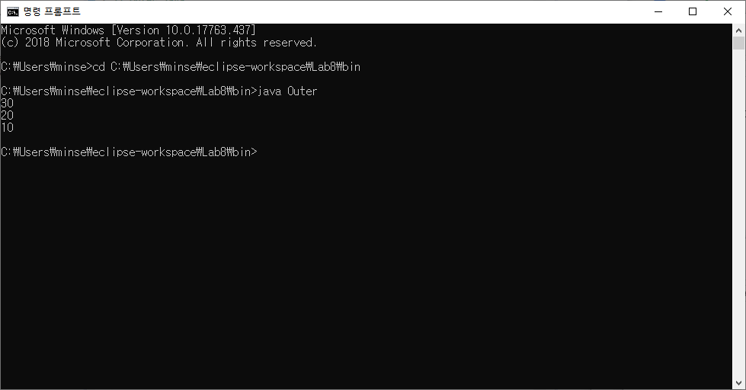

**Q8. Compile and run the following code.**

Question:

1. Can method M2(belongs to local inner class) access the local variable z (local to method M1)?

Yes.(after version JDK1.8). And No(before JDK1.8)

Because of something that depending on whether or not the final access modifier is optional.

1. **Explain your reason.**

Actually, according to the definition, Local inner class can access only final fields in the method that has its own. But after JDK1.8 version we can omit final access modifier in codes. If we omit final modifier, the compiler will automatically attach in it.

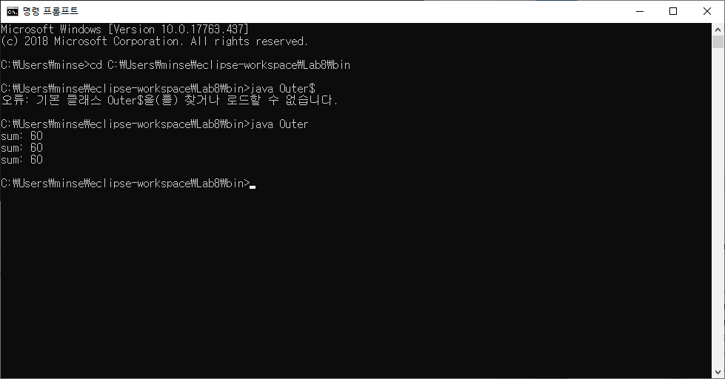

**Q9 : run the following code**

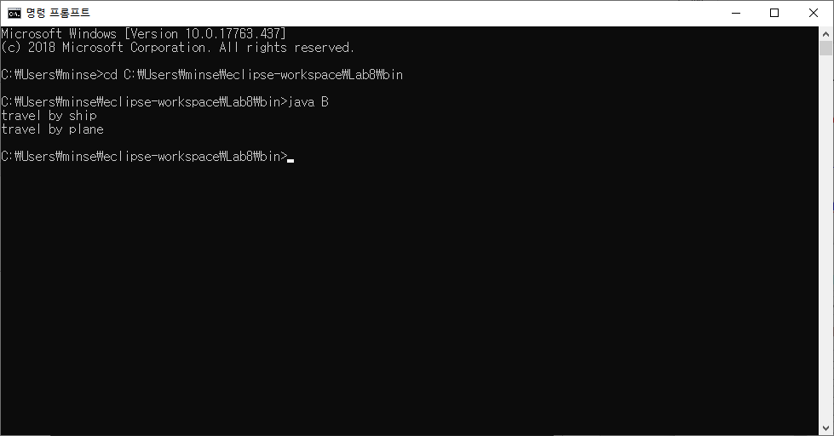

1. **Why you get the above output?**

In code, this "A a1 = new A()// no semicolon" line is to make anonymous class. An anonymous class has no name and they can use one time so this anonymous class is disposable. so first declare an anonymous class and create an object named a1. call method M1(), print travel by ship, after then the anonymous class is disappeared. After then, create a new object named a2. call M1() in real class A. so they print travel by plane.

1. **After compiling, how many classes (.class) files are generated? List their name.**

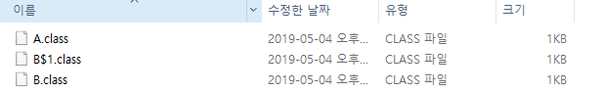

Name is A.class, B$1.class, B.class

**Q10: The partial code and the output of the code is given below.**

Question: To get this output from the above code, write the missing code.

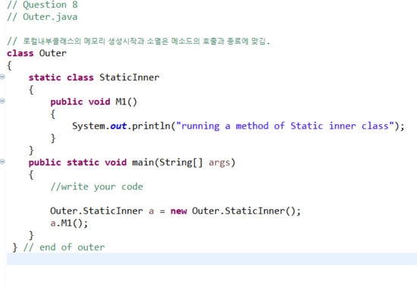

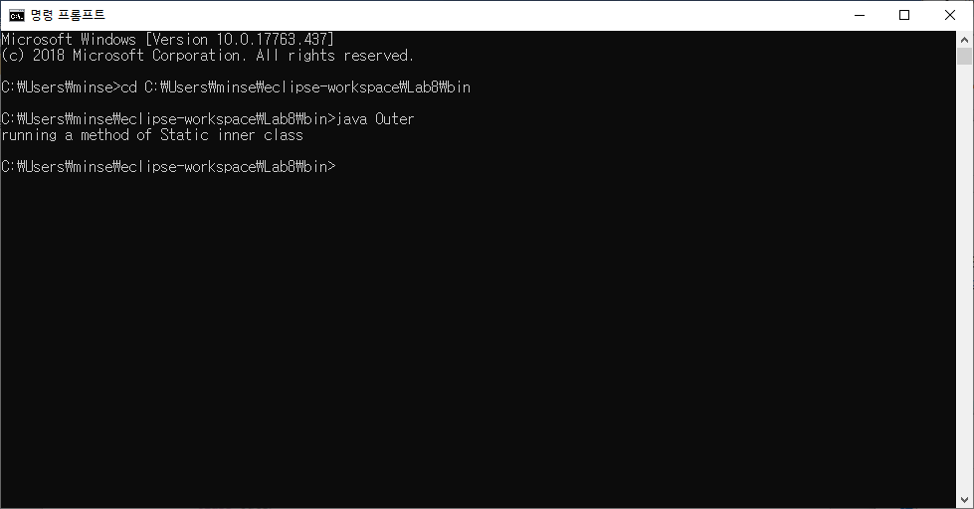

**Q 11: The partial code and the output of the code is given below.**

**Question : To get this output from the above code, write the missing code**

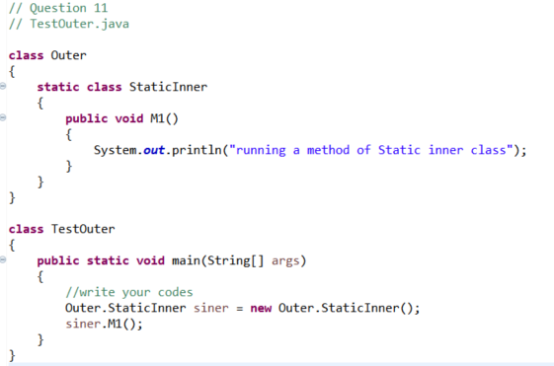

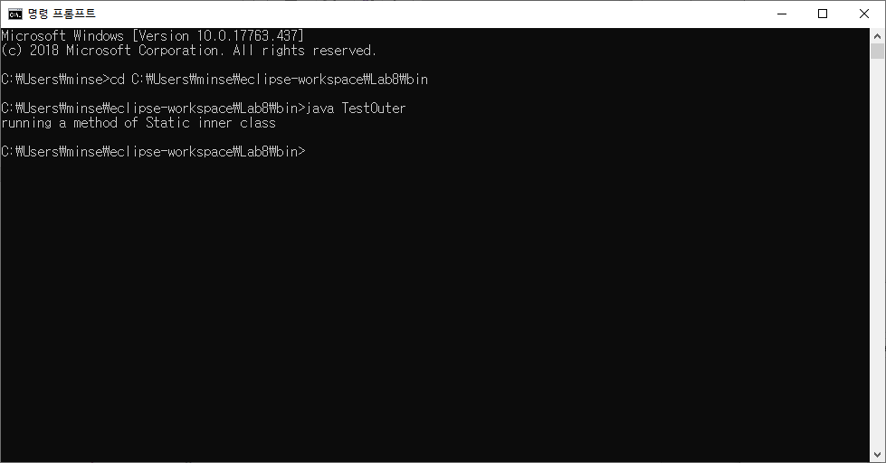

**Q12: After writing the following code, answer the questions that follows.**

**a) After compiling , run the code by using the following command.**

**java outer**

**Question: what is the output ?**

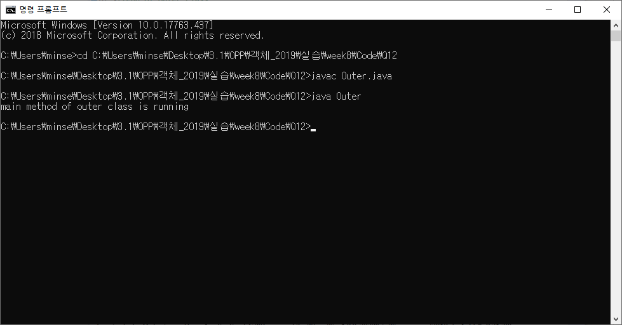

**b) After compiling , run the code by using the following command.**

**java Outer$StaicInner**

**Question: what is the output ?**

