**Nature of Invention:** Chemical molecule and synthesis route  
**Applicant:** VortexChem  
**Inventors:** Dhyanavi Chauhan, Akshat Swarup.  
**Chemical Formula:** C14H17Cl2N3O  
**Chemical Name:** Hexaconazole

## Chemical Synthesis Route

### PRIMARY MODE OF SYNTHESIS

#### RAW MATERIALS REQUIRED:

1. Valeryl Chloride (C5H9ClO)
2. 1,2,4-Triazole
3. 2,4-Dichlorobenzyl Chloride (MDCB)
4. Potassium Hydroxide(KOH)
5. Solvent (Acetonitrile or Toluene)
6. Catalyst (Tertiary Amine or Lewis Acid) (CH3)2S and Aluminium Trichloride
7. Dimethyl Sulphate
8. DMF (Solvent)

### PROCESS ANALYSIS:

#### 1. ACYLATION REACTION:

Conditions: T= 303K, P= 1 atm  
Chemical Reaction:  
*MDCB reacts with valeryl chloride to form an acylated intermediate called Valerophenone. Remove the solvent using rotary evaporation under reduced pressure.*

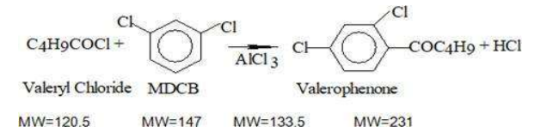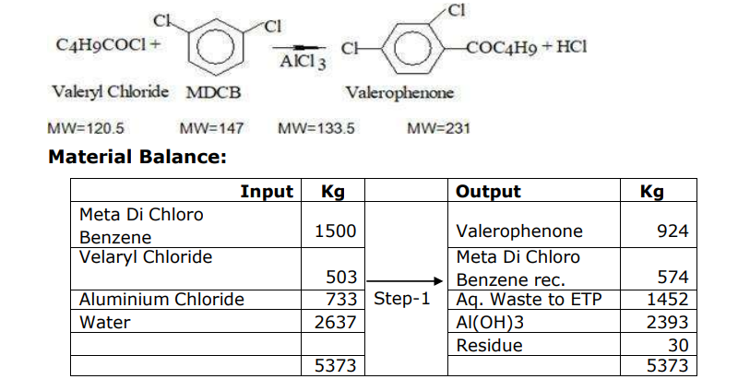Reaction Yield: 85-95% (Based on the above data it is 95.8%)

**DESCRIPTION:**

* MDCB is added to a stirred round bottom flask containing valeryl chloride in the presence of a catalyst like AlCl3 to facilitate the reaction.
* The reaction proceeds under mild conditions, forming an acylated intermediate called Valerophenone.
* The crude product is extracted with an organic solvent and purified by distillation.

#### 2. FORMATION OF OXIRANE

Conditions: T= 333K, P= 0.5 atm  
Chemical Reaction:  
*Valerophenone reacts with Dimethyl sulphate in presence of Dimethyl sulphide to form Oxirane. The mass is then neutralised with caustic flakes and Oxirane is recovered from the mass. We can even use mCPBA and tertbutanol peroxide as epoxide forming agents in the presence of DMF.*

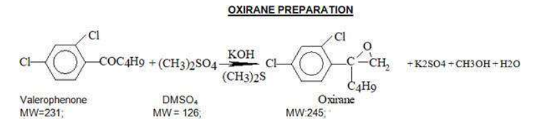

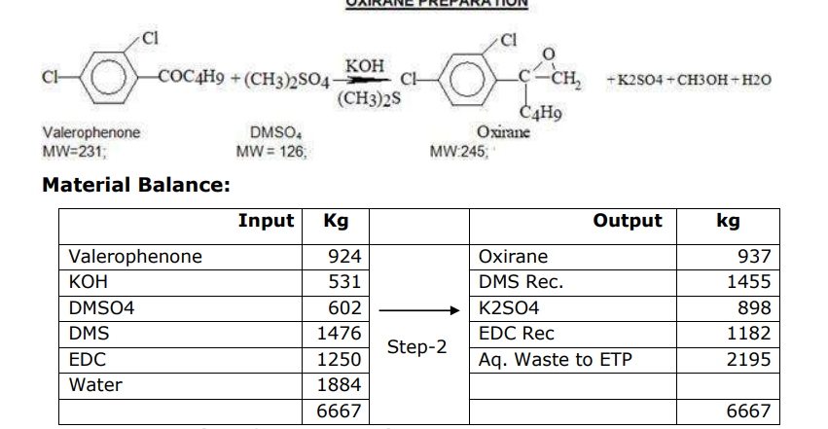Reaction Yield: 80-95% (Based on above data it is 95.6%)

#### 3. PREPARATION OF HEXACONAZOLE

Conditions: T= 333K, P= 0.5 atm

Catalyst**:** Solid alkali (NaOH/KOH) + Phase-transfer catalyst (Tetrabutylammonium bromide)  
Chemical Reaction:  
*Oxirane is added in mass with DMF and Triazole in presence of KOH catalyst to form Hexaconazole, this mass is then crystallised using solvents like toluene and chloroform, Filtered and dried to get Hexaconazole of desired purity*

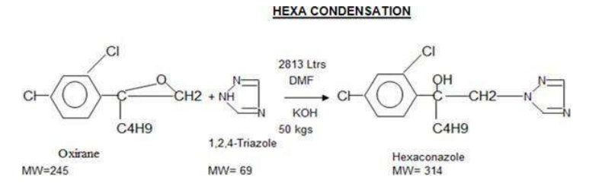

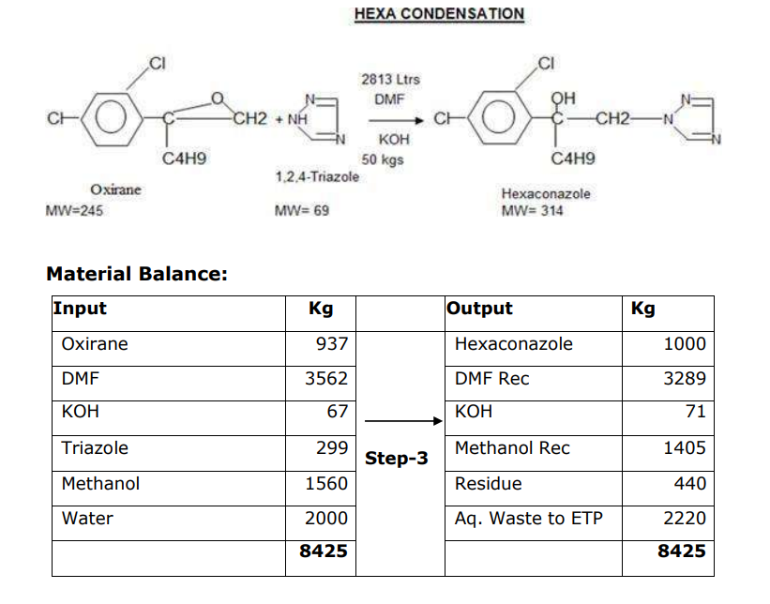

Reaction Yield: 80-90% (Based on above data it is 83.3%)

**DESCRIPTION:**

* MDCB is added to a stirred round bottom flask containing the triazole in the presence of a catalyst like caustic flakes to facilitate the reaction.
* The reaction proceeds under mild conditions, and a solvent like DMF or DMSO.
* There is a nucleophilic substitution result in the oxirane ring opening which forms the final product.

**References:**

<https://environmentclearance.nic.in/writereaddata/Online/TOR/10_Feb_2022_18360085055790452AdditionalDocuments.pdf>? **Page 24-25 (Hexaconazole)**

<https://www.benchchem.com/product/b136387>

<https://biologyinsights.com/flumethrin-structure-action-synthesis-and-application-techniques/>

<https://patents.google.com/patent/CN101805300B/en>

**Dhyanavi Chauhan - Studied the primary synthesis route, raw materials, reaction conditions and worked on the descriptions.**

**Akshat Swarup - Studied the application of different epoxide forming agents, reaction conditions and drafted the RND report.**

**Sign the pdf and upload.**

| Name | Roll No | Signature |
| --- | --- | --- |
| Shubham Kumar |  |  |
| Dhyanavi Chauhan | 230372 |  |
| Akshat Swarup | 230104 |  |