LESSON 1  Unit:6  Tradition and language |  |  | School:
Date: |  |  | Teacher name:
Grade: 9 |  |  | Number present: |  | Number absent:
Theme of the lesson: |  |  | Writing: Quebec winter carnival
Learning objectives: |  | 9.3.1.1 use formal and informal language registers in their talk on a range of general and curricular topics  9.5.2.1 write independently about factual and imaginary past and future events, activities and experiences on a wide range of familiar general and curricular topics
Lesson objectives: |  | To make your description more vivid, interesting and lively, use a variety of descriptive adjectives.
Criteria |  | Listen carefully and good reading with minimum mistakes. Have a HW. Write in Copybook Vocabulary. Doing schoolwork and be active.
Plan
Planned timings | Teacher’s activity |  |  | Student’s activity |  | Assessment | Resoursces
Beginning 3 min | 1.Greeting.  Ask about the weather.  The teacher sets the lesson objectives, letting students know what to anticipate from the lesson.  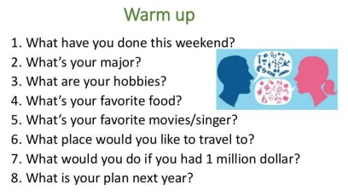  Lead – In   |  |  | The aim: To develop Ss speaking skills and create friendly atmosphere  Students' attention is drawn to the lesson.  Determines the topic and purpose of the lesson  • Learners talk about favourite dayprevious lesson vocabulary  Students say different words from the picture and count one to hundred |  | At the organization moment T tries to award active Ss.  “Good job!  Well done!”  Descriptor  - talk about favourite day  Total: 1 point  Assessment criteria  - Learners have met the learning objectives if they can talk about | S.B. Page 73  - B.
Middle  37 min | Ex:1 P:73  • Read out the Writing Tip and discuss it with Ss.  Read the headings aloud and then give Ss time to read the text and match them to the paragraphs.  Check Ss' answers.  Ex:2 P:73  • Go through the Study Skills box and explain/elicit the meanings of the adjectives in the rubric.  • Give Ss time to read the text and complete the task and then check Ss' answers.  Ex: 3 P:73  •.Read the rubric aloud and ask Ss to identify words that tell them for who and what they have to write.  Check Ss' answers.  Differentiation:  «Verbal support» method is used to help Students ue new words in the text.  .● Conclusion during the lesson some tasks differentiated by outcomes of the students and by their abilities. |  |  | Students read the article and match the paragraphs to the headings.  Text ans: wonderful, amazing, cheerful, decorated, traditional, long, unforgettable  ANSWERS:  A 4  B 3  C I  D 2  Students read the Study Skills box. Then fill in the gaps.  ANSWERS:  1 annual  2 amazing  3 cheerful  4 decorated  5 traditional  6 long  7 unforgettable  Students read the rubric and underline the key words. Answer the question.  ANSWERS:  Key words: magazine for teenagers, article, celebration in your country  I am going to write a descriptive article about an event. I am writing it for teenagers to read |  | Descriptor:  - read the article  - match the paragraphs  Total: 2 point  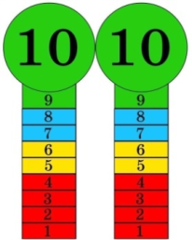  Descriptor:  - read the Study Skills box.  - fill in the gaps.  Total: 2 point  Descriptor:  - read the rubric  - underline the key words  Total: 1 point  -Make CCQ questions  Yes / No | Cards  Student’s book  http://youtu.be/PLnf2JbC6aY?si=_WVBAp9oomm9CLFE  Worksheets
End  5 min | Giving the hometask.  Ex: 1-2 P:47 wb  Self-reflection |  |  | 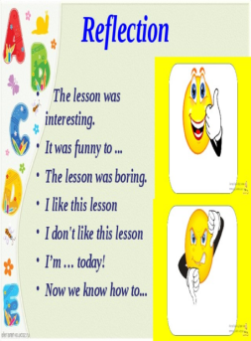 |  |  | Workbook

LESSON 1  Unit:6  Tradition and language |  |  | School:
Date: |  |  | Teacher name:
Grade: 9 |  |  | Number present: |  | Number absent:
Theme of the lesson: |  |  | Edutainment
Learning objectives: |  | 9.6.3.1 use a variety of compound adjectives, adjectives as participles, comparative structures indicating degree, and intensifying adjectives on a wide range of familiar general and curricular topics  9.3.3.1 explain and justify their own point of view on a range of general and curricular topics
Lesson objectives: |  | To use adjectives , To listen and read for gist, to read for specific information
Criteria |  | Listen carefully and good reading with minimum mistakes. Have a HW. Write in Copybook Vocabulary. Doing schoolwork and be active.
Plan
Planned timings | Teacher’s activity |  |  | Student’s activity |  | Assessment | Resoursces
Beginning 3 min | 1.Greeting.  Ask about their mood.  The teacher sets the lesson objectives, letting students know what to anticipate from the lesson.   |  |  | The aim: To develop Ss speaking skills and create friendly atmosphere  Students' attention is drawn to the lesson.  Determines the topic and purpose of the lesson  • Learners talk about favourite dayprevious lesson vocabulary  Students say different words from the picture and count one to hundred |  | At the organization moment T tries to award active Ss.  “Good job!  Well done!”    Descriptor:  - talk about favourite day  Total: 1 point  Assessment criteria  - Learners have met the learning objectives if they can talk about | S.B. Page 74  C.B.  
Middle  37 min | Ex:1 P:73  • Read out the Writing Tip and discuss it with Ss.  Read the headings aloud and then give Ss time to read the text and match them to the paragraphs.  Check Ss' answers.  Ex:2 P:73  • Go through the Study Skills box and explain/elicit the meanings of the adjectives in the rubric.  • Give Ss time to read the text and complete the task and then check Ss' answers.  Ex: 3 P:73  •.Read the rubric aloud and ask Ss to identify words that tell them for who and what they have to write.  Check Ss' answers.  Ex: 4 P:74  • Give Ss time to complete the quiz referring back to the module as necessary.  Check Ss' answers and elicit the correct answers for the false items.  Ex: 5 P:74  • Explain the task and ask Ss to work in pairs.  Give Ss some time to look back through the module and think of quiz questions and compile their quiz.  Ss can exchange their quizzes with other pairs.  Differentiation:  «Verbal support» method is used to help Students ue new words in the text.  .● Conclusion during the lesson some tasks differentiated by outcomes of the students and by their abilities. |  |  | Students look at the list. Choose the correct item.  ANSWERS:  1 shouldn't  2 can  3 should  4 can  5 will  6 might  7 can  Students answer the question. Use the list to tell the class.  ANSWERS:  I think it is important to keep our traditions to remember our history and …Students create your own festival  ANSWERS:  Name: Local History Day  Place: every village/town/city  Time: 1st June every year  Reason: to celebrate the history of the place where people live  Activities: exhibitions of old photos and …  ANSWERS:  1T  2 F (It's in the USA.)  3 T  4 F (Kadyr-Ata is a legendary holy man.)  5T  6 F (It lasts three days.)  7 F (It takes place all over Kazakhstan.)  8T 9T 10 T |  | Descriptor:  - look at the list  - choose the correct item  Total: 2 point  Descriptor:  - answer the question.  - use the list to tell  Total: 2 point  Descriptor:  - create your own festival  Total: 1 point  Descriptor:  - go through Module 6  - write true or false  Total: 1 point  -Make CCQ questions  Yes / No | Cards  Student’s book  Worksheets  https://youtu.be/bpirPuUcUZ8?si=qr4utlYO4tb6W8qD  song
End  5 min | Giving the hometask.  Ex: 3 P:74 sb  Feedback |  |  | 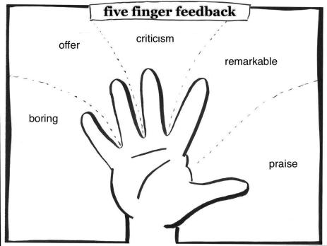 |  |  | Poster Success  S.B.

LESSON 2  Unit:7  Music and film |  |  | School:
Date: |  |  | Teacher name:
Grade: 9 |  |  | Number present: |  | Number absent:
Theme of the lesson: |  |  | Vocabulary: Types of Films
Learning objectives: |  | 9.2.6.1 deduce meaning from context in unsupported extended talk on a wide range of general and curricular topics, including talk on a limited range of unfamiliar topics  9.3.1.1 use formal and informal language registers in their talk on a range of general and curricular topics  9.4.2.1 understand specific information and detail in extended texts on a growing range of familiar general and curricular topics, and some unfamiliar topics
Lesson objectives: |  | Learn new vocabulary. Use new words and write review.
Criteria |  | Have a HW. Write in Copybook Vocabulary. Doing schoolwork and be active.
Plan
Planned timings | Teacher’s activity |  |  | Student’s activity |  | Assessment | Resoursces
Beginning 5 min | Greeting.  Lead – In  Ask students about their favourite movies and cartoon. Who their favourite musician.  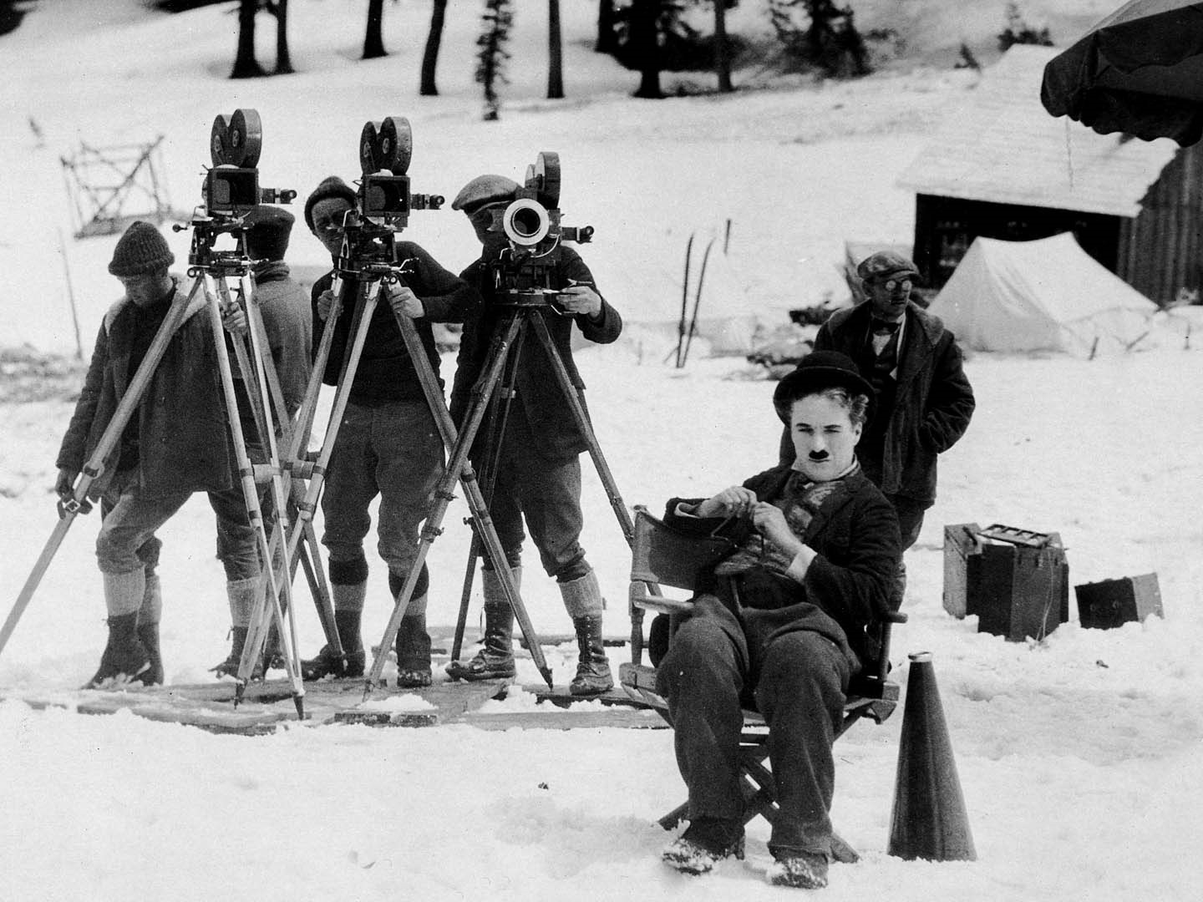   |  |  | The aim: To develop Ss speaking skills and create friendly atmosphere  Students' attention is drawn to the lesson.  Determines the topic and purpose of the lesson  • Learners talk about favourite dayprevious lesson vocabulary  Students say different words |  | At the organization moment T tries to award active Ss.  “Good job!  Well done!”  Descriptor:  - talk about favourite film/music  Total: 1 point  Assessment criteria  - Learners have met the learning objectives if they can talk about | S.B. Page 75  C.B.  Pictures
Middle  37 min | Ex:1 P:75  • Read out the Writing Tip and discuss it with Ss.  Read the headings aloud and then give Ss time to read the text and match them to the paragraphs.  Check Ss' answers.  Ex:2 P:75  • Go through the Study Skills box and explain/elicit the meanings of the adjectives in the rubric.  • Give Ss time to read the text and complete the task and then check Ss' answers.  Ex: 3 P:75  •.Read the rubric aloud and ask Ss to identify words that tell them for who and what they have to write.  Check Ss' answers.  Differentiation:  .● Conclusion during the lesson some tasks differentiated by outcomes of the students and by their abilities. |  |  | Students listen and repeat.  ANSWERS:  Students own answer  Students match the reviews to the film posters.  ANSWERS:  1 B 2 D 3 C 4 A  1 science fiction  2 musical  3 animation  4 action/adventure  Students answer the question. Discuss in pairs.  ANSWERS:  Star Wars: The Force Awakens has broken box office records. It's a must-see.  Have you seen Frozen? It's the perfect film for the whole family to enjoy.  If you haven't seen in the Heart of the Sea yet, make sure your do. It's an incredible true story of human courage |  | Descriptor:  - read the article  - match the paragraphs  Total: 2 point  Descriptor:  - read the Study Skills box.  - fill in the gaps.  Total: 2 point  Descriptor:  - read the rubric  - underline the key words  Total: 1 point  Write a recommending- 2 point ( 3 point if their use new vocabulary) | Cards  Student’s book  http://youtu.be/PLnf2JbC6aY?si=_WVBAp9oomm9CLFE  Worksheets
End  5 min | Giving the hometask.  Ex:2,3 P:48 wb |  |  | Feedback as review to film   |  |  | Workbook

LESSON 3  Unit:7  Music and film |  |  | School:
Date: |  |  | Teacher name:
Grade: 9 |  |  | Number present: |  | Number absent:
Theme of the lesson: |  |  | Film genres around the world.
Learning objectives: |  | 9.2.6.1 deduce meaning from context in unsupported extended talk on a wide range of general and curricular topics, including talk on a limited range of unfamiliar topics  9.3.1.1 use formal and informal language registers in their talk on a range of general and curricular topics  9.4.2.1 understand specific information and detail in extended texts on a growing range of familiar general and curricular topics, and some unfamiliar topics
Lesson objectives: |  | To listen and read for gist, to read for specific information.
Criteria |  | Have a HW. Write in Copybook Vocabulary. Doing schoolwork and be active.
Plan
Planned timings | Teacher’s activity |  |  | Student’s activity |  | Assessment | Resoursces
Beginning 5 min | Greeting.  Checking HW.  Lead – In  Ask students what genres of films they know and which type thee prefer.  Show the PPT. |  |  | Show their HW.  The aim: To develop Ss speaking skills .  Students' attention is drawn to the interactive desk..  Determines the topic and purpose of the lesson  • Learners talk about favourite dayprevious lesson vocabulary |  | At the organization moment T tries to award active Ss.  “Good job!  Well done!”  Descriptor:  - show hw  - talk about favourite genre  Total: 3 point  Assessment criteria  - Learners have met the learning objectives if they can talk about | S.B. Page 77  WB Page 49  C.B.  PPT
Middle  37 min | Giving the students exercises  EX:1  Dicsucc which genre is most popular  Ex:2  - Would you be an actor or a director?  - Which genre would you choose ?  - What would be the filming location?  - Which actor would I invite?  - Would you like to receive an award?  Ex: 3  Write in a few sentences (5-6) which countries cinematography they are interested  Differentiation:  .● Conclusion during the lesson some tasks differentiated by outcomes of the students and by their abilities.  Ex:5 p:77 Find the translation of the next words: strong, closing, true, aerial, praised |  |  | After carefully listening and reading they should do exercises  EX:1  Discuss with other students  EX: 2  Answer the questions  Ex: 3  Ss write which countries cinematography they are interested  Ex: 5  Find the translation of words |  | Descriptor:  Total: 1 point  Descriptor:  - correct pronounciation while reading (1)  - Answer the questions  Total: 2 point  Descriptor:  - Writing a logically full answer  Total : 2  Descriptor:  - Find the translation of words  Total: 1 point | Cards  Student’s book  PPT: https://gamma.app/docs/Global-Cinema-A-Journey-Through-Film-Genres-rq92ue6g26tw69p
End  5 min | Giving the home work.  Ex: 5 P:77 sb  Self-reflection |  |  | Stickers to write their feedback   |  |  | Studentsbook  Workbook

LESSON 3  Unit:7  Music and film |  |  | School:
Date: |  |  | Teacher name:
Grade: 9 |  |  | Number present: |  | Number absent:
Theme of the lesson: |  |  | What impressed you the most about the film?  Relatives.Demonstratives.
Learning objectives: |  | 9.2.6 deduce meaning from context in unsupported extended talk on a wide range of general and curricular topics, including talk on a limited range of unfamiliar topics  9.3.2 ask complex questions to get information about a wide range of general and curricular topics
Lesson objectives: |  | To listen and read for gist, to read for specific information.
Criteria |  | Have a HW. Write in Copybook . Doing schoolwork and be active.
Plan
Planned timings | Teacher’s activity |  |  | Student’s activity |  | Assessment | Resoursces
Beginning 5 min | Greeting.  Checking HW.  Warm-Up. Interactive Quiz match the film.  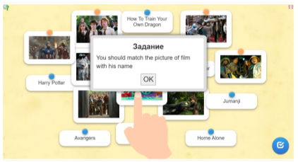 |  |  | Show their HW.  The aim: To develop Ss speaking skills .  Students' attention is drawn to the interactive desk..  • Learners match the films |  | At the organization moment T tries to award active Ss.  “Good job!  Well done!”  Descriptor:  - show hw  - be active in game  Total: 3 point | S.B. Page 78-79  WB Page 50-51  C.B.  https://learningapps.org/watch?v=pepdjvp5c25
Middle  36 min | Grammar Introduction  Relatives  Ex:1 P:78  • Explain that we use relatives (who, which, whose, when, where, why) to introduce relative clauses to identify the noun in the main clause.  Explain that we use who/that instead of subject pronouns to talk about people; we use which/that to talk about objects or animals; we use whose instead of possessive adjectives to talk about possession and we use where/when/why to talk about place/time/reason.  Explain the difference between defining and non- defining relative clauses.g. defining = give essential information, non-defining = give extra  Ex:2 P:78  • Explain the task.  Ex: 3 P:78  • Explain the task.  Give Ss time to complete it.  Check Ss' answers  Differentiation:  «Verbal support» method is used to help Students use new words in the text.  T explain  Demonstratives  This / These → close (This apple, These apples)  That / Those → far (That tree, Those trees)  Ex: 7 P:79  • Explain the task and give Ss time to complete it. Then elicit which words we use for things near/far from us. |  |  | Students read the theory. Say the examples in your language.  1-ANSWER:  Students own answer.  - ANSWER:  - where;2)which;3)whose;4-5-6)who;7)which;8)when;9)who;10)why  Students join the sentences. Answer the question.  - ANSWER:  Defining-3;4;8  Non-definig-1;2;5;6;7  Students listen the theory. Say the examples  Students complete the sentences.  ANSWERS:  1 those  2 This  3 that  4 these  this/these-near  that/those-far |  | Descriptor:  - read the theory  - say the examples in your language  Total: 2 point  Descriptor:  - fill the gaps  - rewrite them using commas where needed  Total: 2 point  Descriptor:  - join the sentences  - answer the question.  Total: 1 point  Descriptor:  -Say the example in eng. to Demonstratives  Total: 1 point  Descriptor:  - complete the sentences.  Total: 1 point | 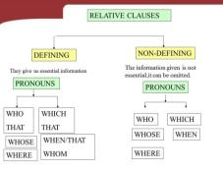  Student’s book p:78  Worksheets  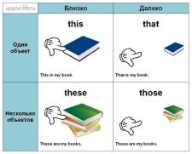
End  4 min | Giving the home work.  Ex: 2 p:50 WB;  Ex: 5 p:51 WB |  |  | 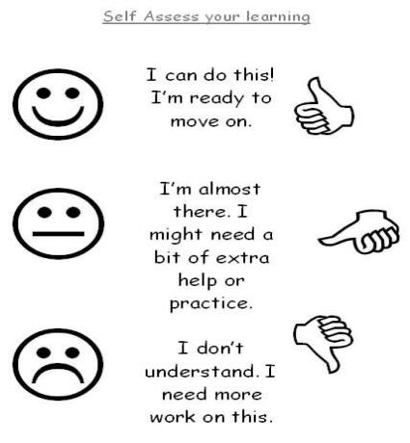 |  |  | Workbook

Unit 6 Tradition and language |  | Lesson

Teacher name:

Date:
Grade: 9 |  | Number present: | absent:
Lesson title | Vocabulary: Adjectives
Learning objectives | 9.2.7.1 recognize typical features at word, sentence and text level of a range of spoken genres  9.3.7.1 use appropriate subject-specific vocabulary and syntax to talk about an increased range of general and curricular topics
Lesson objectives | Learners will be able to:  -arrange sentences, speaker’s ideas in a logical way as they hear it in a listening  -employ subject specific vocabulary and grammar in oral discourse
Value links | Generosity – This may be a core value of yours if you cherish people who will give their time and resources to people in need. You may consider yourself to be a generous person if you find joy and meaning in giving to others.
Plan

Stages / Time | Teachers’ actions | Students’ actions | Assessment criteria | Resources
Beginning of the lesson  Warming-up  3 min | 1.Greeting.  Ask about the weather.  The teacher sets the lesson objectives, letting students know what to anticipate from the lesson.  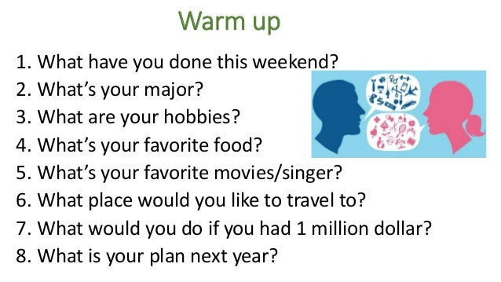  Lead – In  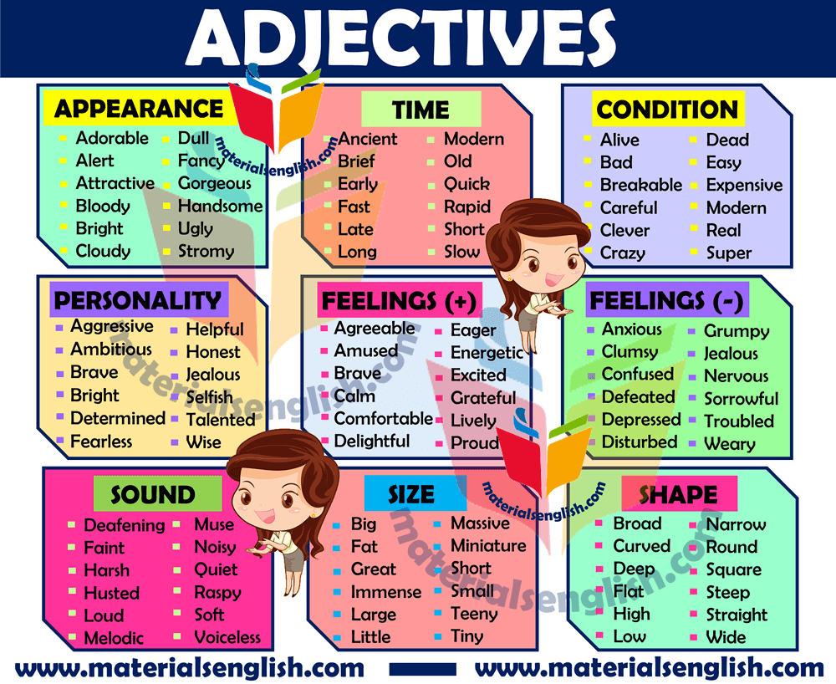 | The aim: To develop Ss speaking skills and create friendly atmosphere  Students' attention is drawn to the lesson.  Determines the topic and purpose of the lesson  • Learners talk about favourite dayprevious lesson vocabulary  Students say different words from the picture and count one to hundred | At the organization moment T tries to award active Ss.  “Good job!  Well done!”    Descriptor:  - talk about favourite day  Total: 3 point  Assessment criteria  - Learners have met the learning objectives if they can talk about | 
Middle of the lesson  Presentation part.  37 min | Ex:1 P:63  • Play the recording. Ss listen and repeat chorally or individually. Check their pronunciation and intonation.  Elicit the L1 equivalents from Ss around the class.(Ss' own answers)  Direct Ss' attention to the pictures and elicit what Ss think the festivals may be like.  Read out the example and then ask various Ss around the class to say similar sentences using the adjectives given for the remaining festivals  Ex: 2 P:63  • Ask various Ss around the class to use the information in the recording to talk about each festival.  Differentiation:  «Verbal support» method is used to help Students ue new words in the text.  ● Conclusion during the lesson some tasks differentiated by outcomes of the students and by their abilities. | Students listen and repeat. Answer the question.  ANSWERS:  The Omaha Pow Wow seems to be a colourful and unusual festival.  Chinese New Year seems to be a colourful and exciting festival. It also looks artistic.  The Roswell UFO Festival seems to be a rather weird festival. The people look serious.  The Sand Sculpting Festival seems to be an artistic and unusual festival.  Nauryz seems to be a serious festival  Students listen and match the descriptions to the pictures. Then talk about festivals.  ANSWERS:  A 3  B 5  C1  D4  E6  F2 | Descriptor:  - listen and repeat.  - answer the question  Total: 2 point  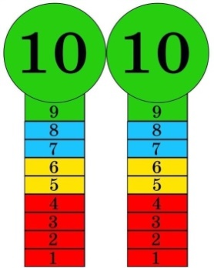  Descriptor:  - listen and match the descriptions  - talk about festivals.  Total: 5 point  -Make CCQ questions  Yes / No | Cards  Student’s book  Worksheets  Student’s book
End of the lesson  5 min | Giving the hometask.  Ex: 3 P:23 wb  Self-reflection | 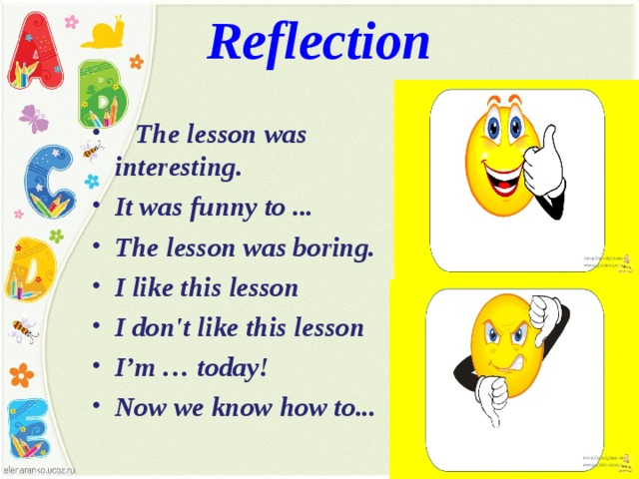  . |  | Poster Success

