**Project Proposal Report**



Mobile programming Term project

2조

201233317 안기훈

201233299 김민성

201233308 박 헌

**Index**

**Brief description**

**Target**

**Contents**

**Key features**

**Role**

**Current progress**

**Time line**

**App title : Trip Diary**

**Member information (+e-mail address)**

Ahn Kihun 201233317 [ohmy3soo@nate.com](mailto:ohmy3soo@nate.com)

Kim Minseong 201233299 [kin0eat@naver.com](mailto:kin0eat@naver.com)

Park Heon 201233308 honeyvvvv@gmail.com

**Brief description**

An application that can capture the memories and photos left by the travel route. Add-ons will be added for travel.

**Target**

A traveler who wants to save photos and feelings like an album between trips and trips. People who need additional features related to travel.

**Contents**

Based on the map, you can leave the route to be moved, and you can leave photos, comments, etc. on what is happening on the map. For example, information about people you met while traveling, accommodation, and meals. And we will add the add-ons for travel. For example, Related to travel expenses.

**Key features**

Used to display and save the user’s travel route by GPS.

Show map on screen by external maps API.

Upload photos and comments on the map with photos taken during trips and feelings.

Save travels to mobile database.

**Role**

Ahn - GPS interworking (Google Maps). Final presentation.

Kim - Building a mobile database. GitHub management. First presentation.

Park - App design. Second presentation.

ALL - Making PPTs and reports. Application programming.

**Current progress**

We are trying to make a chat application called ‘ZZAK’ and do not make a difference with existing chat application. While searching for another topic, we want to make an application that can save memories and help in traveling related to traveling team members.

We do design the overall structure of application.

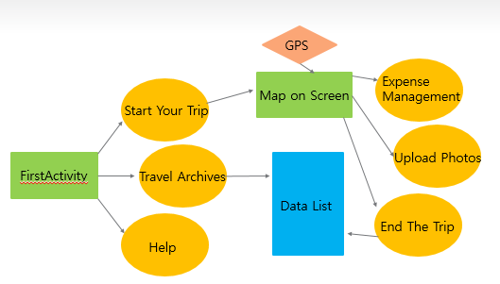

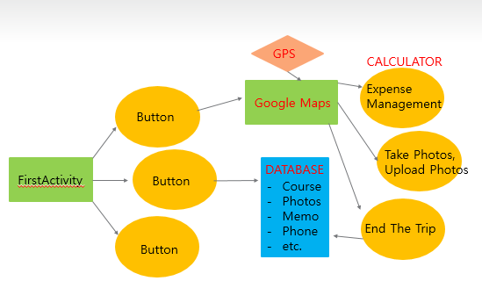

We will add additional features that will be helpful in trips.

**Time line**

Everyday 17:00 ~ 19:00.

1 week - Topic selection, Design the overall structure of application. We done!

2 week - Layout design (1) - Frame of screen using view, widget, layout.

3 week - Layout design (2) - Image, Detailed design.

4 week - Main programming (1) - Connection between activity and fragment.

5 week - Mid Term Example; checking overall.