**Ajax**

**form.html code:**

<html>

<head>

<script>

function showHint(str) {

  if (str.length == 0) {

    document.getElementById("txtHint").innerHTML = "";

    return;

  } else {

    var xmlhttp = new XMLHttpRequest();

    xmlhttp.onreadystatechange = function() {

      if (this.readyState == 4 && this.status == 200) {

        document.getElementById("txtHint").innerHTML = this.responseText;

      }

    };

    xmlhttp.open("GET", "gethint.php?q=" + str, true);

    xmlhttp.send();

  }

}

function showHint1(str) {

  if (str.length == 0) {

    document.getElementById("txtHint1").innerHTML = "";

    return;

  } else {

    var xmlhttp = new XMLHttpRequest();

    xmlhttp.onreadystatechange = function() {

      if (this.readyState == 4 && this.status == 200) {

        document.getElementById("txtHint1").innerHTML = this.responseText;

      }

    };

    xmlhttp.open("GET", "gethint1.php?q=" + str, true);

    xmlhttp.send();

  }

}

function showHint2(str) {

  if (str.length == 0) {

    document.getElementById("txtHint2").innerHTML = "";

    return;

  } else {

    var xmlhttp = new XMLHttpRequest();

    xmlhttp.onreadystatechange = function() {

      if (this.readyState == 4 && this.status == 200) {

        document.getElementById("txtHint2").innerHTML = this.responseText;

      }

    };

    xmlhttp.open("GET", "gethint2.php?q=" + str, true);

    xmlhttp.send();

  }

}

function submitValue() {

        // Get the value entered by the user

        var input = document.getElementById('value-input');

        var value = input.value;

        var input1 = document.getElementById1('value-input1');

        var value1 = input1.value1;

        var input2 = document.getElementById2('value-input2');

        var value2 = input2.value2;

        var input3 = document.getElementById3('value-input3');

        var value3 = input3.value3;

        // Store the value in localStorage

        localStorage.setItem('myValue', value);

        localStorage.setItem1('myValue1', value1);

        localStorage.setItem2('myValue2', value2);

        localStorage.setItem3('myValue3', value3);

        // Redirect to the second page

        window.location.href = 'page2.html';

      }

</script>

</head>

<body>

<p><b>Start typing a name in the input field below:</b></p>

<form action="display.php" method="post" id="nameform">

  <label for="fname">First name:</label>

  <input type="text" id="fname" name="fname" id="value-input" onkeyup="showHint(this.value)"> <br> <br>

  <label for="fname">Last name:</label>

  <input type="text" id="lname" name="lname" id="value-input1" onkeyup="showHint(this.value)"> <br> <br>

  <label for="country">Country:</label>

  <input type="text" id="country" name="country" id="value-input2" onkeyup="showHint1(this.value)"> <br> <br>

  <label for="country">Email:</label>

  <input type="text" id="email" name="email" id="value-input3" onkeyup="showHint2(this.value)"> <br> <br>

    <button type="submit" form="nameform" value="submit">Submit</button>

</form>

<p>Suggestions For Names: <span id="txtHint"></span></p>

<p>Suggestions For Country Names: <span id="txtHint1"></span></p>

<p>Suggestions For Email Id: <span id="txtHint2"></span></p>

</body>

</html>

**gethint.php**

<?php

// Array with names

$a[] = "Anna";

$a[] = "Brittany";

$a[] = "Cinderella";

$a[] = "Diana";

$a[] = "Eva";

$a[] = "Fiona";

$a[] = "Gunda";

$a[] = "Hege";

$a[] = "Inga";

$a[] = "Johanna";

$a[] = "Kitty";

$a[] = "Linda";

$a[] = "Nina";

$a[] = "Ophelia";

$a[] = "Petunia";

$a[] = "Amanda";

$a[] = "Raquel";

$a[] = "Cindy";

$a[] = "Doris";

$a[] = "Eve";

$a[] = "Evita";

$a[] = "Sunniva";

$a[] = "Tove";

$a[] = "Unni";

$a[] = "Violet";

$a[] = "Liza";

$a[] = "Elizabeth";

$a[] = "Ellen";

$a[] = "Wenche";

$a[] = "Vicky";

// get the q parameter from URL

$q = $_REQUEST["q"];

$hint = "";

// lookup all hints from array if $q is different from ""

if ($q !== "") {

  $q = strtolower($q);

  $len=strlen($q);

  foreach($a as $name) {

    if (stristr($q, substr($name, 0, $len))) {

      if ($hint === "") {

        $hint = $name;

      } else {

        $hint .= ", $name";

      }

    }

  }

}

// Output "no suggestion" if no hint was found or output correct values

echo $hint === "" ? "no suggestion" : $hint;

?>

**Output:**

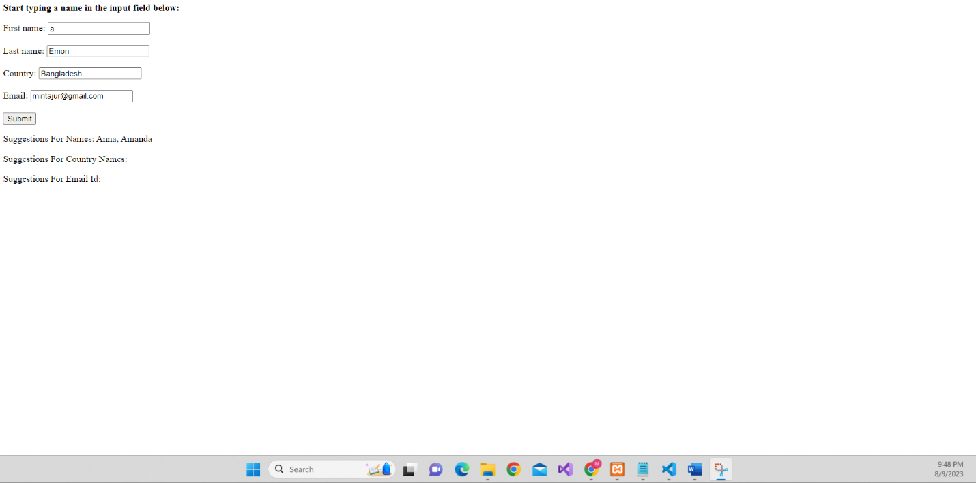

**gethint1.php**

<?php

// Array with names

$a[] = "Australia";

$a[] = "Bangladesh";

$a[] = "Canada";

$a[] = "Denmark";

$a[] = "Ethiopiya";

$a[] = "Finland";

$a[] = "Germeny";

$a[] = "Hondurus";

$a[] = "India";

$a[] = "Jamaika";

$a[] = "Kuet";

$a[] = "Lebanon";

$a[] = "Nigeria";

$a[] = "Oman";

$a[] = "Papua newgini";

// get the q parameter from URL

$q = $_REQUEST["q"];

$hint = "";

// lookup all hints from array if $q is different from ""

if ($q !== "") {

  $q = strtolower($q);

  $len=strlen($q);

  foreach($a as $country) {

    if (stristr($q, substr($country, 0, $len))) {

      if ($hint === "") {

        $hint = $country;

      } else {

        $hint .= ", $country";

      }

    }

  }

}

// Output "no suggestion" if no hint was found or output correct values

echo $hint === "" ? "no suggestion" : $hint;

?>

**Output:**

**gethint2.php**

<?php

// Array with names

$a[] = "anna@gmail.com";

$a[] = "brittany@gmail.com";

$a[] = "cinderella@gmail.com";

$a[] = "diana@gmail.com";

$a[] = "eva@gmail.com";

$a[] = "fiona@gmail.com";

$a[] = "gunda@gmail.com";

$a[] = "hege@gmail.com";

$a[] = "inga@gmail.com";

$a[] = "johanna@gmail.com";

$a[] = "kitty@gmail.com";

$a[] = "linda@gmail.com";

$a[] = "nina@gmail.com";

$a[] = "ophelia@gmail.com";

$a[] = "petunia@gmail.com";

$a[] = "amanda@gmail.com";

$a[] = "raquel@gmail.com";

$a[] = "cindy@gmail.com";

$a[] = "doris@gmail.com";

$a[] = "eve@gmail.com";

$a[] = "evita@gmail.com";

$a[] = "sunniva@gmail.com";

$a[] = "iove@gmail.com";

$a[] = "unni@gmail.com";

$a[] = "violet@gmail.com";

$a[] = "liza@gmail.com";

$a[] = "elizabeth@gmail.com";

$a[] = "ellen@gmail.com";

$a[] = "wenche@gmail.com";

$a[] = "vicky@gmail.com";

// get the q parameter from URL

$q = $_REQUEST["q"];

$hint = "";

// lookup all hints from array if $q is different from ""

if ($q !== "") {

  $q = strtolower($q);

  $len=strlen($q);

  foreach($a as $name) {

    if (stristr($q, substr($name, 0, $len))) {

      if ($hint === "") {

        $hint = $name;

      } else {

        $hint .= ", $name";

      }

    }

  }

}

// Output "no suggestion" if no hint was found or output correct values

echo $hint === "" ? "no suggestion" : $hint;

?>

**Output:**

**display.php code**

<!DOCTYPE html>

<html lang="en">

<head>

    <meta charset="UTF-8">

    <meta name="viewport" content="width=device-width, initial-scale=1.0">

    <title>DisplayPage</title>

</head>

<body>

    <center>

    <h1>You have Inserted</h1>

    </center>

</body>

</html>

<center>

<?php

$first_name = $_POST['fname'];

$last_name = $_POST['lname'];

$CountryName = $_POST['country'];

$EmailId = $_POST['email'];

echo $first_name. "<br>";

echo $last_name. "<br>";

echo $CountryName. "<br>";

echo $EmailId. "<br>";

?>

</center>

**Output:**

