

TriMeter
A GPS-based tricycle fare meter for Cabanatuan City
Mobile Application Technology: Final Case Study
BSIT-4C
Group members
John Mathew Ramoso
Neo Arwen De Guzman
Charles Benedict Leodones
Project files (APK, videos, report):
Google Drive folder
Source code: https://github.com/mintchoco0624/trimeter-app

1. Project Information
Title: TriMeter: a GPS-based tricycle fare meter for Cabanatuan City. Platform: Android (Ionic 9, Angular 22 standalone components, Capacitor 8). Members: John Mathew Ramoso, Neo Arwen De Guzman, Charles Benedict Leodones (BSIT-4C). Version: 1.5 (Android APK).
Installation and access. (1) Download TriMeter.apk from the project's Google Drive folder to an Android phone (Android 7.0 or later). (2) Open the file; if Android asks, allow Install unknown apps for the browser or Files app, then tap Install. (3) Open TriMeter, choose a role and passenger type, and allow location access while using the app. No account, password or API key is needed, and all trips stay on the phone. Internet is used only for place names, road distance, map tiles and fare-matrix updates; the meter itself works offline. Quick test: on the Meter tap Start Trip, move about 100 m or more, then End Trip to get a receipt; or tap the Manual estimate button and search a drop-off to see a fare without moving. Source setup (Node.js 20+): npm install, then npx ng serve; build the APK with npx ng build, npx cap sync android and gradlew assembleDebug (see the README).

2. Problem and Proposed Solution
Problem. Cabanatuan City is known as the “Tricycle Capital of the Philippines”, and thousands of commuters ride tricycles every day. The city has an official fare matrix, but fares in practice are inconsistent: TODAs apply their own rates, drivers estimate by feel, and studies describe overcharging as rampant, with drivers charging up to 300% more than the prescribed rates. Passengers, especially students, seniors, PWDs and visitors, have no easy way to check the fair fare.
Intended users. Primary: commuters (students, workers, seniors, PWDs, tourists). Secondary: tricycle drivers, who gain a neutral reference that prevents disputes.
Proposed solution. A mobile app that measures the real distance of a ride with the phone's GPS and applies the city fare matrix live, then gives a receipt with a fare breakdown and an overcharge check. The group's original proposal also included accounts, ID-verified discounts, multiple languages, real-time gas prices, driver QR pairing and an LGU dashboard. These were set aside as future improvements to keep the scope realistic for a two-week project.

3. Application Features
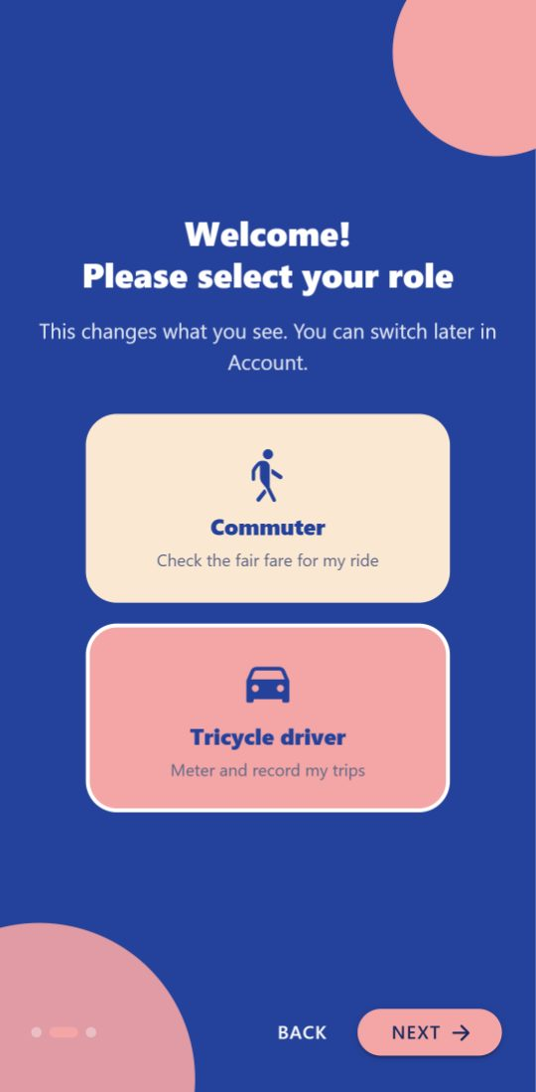  Role selection | 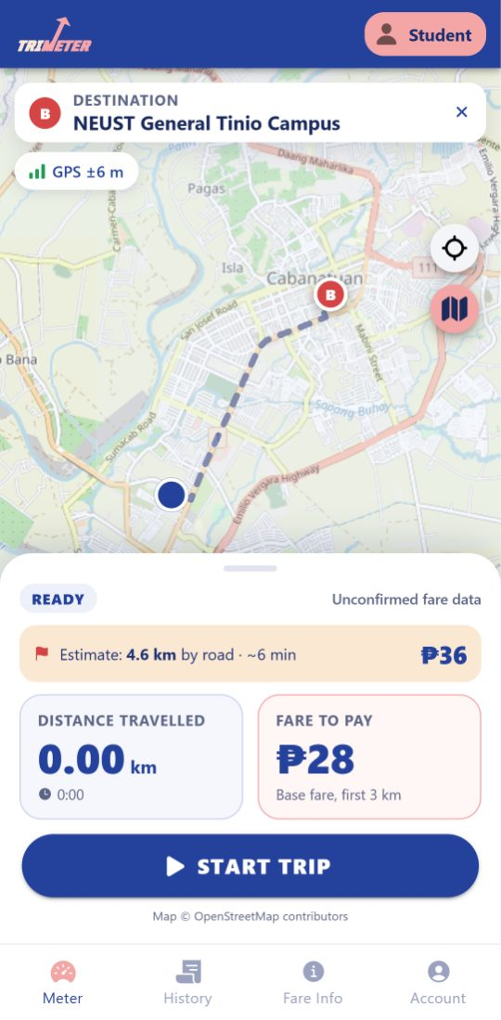  Commuter meter with fare preview | 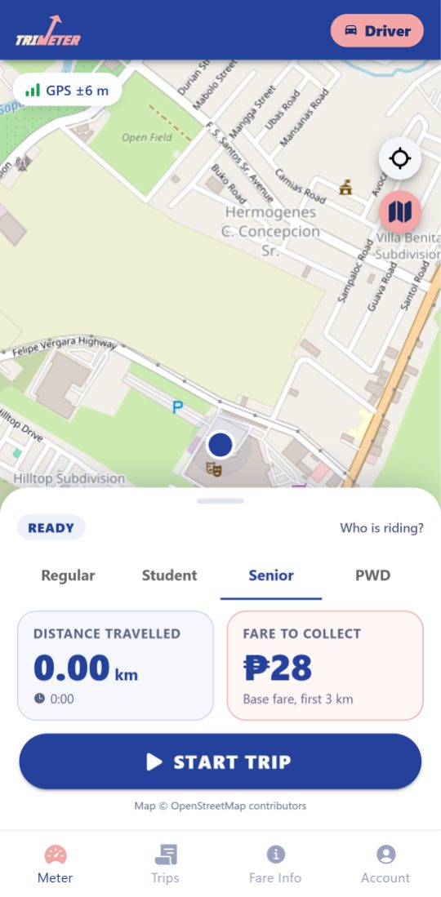  Driver meter
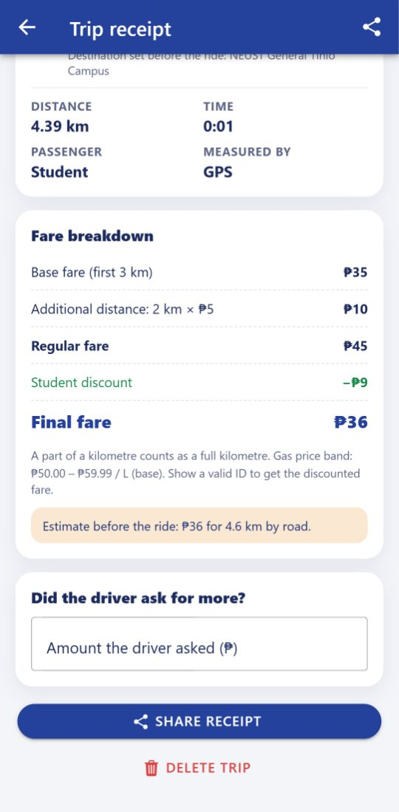  Receipt and overcharge check | 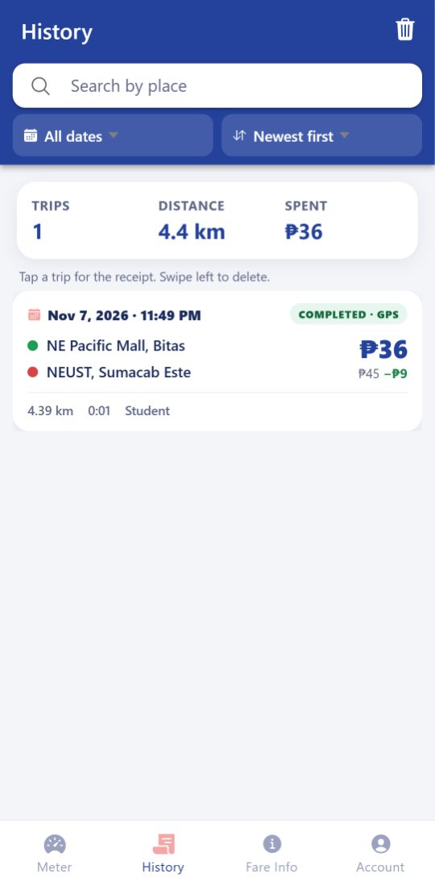  History with search and filters | 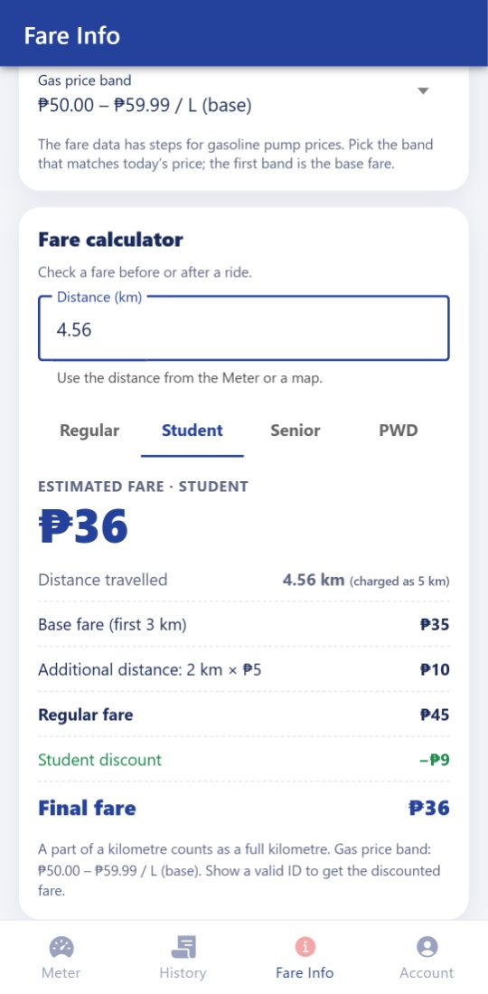  Fare calculator
- Onboarding and roles: the user chooses Commuter or Tricycle driver (as in the proposal prototype). Roles are separate from the passenger type (Regular, Student, Senior, PWD), which sets the fare.
- Live meter (automatic mode): a commuter can search “Where to?” and see the road distance and expected fare before riding; a driver picks the passenger type for each trip. After Start Trip, the map draws the route and the distance, time and fare update live, with a GPS signal indicator, an offline indicator and the trip status. Map areas already viewed are cached, so the map still shows offline (zooming in enlarges the cached map; unvisited areas show a short note). End Trip asks for confirmation; a trip under 50 m cannot be saved as a paid trip. If the app closes or crashes mid-trip, the Meter offers to resume it.
- Trip receipt: route map, places, distance, time, passenger type and a fare breakdown (base fare, additional distance, regular fare, discount, final fare). Commuters can type what the driver asked to see any overcharge in pesos and percent. The receipt can be shared.
- Manual estimate (backup mode): pick-up starts at your current location, so you only search or tap the drop-off to get the road distance and fare. The app offers it whenever GPS is unavailable.
- History: trip cards with date, places, distance, duration, passenger type, regular fare, discount, final fare and status; search by place, date filter, sorting, totals, and delete with confirmation.
- Fare info and Account: the fare matrix (ordinance no., effective date, source, status), a fare calculator, example fares, 8 FAQs and complaint steps. Account holds the local profile, role switch, discount and privacy information, and log out.

4. Technical Implementation
The project was created with the standard Ionic workflow: ionic start trimeter-app blank --type=angular-standalone --capacitor, then every feature was generated with ionic generate, so each has its own TypeScript, HTML, SCSS and test file. The app has 8 pages, 4 reusable components (map, fare breakdown, place search, fare calculator), 9 services, 1 route guard, 2 pipes and 3 model files. Pages only display data; the work is done in services. The Android project was added with ionic capacitor add android.

Capacitor capabilities
- Geolocation (services/location.ts): watchPosition with high accuracy (about one fix every 2 s on Android). Each fix passes judgeFix(), which rejects fixes less accurate than 35 m, movements under 5 m (jitter while waiting) and jumps faster than 30 m/s. Accepted fixes extend the route, and the distance is summed with the haversine formula. Results are Angular signals, so the UI updates automatically. The Screen Wake Lock API keeps the screen on during a trip. Before the first permission prompt the app explains why it needs location, and it tracks only between Start Trip and End Trip.
- Haptics (services/feedback.ts): a light tap when the fare increases, and stronger taps at the start and end of a trip.
- Share: the receipt is shared as plain text, or copied to the clipboard where sharing is unavailable.
- Map: Leaflet with OpenStreetMap tiles (components/trip-map).

Fare computation
services/fare.ts is a pure function. The base fare covers the first 3 km, and each succeeding kilometre adds the per-km rate, with a part of a km charged as a full km (Math.ceil). The distance is rounded to 10 m first, so GPS noise (e.g. 3.004 km) is not billed as an extra km. Students, seniors and PWDs use the discounted column. The rates follow the official Cabanatuan City Tricycle Fare Guidelines for City Ordinance No. 050-2026 (dated April 14, 2026): ₱35 / ₱28 for the first 3 km and ₱5 per succeeding km for all passengers, per passenger (at most 3 per trip), with 11 gasoline-price bands up to ₱150–₱159.99/L.

Data handling
- HttpClient GET (services/fare-matrix.ts): uses the inject(HttpClient) / subscribe({ next, error }) pattern from class to load the fare matrix JSON. If the online copy fails, the app uses the copy saved in Preferences, then the copy bundled in assets/. Fare changes can therefore reach users without a new APK. GET requests also call OpenStreetMap Nominatim (place names) and OSRM (road distance). All endpoints are public and need no API keys.
- Local data (services/trip-storage.ts): Capacitor Preferences stores the trip history as JSON with create (add), read (load/get), update (update: what the driver asked) and delete (remove/clear). The local profile (role, name, passenger type, gas band) is stored the same way; there is no server account. The trip in progress is also saved every 5 seconds (services/trip-recovery.ts), so it can be resumed after a crash. History search, date filter and sorting are a pure function (services/trip-query.ts) so they are unit-tested.
- Validation and errors: the calculator checks the typed distance; a destination closer than 100 m is rejected; failed saves offer a retry; offline, the map uses cached tiles and road distance falls back to a straight-line estimate.
- Navigation: a functional route guard sends first-time users to onboarding; the tabs are Meter, History (drivers: Trips), Fare Info and Account. Android permissions: fine and coarse location, internet, vibrate.

5. Testing and Evaluation
Automated tests: 92 unit tests (Vitest) for the fare rules, the fare data against the city guideline, receipt breakdown, GPS filter, history search, calculator validation, settings, roles and pages, and 11 end-to-end tests (Playwright, Chrome). The end-to-end tests replay a real 4.56 km road route (NE Pacific Mall → NEUST, from OSRM) as GPS fixes, with the online services mocked so results are repeatable. All automated tests pass, and ng lint is clean.
Feature / task tested | Expected result | Actual result | Status
Role selection (commuter / driver) | Role saved; tabs and Meter change | As expected | Pass
GPS meter, 4.56 km route, regular | ₱45 (₱35 + 2 km × ₱5) | ₱45 | Pass
Driver, student passenger, same route | ₱38; receipt shows ₱45 − ₱7 discount | ₱38, as expected | Pass
Destination preview (commuter) | 4.6 km by road, ₱45 before the ride | As expected | Pass
GPS jitter while standing still (30 fixes) | 0.00 km added | 0.00 km | Pass
End a trip with no distance | Not saved; “Discard trip” offered | As expected | Pass
Save, reload, search and delete a trip | Kept after reload; search filters; delete confirmed | As expected | Pass
Overcharge check (₱90 asked vs ₱45) | “Overcharged by ₱45 (100%)” | As expected | Pass
Calculator: 4.56 km student; invalid input | ₱38; error message for 0 or text | As expected | Pass
Fare data vs. city guideline (11 bands) | Every band matches the guideline | As expected (unit test) | Pass
App closed mid-trip, then resumed | Distance kept; full trip charged ₱45 | As expected | Pass
Offline map and search | Cached map; clear messages | As expected (emulator) | Pass
APK 1.3 on emulator, closed mid-trip | Trip resumes; student ₱38 | 4.41 km, ₱38; share, call OK | Pass
Real ride on an Android phone (APK 1.4) | Distance and fare update live | 2.77 km, 9:04, GPS ±4–6 m; student ₱34 | Pass

Issues found and limitations
- During development: the map covered the page header and the bottom panel sat behind the tab bar; the map credit was hidden; a route guard called inject() after await. All were found by testing and fixed.
- Phone GPS drifts near tall buildings and in bad weather, so the distance can differ slightly from the road distance.
- The app should stay open during a trip, since Android can pause GPS in the background. If the app is closed or crashes, the trip is saved every 5 seconds and can be resumed; movement while it was closed counts as a straight line.
- Section 5 of the guideline lists ₱4 per succeeding km for discounted passengers at the base gas price, but its fare box shows ₱5. The group confirmed that ₱5 is charged, so TriMeter uses ₱5.
- Roles and the profile are stored only on the phone: there is no real login, and discounts depend on the driver checking a valid ID.
- Maps, place names and manual road distance need an internet connection (the GPS meter itself does not).

Recommended improvements (from heuristic review)
- A foreground service so tracking continues with the screen off (visibility of system status, error prevention).
- A passenger counter (up to 3 per trip, as the guideline allows) to show the total fare for a group.
- A Filipino language option and a larger-text mode; some secondary labels are 11–12 px (match with the real world, accessibility).
- Later: driver QR pairing, ID-verified discounts and an LGU reporting dashboard from the original proposal.

6. AI Usage Disclosure
Tool: Claude Code (Anthropic), an AI coding assistant used in VS Code. How it assisted: scaffolding the project with the Ionic CLI, writing and refactoring the services, pages and tests, implementing the group’s improvement brief (roles, fare calculator, history filters, error handling), researching and fact-checking the fare data sources, and producing the Remotion presentation video and script. What the group did: reviewed the generated code, ran the unit and end-to-end tests, tested the APK on an Android phone, and fixed the issues found. The group can explain the main code (location.ts, fare.ts, fare-matrix.ts, trip-storage.ts). No passwords, private keys or personal data were used in prompts or code.
What the group reviewed, tested and changed: the group supplied the Figma prototype (logo, role icons, colours) and the official city fare guideline (Ordinance No. 050-2026), and confirmed the ₱5 succeeding-kilometer rate for discounted passengers. Testing the APK on our own Android phone, the group found three usability issues that were then fixed: the manual estimate now starts from the current location, the A/B pins were enlarged, and the onboarding screens no longer overlap; a grey map when zooming in offline led to the cached offline map. The group then recorded a real ride (2.77 km, ₱34 student fare, offline) to confirm the meter. Each member recorded and presented their part of the video: John Mathew Ramoso (problem, solution and walkthrough), Neo Arwen De Guzman (walkthrough and GPS code), Charles Benedict Leodones (fare and data code, testing, AI disclosure).

References
- BetterCabanatuan. bettercabanatuan-fare (community copy of Ordinance No. 050-2026). https://github.com/BetterCabanatuan/bettercabanatuan-fare
- City Government of Cabanatuan (2026). Cabanatuan City Tricycle Fare Guidelines, Ordinansa Blg. 050-2026 (printed guideline, April 14, 2026).
- ResearchPublish (2016). Cabanatuan City: Tricycle Capital of the Philippines. https://www.researchpublish.com/upload/book/Cabanatuan%20City-3270.pdf
- Economic Suitability of Electronic Fare Meters for Tricycle Drivers in Cabanatuan City (2025). ResearchGate.
- Ionic Framework, Capacitor and Angular documentation; OpenStreetMap, Nominatim and OSRM.

