1 . a, d

2. 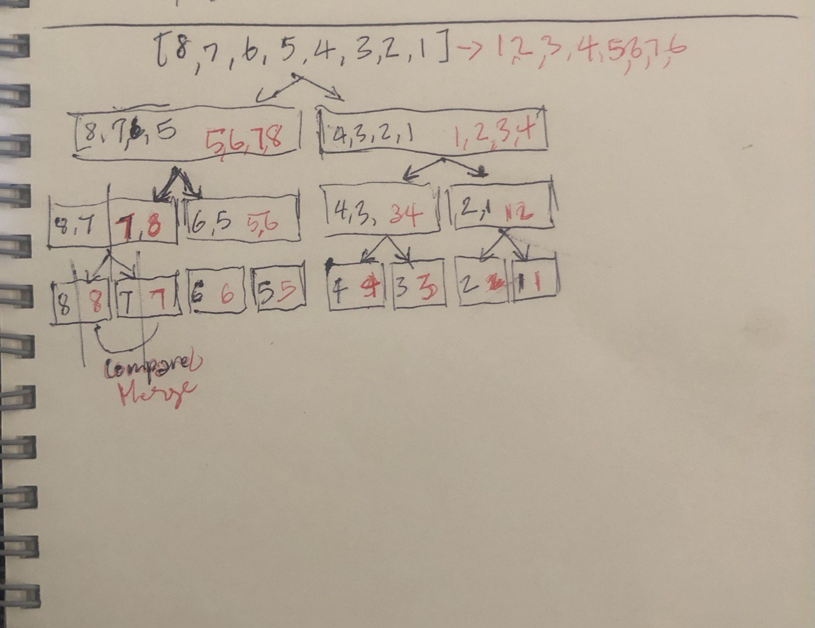

3. Algorithm mergeSort(S)

Input sequence S with n integers

Output sequence S sorted

if S.size() <=20 then return insertionSort arr;

(S 1 , S 2 ) ← partition

(S, n/2) mergeSort(S 1 )

mergeSort(S 2 )

S ← merge(S 1 , S 2 )

return S