1, 2

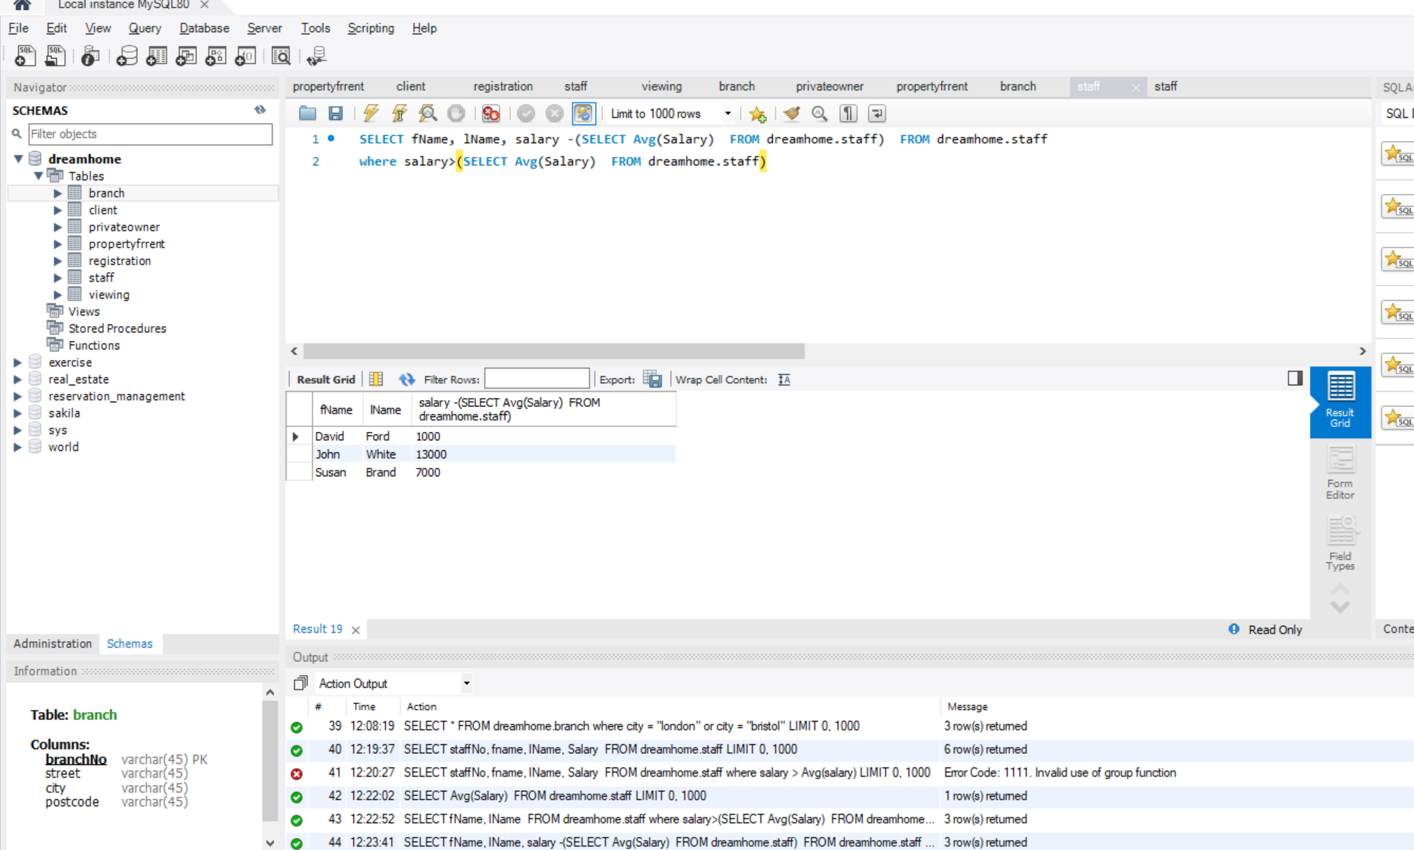

3a.

SELECT \* FROM dreamhome.staff

order by fName asc

b.

SELECT fname, lName, salary, staffNo FROM dreamhome.staff

c.

SELECT propertyNo FROM dreamhome.viewing

group by propertyNo

d.

SELECT staffNo, fname, lName, salary/12 as monthlySalary FROM dreamhome.staff

e.

SELECT staffNo, fname, lName, Salary FROM dreamhome.staff

where salary >10000

order by salary asc

f.

SELECT \* FROM dreamhome.branch

where city = "london" or city = "bristol"