EPIF project end of year research report: 2015

Cóilín Minto, Brian Burke (GMIT), Ronán Cosgrove (BIM)

This report contains a brief summary of research activity under the project “Implications of Alternative Technical Measures on the Economic Performance of the Irish Fishing Fleet (EPIF)”, from April 7th – December 31st 2015. The purpose is to document the analyses conducted with reference to the original and updated project proposal. Plans for research and analytical support activities for 2016 are also outlined.

### 

Table of Contents

Work package developments 2015 2

WP1a – Meta-analysis 2

WP1b – Technical Measure Experimental design and data analysis 3

Technical Measure Experimental design 3

Data analysis 3

Capacity building 4

Work plan 2016 4

Quota optimisation 4

Gear technology 5

Albacore tuna analyses 5

Price Analysis 5

Univariate (single species) price analysis 5

Multivariate (multiple species) price analysis 6

Appendices 7

# Work package developments 2015

## WP1a – Meta-analysis

WP1a proposed a meta-analytical framework for identifying gaps in gear-trial design (mainly for whitefish). Gaps analysis here refers to identification of gaps in the experimental design rather than gaps in the statistical methods (WP1b). The method used was straightforward gridding of parameter estimates from previously conducted trials (Figure 1). Discussion of these trials and present industry needs highlighted that there was a gap in the design for the 70mm cod-end mesh (Figure 1). No formal meta-analyses were conducted here though these are possible depending on needs.

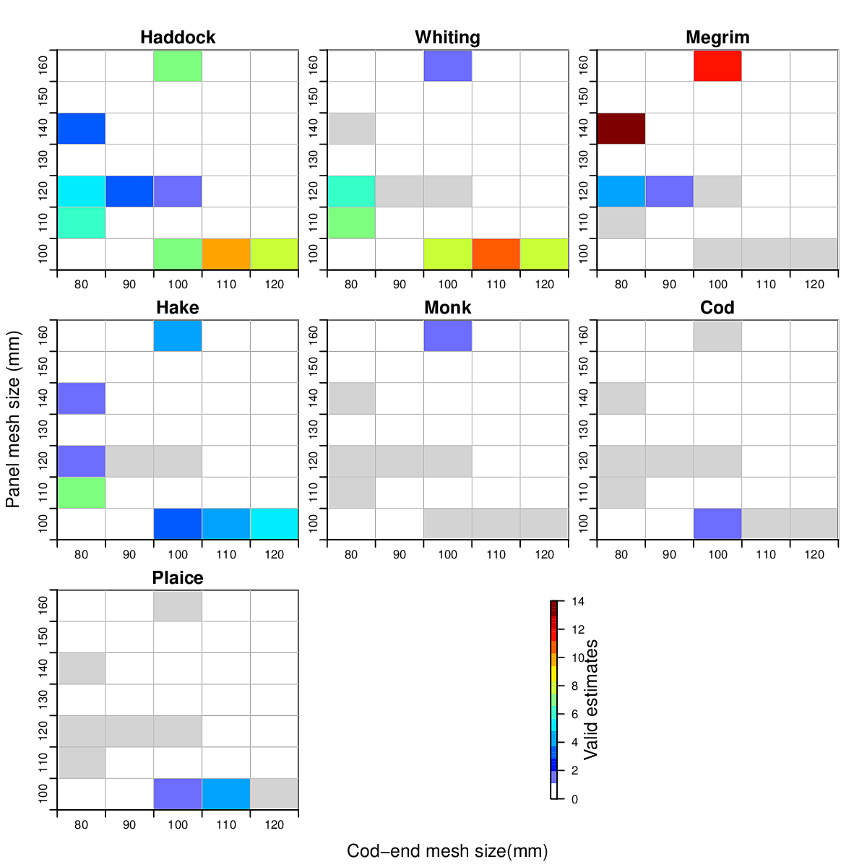

Figure 1. Gap analysis used for discussion on whitefish trials. Each grid cell represents a combination of a cod-end mesh size and panel mesh size trialled in selectivity experiments. The colour indicates the number of L50 parameters estimated for that combination. Grey indicates a trial conducted but insufficient data to estimate the parameters.

## WP1b – Technical Measure Experimental design and data analysis

### Technical Measure Experimental design

A simulation model for abundance-at-length and fishing of *Nephrops* in the Western Irish Sea was developed for the specific purpose of assisting BIM gear technologists in planning and executing gear trial experiments. As requested by BIM gear technologists, the first simulation focussed on what influence net position may have on retention of *Nephrops*. This is an important question as strong position effects may mask design variable effects. Simulation code was developed to address this question and comprised three main elements

* 1. Abundance simulation
     + Length distributions on the grounds, based on previous trials
     + Burrow density using underwater camera survey density estimates
  2. Gear contacts
     + Based on the swept area of a tow
     + Assumed probability of emergence
  3. Fishing Gear Simulation
     + Simplified estimation of how the gear may affect catch composition
     + Estimate the number of *Nephrops* contacting the net per hour
     + Simulating the Relative fishing intensity of each of the gears with realistic difficulties such as door and net effects included
     + Simulation of retention selectivity

A report on this investigation (Appendix I) highlighted the importance of net rotation to mitigate for position effects. This resulted in a development in trial design whereby the nets are rotated each night. This enhanced understanding was brought about by rounds of detailed collaboration between the gear technologists and the modelling team.

It is envisaged that further development of the power analysis simulation framework will assist in the design and implementation of additional trials during the course of the EPIF project.

### Data analysis

Work Package 1b focuses on the development of modelling frameworks for the analysis of gear trials carried out by an Bord Iascaigh Mhara (BIM).

Gear trials conducted by BIM during the year focused on the quad-rig trawl, which is being utilised in the *Nephrops* fisheries - one of the most commercially important fisheries in Ireland. Usage of this new gear along with the implementation of the landing obligation for this fishery necessitated evaluation of the catch of this gear so that improvements in management strategy could be made.

Discussions with gear technologists at BIM indicated a lack of suitable methods for analysing catch composition of this gear. We addressed this gap by extending the method of Holst and Revill (2009) for twin-rig trawls to two or more cod-end comparisons. Initial model developments helped to identify necessary explanatory variables and model type (GLMM as opposed to GAMM). Also from the initial models variability which had not been taken into account was identified.

By working closely with gear technologists and through the completion of preliminary analysis of trials (Appendix II, III, IV) a number of important factors were identified for inclusion into the analysis such as; the inclusion of net rotation to account for net position effects and the importance of bulk weights in the cod-end per haul. Catch comparison analysis of the quad rig data using the multinomial mixed effects model provided an understanding of how much variability they accounted for in the measured counts at length. The culmination of this work has provided a new statistical framework for analysing gear with 2 or more alternatives and has also helped in the identification of variables of importance for best fitting the model for these types of gears.

This work resulted in the writing and submission of a paper to the *ICES Journal of Marine Science*:

Browne, D., Minto, C., Cosgrove, R., Burke, B., McDonald, D., Officer, R. and Keatinge, M (in review). A general catch comparison method for multi-gear trials: application to a quad-rig trawling fishery for Nephrops.

We also assisted with data analysis for the following BIM report which has formed the basis of a proposed increase in minimum cod-end mesh size from to 70 to 80mm in Ireland’s demersal fisheries:

Cosgrove, R., Browne, D., McDonald, D., Curtin, R., and Keatinge, M., 2015. Assessment of an increase in cod-end mesh size in the Irish Sea Nephrops fishery. Irish Sea Fisheries Board (BIM), Marine Technial report, 16 pp.

Contributions to this report are provided in Appendix V.

### Capacity building

BIM staff attended an applied course in R and statistical modelling at GMIT September 28th – October 2nd and October 12th – 16th 2015.

# Work plan 2016

To reflect and adapt to updated requirements, the project plan for 2016 departs from the original project proposal. Work plan 2016 is prioritised here with additional details given below. The priorities for 2016 are:

1. Quota optimisation
2. Gear technology
3. Albacore indices contributing to ICCAT assessments
4. Price analysis

## Quota optimisation

In place of packages 3 and 4, GMIT will assist in the development of an alternative fishery based quota allocation system. The system will seek to optimise quota shares to groups of vessels based on the main species they target ensuring the continued viability of fisheries which are heavily impacted by the landing obligation such as the whitefish mixed demersal fishery.

## Gear technology

GMIT will continue to work on the design and analysis of gear trials with BIM gear technologists as required during 2016. Work in 2016 will continue to focus on methods to reduce unwanted catches in *Nephrops* and whitefish fisheries. Building on work carried out in 2015, a bioeconomic analysis of the effects of sorting grids on catches of *Nephrops* and whitefish will be carried out. GMIT will also assist in designing and analysing data from a major assessment of the catch composition in single, twin and quad-rigged trawls in a *Nephrops* fishery.

## Albacore tuna analyses

This work will be a collaboration between experts at BIM and analysts at GMIT to assist in the production of indices for ICCAT assessment of North Atlantic albacore tuna. Methods developed in previous collaborations will be extended temporally and new research on fleet dynamics contributing to the index will be explored by a PhD student at GMIT.

## Price Analysis

An imperative to understanding the implications of gear changes on the economic performance of fleet segments is to understand price dynamics. We will focus on developing a framework for price analysis at multiple levels.

Prices of fish may vary based on a multitude of drivers, including: supply (local and international), season, size/grade, condition, species, product differentiation, processing, etc. The goal of the EPIF price analysis component of WP 4 is to investigate the influence of these factors on the price obtained at first point of sale by select segments in the Irish fleet, as identified by BIM. All methods will be trialled and discussed in close collaboration with BIM staff.

### Univariate (single species) price analysis

Here we can focus on explaining variability in observed prices per species. Methods which can be explored for analysing univariate data would include regression approaches such as price elasticity models and time series methods such as autoregressive models (AR), moving average models (MA) or some combination of these (such as ARMA, or ARIMA models). These can be used for analysing fish price dynamics and trends, taking the temporal aspect into account when fitting.

Regression Model:

* For example regressing price on quantity, quality, location, etc. This model can be used to derive varying price elasticities.

Autoregressive Model:

* Used to describe a random process, the model assumes that the output variable depends, linearly, on the previous values of the output variable and a stochastic error term.

Moving Average Model:

* Also used to describe a random process, the model assumes that the output variable depends, linearly, on current and previous values of the stochastic error term.

Autoregressive Moving Average Models (ARMA):

* Comprised of both autoregressive and moving average components.

### Multivariate (multiple species) price analysis

These analyses will focus on inter-relationships of prices among species and possibly locations (e.g., ports). Methods to be investigated include:

* Multivariate versions of the time series analysis highlighted above.
* Seemingly Unrelated Regression:

This model will be used in identifying relationship between different fish prices, identification of substitutes or inferior goods within fish markets for given fish.

It could also be used to analysis the price at port level, is there a coastal bias (additional transportation costs?) or port size bias (larger ports give lower prices?) when landing catches.

The Seemingly Unrelated Regression (SUR) model

* Runs a number of individual equations, each having a dependent variable and either the same or different predictor variables
* These equations are then generalized into a linear regression model
* The covariance structure of the residuals of these equations are then able to be taken into account providing efficient estimates which is then analysed to determine if a relationship between the equations exist.
* Determination of the exact estimators (such as using FGLS, GLS or OLS) for the best estimates will require investigation of the data in question.

# Appendices