### Materials and methods

### Data analysis

*Response*

In a quad-rig trial the response was a matrix of *Nephrops* counts per observation () and cod-end (). Each row contained four counts (one for each cod-end) for length-bin in haul . For example, for the 30mm length bin in haul 5, the response might be denoting that 10 *Nephrops* were counted in the first cod-end, 20 in the second, etc.

The response data are multivariate counts for which interest lies in describing how the relative proportions retained per length-class in each of the cod-ends varies as a function of the cod-end design (predominantly mesh size) and other explanatory variables. When trials consist of counts per category (cod-end), a starting distribution is the multinomial (Agretsi, 2002) with probability mass function

(1)

where: is the count in the th cod-end and ; and is the probability of outcome , , implying 3 parameters in the basic model.

*Covariates*

A common model when explanatory variables are included (such as carapace length) is the multinomial logit model, where the probability of a given outcome depends on values of the explanatory variables for the th observation (row):

, (2)

where is a () row vector of case/row-specific explanatory variables for the th observation and is a () column vector of parameters for the th category. Note that so that the first cod-end is set to the baseline, assuring that the probabilities sum to unity across the categories (Greene, 2000). The explanatory variables, included were: carapace length, net configuration (the cod-end positions were changed each night to account for position effects thus 4 net configurations were tested) and total weight per cod-end. The total weight per cod-end covariate deserves special attention as it requires different treatment to the case-specific variables such as carapace length. Cod-end bulk weights vary by cod-end and can thus be considered a choice-specific attributes. Choice-specific variables in a multinomial setting are typically modelled as conditional logit models (McFadden, 1973), which remove the subscript *k* from the parameter for that covariate, thus for weight the effect is so at equal weights in the cod-end the effect is cancelled. We thus use a mixture of case-specific and choice-specific covariates leading to the fixed effects model

(3)

*Subsampling offset*

As the counts are sub-sampled, it is also necessary to include an offset for the proportion of the catch in each cod-end sampled (Holst and Revill, 2009). In a twin-rig (two category) trial the offset is given by where and are the proportions of the catch sampled in the test and control, respectively (Holst and Revill, 2009). In the quad-rig trial with the proportion of the th net in the th observation sampled, the vector of offsets for the is given by , where the first zero comes from . A numerical illustration of the offset terms is provided in the Appendix. The offset is incorporated as

, (4)

*Extra-multinomial variation*

Counts for category in a multinomial have an expected mean and variance , however, there is often more variability in the counts than the mean-variance (and covariance) allows for, which is termed overdispersion (Hinde and Demétrio, 1998). This may reflect uncaptured variability or clustering, in particular haul-level variability not accounted for when the observations are treated as independent multinomials. Overdispersion was tested for in the best fitting multinomial model by testing the residual deviance on a chi-squared distribution with the residual degrees of freedom (GET CORRECT CITATION – Paul et al. 1989).

Given that the observations are clustered by hauls, the approach we focus on for accounting for extra-multinomial variability is to include random effects in the model (Hinde and Demétrio, 1998). Multinomial random effects include the baseline category logit random effects model (Hartzel et al., 2001). This model has a multinomial response distribution with the addition of random effects that more explicitly capture the variability attributable to hauls, as opposed to the more general additional variability unattributed to specific grouping but included in, for example, the Dirichlet-multinomial model. The random effects multinomial model we test is an extension of Equation (4) given by

, (7)

where the random effects per haul have a multivariate normal distribution . The baseline category random effect is again set to zero, resulting in a trivariate normal distribution for . An arbitrary (6 parameter) covariance matrix structure, as recommended in Hartzel et al. (2001) was implemented.

*Inference*

We use likelihood ratio tests of nested models to test the significance of each of the fixed effects. As the models are estimated via maximum likelihood we also report Akaike’s Information Criterion for each model. Overall predictions in the presence of a categorical variable (net configuration) were obtained by setting the net configuration values in the predicted model matrix to 1/3 (Fox, 2003).

*Estimation*

Estimation of the multinomial random effects model necessitates integrating over the random effects to estimate the marginal likelihood. We did not find readily available software to fit Equation (7) we therefore wrote an estimation routines in AD Model Builder (ADMB) (Fournier et al., 2012). The ADMB-RE module (Skaug and Fournier, 2006) was used to estimate the multinomial mixed conditional and logit random effects model with the variance-covariance matrix specified via a Cholesky-decomposition. ADMB also allows for estimates of uncertainty on the linear predictor scale via the delta-method approximation. All pre- and post-processing code was run in R 3.2.0 (R Core Team, 2015). Code for running this analysis is stored at (github public repository).

## Results

A total of 15,443 Nephrops were measured during the 12 hauls of the trial used. Most of the carapace length measurements were in the range of 20-45mm (Figure 1). Considerable between-haul variability was observed in the proportions retained at length with some hauls displaying consistently lower or higher retention across carapace lengths (Figure 1). The observed proportions at the extremes of the length distribution were more variable but derived from fewer observations (e.g., zero or unity proportions in Figure 1).

Separate inclusion of each of the main effects (carapace length, net configuration and bulk weight) resulted in large decreases in the AIC relative to a model with fixed proportions (Table 1). Net configuration was important with inner port position typically fishing worst, and the outer starboard or port fishing better. These likely reflect non cod-end net differences. Higher-order carapace length effects did not improve the AIC nor residual patterns.Combining carapace length and total cod-end weight or net configuration resulted in a further decreases in the AIC and the model including the three main effects fit best overall (Table 1). A model including carapace length squared was rejected highlighting that over the range of carapace lengths observed a linear model fit best (Table 1). Note that higher-order interactions were not included in the models, as with 12 hauls and 4 mesh types there are 36 independent cells from which to estimate the parameters and the models can quickly become overfit.

From the best fitting model the estimated covariance and correlation matrices of the random effects were:

and , respectively.

Note that the variance of the random effects was similar across the three log-odds ratios (diagonal of ) and strong correlation exists between the random effects (Figure 2). The magnitude of the variance of the random effects (e.g., ) implies that having accounted for the fixed effects of carapace length, net configuration and total cod-end weight (Table 1), the expected proportions vary in extremes by +/- 12% by haul (inverse logit of 95% intervals -0.5, +0.5). Typically the variability will be lower than this (Figure 2). The relatively low inter-haul variability estimated together with the model comparisons (Table 1) highlight that a considerable amount of between-haul variability is captured by the fixed effects of net configuration and bulk weight though some inter-haul variability remains, as captured by the random effects (Figures 2 and 3).

The by-haul predictions fit the data well in both the fixed effects and random effects models (Figure 3) though the random effects models expectedly fit some haul and mesh combinations better (e.g., 70mm and 80mm in hauls 3 and 5). The overall predictions show a higher proportion of small Nephrops retained in the 70mm, this decreases in the 80mm, 90mm and 100mm (Figure 4). In addition the slope of the proportion retained over length classes goes from negative in the 70mm to positive in the 100mm (Figure 4). The estimated confidence intervals on the mean proportions are tight reflecting the number of observations contributing to the mean with the considerable between-haul variability accounted for via the fixed and random effects (Figure 3). Note that confidence intervals on proportions cannot be interpreted separately as the proportions necessarily sum to unity (the region is a simplex).

## References

Agresti, A. (2002). *Categorical Data Analysis* (2nd edition). John Wiley & Sons, Inc., Hoboken, New Jersey.

Chen, J., & Li, H. (2013). Variable selection for sparse dirichlet-multinomial regression with an application to microbiome data analysis. *The Annals of Applied Statistics*, 7(1) 1-25.

Fournier, D.A., H.J. Skaug, J. Ancheta, J. Ianelli, A. Magnusson, M.N. Maunder, A. Nielsen, and J. Sibert. (2012). AD Model Builder: using automatic differentiation for statistical inference of highly parameterized complex nonlinear models. *Optimization Methods Software*. 27:233-249.

Fox, J. (2003). Effect Displays in R for Generalised Linear Models. Journal of Statistical Software, 8(15), 1-27.

Greene, W.H. (2000). *Econometric Analysis* (4th edition). Prentice Hall, Upper Saddle River, New Jersey.

Hartzel, J., Agresti A., and Caffo, B. (2001). Multinomial logit random effects models. *Statistical Modelling*, 1, 81-102.

Hinde, J. and Demétrio, C.G.B (1998). Overdispersion: models and estimation. *Computational Statistics & Data Analysis* 27(2) : 151-170.

Holst, R. and Revill, A. (2009). A simple statistical method for catch comparison studies. *Fisheries Research* 95(2): 254-259.

McFadden, D. (1973). Conditional logit analysis of qualitative choice behavior. In P. Zarembka, ed., *Frontiers in Econometrics*. New York: Academic Press.

Miller, T.J. (2013). A comparison of hierarchical models for relative catch efficiency based on paired-gear data for US Northwest Atlantic fish stocks. *Canadian Journal of Fisheries and Aquatic Sciences*, 70: 1306-1316.

Paul, S.R., Liang, K.Y. and Self, S.G. (1989). On testing departure from the binomial and multinomial assumptions. *Biometrics*, 45: 231-236.

Plummer, M. (2003). JAGS: A Program for Analysis of Bayesian Graphical Models Using Gibbs Sampling. Proceedings of the 3rd International Workshop on Distributed Statistical Computing (DSC 2003), March 20–22, Vienna, Austria. ISSN 1609-395X.

R Core Team (2015). R: A language and environment for statistical computing. R Foundation for Statistical Computing, Vienna, Austria. URL <http://www.R-project.org/>

Skaug, H.J. and Fournier, D.A. (2006). Automatic approximation of the marginal likelihood in non-Gaussian hierarchical models. Computational Statistics & Data Analysis, 51(2): 699–709.

Table 1, vessel and gear information

|  |  |
| --- | --- |
| Vessel | Our Lass II (DA261) |
| Vessel Length Overall | 21.7m |
| Engine power | 484kW |
| Home port | Howth, Ireland |
| Trawl type | Quad-rig Nephrops |
| Trawl manufacturer | Pepe Trawls Ltd., Ireland |
| Otter board manufacturer/ type | Dunbar 7’6” |
| Door weight | 492kg |
| Clump weight type/ weight | Roller/ 680kg |
| Door to clump spread (average) | 34.4m |
| Sweep length | 50 + 20m |
| Codend nominal mesh size | Codend measured mesh size |
| 70mm | 70.8mm |
| 80mm | 80.8mm |
| 90mm | 92.6mm |
| 100mm | 103.0mm |

Table 1. Multi-rig catch comparison. Multinomial random effects model fit summary. Explanatory variables are abbreviated: carapace length (CL), net configuration (NC) and cod-end total weight (W). The model degrees of freedom (df) includes 6 parameters parameterising the trivariate covariance matrix of the random effects.

|  |  |  |  |
| --- | --- | --- | --- |
| Explanatory variables | Log-likelihood | Model df | AIC |
| None | -2084.79 | 9 | 4187.58 |
| CL | -2062.56 | 12 | 4149.12 |
| NC | -2049.41 | 18 | 4134.82 |
| W | -2058.52 | 10 | 4137.04 |
| CL + NC | -2027.31 | 21 | 4096.62 |
| CL + W | -2036.2 | 13 | 4098.4 |
| NC + W | -2039.81 | 19 | 4117.62 |
| CL + NC + W | -2017.17 | 22 | 4078.34 |
| CL + CL2 + NC + W | -2016.79 | 25 | 4083.58 |

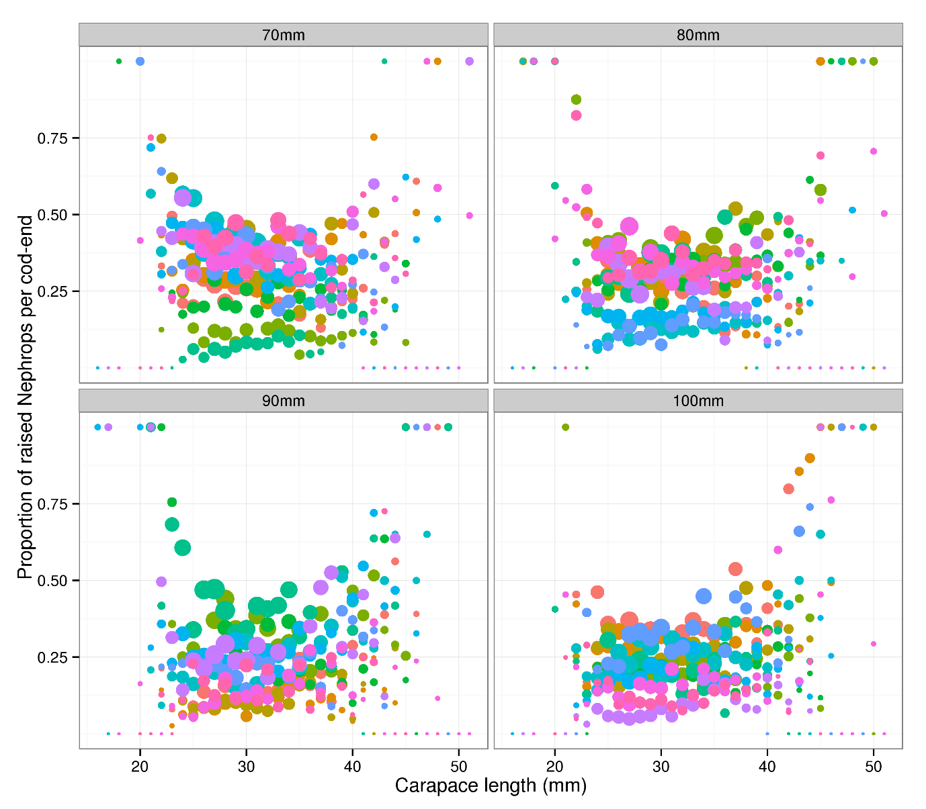

Figure 1. Multi-rig catch-comparison. Proportion of Nephrops retained per length-class by diamond mesh size. Hauls are coloured to demonstrate the haul effects. The diameter of the points is proportional to the log base 10 of the raised counts to illustrate where the distribution of the counts.

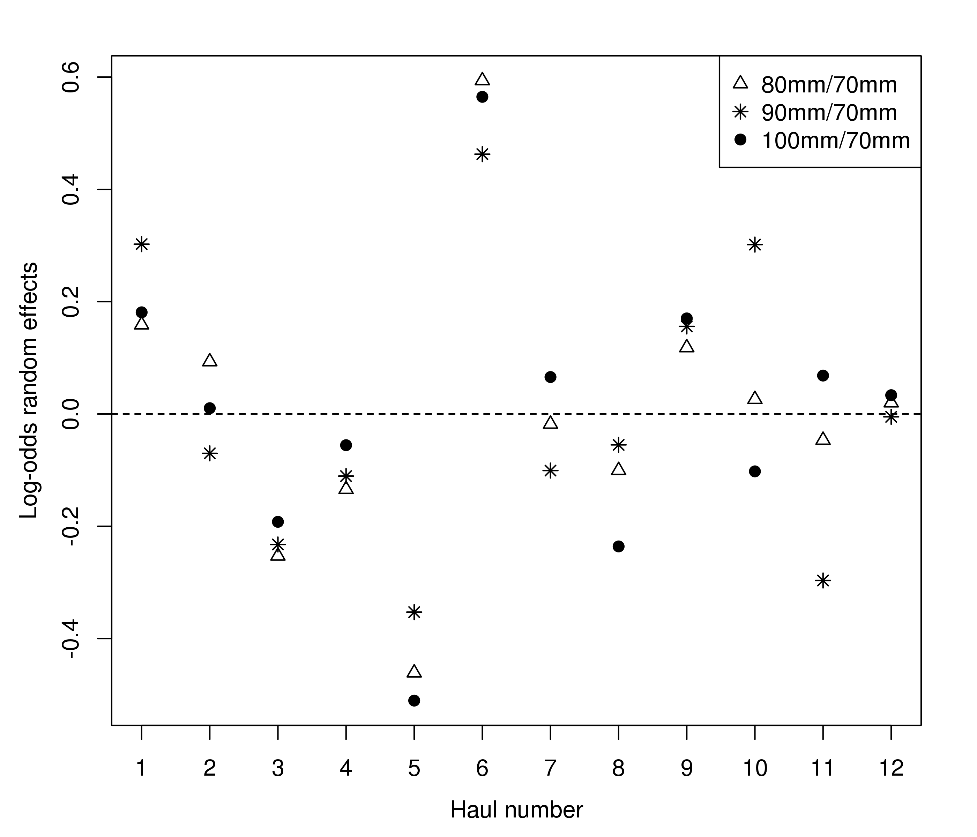

Figure 2. Multi-rig catch comparison. Estimated trivariate random effects (log-odds ratios to the baseline 70mm case: in Equation 6) by haul.

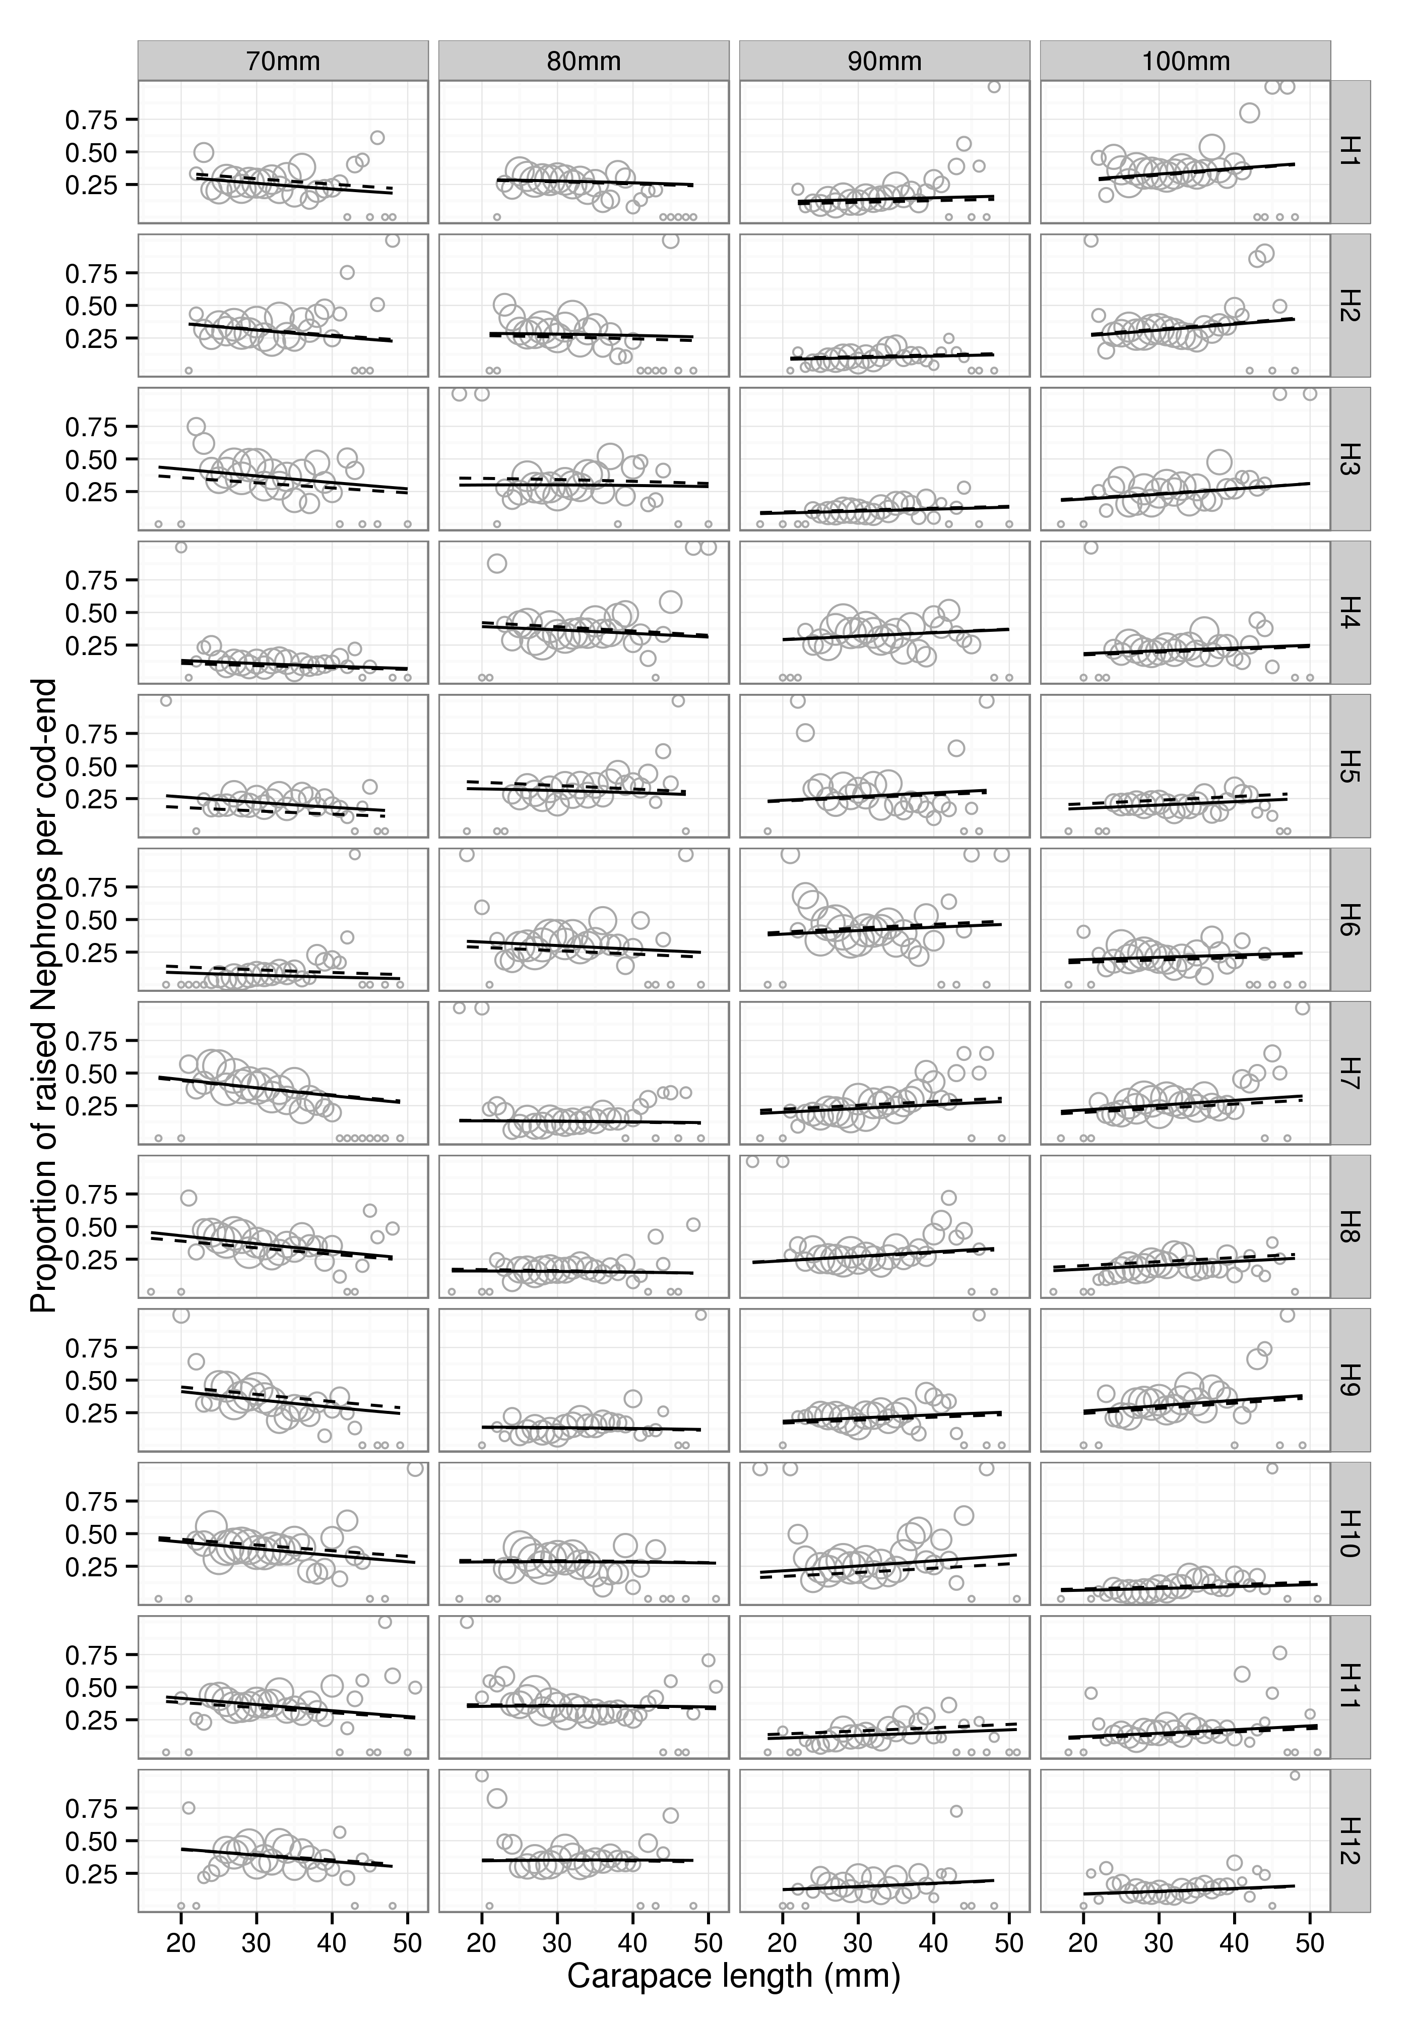

Figure 3. Multi-rig catch comparison. Fitted multinomial mixed effects proportions by haul. Solid and dashed lines represent the predictions from the best fitting model with and without random effects

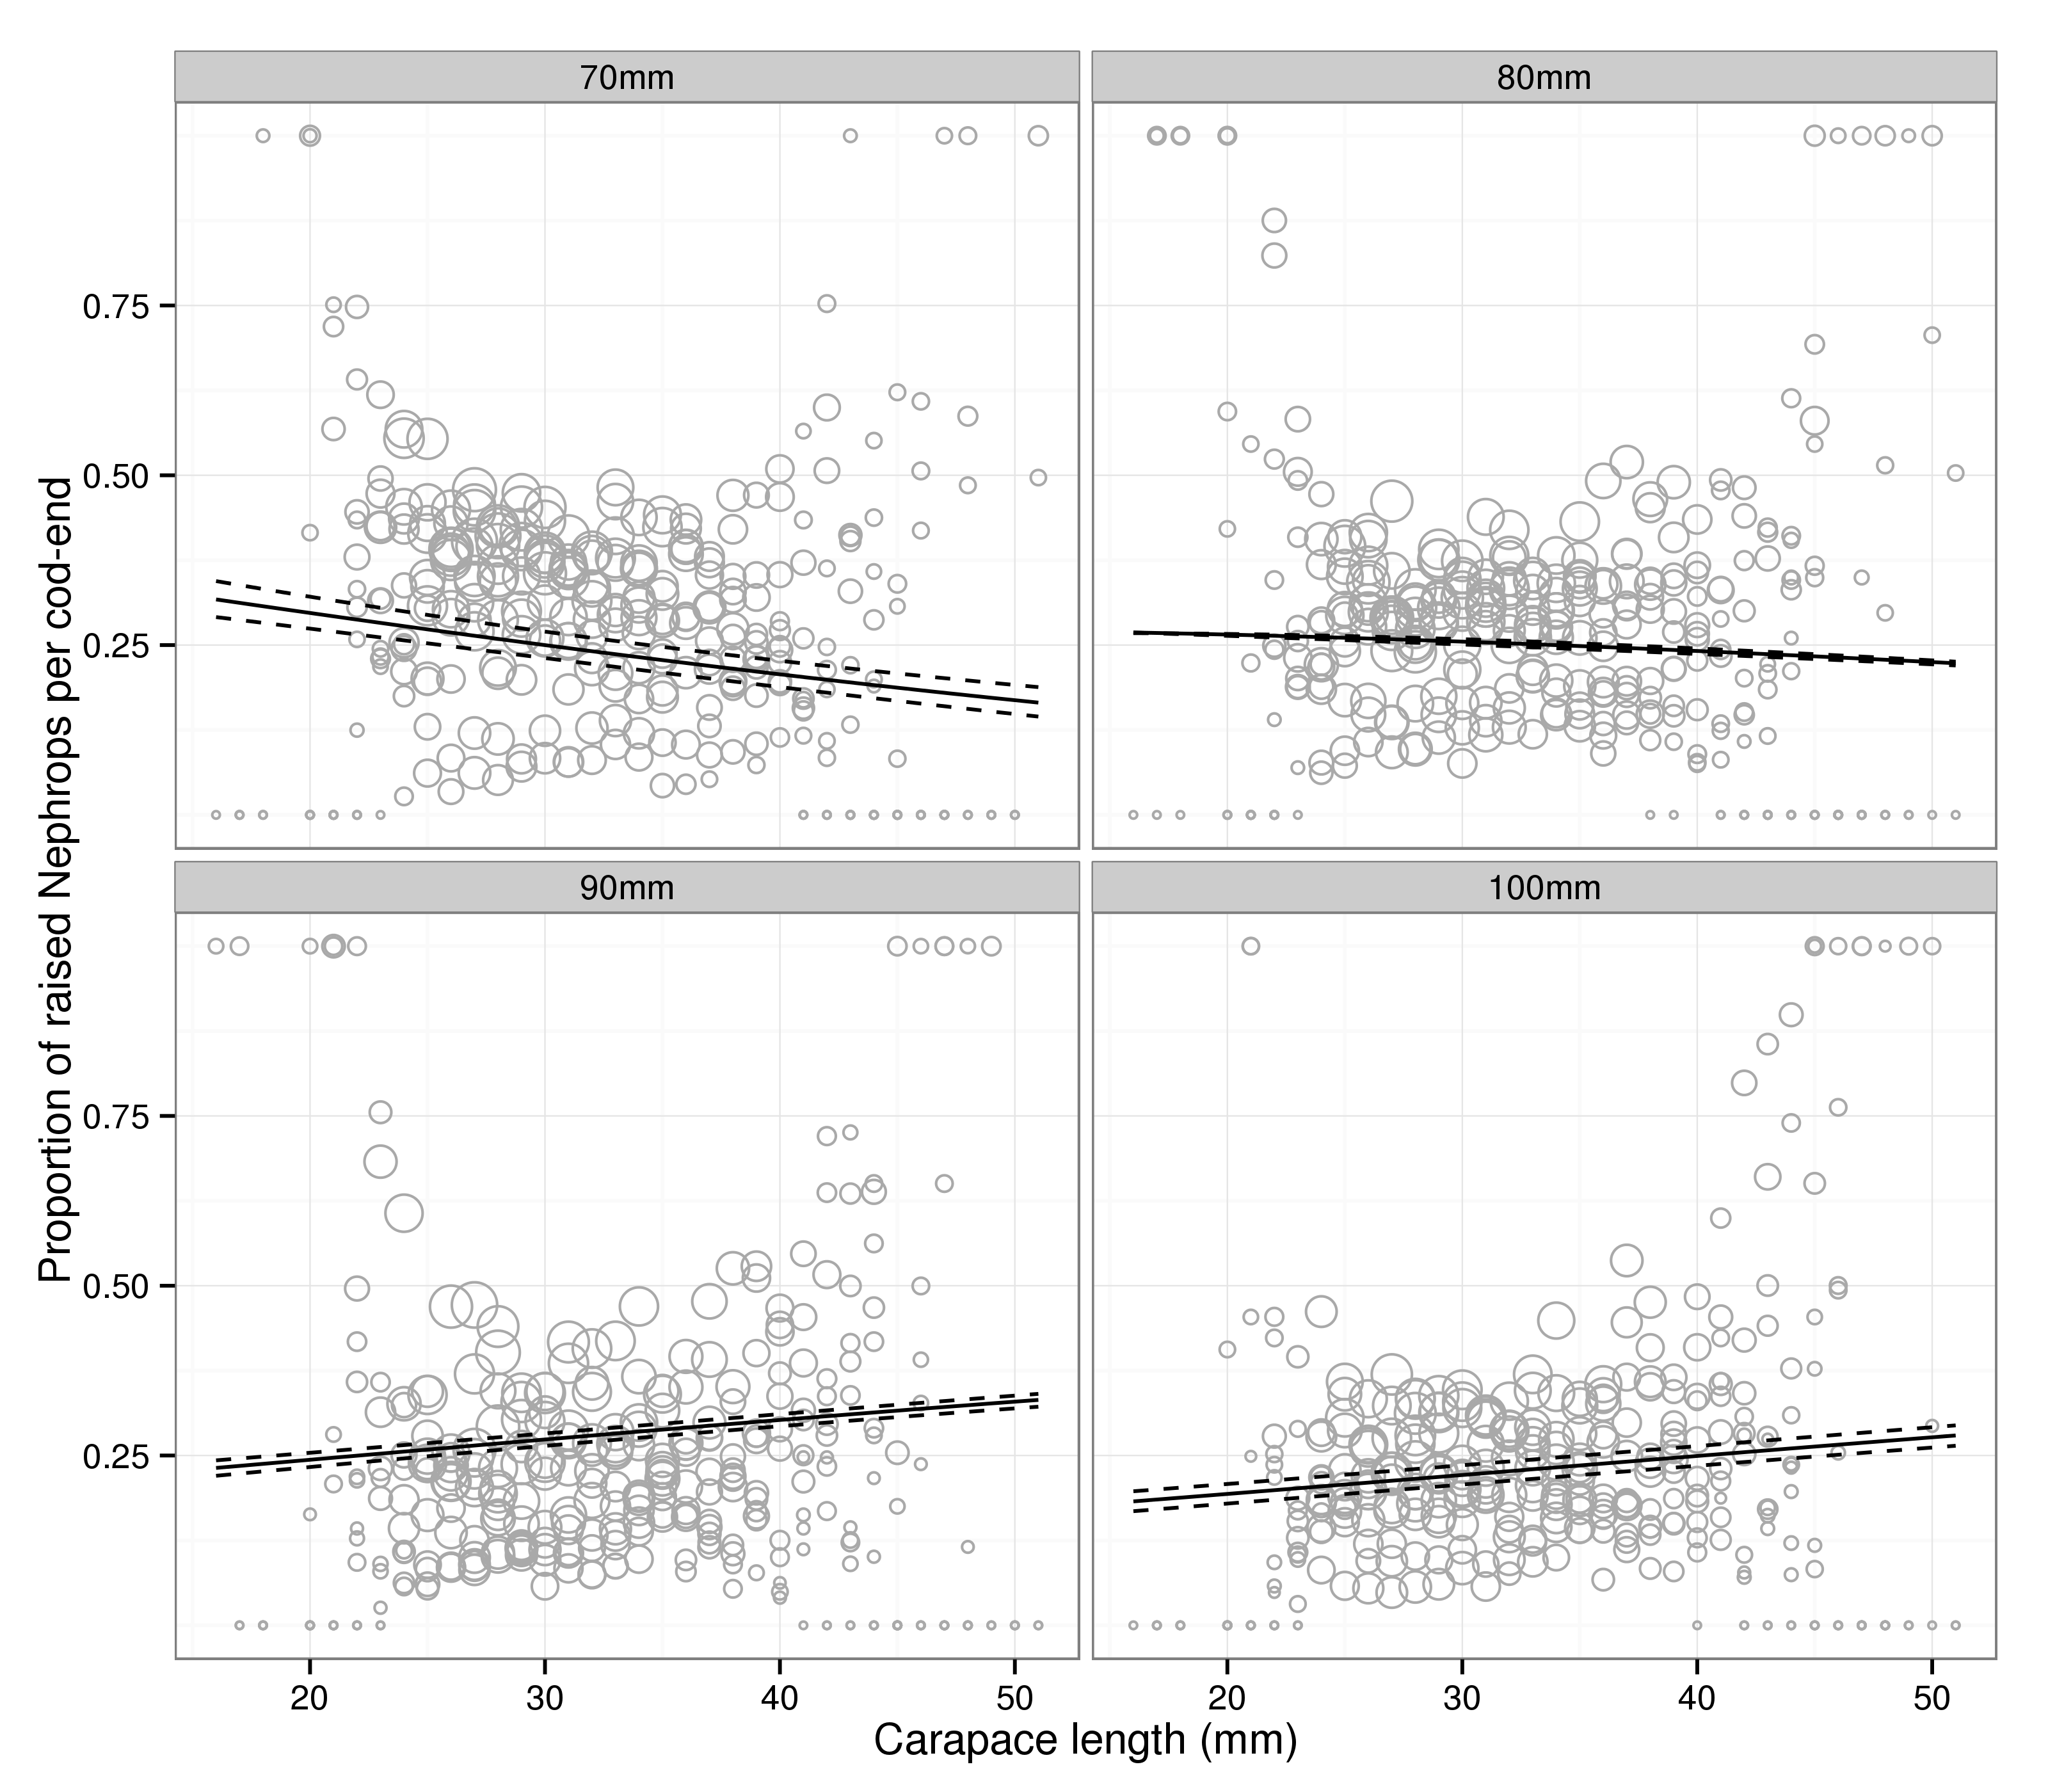

Figure 4. Multi-rig catch comparison. Overall predicted proportions at length. Solid and dashed lines represent the mean and 95% confidence intervals on the mean (see text for discussion on confidence intervals in this setting).