### Materials and methods

### Data analysis

In a quad-rig trial the response $Y$ was a $\left(n×4\right)$ matrix of *Nephrops* counts per observation ($i=1,…,n$) and cod-end ($k=1,2,3,4$). Each row $Y_{i}$ contained four counts (one for each cod-end) for length-bin $l_{i}$ in haul $h_{i}$. For example, for the 30mm length bin in haul 5, the response might be $Y_{i}=10,20,15,40$ denoting that 10 *Nephrops* were counted in the first cod-end, 20 in the second, etc.

The response data are multivariate counts for which interest lies in describing how the relative proportions retained per length-class in each of the cod-ends varies as a function of the cod-end design (predominantly mesh size) and other explanatory variables. When trials consist of counts per category (cod-end), a starting distribution is the multinomial (Agretsi, 2002) with probability mass function

$p\left(n_{1},n_{2},n_{3},n_{4}\right)=\frac{N!}{n_{1}!n_{2}!n_{3}!n_{4}!}π_{1}^{n_{1}}π_{2}^{n_{2}}π_{3}^{n_{3}}π_{4}^{n_{4}}$ (1)

where: $n_{k}$ is the count in the th cod-end and $N=\sum_{k}{n_{k}}$; and $π_{k}$ is the probability of outcome $k$, $\sum_{k}{π_{k}}=1$, implying 3 parameters in the basic model. A common model when explanatory variables are included (such as carapace length) is the multinomial logit model, where the probability of a given outcome depends on values of the explanatory variables for the th observation:

$π_{k,i}={e^{X_{i}β_{k}}}/{\left(\sum_{j=1}^{4}{e^{X_{i}β_{j}}}\right)}$, (2)

where $X_{i}$ is a ($1×p$) row vector of explanatory variables for the th observation and $β_{k}$ is a ($p×1$) column vector of parameters for the th category. Note that $β_{1}=0$ so that the first cod-end is set to the baseline, assuring that the probabilities sum to unity across the categories (Greene, 2000). The explanatory variables, included were: carapace length, total weight per cod-end, net position (in cases of rotated cod-ends). All model combinations were fit up to two-way interactions. Best fitting models were chosen by Akaike’s Information Criterion.

As the counts are sub-sampled, it is also necessary to include an offset for the proportion of the catch in each cod-end sampled (Holst and Revill, 2009). In a twin-rig (two category) trial the offset is given by $ln⁡\left({q_{t}}/{q_{c}}\right)$ where $q_{t}$ and $q_{c}$ are the proportions of the catch sampled in the test and control, respectively (Holst and Revill, 2009). In the quad-rig trial with the proportion $q_{k,i}$ of the th net in the th observation sampled, the vector of offsets for the is given by $o_{i}=\left(0,ln\left(\frac{q_{2,i}}{q_{1,i}}\right),ln\left(\frac{q_{3,i}}{q_{1,i}}\right),ln\left(\frac{q_{4,i}}{q_{1,i}}\right)\right)$, where the first zero comes from $ln\left(\frac{q_{1,i}}{q_{1,i}}\right)$. A numerical illustration of the offset terms is provided in the Appendix. The offset is incorporated in the multinomial logit as

$π_{k,i}={e^{X_{i}β_{k}+o_{i,k}}}/{\left(\sum_{j=1}^{4}{e^{X_{i}β_{j}+o_{i,j}}}\right)}$, (3)

*Extra-multinomial variation*

Counts for category $k$ in a multinomial have a mean $E\left[n_{k}\right]=π_{k}N$ and variance $Var\left[n_{k}\right]=π_{k}N\left(1−π_{k}\right)$, however, there is often more variability in the counts than the mean-variance (and covariance) allows for, which is termed overdispersion (Hinde and Demétrio, 1998). This may reflect uncaptured variability or clustering, in particular haul-level variability not accounted for when the observations are treated as independent multinomials. Overdispersion was tested for in the best fitting multinomial models by testing the residual deviance on a chi-squared distribution with the residual degrees of freedom (GET CORRECT CITATION – Paul et al. 1989).

We fit two alternative models to the multinomial, the first assumes that the parameters of the multinomial $π_{k}$ are not fixed constants but are distributed according to the Dirichlet distribution $π Dir\left(α\right)$, where $α=α_{1},α_{2},α_{3},α_{4}$, the resulting compound distribution is the Dirichlet-multinomial with probability mass function

$p\left(n_{1},n_{2},n_{3},n_{4}\right)=\frac{N!}{n_{1}!n_{2}!n_{3}!n_{4}!}\frac{Γ\left(\sum_{k=1}^{4}{α_{k}}\right)}{Γ\left(\sum_{k=1}^{4}{α_{k}+n_{k}}\right)}\prod_{k=1}^{4}{\frac{Γ\left(α_{k}+n_{k}\right)}{Γ\left(α_{k}\right)}}$. (4)

Note that the Dirichlet-multinomial model has four free parameters in the basic model, allowing for additional variability in the counts. Covariate effects can be included via loading on the parameters of the Dirichlet (Chen and Li, 2013):

$α_{k,i}=exp\left(X_{i}β_{k}\right)$. (5)

Offsets $o_{i}=\left(ln\left(q_{1,i}\right),ln\left(q_{2,i}\right),ln\left(q_{3,i}\right),ln\left(q_{4,i}\right)\right)$ are included as $α_{k,i}=exp⁡\left(X_{i}β_{k}+o_{i,k}\right)$ (here – test in the morning). As the probability mass function is available in closed form (Equation 4), the model can be fit via maximum likelihood. The case of two nets has previously been investigated using the beta-binomial (two category Dirichlet-multinomial) by Miller (2013).

An alternative approach to accounting for extra-multinomial variability is to include random effects in the model (Hinde and Demétrio, 1998). Multinomial random effects include the baseline category logit random effects model (Hartzel et al., 2001). This model has a single (non-compound) multinomial response distribution with the addition of random effects that more explicitly capture the variability attributable to hauls, as opposed to the more general additional variability unattributed to specific grouping but included in the Dirichlet-multinomial model. The random effects multinomial model we test is an extension of Equation (2) given by

, (6)

where the random effects per haul have a multivariate normal distribution $u_{h} MVN\left(0,Σ\right)$. The baseline category random effect is again set to zero, resulting in a trivariate normal distribution for $u_{h}$. An arbitrary (6 parameter) covariance matrix structure, as recommended in Hartzel et al. (2001) was implemented.

Estimation of the multinomial random effects model is complicated by the necessity of integrating over the random effects to estimate the marginal likelihood. We did not find readily available software to fit this model so for comparison we wrote estimation routines in AD Model Builder (ADMB) (Fournier et al., 2012) and Just Another Gibb’s Sampler (JAGS) (Plummer 2003). The ADMB-RE module (Skaug and Fournier, 2006) was used to estimate the multinomial logit random effects model with the variance-covariance matrix specified via a Cholesky-decomposition. JAGS is a general method for Bayesian MCMC estimation using the Gibb’s sampling. Wide priors were set for each of the fixed effects ($β_{j} N\left(0,100\right)$) and an inverse-Wishart prior for the precision of the random effects ($Σ W^{−1}$ (**I**,3)). Three MCMC chains were run for 1e5 iterations with the first half discarded for burn-in and the second half sampled at every 10 step to provide 15,000 samples for the posterior distribution of each parameter. All pre- and post-processing code was run in R 3.2.0 (R Core Team, 2015). Code for running the analysis with an example is stored at (INCLUDE github public repository).

## Results

Figure 1: Design of quad-rig

Figure 2: Bubble gum plots showing inter-haul variability make the point regarding 0.25, challenges with the data, clear inter-haul differences,

Figure 3: By-haul with fits

Figure 4: Overall effects across the 3 models: MN, MN-RE, DM

Correlation of the random effects

Betacond was significant and positive: include table of estimated coefficients?

Extra-multinomial variation was found in the best fitting models for all three trials.

Net configuration very important with position 4 has higher counts, position 2 had lower, as shown by strong patterns in the residuals by net configuration. When netconfig included in the model the residuals were vastly improved. This accounts for a good deal of the inter-haul variability observed. Higher-order carapace length effects did not improve the AIC nor residual patterns.

Bulk weights (CONDITIONAL LOGIT MODEL)

If the bulk weight of a given net is high, others lower, we would expect the proportion retained in that net to be higher. The key question is how the cod-end weight interacts with the carapace length effect such that the strectching of the meshes changes and thus the proportions at length change.

Can be quite easy to over-fit these models

How about setting the weight variables as the difference from the baseline? No difference, no effect. We expect there to be no difference due to weight when the bulk weights are the same. All relative to the 70mm.

N is fixed so only three counts are free to determine the available degrees of freedom. To model the effect of weight correctly would need to have the interactions in there, think of when 80mm has a high bulk and others are low, 80mm has a preicted high count, when all are high all nets should be fishing correctly and the proportions the same, so the effect of the variable 80mm bulk is depends on the value of the other variables and hence an interaction term is required to model correctly. Could bin them and say for high medium and low catches.

## References

Agresti, A. (2002). *Categorical Data Analysis* (2nd edition). John Wiley & Sons, Inc., Hoboken, New Jersey.

Chen, J., & Li, H. (2013). Variable selection for sparse dirichlet-multinomial regression with an application to microbiome data analysis. *The Annals of Applied Statistics*, 7(1) 1-25.

Fournier, D.A., H.J. Skaug, J. Ancheta, J. Ianelli, A. Magnusson, M.N. Maunder, A. Nielsen, and J. Sibert. (2012). AD Model Builder: using automatic differentiation for statistical inference of highly parameterized complex nonlinear models. *Optimization Methods Software*. 27:233-249.

Greene, W.H. (2000). *Econometric Analysis* (4th edition). Prentice Hall, Upper Saddle River, New Jersey.

Hartzel, J., Agresti A., and Caffo, B. (2001). Multinomial logit random effects models. *Statistical Modelling*, 1, 81-102.

Hinde, J. and Demétrio, C.G.B (1998). Overdispersion: models and estimation. *Computational Statistics & Data Analysis* 27(2) : 151-170.

Holst, R. and Revill, A. (2009). A simple statistical method for catch comparison studies. *Fisheries Research* 95(2): 254-259.

Miller, T.J. (2013). A comparison of hierarchical models for relative catch efficiency based on paired-gear data for US Northwest Atlantic fish stocks. *Canadian Journal of Fisheries and Aquatic Sciences*, 70: 1306-1316.

Paul, S.R., Liang, K.Y. and Self, S.G. (1989). On testing departure from the binomial and multinomial assumptions. *Biometrics*, 45: 231-236.

Plummer, M. (2003). JAGS: A Program for Analysis of Bayesian Graphical Models Using Gibbs Sampling. Proceedings of the 3rd International Workshop on Distributed Statistical Computing (DSC 2003), March 20–22, Vienna, Austria. ISSN 1609-395X.

R Core Team (2015). R: A language and environment for statistical computing. R Foundation for Statistical Computing, Vienna, Austria. URL <http://www.R-project.org/>

Skaug, H.J. and Fournier, D.A. (2006). Automatic approximation of the marginal likelihood in non-Gaussian hierarchical models. Computational Statistics & Data Analysis, 51(2): 699–709.

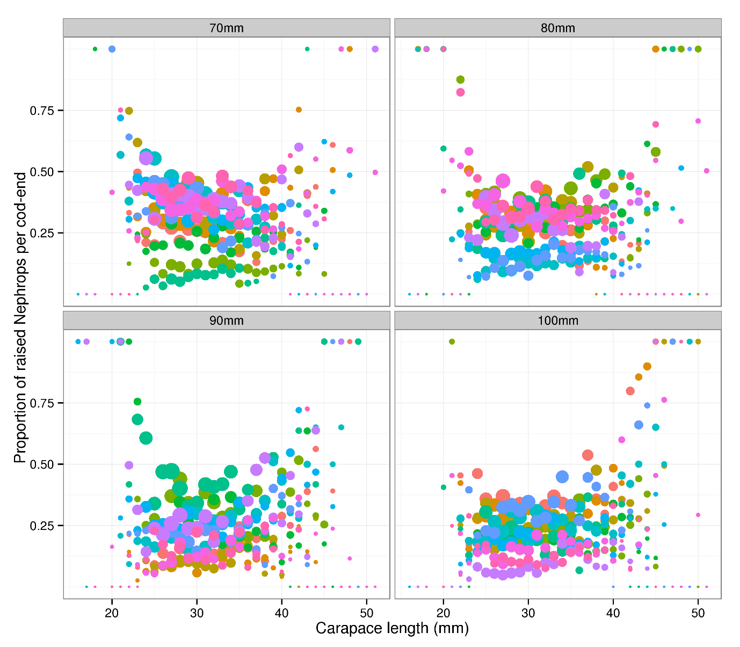

Figure 1. Multi-rig catch-comparison. Proportion of Nephrops retained per length-class by diamond mesh size. Hauls are coloured to demonstrate the haul effects. The diameter of the points is proportional to the log base 10 of the raised counts to illustrate where the distribution of the counts.

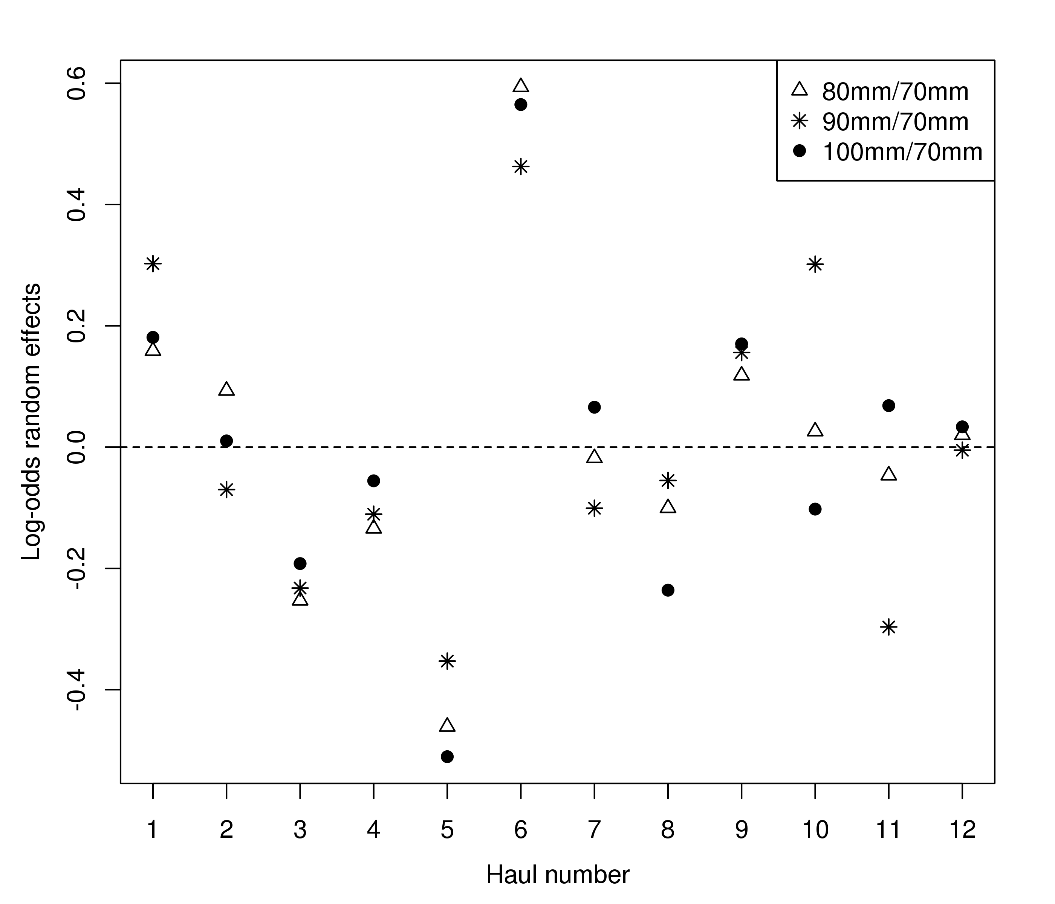

Figure 2. Multi-rig catch comparison. Estimated trivariate random effects (log-odds ratios to the baseline 70mm case: in Equation 6) by haul.

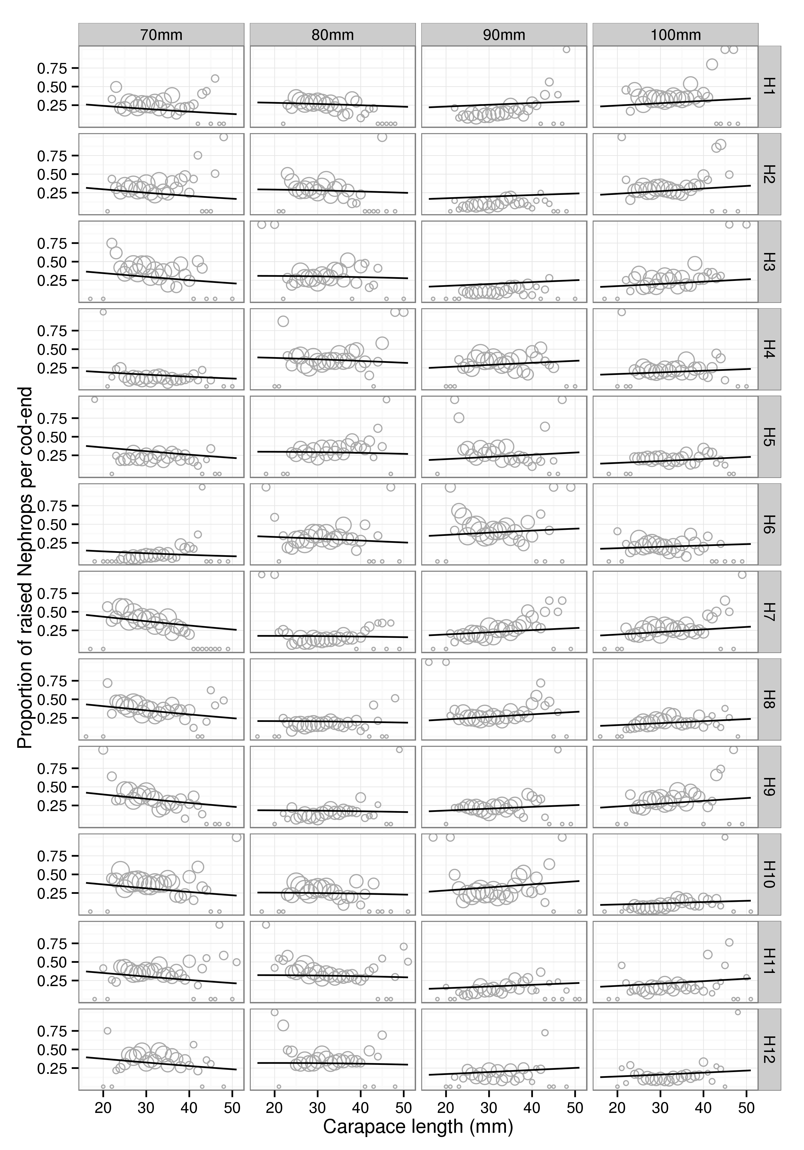

Figure 3. Multi-rig catch comparison. Fitted multinomial mixed effects proportions by haul.

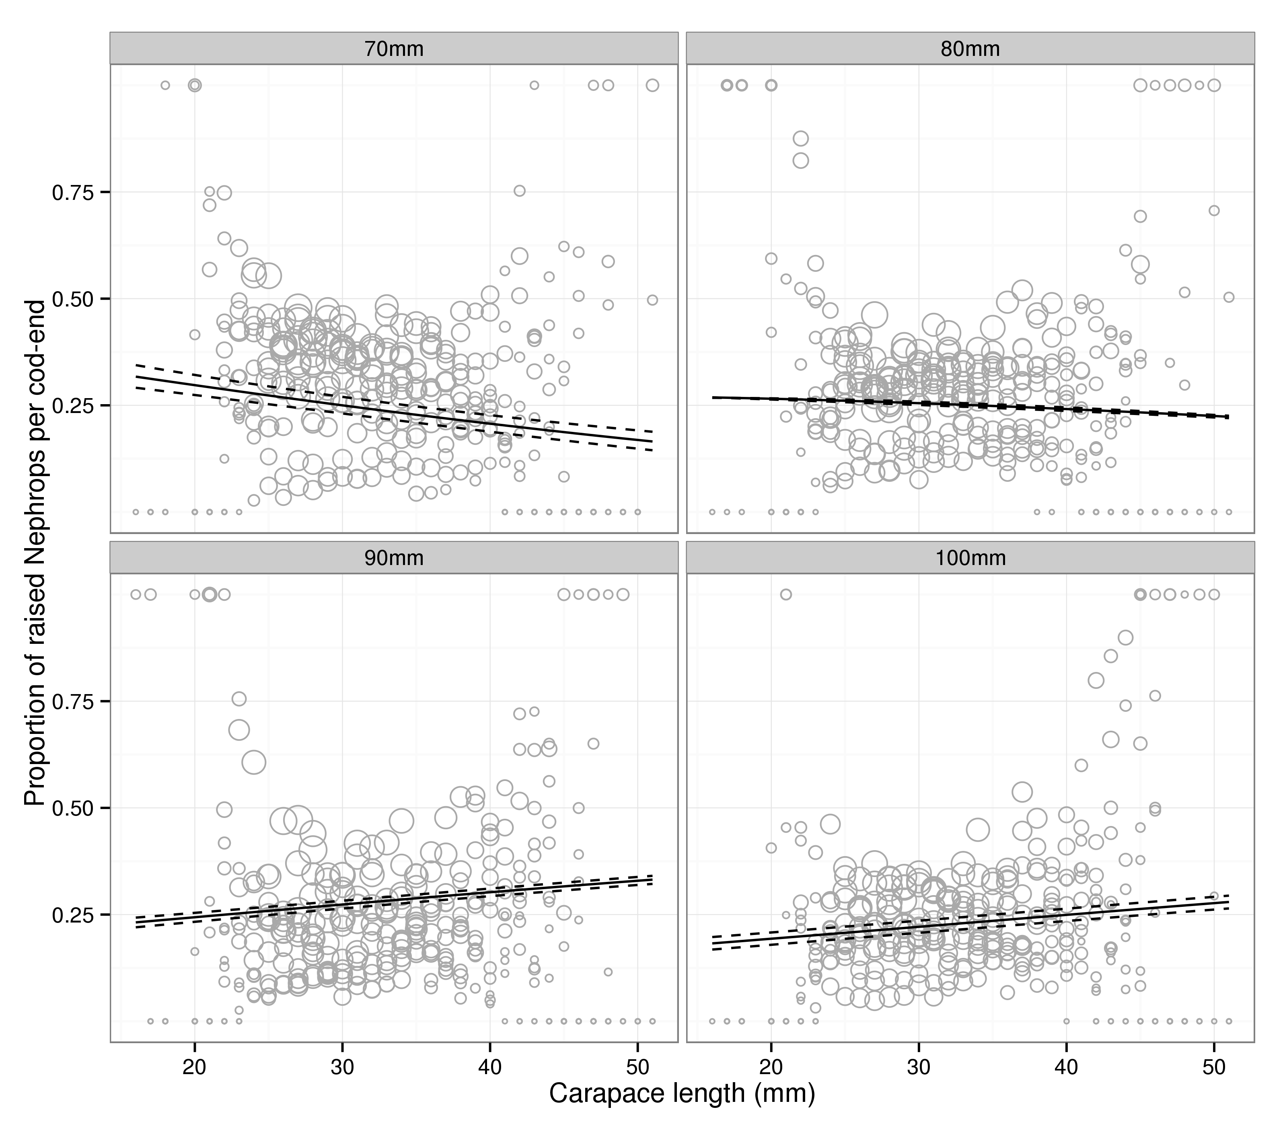

Figure 4. Multi-rig catch comparison. Overall predicted proportions at length. Solid and dashed lines represent the mean and 95% confidence intervals on the mean (see text for discussion on confidence intervals in this setting).