
A DBMS MINI PROJECT REPORT
DRIVEEASE
Car Rental Management System

Submitted by:
Aarushi Raizada- 25070122002
Abhyuday Rahul Tripathi- 25070122013
Aditya Barnwal- 25070122019

Under the guidance of: Dr. Rahul Joshi
Department of Computer Science
Symbiosis Institute of Technology, Pune
October 2026

Declaration and Report Scope
This report documents the DriveEase Car Rental Management System based on the supplied project ZIP, its Java source code, frontend pages, MySQL schema, README and design notes. It follows the requested mini-project guideline steps and uses the supplied Personal Finance Management System report as a structural reference. The project details below distinguish functionality present in the code from suggested database extensions.
Group details and faculty name are left as placeholders because they were not reliably available in the supplied project files. Replace these placeholders before submission.

Contents
1. Introduction
2. Problem Statement and Objectives
3. Project Planning and Requirement Analysis
4. System Architecture and Modules
5. Functional and Non-Functional Requirements
6. Entities, Relationships and Attributes
7. ER/EER Diagram
8. Relational Schema and Constraints
9. Functional Dependencies and Normalization
10. Anomaly Analysis
11. Database Implementation in MySQL
12. Queries and Transaction Logic
13. Functions, Procedures and Triggers: Current Status and Proposed Extensions
14. Testing and Results
15. Application of Codd’s Rules
16. Limitations and Future Enhancements
17. Conclusion
Appendix A: Demonstration Checklist

1. Introduction
DriveEase is a browser-based car rental management system developed as a Java and MySQL mini project. It provides a single place for customers to browse a fleet of vehicles, create an account, sign in, make a reservation for selected dates and pickup/drop-off locations, review their bookings, cancel eligible future bookings, and maintain their profile.
The frontend is built with HTML, CSS and JavaScript. A Java backend uses the JDK built-in HTTP server and JDBC to communicate with MySQL. The database stores user accounts, vehicle details, bookings and login sessions. This arrangement allows the project to demonstrate relational database design alongside Java concepts such as inheritance, collections, exception handling, prepared statements, transactions and multithreading.

2. Problem Statement and Objectives

2.1 Problem statement
Manual or loosely coordinated rental workflows can make it difficult to keep vehicle information consistent, calculate rental costs correctly, track customer reservations and prevent two confirmed bookings for the same car from overlapping. A database-backed application is needed to maintain reliable records and apply validation rules consistently.

2.2 Objectives
- Provide an easy-to-use interface for browsing, filtering and sorting available cars.
- Store users, cars, bookings and sessions in a relational MySQL database.
- Support registration, login/logout, profile editing and password changes.
- Allow authenticated customers to create, view and cancel eligible bookings.
- Calculate rental cost on the server using the car’s daily rate and rental duration.
- Reject invalid dates and overlapping confirmed reservations.
- Demonstrate SQL/JDBC CRUD operations, constraints, transactions and core Java concepts.

3. Project Planning and Requirement Analysis

3.1 Project scope
The supplied implementation is a local demonstration application, not a production rental marketplace. The HTTP server binds to 127.0.0.1 and the available pickup/drop-off locations are configured as Pune, Mumbai, Nashik and Bengaluru. The current system supports customer-facing workflows and seeds six sample cars when the cars table is empty.

3.2 Stakeholders
Stakeholder | Interest / responsibility
Customer | Browse vehicles, create account, book a car, view/cancel own bookings, update profile.
Project team | Design schema, implement Java API and frontend, test workflows, explain individual contribution.
Database / application maintainer | Configure MySQL, preserve integrity, monitor errors and maintain sample fleet data.

3.3 Assumptions and business rules
- Only registered and authenticated users can create or manage bookings.
- A booking must refer to an active car and a valid customer.
- Return date must be later than pickup date; pickup cannot be in the past.
- The rental duration is limited to 30 days by the booking API.
- A confirmed booking conflicts with another confirmed booking for the same car when the date intervals overlap.
- The interval convention permits a new booking to start on the previous booking’s return date.
- Only future bookings can be cancelled; completed or already-cancelled bookings cannot be cancelled again.
- The application calculates total price on the server rather than trusting a browser-supplied total.

3.4 Development environment
Component | Observed project choice
Language / runtime | Java; Maven compiler release configured as Java 17 or later.
Web server | JDK built-in com.sun.net.httpserver.HttpServer; no Spring Boot.
Database | MySQL, using MySQL Connector/J via JDBC.
Frontend | HTML pages (.htm), CSS and JavaScript.
Tests | JUnit 5 unit tests for selected validation and Java concepts.
Default local URL | http://localhost:5000 (server binds to 127.0.0.1).

4. System Architecture and Modules
The browser requests static frontend pages and sends JSON requests to the Java API hosted by the same local server. API handlers validate input, check authentication where required, execute prepared SQL statements through JDBC and return JSON responses. MySQL stores persistent records.

4.1 Architecture overview
Layer | Responsibilities | Project files / components
Presentation layer | Pages, forms, car cards, booking details, dashboard and profile interactions. | frontend/*.htm, style.css, script.js
HTTP/API layer | Routes requests, applies login requirements, returns JSON and HTTP status codes. | Main.java, Ctx.java, ApiException.java
Business logic | Registration/login, car filtering, booking validation, cancellation and dashboard calculations. | UserApi.java, Auth.java, CarApi.java, BookingApi.java
Data access | Opens JDBC connections, runs prepared statements, initializes schema and seeds cars. | Db.java, database/schema.sql
Data storage | Stores users, cars, bookings and sessions with keys, indexes and constraints. | MySQL database: driveease

4.2 Main modules
Module | Description
Home / About | Introduces DriveEase, describes the service and displays contact information.
Registration and authentication | Creates accounts, verifies credentials, establishes cookie-based sessions and supports logout.
Car catalogue | Lists active cars, filters by category and sorts by recommendation, price or name.
Dashboard | Shows booking statistics, the next active booking and featured cars.
Booking | Validates dates and locations, checks availability, calculates price and saves a confirmed booking.
My Bookings | Lists the logged-in user’s bookings, exposes booking details and supports eligible cancellations.
Profile | Reads and updates name, email and phone; provides password change functionality.
Database initialization | Executes schema definitions at startup and inserts sample cars when the catalogue is empty.

4.3 API route summary
Method and route | Access | Purpose
POST /api/register | Public | Create user and start a session.
POST /api/login | Public | Verify credentials and start a session.
POST /api/logout | Public route; clears current token | End current session.
GET /api/me | Login required | Return current user profile.
PUT /api/me | Login required | Update name, email and phone.
PUT /api/me/password | Login required | Change password after verifying current password.
GET /api/cars | Public | List active cars with optional category and sort filters.
GET /api/cars/{id} | Public | Fetch one active car.
GET /api/locations | Public | Return supported rental locations.
POST /api/bookings | Login required | Create a booking after validation and conflict checks.
GET /api/bookings | Login required | List the current user’s bookings.
GET /api/bookings/{id} | Login required | Fetch a booking only if it belongs to the current user.
POST /api/bookings/{id}/cancel | Login required | Cancel an eligible booking.
GET /api/dashboard | Login required | Return booking statistics and featured cars.

5. Functional and Non-Functional Requirements

5.1 Functional requirements
- FR1: Visitors can browse active cars and see category, seating, transmission, fuel and daily price.
- FR2: Visitors can register with a name, email and password; phone is optional.
- FR3: Registered users can log in and log out.
- FR4: The system maintains server-side sessions in MySQL and supports a “Remember me” duration.
- FR5: Users can view and update their profile and change their password after supplying the current password.
- FR6: Users can filter the car catalogue by category and sort by recommended order, price or name.
- FR7: Authenticated users can book an active car for valid dates and supported locations.
- FR8: The system calculates the booking total using price per day multiplied by rental days.
- FR9: The system rejects invalid date ranges, rentals over 30 days and overlapping confirmed bookings.
- FR10: Users can list and view only their own bookings.
- FR11: Users can cancel future bookings that are not already cancelled or completed.
- FR12: The dashboard displays booking counts, the next active booking and up to three featured cars.

5.2 Non-functional requirements
- Security: passwords are stored as PBKDF2-HMAC-SHA256 hashes; session tokens are stored as SHA-256 hashes.
- Data integrity: primary keys, foreign keys, unique email constraint, date check constraint and status enum constrain stored data.
- SQL safety: prepared statements are used for values supplied by users; sorting options use a whitelist.
- Reliability: booking creation uses a transaction and locks the selected car row while checking availability.
- Usability: a browser-based interface organizes the key rental workflows.
- Error handling: validation, missing resources and booking conflicts map to clear HTTP status codes (400, 404 and 409); unauthenticated requests receive 401.
- Concurrency: a fixed-size executor with 16 worker threads handles HTTP requests.
- Deployment boundary: the default server binds to localhost and is intended for a lab demonstration.

6. Entities, Relationships and Attributes

6.1 Entity: USERS
Represents a registered customer.
Attribute | Type / constraint | Meaning
id | INT UNSIGNED, PK, AUTO_INCREMENT | Unique customer identifier.
name | VARCHAR(80), NOT NULL | Customer name.
email | VARCHAR(254), NOT NULL, UNIQUE | Login email; duplicates are prevented.
phone | VARCHAR(20), NULL | Optional contact number.
password_hash | VARCHAR(255), NOT NULL | Password hash, not plaintext password.
created_at | DATETIME, default current timestamp | Account creation time.

6.2 Entity: CARS
Attribute | Type / constraint | Meaning
id | INT UNSIGNED, PK, AUTO_INCREMENT | Unique car identifier.
name | VARCHAR(100), NOT NULL | Display name / model.
category | VARCHAR(40), NOT NULL | Vehicle class, e.g. SUV or Sedan.
description | TEXT, NOT NULL | Description of the vehicle.
seats | TINYINT UNSIGNED, NOT NULL | Passenger capacity.
transmission | VARCHAR(30), NOT NULL | Transmission type.
fuel | VARCHAR(30), NOT NULL | Fuel type.
price_per_day | INT UNSIGNED, NOT NULL | Daily rental rate.
popular | TINYINT(1), default 0 | Whether the car is featured/popular.
active | TINYINT(1), default 1 | Whether the car is available for listing/booking.
created_at | DATETIME, default current timestamp | Record creation time.

6.3 Entity: BOOKINGS
Attribute | Type / constraint | Meaning
id | INT UNSIGNED, PK, AUTO_INCREMENT | Unique reservation identifier.
user_id | INT UNSIGNED, FK → users.id | Customer who placed the booking.
car_id | INT UNSIGNED, FK → cars.id | Vehicle being reserved.
pickup_date | DATE, NOT NULL | Start date of rental.
return_date | DATE, NOT NULL | Return date; must be later than pickup.
pickup_location | VARCHAR(80), NOT NULL | Pickup city/location.
drop_location | VARCHAR(80), NOT NULL | Return/drop-off city/location.
total_price | INT UNSIGNED, NOT NULL | Server-calculated total rental price.
status | ENUM confirmed/cancelled | Persisted booking status.
created_at | DATETIME, default current timestamp | Booking creation time.

6.4 Entity: SESSIONS
Attribute | Type / constraint | Meaning
token_hash | CHAR(64), PK | SHA-256 hash of the browser’s random session token.
user_id | INT UNSIGNED, FK → users.id | Owner of the session.
expires_at | DATETIME, NOT NULL | Session expiry timestamp.
created_at | DATETIME, default current timestamp | Session creation time.

6.5 Relationships and cardinality
- USERS to BOOKINGS: one user can place zero or many bookings; each booking belongs to exactly one user (1:N).
- CARS to BOOKINGS: one car can appear in zero or many bookings over time; each booking refers to one car (1:N).
- USERS to SESSIONS: one user can own zero or many stored sessions; each session belongs to one user (1:N).
- No separate PAYMENT, BRANCH, ADMIN, CATEGORY or VEHICLE-IMAGE entity exists in the supplied schema. Locations and car categories are stored as values, and payment processing is outside the current implementation.

7. ER / EER Diagram
The diagram below reflects the four tables actually defined in database/schema.sql. It is an ER diagram; the current project does not define a separate EER specialization hierarchy in the database. In the Java model, a Vehicle base class and Models.Car subclass demonstrate object-oriented inheritance, but this is not a separate relational subtype table.
TO ACCESS ER/EER DIAGRAM LINK USING DRAW.IO
https://drive.google.com/file/d/1_pjSdqpf0WlnBsS8FbTZJOF-GkXIzNHs/view?usp=sharing
https://drive.google.com/file/d/1He1kImfuW270Etfx866Ne_5PGvtUEHLo/view?usp=sharing
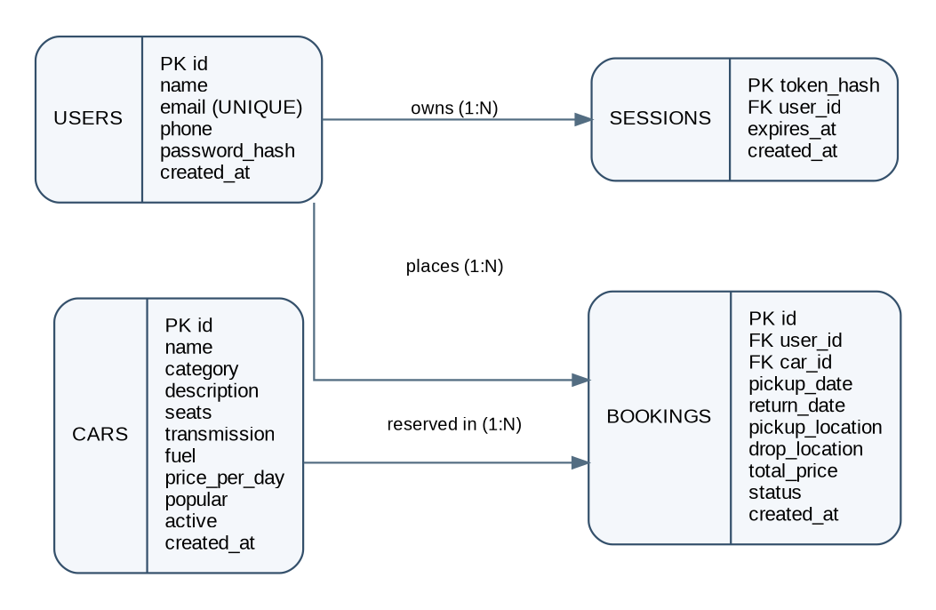
Figure 1. DriveEase relational entities and one-to-many relationships.

8. Relational Schema and Constraints
USERS(id PK, name, email UNIQUE, phone, password_hash, created_at)
CARS(id PK, name, category, description, seats, transmission, fuel,
price_per_day, popular, active, created_at)
BOOKINGS(id PK, user_id FK → USERS.id, car_id FK → CARS.id,
pickup_date, return_date, pickup_location, drop_location,
total_price, status, created_at)
SESSIONS(token_hash PK, user_id FK → USERS.id, expires_at, created_at)

8.1 Integrity constraints
Constraint | Where used | Purpose
Primary keys | id in users/cars/bookings; token_hash in sessions | Uniquely identify each row.
Unique key | users.email | Prevent duplicate accounts with the same email.
Foreign keys | bookings.user_id, bookings.car_id, sessions.user_id | Prevent orphan booking/session records.
CHECK | bookings.return_date > bookings.pickup_date | Prevent zero-length or negative-duration rentals at database level.
ENUM | bookings.status | Restrict persisted status to confirmed or cancelled.
NOT NULL / defaults | Across required columns | Ensure required data exists and set creation/status defaults.
Indexes | cars active/category/popular; bookings user/date and car/status/date; sessions user/expiry | Support common listing, booking and session queries.

8.2 Referential actions
When a referenced user or car identifier is updated, the foreign key uses ON UPDATE CASCADE. Deleting a user or car is restricted when bookings reference it. Sessions use ON DELETE CASCADE from users, so session records are removed if a user row is deleted. These rules reduce orphaned records.

9. Functional Dependencies and Normalization

9.1 Functional dependencies
The following dependencies are implied by the table keys and the meaning of the columns. They assume that each row describes one entity or one booking/session.
Relation | Main functional dependencies
USERS | id → name, email, phone, password_hash, created_at; email → id, name, phone, password_hash, created_at (email is UNIQUE).
CARS | id → name, category, description, seats, transmission, fuel, price_per_day, popular, active, created_at.
BOOKINGS | id → user_id, car_id, pickup_date, return_date, pickup_location, drop_location, total_price, status, created_at.
SESSIONS | token_hash → user_id, expires_at, created_at.

9.2 First Normal Form (1NF)
Each table has atomic column values and a primary key. For example, pickup_location and drop_location each hold one location value, while car details are stored as separate attributes. There are no repeating groups or multivalued columns in the schema.

9.3 Second Normal Form (2NF)
All four relations use a single-attribute primary key. Therefore, there can be no partial dependency on only part of a composite primary key. The relations satisfy 2NF, assuming the stated keys.

9.4 Third Normal Form (3NF)
The schema is designed to satisfy 3NF because non-key attributes describe the entity identified by the primary key, and the design separates users, cars, bookings and sessions. The current schema does not store customer name/email or car description/rate redundantly inside BOOKINGS; instead, it references USERS and CARS using foreign keys. A booking total is stored as a transaction-time snapshot of the calculated cost. This is intentional because a car’s daily rate may change later; the stored total preserves the amount recorded for that booking.

9.5 BCNF discussion
Based on the documented functional dependencies, the determinants shown are candidate keys (USERS also has unique email). Therefore the relations appear to satisfy BCNF under these assumptions. If the business rules later allow duplicate emails or introduce additional dependencies, the dependencies and normal forms should be reassessed.

10. Anomaly Analysis
The normalized design reduces common insertion, update and deletion anomalies by keeping user, car, booking and session facts in separate relations.
Anomaly type | Risk in a poorly designed single table | How DriveEase reduces it
Insertion anomaly | A new car could not be recorded until a customer books it, or user data would need to be duplicated for each car. | CARS and USERS can be inserted independently of BOOKINGS.
Update anomaly | Changing a customer email or car description in many booking rows could leave inconsistent copies. | Customer details are stored once in USERS; car specifications/rate are stored once in CARS.
Deletion anomaly | Deleting a booking row could accidentally remove the only stored copy of customer or car details. | USERS and CARS are separate entities; foreign-key restrictions protect referenced rows.
Redundancy risk | Repeating passwords, customer names or car descriptions in every booking increases inconsistency and exposure. | BOOKINGS stores user_id and car_id foreign keys rather than duplicating these attributes.

A deliberate exception is BOOKINGS.total_price. It is a derived value from daily rate and rental duration, but storing it is useful to preserve the amount agreed at booking time. It should be calculated and validated by the backend, as the current implementation does.

11. Database Implementation in MySQL

11.1 Startup and schema creation
Db.init() reads database/schema.sql, executes each table-definition statement and then seeds six sample vehicles if the CARS table is empty. The JDBC URL selects/creates the driveease database when permitted by the configured MySQL account. The SQL schema file contains CREATE DATABASE and USE statements for manual execution; the Java initializer skips these two statements because the JDBC URL handles database selection.

11.2 Sample catalogue data
Car | Category | Transmission | Fuel | Daily rate (₹)
Hyundai Creta | SUV | Automatic | Petrol | 1,500
Honda City | Sedan | Automatic | Petrol | 1,300
Tata Altroz | Hatchback | Manual | Petrol | 900
Kia Seltos | SUV | Automatic | Diesel | 1,700
Skoda Slavia | Sedan | Automatic | Petrol | 1,600
BMW 3 Series | Luxury | Automatic | Petrol | 4,500

11.3 CRUD mapping
Operation | Examples in project
CREATE / INSERT | Register a user; create a booking; create a session; seed initial cars.
READ / SELECT | Load profile; list active cars; retrieve user-owned bookings; check car availability; calculate dashboard statistics.
UPDATE | Update user profile; change password; cancel booking by changing status.
DELETE | Delete/replace session tokens and clean expired sessions. The user-facing booking cancellation is a status update, not a physical deletion.

12. Queries and Transaction Logic

12.1 Representative SQL queries
-- List active cars, sorted by daily rate
SELECT id, name, category, price_per_day
FROM cars
WHERE active = 1
ORDER BY price_per_day ASC;

-- Retrieve bookings for one customer
SELECT b.id, c.name, b.pickup_date, b.return_date,
b.pickup_location, b.drop_location, b.total_price, b.status
FROM bookings b
JOIN cars c ON c.id = b.car_id
WHERE b.user_id = ?
ORDER BY b.pickup_date DESC, b.id DESC;

-- Detect overlapping confirmed bookings for a selected car
SELECT 1
FROM bookings
WHERE car_id = ?
AND status = 'confirmed'
AND pickup_date < ?
AND return_date > ?
LIMIT 1;

-- Dashboard: count bookings by persisted status for one user
SELECT status, COUNT(*) AS booking_count
FROM bookings
WHERE user_id = ?
GROUP BY status;

-- Cancel a booking only for its owner (application also checks eligibility)
UPDATE bookings
SET status = 'cancelled'
WHERE id = ? AND user_id = ?;

These statements illustrate the SQL patterns used by the Java implementation. In the actual application, user-supplied values are bound through PreparedStatement placeholders rather than concatenated into SQL strings.

12.2 Booking transaction
Booking creation is the most important integrity workflow because two users may attempt to reserve the same car for overlapping dates. The API checks authentication and input, begins a transaction, selects the active car row FOR UPDATE, checks for an overlap among confirmed bookings, calculates the total and inserts the booking. On conflict it rolls back; otherwise it commits.
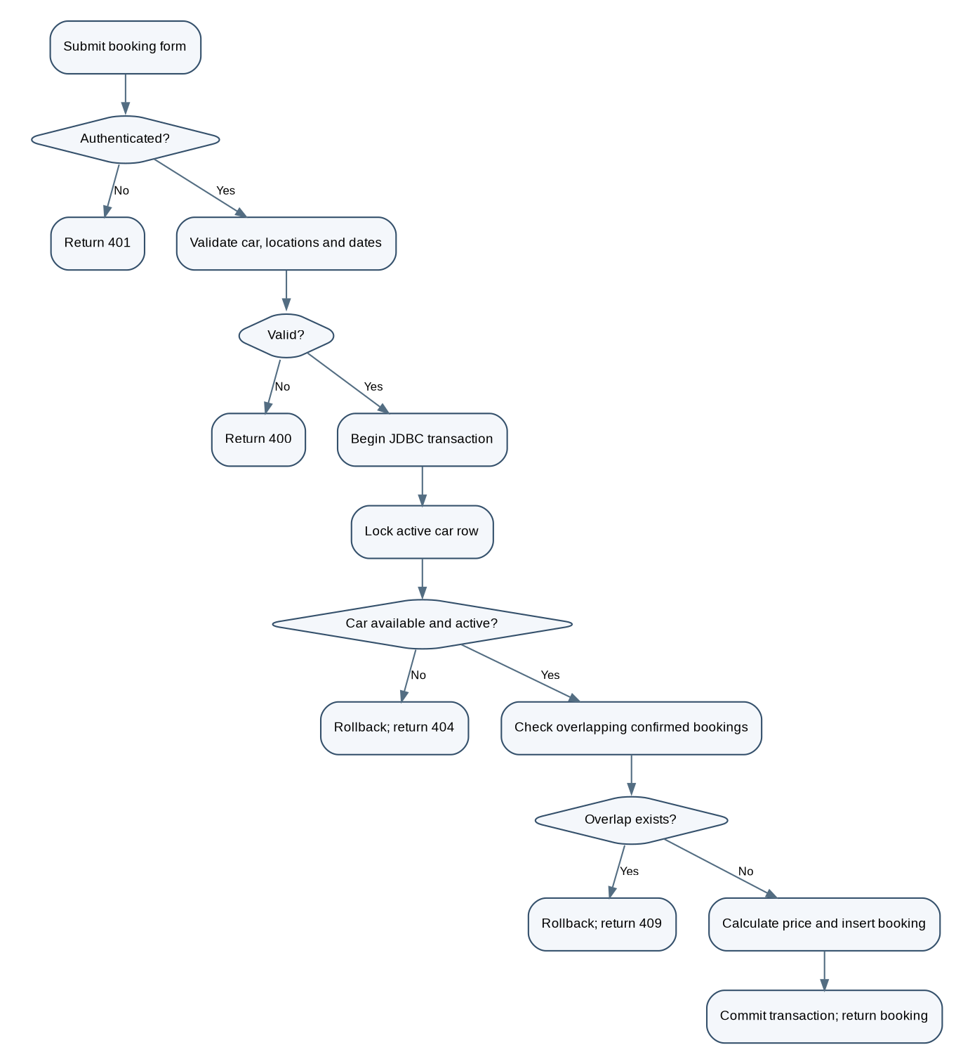
Figure 2. Booking validation and transaction flow.
The overlap predicate is: existing.pickup_date < requested.return_date AND existing.return_date > requested.pickup_date. This interval logic treats the return date as the end boundary, allowing one booking to begin on the same date another booking ends.

12.3 Example total-price calculation
rental_days = return_date - pickup_date
total_price = rental_days × cars.price_per_day

For example, a 3-day booking for a car costing ₹1,500 per day has a total of ₹4,500. The implementation computes the price on the server and saves it in BOOKINGS.total_price.

13. Functions, Procedures and Triggers: Current Status and Proposed Extensions
The supplied project executes SQL queries through JDBC, but database/schema.sql does not define custom stored functions, stored procedures or triggers. The report must not claim that these objects have already been implemented. The following are optional extensions that can be added and demonstrated if required by the evaluation rubric.

13.1 Proposed stored function: calculate rental amount
DELIMITER //
CREATE FUNCTION fn_rental_total(p_daily_rate INT, p_days INT)
RETURNS INT
DETERMINISTIC
BEGIN
RETURN p_daily_rate * p_days;
END//
DELIMITER ;

-- Example demonstration:
SELECT fn_rental_total(1500, 3) AS total_price; -- 4500

This example assumes positive daily rates and rental days have already been validated. It is a suggested extension, not part of the current schema.

13.2 Proposed stored procedure: booking summary
DELIMITER //
CREATE PROCEDURE sp_user_booking_summary(IN p_user_id INT)
BEGIN
SELECT status, COUNT(*) AS booking_count,
SUM(total_price) AS total_value
FROM bookings
WHERE user_id = p_user_id
GROUP BY status;
END//
DELIMITER ;

-- Example demonstration:
CALL sp_user_booking_summary(1);

This procedure returns counts and total recorded booking value by persisted status. It does not replace the Java dashboard, which also derives a completed status from return dates.

13.3 Trigger consideration
A trigger could audit status changes or enforce an additional row-level rule. However, a trigger alone is not a replacement for the transaction-level overlap check, because availability depends on other rows and concurrent requests. A safe future extension is a separate booking_audit table plus an AFTER UPDATE trigger that records a status transition; that would require adding the audit table and testing trigger behavior before claiming it as implemented.
-- Optional design sketch only; requires a booking_audit table first.
-- CREATE TABLE booking_audit (
-- audit_id BIGINT AUTO_INCREMENT PRIMARY KEY,
-- booking_id INT UNSIGNED NOT NULL,
-- old_status VARCHAR(20),
-- new_status VARCHAR(20),
-- changed_at DATETIME NOT NULL DEFAULT CURRENT_TIMESTAMP
-- );
--
-- DELIMITER //
-- CREATE TRIGGER trg_booking_status_audit
-- AFTER UPDATE ON bookings
-- FOR EACH ROW
-- BEGIN
-- IF OLD.status <> NEW.status THEN
-- INSERT INTO booking_audit(booking_id, old_status, new_status)
-- VALUES (OLD.id, OLD.status, NEW.status);
-- END IF;
-- END//
-- DELIMITER ;

14. Testing and Results

14.1 Existing automated tests
The supplied JUnit test class CoreConceptsTest.java checks email normalization, invalid email rejection and its HTTP-style validation status, the Vehicle/Car inheritance relationship, JSON fields produced by a car model, and rejection of fractional values where an integer is expected. These tests do not establish that all database workflows have been integration-tested.

14.2 Manual test plan
Test case | Procedure | Expected result
Registration | Register with valid name, unique email and password of at least 8 characters. | Account is stored and session starts.
Duplicate email | Register another account with the same email. | Request rejected as a conflict.
Login/logout | Log in with correct credentials, then log out. | Authenticated pages work before logout; session is cleared after logout.
Car filtering/sorting | Filter by SUV and sort by price ascending. | Only active SUVs appear in ascending rate order.
Valid booking | Book an active car for a future valid date range. | Confirmed booking saved; total calculated server-side.
Invalid dates | Use return date on/before pickup or pickup in the past. | Validation error; no booking inserted.
Overlapping booking | Attempt a second confirmed booking for same car with overlapping dates. | Conflict response; second booking is not inserted.
Adjacent booking | Set next pickup equal to previous return date. | Allowed if no other overlap exists.
Ownership check | Attempt to open another user’s booking ID. | Booking is not disclosed; not-found response.
Cancellation | Cancel an eligible future booking, then repeat cancellation. | First request updates status; repeated request is rejected.
Persistence | Restart server and inspect the account/bookings. | Records remain in MySQL.

14.3 Result interpretation
The source code implements the above rules, but the full manual test plan should be executed against the local MySQL instance before submission. The project README reports the expected startup messages “MySQL connected, tables ready.” and “DriveEase running at http://localhost:5000”; these are runtime indicators, not substitutes for recording actual test evidence.

15. Application of Codd’s Rules
Codd’s rules are included here as a brief relational-database discussion, following the structure of the sample report. They are not a formal certification of MySQL or DriveEase.
Rule / principle | Assessment for DriveEase
Information rule | Followed in principle: persistent business data is represented as values in relational tables.
Guaranteed access | Followed: rows and attributes can be accessed through SQL using keys and column names.
Systematic treatment of NULL | Partially relevant: phone is nullable to represent an unknown/not-provided phone; required fields are NOT NULL.
Active online catalog | Supported by MySQL metadata/catalog views; authorized users can inspect table definitions.
Comprehensive data sublanguage | SQL is used for schema definition and data manipulation; transaction handling is used in booking logic.
View updating | No custom SQL views are defined in the supplied schema; this rule is not directly demonstrated.
High-level insert/update/delete | Supported through SQL INSERT, UPDATE and DELETE statements.
Physical data independence | MySQL manages physical storage details, but physical changes were not specifically tested in this project.
Logical data independence | Not fully demonstrated: changing column names or API-facing fields may require code changes.
Integrity independence | Constraints are declared in the database, although some business rules are also enforced in Java.
Distribution independence | Not demonstrated; the project uses one local MySQL database.
Non-subversion | Prepared statements and server-side checks help protect data access, but full security certification is outside project scope.

16. Limitations and Future Enhancements

16.1 Current limitations observed in supplied files
- The project is configured for local demonstration and is not hardened for public internet deployment.
- The schema has no payment, invoice, vehicle maintenance, branch inventory, admin/staff or audit-log tables.
- Custom stored functions, stored procedures, triggers and custom SQL views are not present in the supplied schema.
- The About page displays contact information, but a support/ticket workflow is not implemented.
- The login page includes a “Forgot password?” link, but the supplied API routes do not implement an email-based password-reset workflow.
- Completed status is derived by Java from a confirmed booking whose return date has passed; the database enum stores only confirmed/cancelled.
- The available automated tests cover selected core concepts; full live-MySQL integration and concurrency testing should be performed separately.
- The frontend is browser-based. If the faculty requires a Java Swing/JavaFX GUI specifically, confirm whether this HTML/CSS/JavaScript interface satisfies that criterion.

16.2 Future enhancements
- Add payment and invoice records with payment status and transaction references.
- Add vehicle maintenance and branch/vehicle availability management.
- Add administrative tools for managing cars, prices, active status and bookings.
- Add an audit log for booking status and profile changes.
- Implement password reset using a secure, time-limited token and verified email delivery.
- Add database stored routines and trigger demonstrations if required by the assessment.
- Add integration tests for MySQL persistence, concurrent booking attempts and transaction rollback.
- Perform a deployment security review before hosting beyond localhost; configure HTTPS, secrets management, backups, logging and access controls.

17. Conclusion
DriveEase demonstrates a complete foundational database-backed workflow for a car rental service. Its schema separates users, cars, bookings and sessions; primary/foreign keys, uniqueness, date constraints and indexes support data integrity. The Java backend connects to MySQL through JDBC, uses prepared statements for data access, and applies transactional locking and interval-overlap checks to reduce the risk of conflicting reservations. The frontend provides the principal customer-facing pages for catalogue browsing, booking management and account settings.
The strongest database concepts demonstrated are relational modelling, key constraints, CRUD operations, functional dependencies, normalization, prepared statements and transaction-based booking validation. Before final submission, the team should fill in member/faculty details, run and document the manual tests, and clarify whether stored functions/procedures/triggers and a Java-native GUI are mandatory. Those database objects are described as proposed extensions here because they are not present in the supplied project code.

Appendix A: Demonstration Checklist
- Start MySQL and verify the configured database credentials.
- Start DriveEase and show the MySQL/server startup messages.
- Open the home page and demonstrate car catalogue filtering and sorting.
- Register a test account; log out and log back in.
- Show the profile page and update profile details/password using test data.
- Create a valid booking and explain the server-calculated total.
- Attempt an overlapping booking and show the conflict rejection.
- Open My Bookings, view booking details and cancel an eligible future booking.
- Show the USERS, CARS, BOOKINGS and SESSIONS tables and explain primary/foreign keys.
- Explain the ER diagram, functional dependencies, 1NF/2NF/3NF and anomaly prevention.
- Demonstrate the JUnit tests and, if implemented, any added SQL routines/triggers.

