This is a LibreOffice Writer File

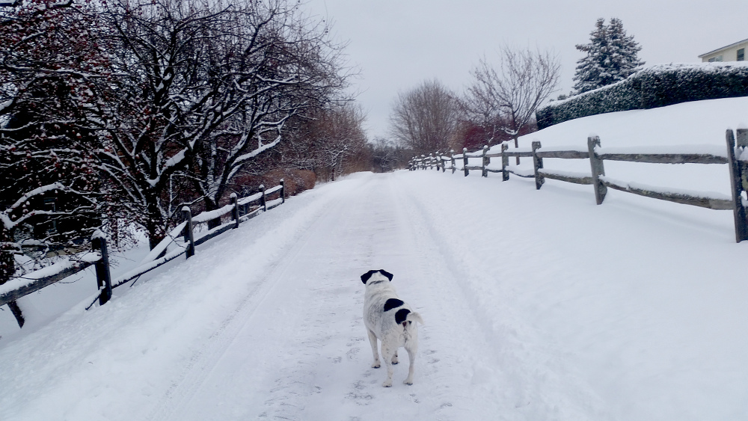
Gus on the rec path.

