**Assignment4.5**

**Problem Statement**:

A die marked A to E is rolled 50 times. Find the probability of getting a “D” exactly 5

Times

**Answer:**

Here, n = 50, x= 5, n - x = 45.

Binomial distribution

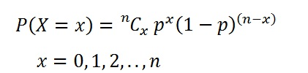

The probability of success = probability of getting a “D”= P = 1/5

Hence, the probability of failure = probability of not getting a “D” = 1 - p = 4/5

When we substitute these values in the formula for Binomial distribution we get,

P(X=5)=50C5(1/5)5(4/5)45

= 46*47*48*49*50

1*2*3*4*5 * (1/5)5(4/5)45

=678.0032*(0.8)45

**= 0.02953120431**