**Assignment4.4**

**Problem Statement**:

A test is conducted which is consisting of 20 MCQs (multiple choices questions) with every MCQ having its four options out of which only one is correct. Determine the probability that a person undertaking that test has answered exactly 5 questions wrong

**Answer:**

Binomial distribution

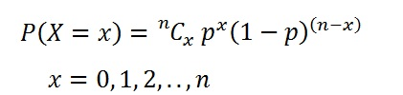

Here, n = 20, x = 5, n-x= 20 - 5 = 15

The probability of success = 1/4

The probability of failure = 1-1/4=3/4

When we substitute these values in the formula for Binomial distribution we get,

P(X=5)=20C5(1/4)15(3/4)5

= 16*17*18*19*20

1*2*3*4*5 * (1/4)15(3/4)5

= **0.0000034**

Thus the required probability is **0.0000034** approximately.