**Assignment5.3**

**Problem Statement:**

Calculate F Test for given 10, 20, 30, 40, 50 and 5,10,15, 20, 25. For 10, 20, 30, 40, 50:

**Answer:**

**Calculate Variance of first set**   
  
Total Inputs (N) =(10,20,30,40,50)   
Total Inputs (N)=5   
Mean   
 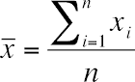

= 150/5   
 = 30   
standard deviation

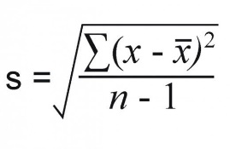  
=√ ((10-30)2+(20-30)2+(30-30)2+(40-30)2+(50-30)2)) /4  
=√((400)+(100)+(0)+(100)+(400))/4  
=√250  
=15.8114  
Variance=SD2   
Variance=250

**Calculate Variance of second set**Total Inputs(N) =(5,10,15,20,25)   
Total Inputs(N)=5   
Mean   
 

= 75/5   
 = 15  
standard deviation

  
  
=√(1/(5-1)((5-15)2+(10-15)2+(15-15)2+(20-15)2+(25-15)2)) /4  
=√((10)2+(-5)2+(0)2+(5)2+(10)2)) /4  
=√((100)+(25)+(0)+(25)+(100))/4  
=√62.5  
=7.9057   
Variance=SD2   
Variance=62.5

**To calculate F Test**   
F Test = (variance of 10, 20,30,40,50) / (variance of 5, 10, 15, 20, 25)   
= 250/62.5   
= 4.   
  
The F Test value is 4.