QUOTATIONS

Table of Contents:

1. **Document Control**
2. **Change Record**
3. **Reviewers**
4. **Introduction**

# **1. Document Control**

## 1.1 Change Record

|  |  |  |  |
| --- | --- | --- | --- |
| Date | Author | Revision | Change Reference |
| 20/06/2018 | M.Vamsidhar Reddy | 1.0 | POS |
|  |  |  |  |
|  |  | 1.2 |  |

## 1.2 Reviewers

|  |  |  |  |
| --- | --- | --- | --- |
| Name | Position | Reviewed Date | Remarks |
|  |  |  |  |
|  |  |  |  |

**Introduction:**

Quotations are documents sent to customers to offer an estimated cost for a particular set of goods or services. The customer can accept the quotation, in which case the seller will have to issue a sales order, or refuse it.

For example, my company sells electronic products and my client showed interest in buying **3 iPads** to facilitate their operations. I would like to send them a quotation for those iPads with a sales price of **32000 INR** by iPad with a **5%** discount.

This section will show you how to proceed.

## Configuration

### Install the Sales Management module

In order to be able to issue your first quotation, you'll need to install the **Sales Management** module from the app module

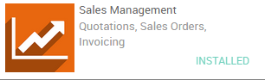

### Allow discounts on sales order line:

Allowing discounts on quotations is a common sales practice to improve the chances to convert the prospect into a client.

In our example, we wanted to grant with a **5%** discount on the sale price. To enable the feature, go into the **Sales** application, select **Configuration ‣ Settings** and, under **Pricing**, tick **Allow discounts on sales order line** (see picture below) and apply your changes.

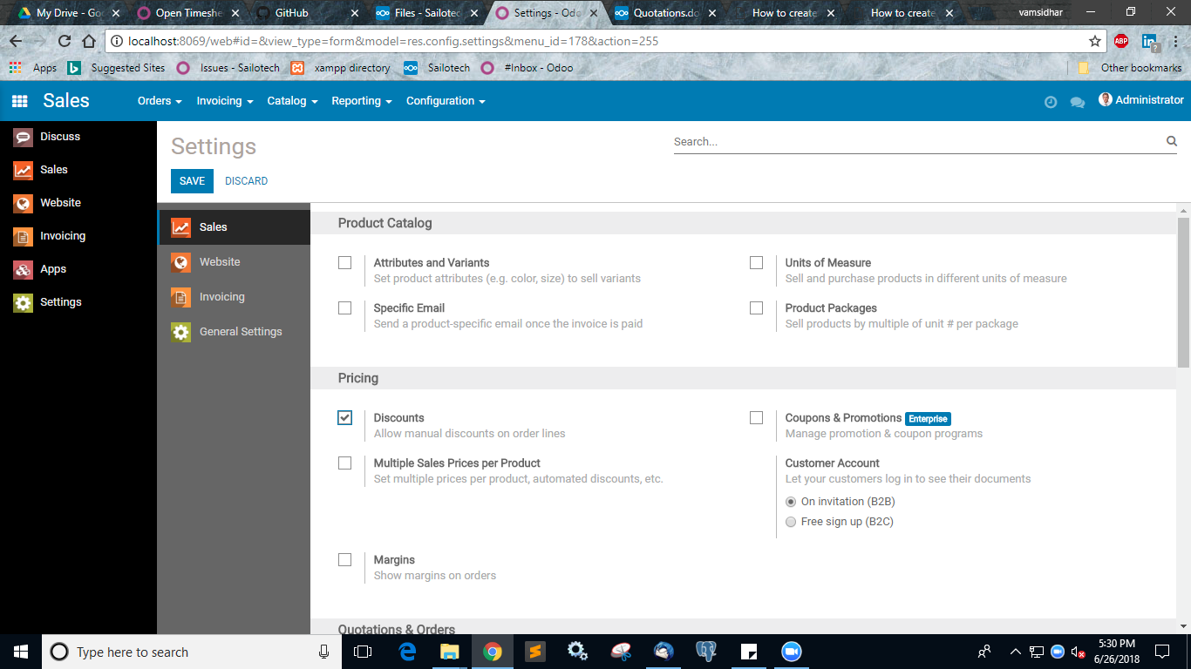

.



## Create your quotation

To create your first quotation, click on **Sales ‣ Quotations** and click on **Create**. Then, complete your quotation as follows:

### Customer and Products

The basic elements to add to any quotation are the customer (the person you will send your quotation to) and the products you want to sell. From the quotation view, choose the prospect from the **Customer** drop-down list and under **Order Lines**, click on **Add an item** and select your product. Do not forget to manually add the number of items under **Ordered Quantity** and the discount if applicable.