ABOUT CUSTOMER:-
1).

CREATE TABLE Customers
(
CustomerID INT PRIMARY KEY,
Name VARCHAR(50) NOT NULL,
Email VARCHAR(100) UNIQUE,
Address VARCHAR(100)
);

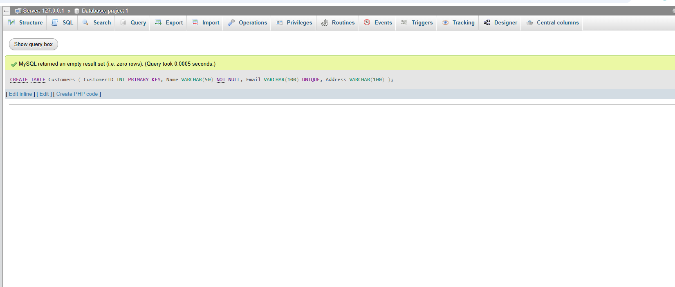

2)
INSERT INTO Customers (CustomerID, Name, Email, Address)
VALUES
(101, 'Alice Sharma', 'alice@gmail.com', 'Ahmedabad'),
(102, 'Rahul Patel', 'rahul@gmail.com', 'Surat'),
(103, 'Priya Shah', 'priya@gmail.com', 'Vadodara'),
(104, 'Riya Mehta', 'riya@gmail.com', 'Rajkot'),
(105, 'Jay Patel', 'jay@gmail.com', 'Anand');
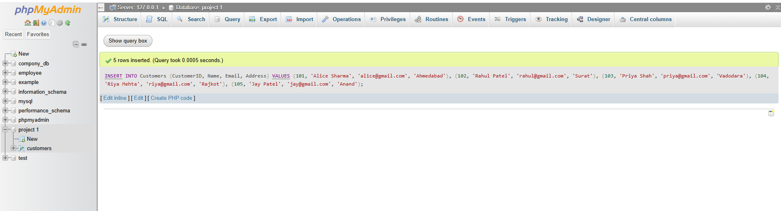

3)
SELECT * FROM Customers;
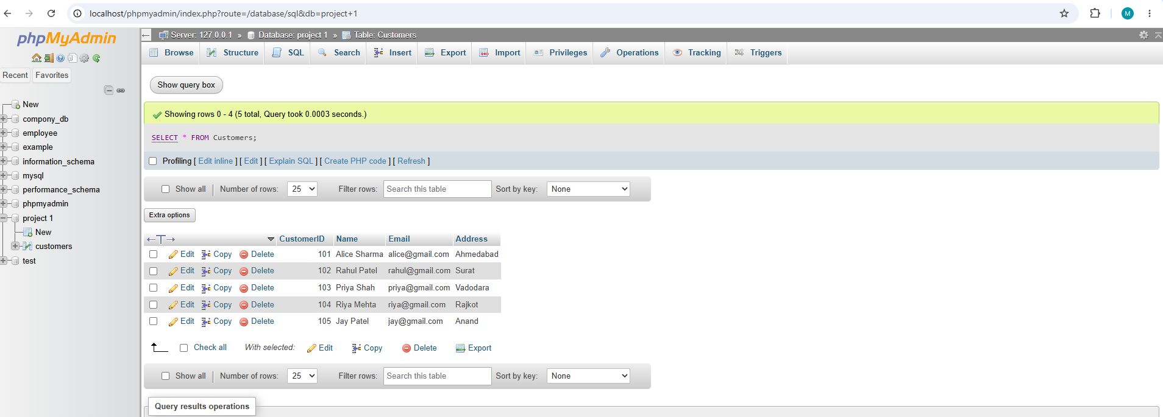

4)
UPDATE Customers
SET Address = 'Gandhinagar'
WHERE CustomerID = 101;
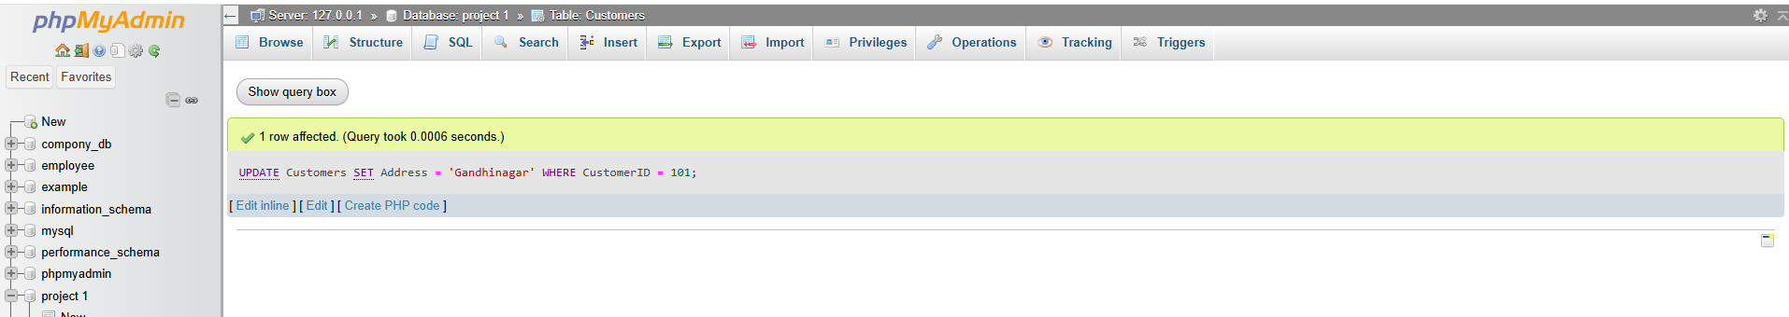

5)
DELETE FROM Customers
WHERE CustomerID = 105;
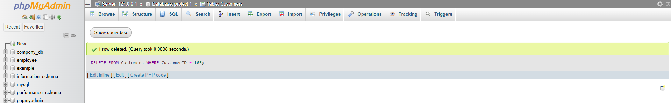
6)
SELECT * FROM Customers
WHERE Name = 'Alice Sharma';
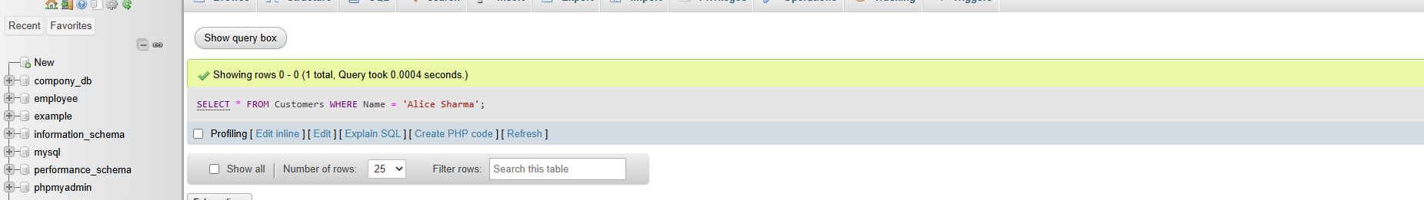

ORDER :-
1)
CREATE TABLE Orders
(
OrderID INT PRIMARY KEY,
CustomerID INT,
OrderDate DATE,
TotalAmount DECIMAL(10,2),
FOREIGN KEY (CustomerID)
REFERENCES Customers(CustomerID)
ON DELETE CASCADE
);
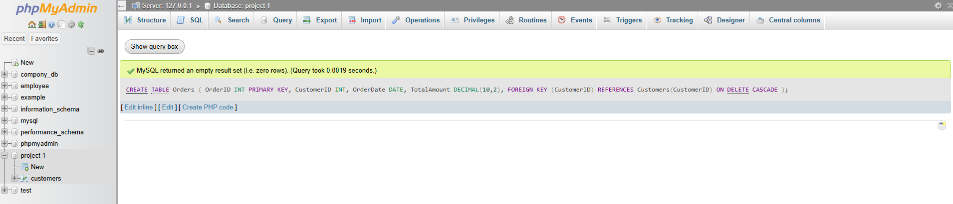
2)
INSERT INTO Orders (OrderID, CustomerID, OrderDate, TotalAmount)
VALUES
(1001, 101, '2026-09-01', 6000),
(1002, 102, '2026-09-05', 30000),
(1003, 101, '2026-09-10', 55000),
(1004, 103, '2026-09-15', 3500),
(1005, 104, '2026-09-20', 2500);
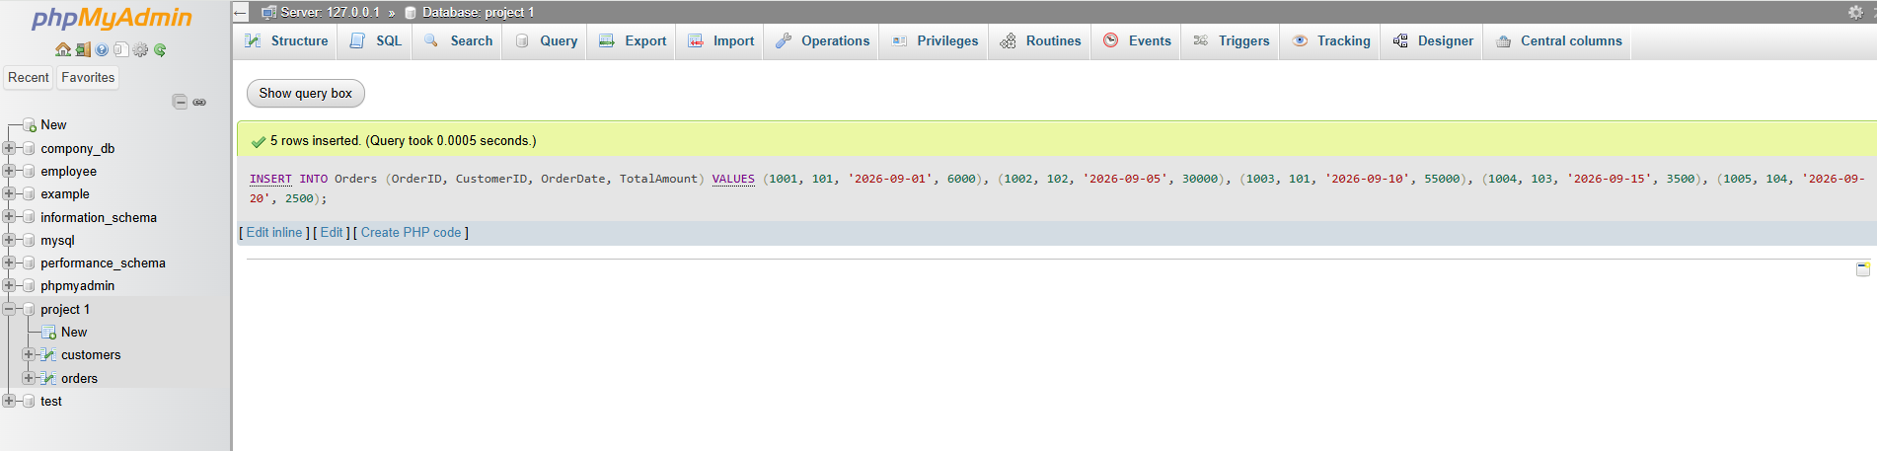
3) Retrieve all orders made by a specific customer
SELECT *
FROM Orders
WHERE CustomerID = 101;
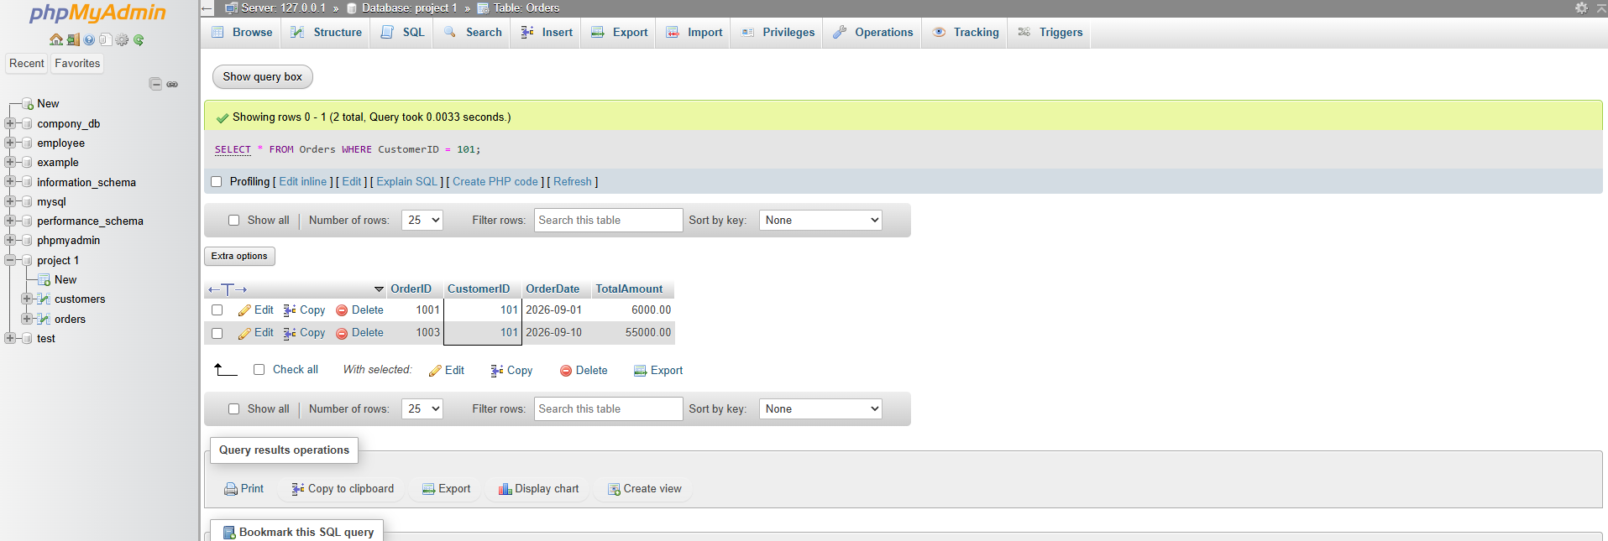
(4) Calculate overall total order amount
SELECT SUM(TotalAmount) AS Total_Order_Amount
FROM Orders;
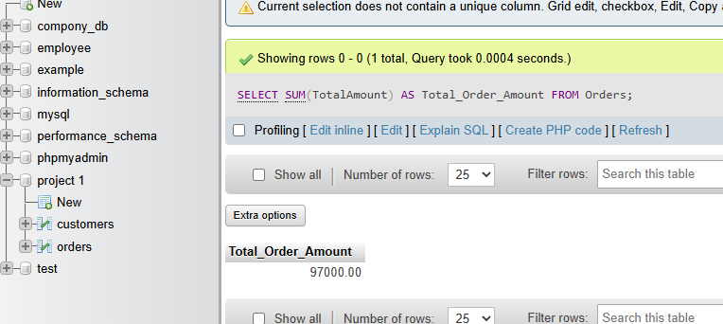
(5)
Delete an order using OrderID
DELETE FROM Orders
WHERE OrderID = 1005;
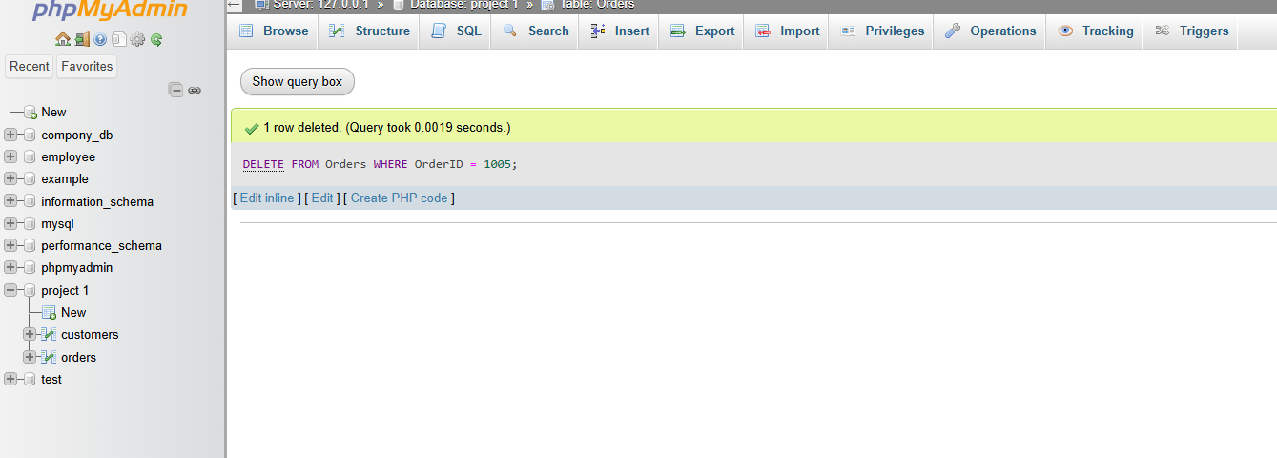

(6)
Retrieve orders placed in the last 30 days
SELECT *
FROM Orders
WHERE OrderDate >= CURDATE() - INTERVAL 30 DAY;
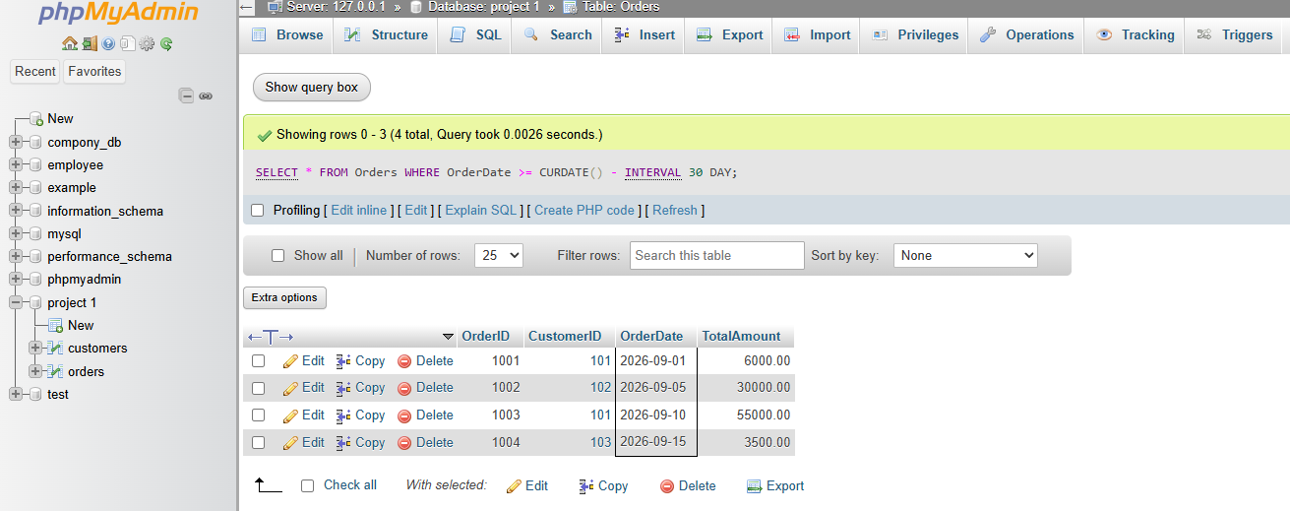
(7)
Find highest, lowest and average order amount
SELECT
MAX(TotalAmount) AS Highest_Order,
MIN(TotalAmount) AS Lowest_Order,
AVG(TotalAmount) AS Average_Order
FROM Orders;
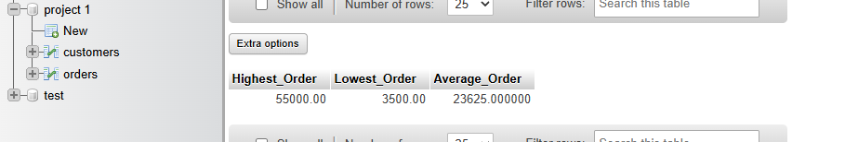

Products Table:-
(1)CREATE TABLE Products
(
ProductID INT PRIMARY KEY,
ProductName VARCHAR(100) NOT NULL,
Price DECIMAL(10,2),
Stock INT
);
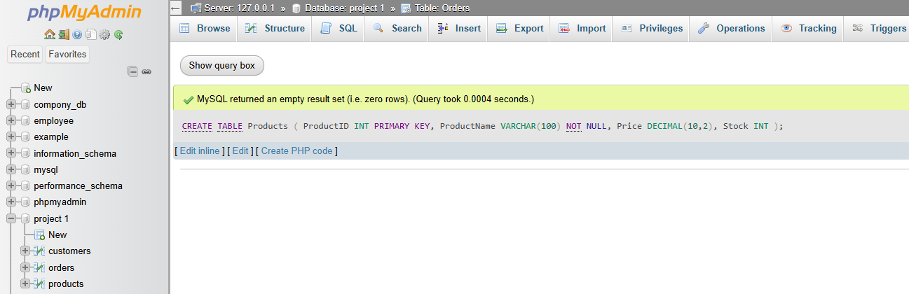

(2) INSERT INTO Products (ProductID, ProductName, Price, Stock)
VALUES
(201, 'Laptop', 55000, 10),
(202, 'Smartphone', 30000, 15),
(203, 'Headphones', 3500, 20),
(204, 'Keyboard', 2500, 25),
(205, 'Mouse', 1200, 0);
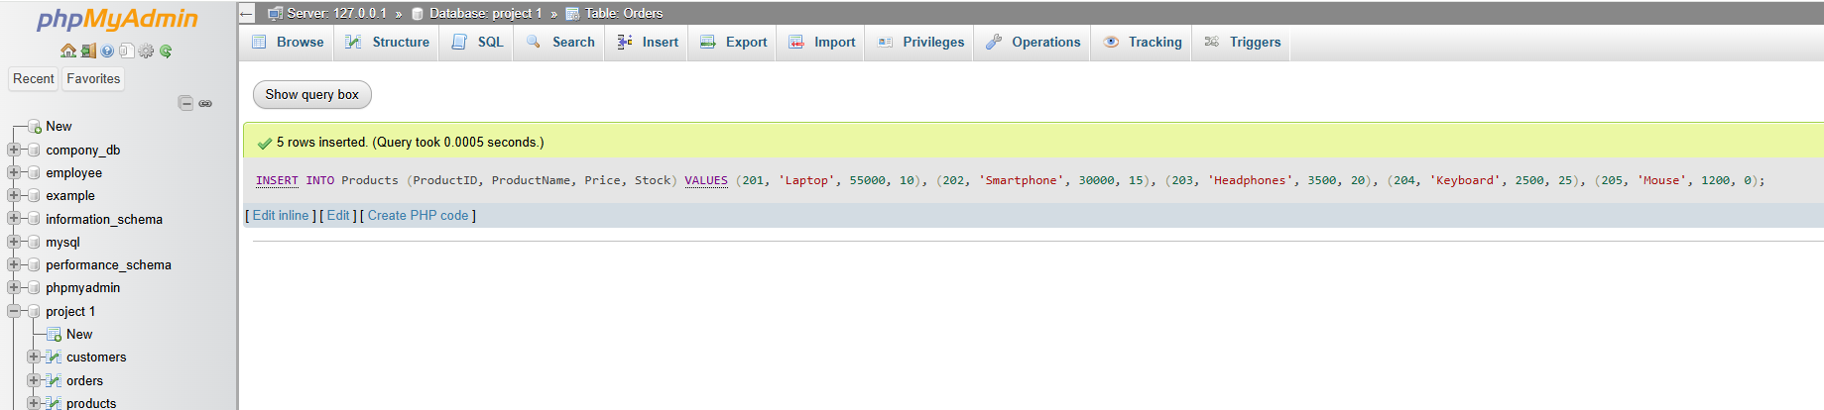

(3) )Retrieve products sorted by price in descending order
SELECT *
FROM Products
ORDER BY Price DESC;
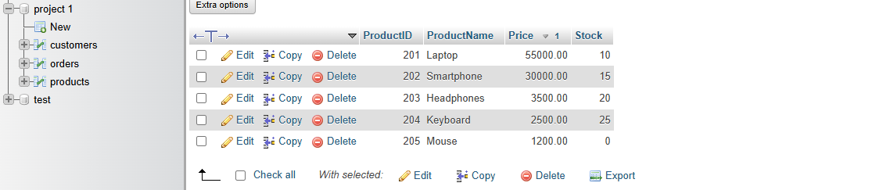

(4) Display price of a specific product
SELECT ProductName, Price
FROM Products
WHERE ProductName = 'Laptop';
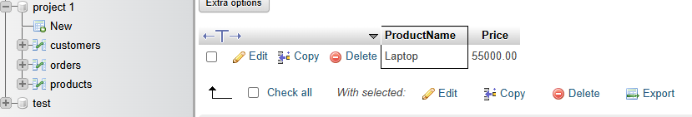
(5) Delete a product if it is out of stock
DELETE FROM Products
WHERE Stock = 0;
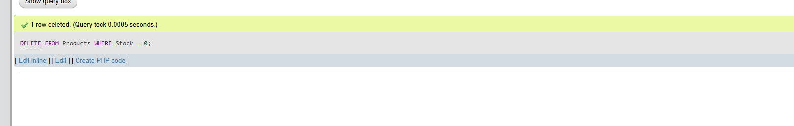
(6) Retrieve products whose price is between ₹2500 and ₹5000
SELECT *
FROM Products
WHERE Price BETWEEN 2500 AND 5000;
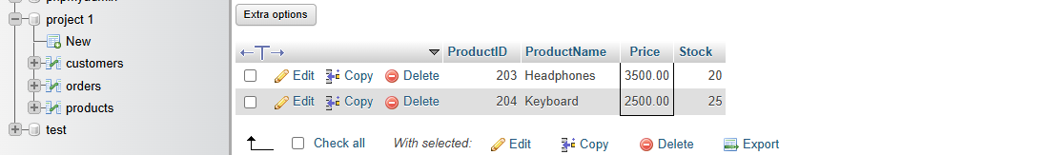
(7) Find the most expensive and cheapest product using MAX() and MIN()
SELECT
MAX(Price) AS Maximum_Price,
MIN(Price) AS Minimum_Price
FROM Products;
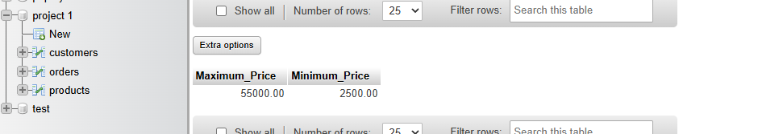

OrderDetails Table:-
(1)CREATE TABLE OrderDetails
(
OrderDetailID INT PRIMARY KEY,
OrderID INT,
ProductID INT,
SubTotal DECIMAL(10,2),

FOREIGN KEY (OrderID)
REFERENCES Orders(OrderID)
ON DELETE CASCADE,

FOREIGN KEY (ProductID)
REFERENCES Products(ProductID)
);
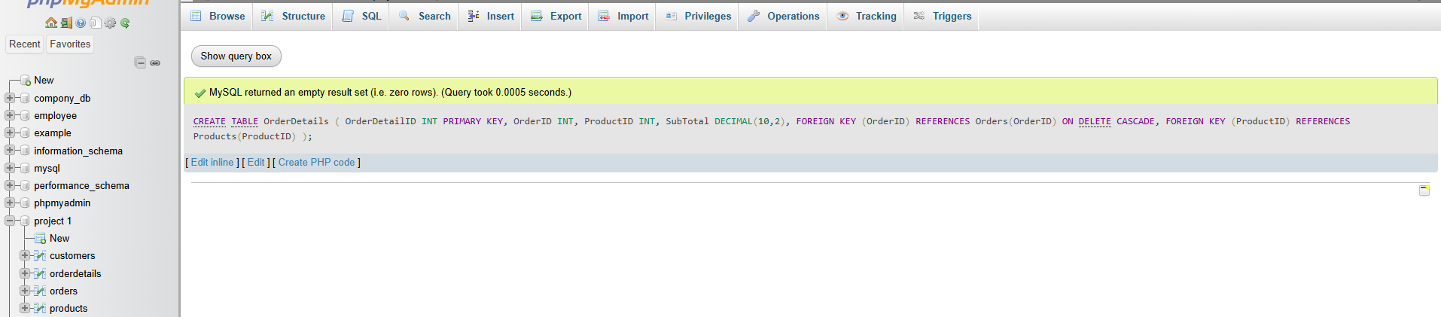
(2) INSERT INTO OrderDetails
(OrderDetailID, OrderID, ProductID, SubTotal)
VALUES
(1, 1001, 203, 3500),
(2, 1001, 204, 2500),
(3, 1002, 202, 30000),
(4, 1003, 201, 55000),
(5, 1004, 203, 3500);
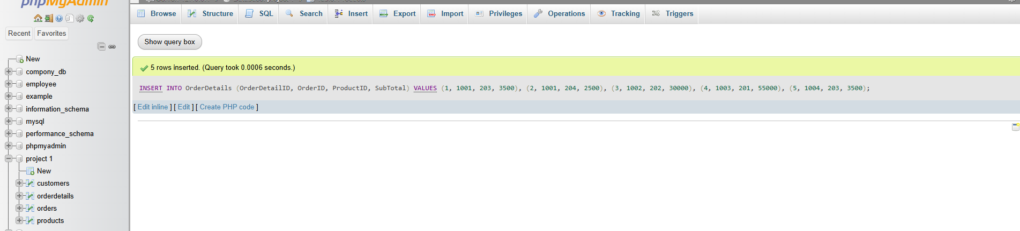
(3) Retrieve all order details for a specific order
SELECT *
FROM OrderDetails
WHERE OrderID = 1001;
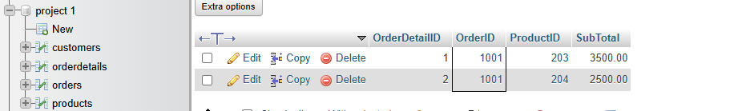
(4) Calculate total revenue generated from all orders
SELECT SUM(SubTotal) AS Total_Revenue
FROM OrderDetails;
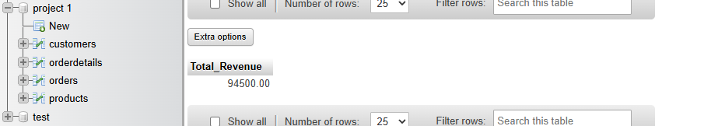

(5) Retrieve the top 3 most ordered products
SELECT
ProductID,
COUNT(*) AS Order_Count
FROM OrderDetails
GROUP BY ProductID
ORDER BY Order_Count DESC
LIMIT 3;
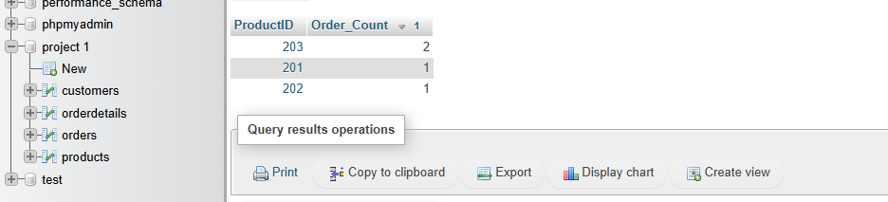

(6) Count how many times a specific product has been sold
SELECT
ProductID,
COUNT(*) AS Times_Sold
FROM OrderDetails
WHERE ProductID = 203
GROUP BY ProductID;
