I4IKN - Øvelse 7

Application Layer, Transport Layer, TCP/IP Socket Programming

|  |  |
| --- | --- |
| Jonas Lind | 201507296 |
| Tais Hjortshøj | 201509128 |

# Problemformulering

# Server

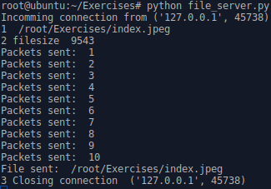

# Client

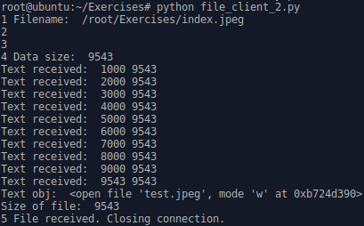

# Test



# Konklusion