Trade Flows Between India and Asia: Statistical & Business Insights
Python | 2015–2025

Source | indiadataportal.com — Export Trade Statistics
Link | https://indiadataportal.com/p/export-trade-statistics/r/mci-tradestat_export_lfy-cn-mn-asi
Timeline | 2015 – 2025
Domain | Commerce
Environment | Google Colab (Python, Pandas, NumPy, Matplotlib, Seaborn)

1. Executive Summary

This project analyses India’s exports to Asia between 2015–2025 using shipment-level data. The study applies descriptive statistics, seasonal analysis, and commodity categorization to uncover trade trends, top partners, and structural risks. Key findings highlight the dominance of Cosmetics & Personal Care, Western Asia as the largest market, recurring fiscal year-end and holiday peaks, and Central Asia’s minimal role.

2. Introduction & Industry Context

Asia is one of India’s largest trading regions. Understanding decade-long export flows provides insights into growth, partner concentration, and sectoral strengths. This project uses Python-based analytics to transform raw trade data into actionable intelligence for commerce and policy.

3. Problem Statement

Raw trade data is vast and noisy, with missing values and inconsistent formats. Without structured analysis, it is difficult to identify growth drivers, seasonal patterns, or market risks. This study builds a complete pipeline to convert raw shipment records into decision-ready insights.

4. Project Objectives

Track Trade and Export Trends Over the Years

Study how India's total trade and exports have changed from year to year, in order to understand whether trade is growing, shrinking, or staying steady over time.

Objective 1: Track Trade and Export Trends Over Time Analyse how India's total export value to Asian countries has changed month-by-month and year-by-year (2015–2025) to identify overall growth, decline, or stability in trade.

Objective 2: Identify Top Subregions by Export Revenue Determine Which Asian subregions (Western Asia, Eastern Asia, South-eastern Asia, Southern Asia, Central Asia) generate the highest export revenue for India, and quantify the gap between top and bottom performers.

Objective 3: Evaluate Geographic Trade Share Across Countries Identify India's top 10 and bottom 10 trading partner countries by export value, and assess how concentrated or diversified India's export revenue is across its Asian partners.

Objective 4: Uncover Monthly Trade Seasonality Across Years Examine seasonal patterns in export revenue using a year-by-month heatmap to detect recurring peaks (e.g., financial year-end surges) and anomalies (e.g., pandemic-driven drops).

Objective 5: Compare Unit Value Realization (Value/Quantity) Across Sectors Calculate and compare price-per-unit realization across commodity categories to distinguish high-margin, low-volume sectors from high-volume, low-margin bulk sectors.

Objective 6: Analyse Commodity Specialization Across Asian Subregions Map which commodity categories dominate exports to each Asian subregion, revealing regional specialization patterns in India's trade basket.

5. Tools & Technologies

Python, Pandas, NumPy, Matplotlib, Seaborn, Google Colab.

6. Methodology Framework

CRISP-DM lifecycle: Business Understanding → Data Preparation → EDA → Statistical Analysis → Visualization → Recommendations.

7. Data Pre-Processing & Feature Engineering

1. Standardized column names.

2. Cleaned units and commodity text.

3. Created COMMODITY_CATEGORY field (Food, Textiles, Apparel, Cosmetics, Pharmaceuticals, etc.).

4. Imputed missing values with medians.

5. Dropped redundant fields (VALUE_USD, REGION_CODE, SUBREGION_CODE).

8. Data Loading & Initial Inspection
- Dataset loaded from Google Drive: exports-to-asian-countries.csv
- Shape: 5,541,809 rows × 15 columns
- Columns: id, date, country_name, alpha_3_code, country_code, region_name, region_code, subregion_name, subregion_code, hs_code, commodity, unit, value_qt, value_rs, value_dl
- Nulls found: unit (5,868), value_qt (45,289), value_rs (24), value_dl (282,888)
- Duplicates: 0

9. Data Cleaning, Transformation & Feature Engineering
- Standardized column names to uppercase; renamed VALUE_QT → QUANTITY, VALUE_DL → VALUE_USD
- Converted DATE to datetime
- Cleaned inconsistent unit labels (e.g., "Kg" → "Kgs", "Cum" → "Cbm")
- Cleaned messy commodity text (spacing, abbreviations like "Mlk"→"Milk", "Pwdr"→"Powder")
- Engineered a new COMMODITY_CATEGORY field via regex pattern-matching into groups: Food & Agriculture, Paper & Paper Products, Tobacco, Rubber & Tyres, Textiles & Fabrics, Apparel & Garments, Cosmetics & Personal Care, Leather & Travel Goods, Plastics, Wood & Wooden Products, Packaging, Jewellery & Accessories, Stationery, Pharmaceuticals, Medical & Healthcare Equipment, Agriculture & Plantation, Other
- Missing QUANTITY and VALUE_RS imputed with median
- Dropped VALUE_USD, REGION_CODE, SUBREGION_CODE

10. Statistical Analysis & Visualizations

Central Tendency & Dispersion
- Quantity: Mean 54,876.85 | Median 3.00 | Mode 0.00 → strongly right-skewed
- Value_RS: Mean 130.56 | Median 2.82 | Mode 0.00 → strongly right-skewed
- Quantity Std Dev: 3,926,595.81 | Variance: ~15.4 trillion
- Value_RS Std Dev: 3,051.99 | Variance: ~9.3 million

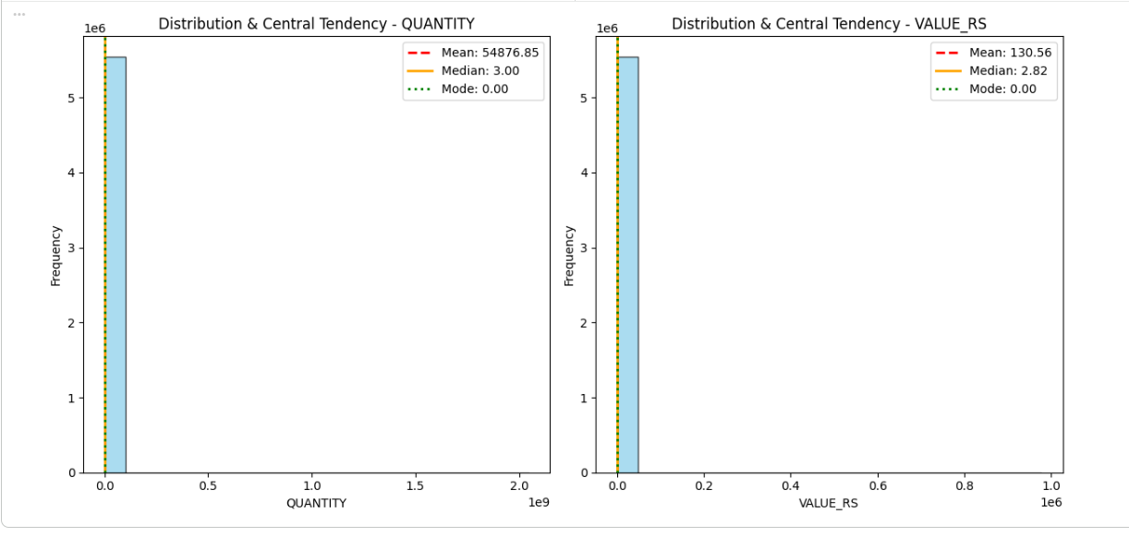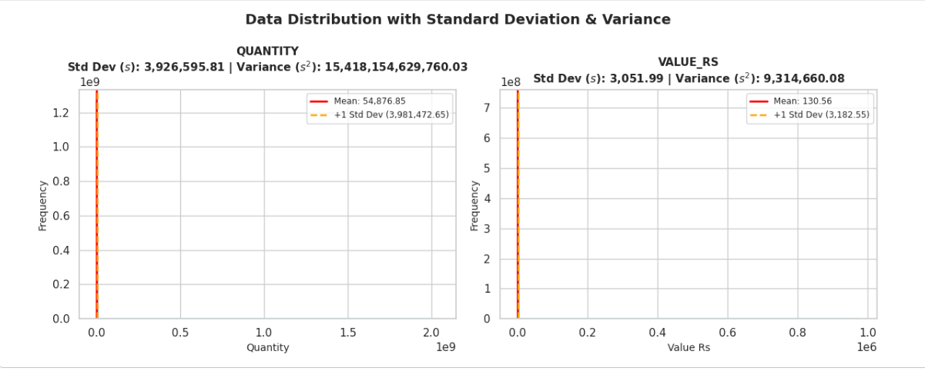

Objective 1 — Monthly Seasonality (Aggregated Across All Years)
- Peak: December (₹66,362,788) and March (₹66,156,038) — tied to fiscal year-end (March) and global holiday demand (December)
- Lowest: April (₹55,404,467) — post-fiscal-year reset
- Mid-year dip through June–August, rebound in September
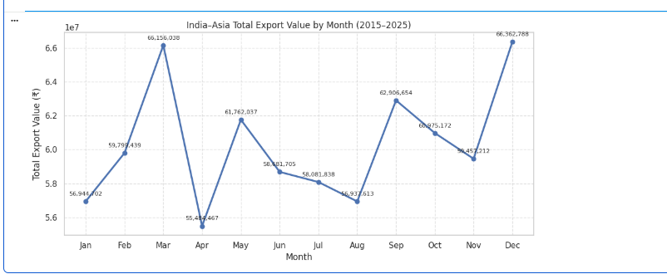

Objective 2 — Top Subregions by Export Revenue
- Western Asia: ₹247.8M (largest, led by UAE)
- Eastern Asia: ₹190.9M
- South-eastern Asia: ₹159.4M
- Southern Asia: ₹123.2M
- Central Asia: ₹2.3M (far smallest)
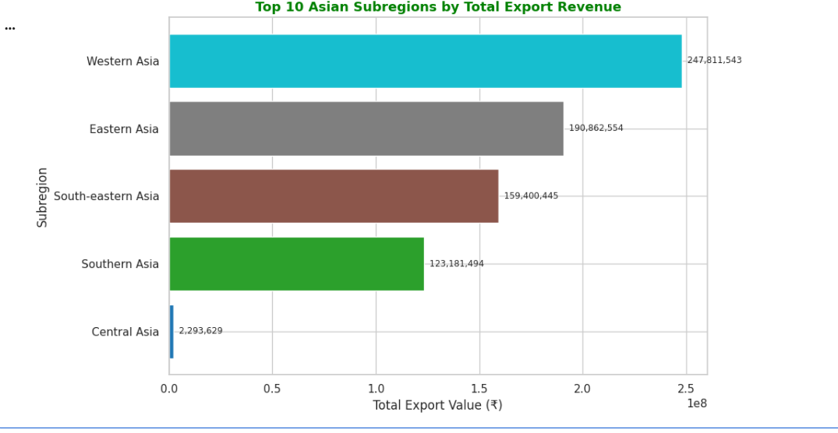

Objective 3 — Country-wise Trade Share
- Top 10: UAE (26.5%), China (15.0%), Hong Kong (11.9%) lead; together >53% of top-tier revenue
- Bottom 10: Armenia, North Korea, Kyrgyzstan, Lao PDR dominate the lower tier; Palestine (0.5%) and Turkmenistan (0.2%) are smallest

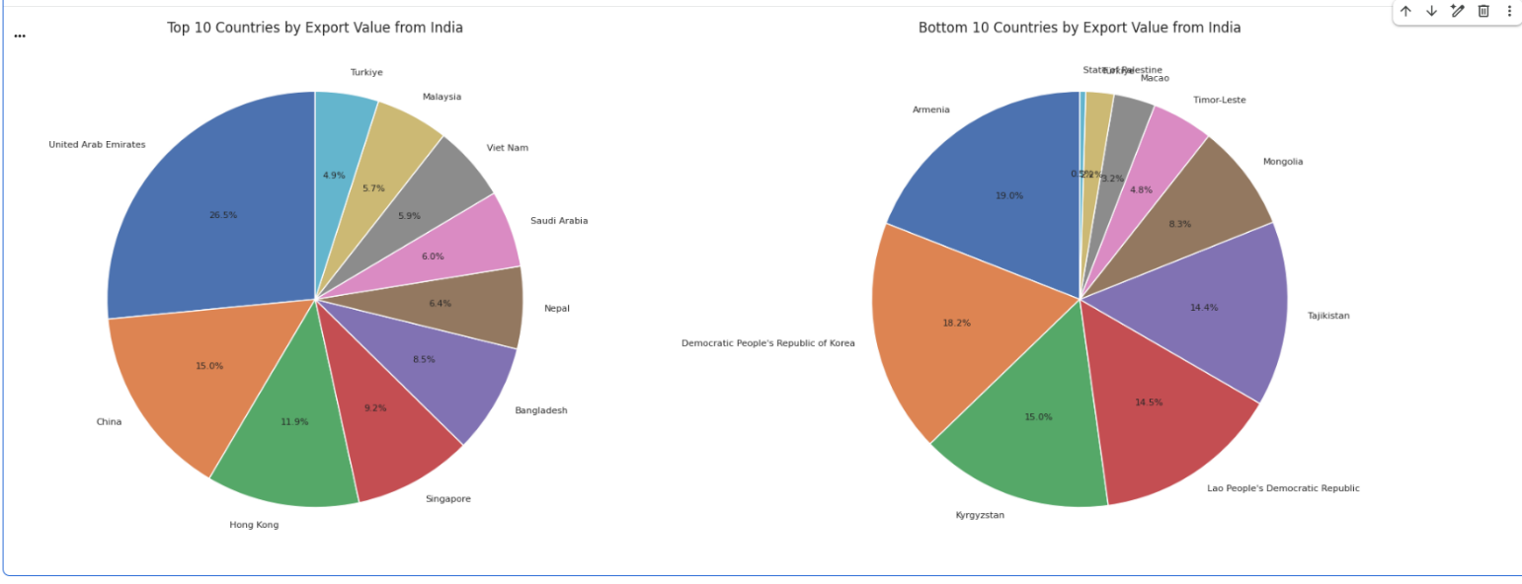

Objective 4 — Year-by-Year Seasonality Heatmap
- Confirms recurring "March surge" (notably 2017, 2019, 2021)
- 2021 identified as the peak year overall, with December 2021 the single highest month in the decade
- April 2020 stands out as a sharp anomaly (COVID-19 trade shutdown)
- Data thins / drops off from 2024 onward

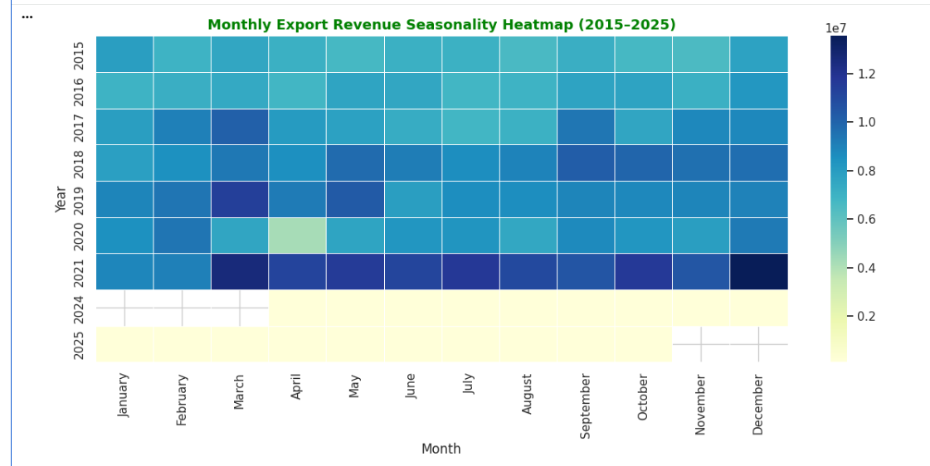

Objective 5 — Unit Price Realization by Sector
- Pharmaceuticals show widest price spread (up to ~₹122/unit) due to mix of generics and specialized drugs
- Wood & Wooden Products and Medical & Healthcare Equipment also show high upper-range values
- Plastics, Packaging, Stationery, Agriculture & Plantation cluster near ₹0–10/unit (bulk, low-margin goods)
- Jewellery & Accessories and Cosmetics & Personal Care show moderate, stable pricing

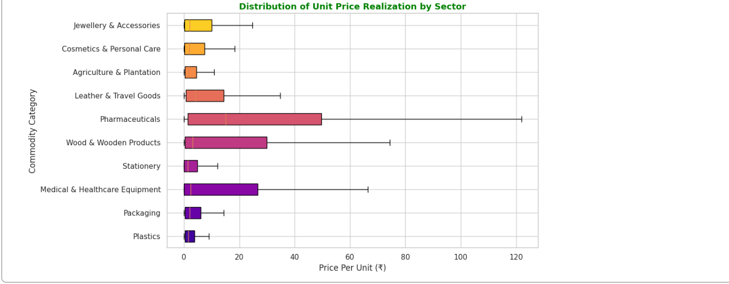

Objective 6 — Commodity Specialization by Subregion
- Cosmetics & Personal Care dominates exports, contributing the majority of revenue across Eastern, South-eastern, Southern, and Western Asia.
- Western Asia is the largest overall market, with the biggest share in Cosmetics & Personal Care, making it the strongest subregion-commodity pairing.
- India exports all 10 commodity categories to all 5 subregions, showing broad market presence despite revenue concentration in consumer care products.
- Central Asia remains a minor market, with consistently small export volumes across all categories compared to other regions.
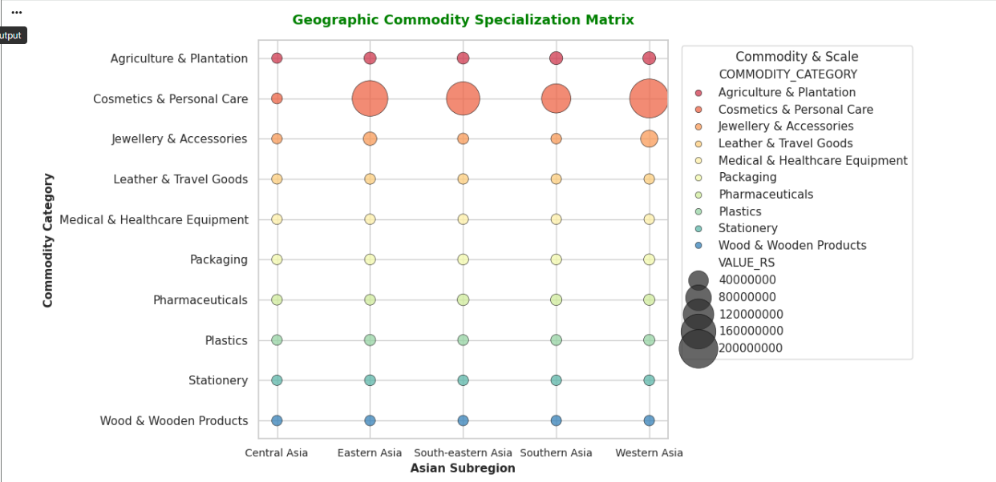

9. Four-Layer Analytics Interpretation
- Descriptive — What Happened: The analysis confirms that Western Asia dominates India’s export landscape, accounting for the largest share of trade revenue. Within commodities, Cosmetics & Personal Care clearly leads, dwarfing other categories in both transaction count and value. This establishes the baseline picture: India’s exports are concentrated in one sector and one region.
- Diagnostic — Why It Happened: The recurring peaks in March and December are explained by fiscal cycles (March year-end targets) and global consumer demand (December holiday season). Meanwhile, Central Asia consistently underperforms due to limited market size and weaker trade corridors. These diagnostic insights highlight structural drivers behind the observed patterns.
- Predictive — What Will Happen: Given the skewed distributions and high variance, the dataset suggests that mega-deals will continue to dominate overall revenue. A handful of large transactions will disproportionately influence averages, meaning future trade performance will remain vulnerable to fluctuations in these big-ticket deals.
- Prescriptive — What Should Be Done: To mitigate risks, India should diversify into underpenetrated subregions such as Northern and Eastern Asia. Policymakers and exporters must protect single-category corridors (e.g., cosmetics, pharmaceuticals) from supply chain shocks. Additionally, logistics segmentation should be strengthened to handle high-value, low-volume shipments differently from bulk, low-margin goods.

10. Key Findings — Consolidated
- Cosmetics & Personal Care is the largest category, contributing the majority of export revenue across Asia.
- Western Asia is the biggest market, while Central Asia remains negligible in trade volume and value.
- Seasonal peaks occur in March and December, with consistent dips in April due to fiscal resets.
- Pharmaceuticals and healthcare equipment show high price spreads, reflecting both generic and specialized product exports.
- COVID-19 caused a sharp anomaly in April 2020, with exports collapsing temporarily before recovery.
11. Business Recommendations
- Expand into Northern & Eastern Asia: Reduce reliance on Western Asia by building stronger trade corridors with underpenetrated regions.
- Strengthen supply chain protections: Safeguard narrow corridors like cosmetics and pharmaceuticals against disruptions by diversifying suppliers and logistics routes.
- Segment logistics operations: Route high-value, low-volume shipments through premium channels, while bulk goods continue via cost-efficient freight.
- Automate anomaly detection: Implement real-time monitoring systems to flag sudden shocks (like COVID-19) and enable faster response.

12. Conclusion
India’s exports to Asia are structurally concentrated in Cosmetics & Personal Care and Western Asia, creating both opportunities and risks. While the export basket is diversified across categories, revenue is skewed by a few large transactions. This concentration makes trade performance highly sensitive to mega-deals and regional demand cycles. To ensure resilience, India must strategically diversify markets, protect vulnerable corridors, and modernize logistics and monitoring systems. Doing so will strengthen India’s position in Asia and reduce exposure to external shocks

