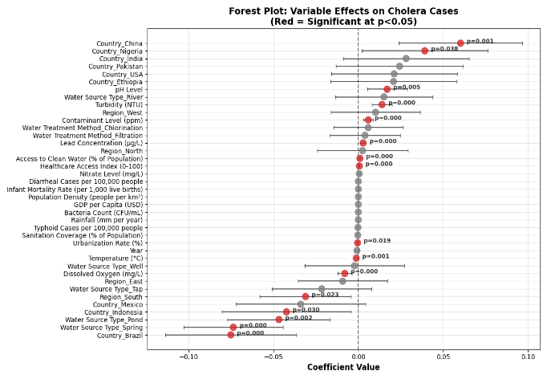

**B**

**A**

**C**