实验名称 实验3 复杂网络的度相关性

一、实验内容及结果
1、给定网络1tux400.csv，计算节点的余平均度< knn >i、度同配系数，余平均度< knn >(k)
2、画出< knn >(k)-k图，条件概率分布图（参考教材P126图4-5）

源代码：
Task1:
import numpy as np
import networkx as nx
import pandas as pd
import matplotlib.pyplot as plt
df= pd.read_csv("D:/Netdata/ex3/1tux400.csv")
G=nx.from_pandas_edgelist(df,'source','target','weight',create_using=nx.Graph())
print("节点度为；",nx.degree(G,weight="weight"))
print("余平均度<knn>i为:",nx.average_neighbor_degree(G,weight="weight"))
print("网络的度同配系数为：",nx.degree_assortativity_coefficient(G,weight="weight"))
nx.draw(G,node_size=50,with_labels=True)
plt.show()
num_nodes = G.number_of_nodes()

def average_nearest_neighbor_degree(G):
w_gd = dict(nx.degree(G, weight="weight"))

k = set(degree for node, degree in w_gd.items())
sorted_k = sorted(k)

k_nn_k = []
for ki in sorted_k:
c = 0
k_nn_i = 0
for i in G.nodes():
if w_gd[i] == ki:
total_weighted_degree = sum([G[i][j]['weight'] * w_gd[j] for j in list(nx.all_neighbors(G, i))])
k_nn_i += total_weighted_degree / ki
c += 1
if c != 0:
k_nn_k.append(k_nn_i / c)
else:
k_nn_k.append(0)

return sorted_k, k_nn_k

r=nx.degree_assortativity_coefficient(G,weight="weight")
x,y=average_nearest_neighbor_degree(G)
for x, y in zip(x, y):
print("度为 {} 的节点余平均度是 {}".format(x, y))

Task2:
x,y=average_nearest_neighbor_degree(G)
plt.figure(figsize=(12,4))
plt.plot(x,y,'ro')
plt.legend(loc=0)
plt.xlabel("$k$")
plt.ylabel("$k_{nn}()")
plt.xscale("log")
plt.yscale("log")
plt.xlim([0,52])

def calculate_conditional_probability(G):
conditional_prob = {}

w_gd = dict(nx.degree(G, weight="weight"))
k_values = set(w_gd.values())

for k in k_values:
p_k_prime = {}
for node, degree in w_gd.items():
if degree == k:
neighbors = list(G.neighbors(node))
neighbor_degrees = [w_gd[neighbor] for neighbor in neighbors]
total_neighbor_weighted_degree = sum([G[node][neighbor]['weight'] * w_gd[neighbor] for neighbor in neighbors])
for neighbor, neighbor_degree in zip(neighbors, neighbor_degrees):
if neighbor_degree in p_k_prime:
p_k_prime [neighbor_degree] += (G[node][neighbor]['weight'] * w_gd[neighbor]) / total_neighbor_weighted_degree
else:
p_k_prime [neighbor_degree] = (G[node][neighbor]['weight'] * w_gd[neighbor]) / total_neighbor_weighted_degree

conditional_prob[k] = {k_prime: p_k_prime [k_prime] for k_prime in sorted(p_k_prime.keys())}

return conditional_prob

conditional_prob = calculate_conditional_probability(G)
conditional_prob

from scipy.interpolate import interp1d
def plot_conditional_probability(conditional_prob):
for k, p_k_prime in conditional_prob.items():
degrees = list(p_k_prime.keys())
probabilities = list(p_k_prime.values())
if k in [6, 18, 29, 46]:
# if k in [6]:
degrees = list(p_k_prime.keys())
probabilities = list(p_k_prime.values())
f = interp1d(degrees, probabilities, kind='cubic')
x_interp = np.linspace(min(degrees), max(degrees), 1000)
y_interp = f(x_interp)
plt.plot(x_interp, y_interp, label=f"k={k}", linewidth=2)
# plt.plot(degrees, probabilities, label=f"k={k}")
# for x, y in zip(degrees, probabilities):
# plt.text(x, y, f'({x}, {y:.2f})', fontsize=8, verticalalignment='bottom')

plt.xlabel(' k\'')
plt.ylabel('P(k\' | k)')
plt.legend()
plt.grid(True)
plt.show()

plot_conditional_probability(conditional_probabilities)

运行结果（截图）：
Task1:
余平均度<knn>i:
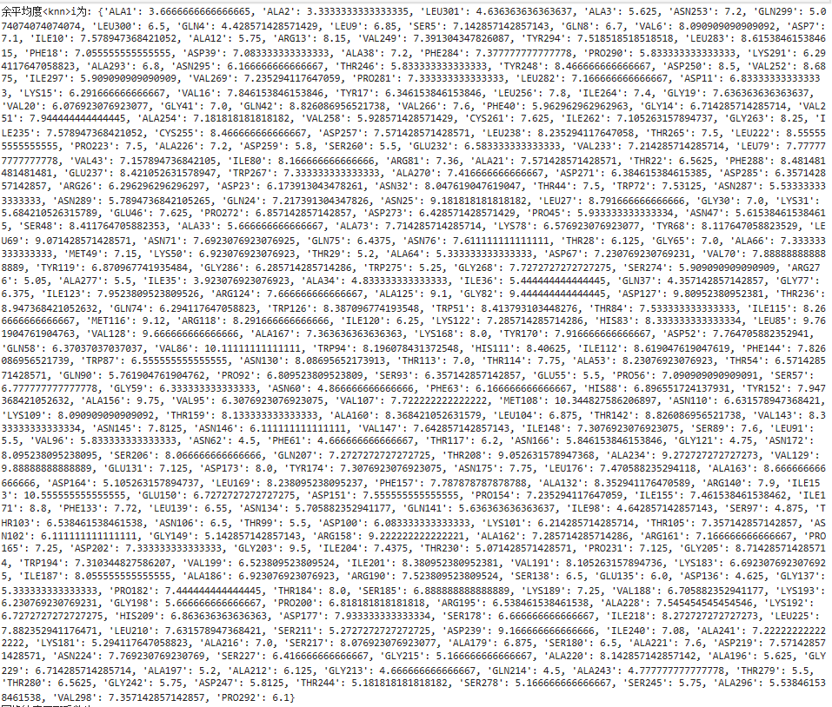
共301个节点，每个节点所有邻居节点的平均度为余平均度<knn>i；对于此数据集，所有度的计算都要考虑权重。

度同配系数：
网络度同配系数为0.2，代表节点倾向连接具有相似度的节点，但同配趋势不十分强烈。

余平均度<knn>(k):
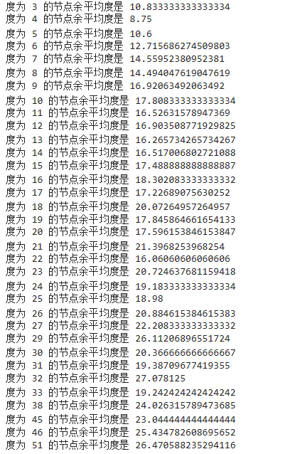

将网络中所有节点可能的度按序排列，共34种，余平均度<knn>(k)是对度相同的节点的<knn>i再次取平均。

Task2:
<knn>(k)-k: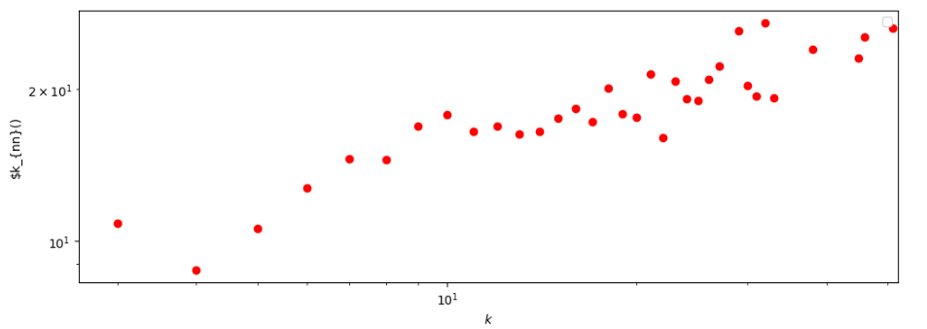
<knn>(k)图像如上图所示，可以看出递增趋势，表明网络具有一定程度的同配性质。

K=[6,18,29,46]时的P(K’|K):
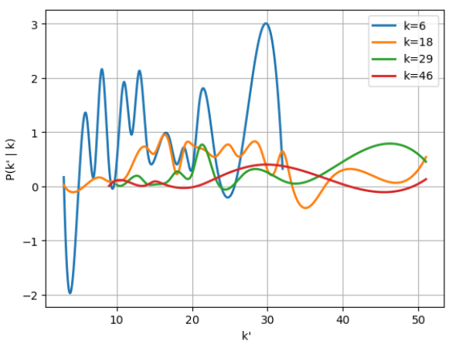
从34个可能取值的K中选取其中4个绘制图像，任意改变K值，可以获得不同K下的条件概率。

K=6时的条件概率及图像：
：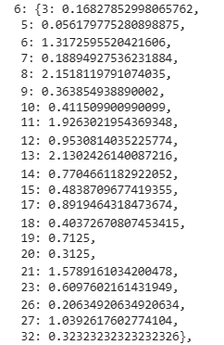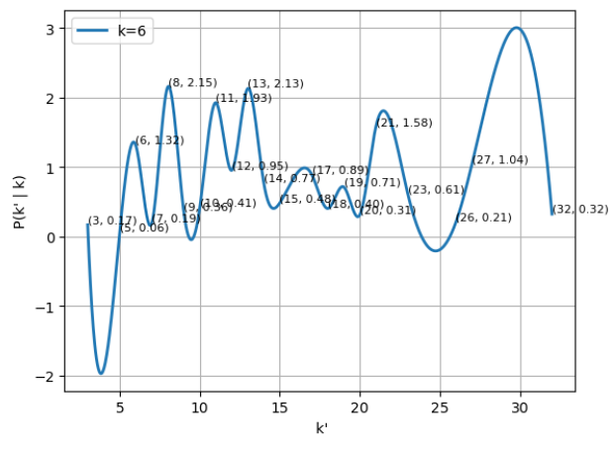
K=6时，所有度为6节点邻居节点可能的度和出现概率如上，图像通过插值方法连接离散点绘制形成。

