复化求积实验报告
██████ ██████████ ██
代码：
#include <stdio.h>
#include <math.h>
double CTR(int n, double a, double b, double (*f1)(double)) {
double h = (b - a) / n;
double F = 0;
double T;

for (int i = 1; i <= n-1; i++) {
double x = a + i * h;
F += 2 * f1(x);
}

T = (h / 2) * (f1(a) + f1(b) + F);
return T;
}

double CSR(int n, double a, double b, double (*f2)(double)) {
double h = (b - a) / n;
double F = 0;
double F1 = 0;
double F2 = 0;
double S;

for (int i = 1; i < n; i++) {
double x = a + i * h;
if (i%2==0)
{F1 += 2 * f2(x);}
else
{F2 += 4 * f2(x);}
}
F=F1+F2;
S = (h / 3) * (f2(a) + f2(b) + F);
return S;
}

double f1(double x) {
return 1 / (1 + sin(x) * sin(x));
}
double f2(double x) {
return x * log10(x);
}

int main() {
int n = 10;
double a = 0.0;
double b = 1.0;
printf("f1的复合梯形公式积分为：%12.9e\n", CTR(n, a, b, f1));
printf("f1的复合Simpson公式积分为：%12.9e\n", CSR(n, a, b, f1));

int n1 = 8;
double a1 = 1.0;
double b1 = 2.0;
printf("f2的复合梯形公式积分为：%12.9e\n", CTR(n1, a1, b1, f2));
printf("f2的复合Simpson公式积分为：%12.9e\n", CSR(n1, a1, b1, f2));
return 0;
}

运行结果：
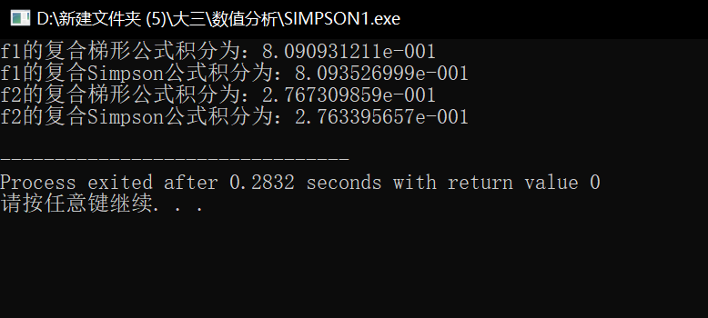
MATLAB检验:
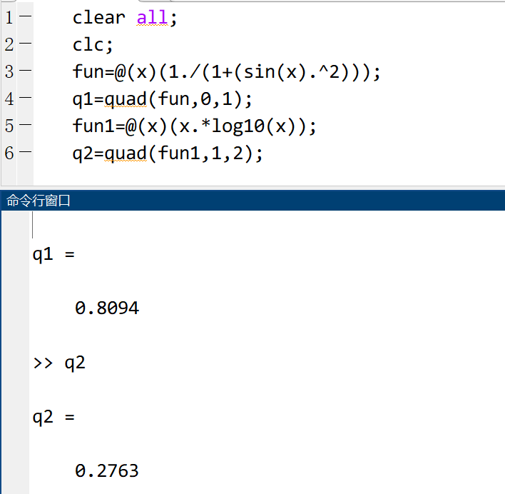

由检验结果可知，所编程序复合梯形公式与复合Simpson公式积分结果均有较高精确度，且复合Simpson公式更为精确。

