四阶Runge-Kutta方法求常微分数值解报告
██████ ██████████ ██
代码：
#include <stdio.h>
#include <math.h>

double f(double x, double y);

double RK4(double (*f)(double, double), double a, double b, double y0, int N, FILE *outfile) {
double h = (b - a) / N;
double x_0 = a;
double y_0 = y0;
double x, y;

for (int i = 0; i < N; ++i) {
double K1 = f(x_0, y_0);
double K2 = f(x_0 + h / 2, y_0 + h * K1 / 2);
double K3 = f(x_0 + h / 2, y_0 + h * K2 / 2);
double K4 = f(x_0 + h, y_0 + h * K3);
y = y_0 + h * (K1 + 2 * K2 + 2 * K3 + K4) / 6;
x_0 += h;
y_0 = y;
fprintf(outfile, "%lf %lf\n", x_0, y_0);
}
}

int main() {
FILE *outfile=fopen("out.txt","w");
int N;
double a,b,y0;
a=0.0;b=2.0;
y0=0.5;
N=10;
RK4(f,a,b,y0,N,outfile);
fclose(outfile);
}

double f(double x, double y) {
return y - pow(x, 2) + 1;
}

结果：
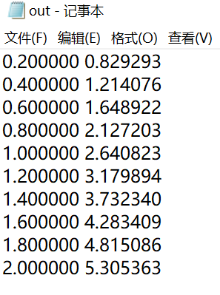

Matlab验证：
clear all;
clc;
options=odeset('Reltol',1e-4,'Refine',1,'Maxstep',0.2);
[x,y]=ode45(@(x,y)y-x^2+1,[0 2],0.5,options)
ANSWER(:,1)=x(:,1);
ANSWER(:,2)=y(:,1);

