DAY8
SESSION ASSIGNMENTS

1.When to use (Rapid Application Development) RAD model
When not to use (Rapid Application Development) RAD model

When to use RAD model?:-

The Rapid Application Development(RAD) model,also called as

prototyping model is a leading SDLC model which is recommended to use in

the following cases;

- RAD should be used when there is a need to create a system that can be modularized in 2-3 months of time.
- It should be used if there’s high availability of designers for modeling .

- It should be used if the budget is high enough to afford designers cost and the cost of automated code generating tools.

- RAD SDLC model should be chosen only if resources with high business knowledge are available and there is a need to produce the system in a short span of time (2-3 months)
- RAD should be used when the requirements are well known.
- RAD should be used when the user will be involved all through the lifecycle.
- Rad should be used when the functionality of the project is delivered to customers as increments.
- RAD should be used when the technical risks identified in the project are less.
When not to use RAD mode?:-

- When there is lack of human resources to create the right number of RAD teams.
- When the system is not properly modularized.
- When the technical risks are high RAD may not be a suitable choice.
- When the syatem requires high performance
- When technically strong team members are not available.
- When the system is not component based and scalable.
- When the management complexity is more.
- When the project requires larger development times.
- RAD model is not suitable for low budget projects

2.Define an ER diagram of a software Organization with all the relationship model that was discussed in the classroom
Account
numbr
bank
name
salary

Salary
Details

DOB
Emp
id
Number
Location
Dept
name
has
Emp
name

belongs
to
Employee
Department

takes
controls

Propject
name
Works
on
Type

Leaves
Project

Project
id
From
date
Leave id

Start
date
To
date

3.Describe the Entity Relationships for the following diagram

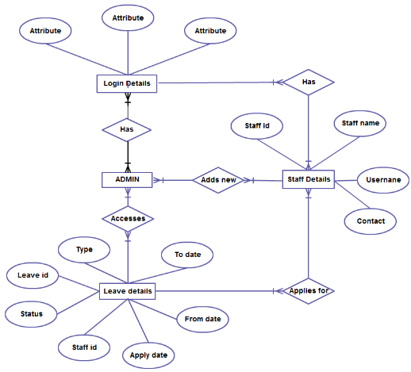

Different Entities are in the ER Diagram

Entities:-

- Admin
- Staff details
- Login details
- Leave details

Attributes:-

Each entities have different attributes,

- Login details have different attributes

- Staff details have 4 atributes
-Staffid
-Staffname
-username
-contact

- Login details have 7 atributes
-Type
-Leave id
-Status
-Staff id
-Apply date
-From date
-To date

Different Relationships are in the ER Diagram

- Relationship between Login details and Admin
- There exist many to many relationship.
- Different employees have different login details and can login as different admins.

- Relationship between Login detials and staff details
- There exist many to many relationship.
- Different employees have different login details and can login as different staff.

- Relationship between Admin and Staff details
- There exist many to many relationship.
- Different Admins can add different staffs.

- Relationship between Staff details and leave details
- There exist many to many relationship.
- different staffs can apply for leaves

- Relationship between Admin and Leave details
- There exist many to many relationship.
- Different admins can access and proceed leave applications of different staffs.

