DAY8
SESSION ASSIGNMENTS

1.When to use (Rapid Application Development) RAD model
When not to use (Rapid Application Development) RAD model

When to use RAD model?:-

The Rapid Application Development(RAD) model,also called as

prototyping model is a leading SDLC model which is recommended to use in

the following cases;

- RAD should be used when there is a need to create a system that can be modularized in 2-3 months of time.
- It should be used if there’s high availability of designers for modeling .

- It should be used if the budget is high enough to afford designers cost and the cost of automated code generating tools.

- RAD SDLC model should be chosen only if resources with high business knowledge are available and there is a need to produce the system in a short span of time (2-3 months)
- RAD should be used when the requirements are well known.
- RAD should be used when the user will be involved all through the lifecycle.
- Rad should be used when the functionality of the project is delivered to customers as increments.
- RAD should be used when the technical risks identified in the project are less.
When not to use RAD mode?:-

- When there is lack of human resources to create the right number of RAD teams.
- When the system is not properly modularized.
- When the technical risks are high RAD may not be a suitable choice.
- When the syatem requires high performance
- When technically strong team members are not available.
- When the system is not component based and scalable.
- When the management complexity is more.
- When the project requires larger development times.
- RAD model is not suitable for low budget projects

2.Define an ER diagram of a software Organization with all the relationship model that was discussed in the classroom
Account
numbr
bank
name
salary

Salary
Details

1
DOB
Emp
id
Number
Location
Dept
name
has
Emp
name

M
belongs
to
Employee
Department

M
M M
takes
controls

Propject
name
Works
on
Type

M M
Leaves
Project

Project
id
M
From
date
Leave id
Start
dateS
To
date

3.Describe the Entity Relationships for the following diagram

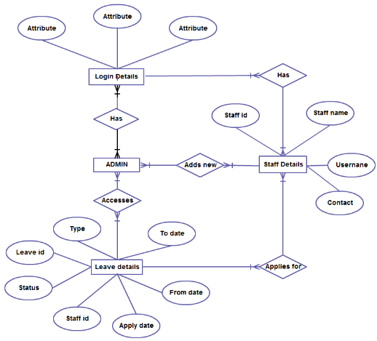

Different Entities are in the ER Diagram

Entities:-

- Admin
- Staff details
- Login details
- Leave details

Attributes:-

Each entities have different attributes,

- Login details have different attributes

- Staff details have 4 atributes
-Staffid
-Staffname
-username
-contact

- Login details have 7 atributes
-Type
-Leave id
-Status
-Staff id
-Apply date
-From date
-To date

Different Relationships are in the ER Diagram

- Relationship between Login details and Admin
- There exist many to many relationship.
- Different employees have different login details and can login as different admins.

- Relationship between Login detials and staff details
- There exist many to many relationship.
- Different employees have different login details and can login as different staff.

- Relationship between Admin and Staff details
- There exist many to many relationship.
- Different Admins can add different staffs.

- Relationship between Staff details and leave details
- There exist many to many relationship.
- different staffs can apply for leaves

- Relationship between Admin and Leave details
- There exist many to many relationship.
- Different admins can access and proceed leave applications of different staffs.

