Week 1 Notes
Day 1 (24/3/25)
Orca recognition
- See Aerial ID folders for training images
- High-resolution photographs of surfaced orca, identify by trained recognition of saddle/markings
- Find coat/saddle/feature recognition ML program for frames (preferably python)
  - Preferably with function for displaying the range of possible identities
- Train model for feature recognition and labelling clear frame in each video
- Integrate label with tracking video or data output via python pipeline

DORSAP Trial model (see Trial_model file)
Sample random video file (20240703-01.MP4)
Creating a skeleton (Fig 1)
- Node positions:
  - Rostrum tip
  - Caudal flukes x2
  - Pectoral fin tips x2
  - Mid-saddle patch
  - Caudal peduncle
- Edge positions:
  - Rostrum tip -> saddle patch
  - Saddle -> caudal peduncle
  - Saddle -> left pectoral
  - Saddle -> right pectoral
  - Caudal peduncle -> left caudal fluke
  - Caudal peduncle -> right caudal fluke
Training notes:
- Multi-animal top-down training & inference (see train_script.sh)
  - Identifies individuals (centroid), then separate node locations (centred-instance confidence map)
- Epoch limit seems to be tied to no. training frames available (23 in first trial)
- Best model chosen
- Predict on a further 20 random frames (example frame in Fig 2)
Next steps: First general model
- Find 8 (behaviourally & visually) diverse videos, label each with ~ 30 training frames
- Progressive labelling strategy
  - Train new top-down model to predict a further unseen 20 frames
  - Review predictions and correct positioning if required
  - Train further iterations of the model with the expanding training database
- Copy and save each of the following iterations in a file as you move on (keep video files in higher general file, as file locations seem to be sensitive)

Trigonometric adjustments
- Integrate into python workflow after DORSAP + feature recognition is complete
- Produce true relative velocity/position output for each tracked node and labelled orca
Figure 1: Training frame (human-labelled) for two females – Adult and juvenile
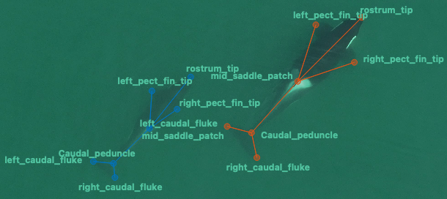

Figure 2: Inference frame (model-labelled) for the juvenile in a previously unlabelled frame
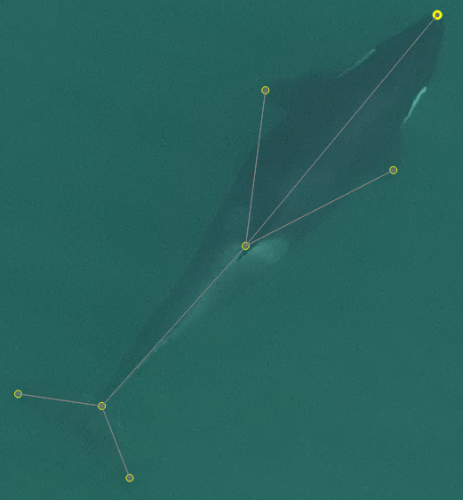

Day 2
First General Model (FGM)
Video selection criteria:
- B: Complex behaviour (rotation, overlap, non-parallel to surface plane)
- D: Significant drone (or camera) movement
- M: Murky conditions/overcast sky
FGM videos (trimmed times in brackets)
- 20231018-48 (0:07 – end) Perfect conditions
- 20240727-84 (full video) B
- 20240727-60 (0:02 – end) B
- 20240527-22 (full video) D
- 20231018-40 (0:04 – end) D
- 20231018-34 (0:03 – frame 639)) DM
- 20240127-7 (0:06 – end) DM
- 20240127-3 (0:20 – end) BDM
Frame selection for each video
- Sample 30 suggested frames in each video by stride method
- Remove any absent frames
- Some videos freeze in last few seconds

Finishing point: 30% training frames labelled

Extra notes
Video 20180614 – Breathtaking views of Salish sea & CWR base

Day 3
Finish Labelling all videos
- Run training
  - 200 epochs for both sub-models
  - Best model

Figure 3: Training screen (it’s alive!)
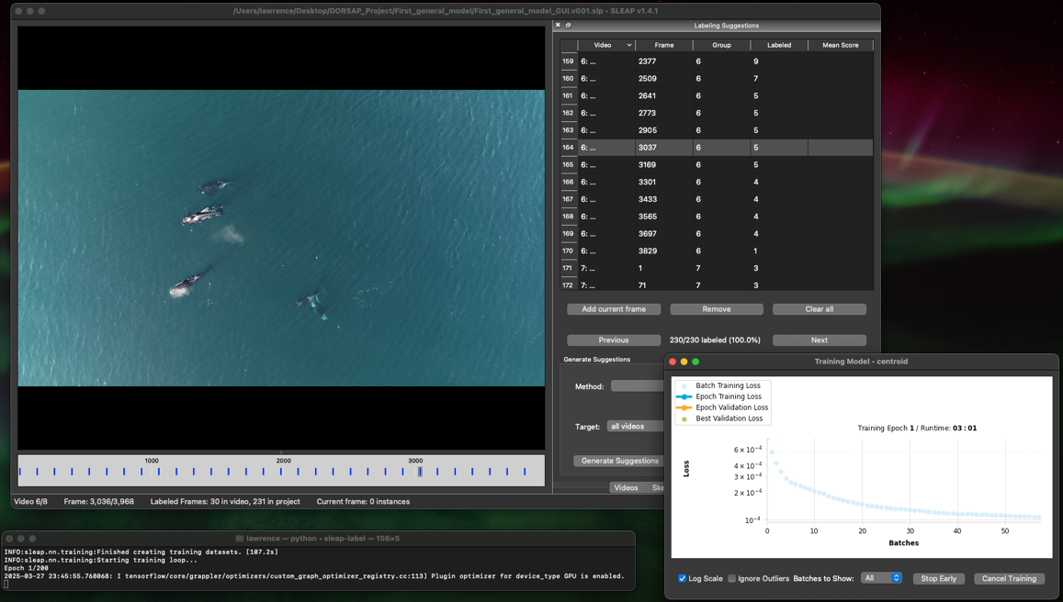

Error correction: Frame syncing with .mov trim function
Trimming .mov files doesn’t follow with the metadata, leading to frame errors
Fix instructions below:
- Re-encode the video to .mp4 format with frame metadata synced

ffmpeg -i input.mov -vf "select=not(mod(n\,1))" -vsync vfr -c:v libx264 -preset slow -crf 18 -c:a copy output.mp4

- Convert .slp file to .json readable format
sleap-convert First_general_model_GUI.v001.slp -o First_general_model_GUI.v001.json

- Modify filename assigned to ‘video number x’ to corrected video in the text file
- Reconvert .json to .slp and confirm corrected frames in GUI
sleap-convert First_general_model_GUI.v001.json -o First_general_model_GUI.v001.slp

