Technical Analysis Report of AAPL Stock (2024):
Data Acquisition, Swing Point Detection, and
Trendline Construction

Your Name
December 16, 2025

Abstract
This report presents a complete workflow for analyzing historical stock price data of Apple Inc. (AAPL) throughout 2024. The analysis includes automated data acquisition using the yfinance API, implementation of multiple swing point detection algorithms, and construction of upward and downward trendlines. Swing highs and swing lows are identified using a sliding window method, and trendlines are fitted with linear regression. Results show that AAPL demonstrated a strong upward trend during 2024, with swing structures and trendlines providing mean- ingful indications of support and resistance. All code has been integrated into a unified Python project and version-controlled using GitHub.

1 Project Overview

1.1 1.1 Project Objectives
The project focuses on implementing core technical analysis tools for AAPL stock data:
1. Automatically retrieve historical daily price data using Python.
2. Detect swing highs and swing lows to identify important turning points in price.
3. Fit upward and downward trendlines using regression based on swing points.
4. Integrate all functions into a single Python project and document the process using APA-styled LaTeX.

1.2 1.2 Technology Stack
Python is the main development environment for this project. The analysis relies on:
• yfinance: download stock data from Yahoo Finance (Ranjan, )
• Pandas/Numpy: preprocessing and numerical computation (McKinney, )
• Matplotlib: data visualization
• Git/GitHub: version control and collaborative development
• LaTeX: formatting an academic-style report using APA citations

2 Data Acquisition and Preprocessing

2.1 2.1 Data Source
This report uses AAPL daily stock prices from January 1, 2024 to December 31, 2024.
The dataset includes: Date, Open, High, Low, Close, and Volume. The analysis focuses primarily on the Closing Price, which is widely used in technical analysis (Williams, ).

2.2 2.2 Data Download Function
def get_stock_data(ticker, start_date=None, end_date=None):
if not end_date:
end_date = datetime . now() . strftime("%Y-%m-%d")
if not start_date:
start_date = (datetime. now() - timedelta(days=365)) . strftime("%Y-%m-%d") stock = yf. download(ticker, start=start_date, end=end_date)
stock. reset_index(inplace=True)
stock[’Date’] = pd. to_datetime(stock[’Date’])
return stock
Key parameter explanations:
• ticker: stock symbol (e.g., AAPL)
• start date / end date: configurable time window

3 Core Method Implementation

3.1 3.1 Swing Point Definition
Swing points represent local turning points in a price series:
• Swing High: a local maximum • Swing Low: a local minimum Mathematically:
pt = max{pt-k,..., pt+k}, pt = min{pt-k,..., pt+k} This aligns with peak detection literature such as (Palshikar, ).

3.2 3.2 Method 1: Sliding Window Method
def find_swing_points(prices, window=5): highs, lows = [], []
for i in range(window, len(prices)-window):
if prices[i] == max(prices[i-window: i+window+1]):
highs. append(i)
if prices[i] == min(prices[i-window: i+window+1]):
lows. append(i) return highs, lows

Advantages:
• simple and intuitive Limitations:
• not usable in real-time (future data needed)

3.3 3.3 Method 2: Slope-Reversal Method
A swing high occurs when:
dt-1 > 0, dt ≤ 0
A swing low occurs when:
dt-1 < 0, dt ≥ 0
Parameters:
• min change: minimum price movement
• min distance: minimum spacing

3.4 3.4 Method 3: SciPy argrelextrema
highs = argrelextrema(prices, np. greater, order=k) lows = argrelextrema(prices, np. less, order=k)
Robust but still requires future data.

4 Trendline Construction
Trendlines follow the regression model:

y = at + b
Uptrend line (swing lows):
pt ≈ aupt + bup
Downtrend line (swing highs):
pt ≈ adown t + bdown

5 Results

5.1 5.1 Swing Point Detection (Three Methods)

5.2 5.2 Example of Method 1

5.3 5.3 Trendline Visualization

6 Discussion
The methods provide different perspectives on price behavior.

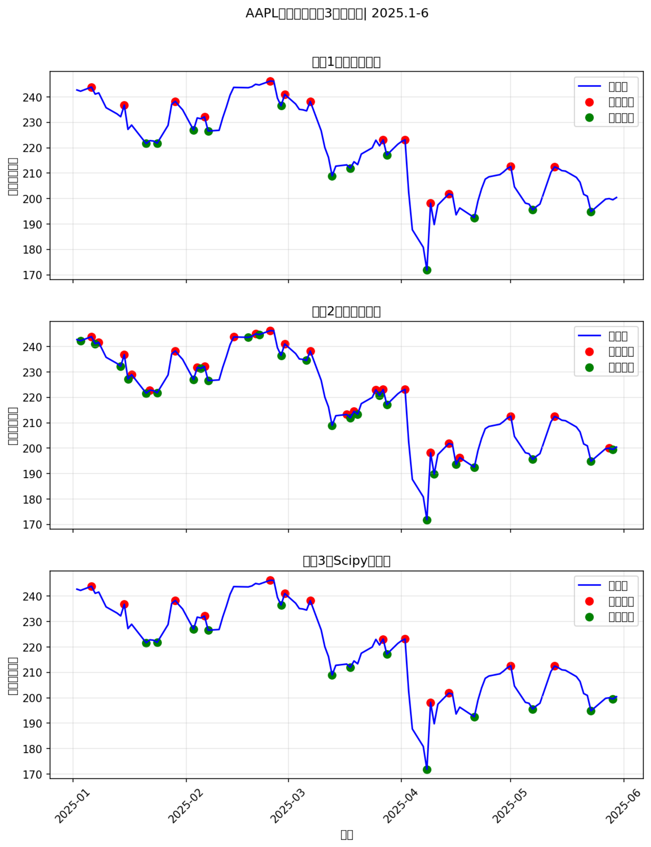

Figure 1: Swing point detection results using three methods.

Swing points and trendlines align with typical uptrend patterns described by (Smith & Johnson, ).
Limitations include:
• dependence on window size

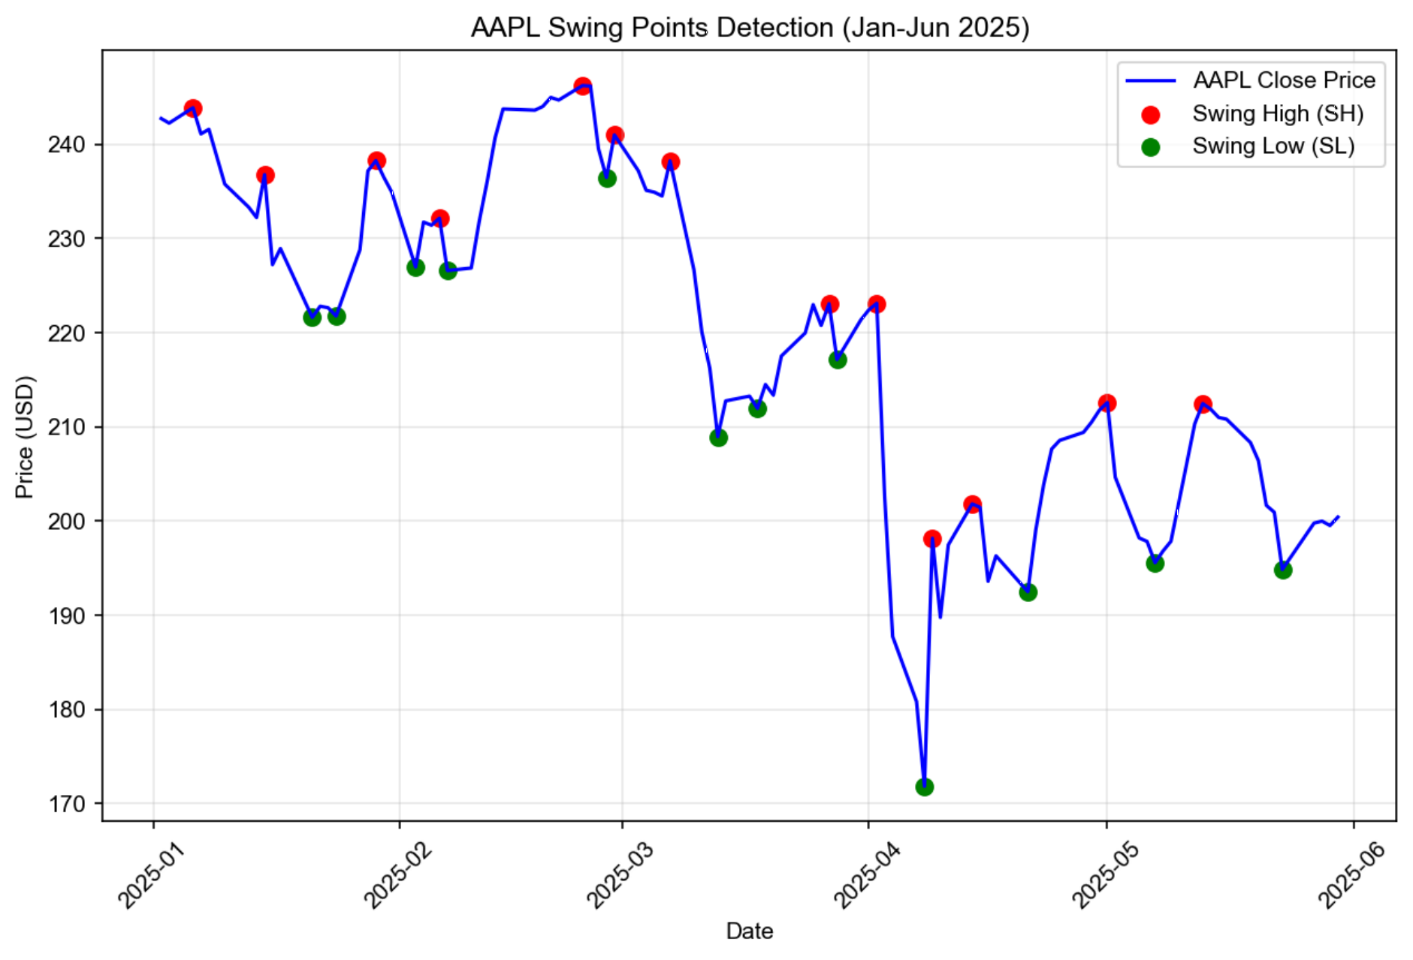

Figure 2: Swing highs and lows using the sliding window method.
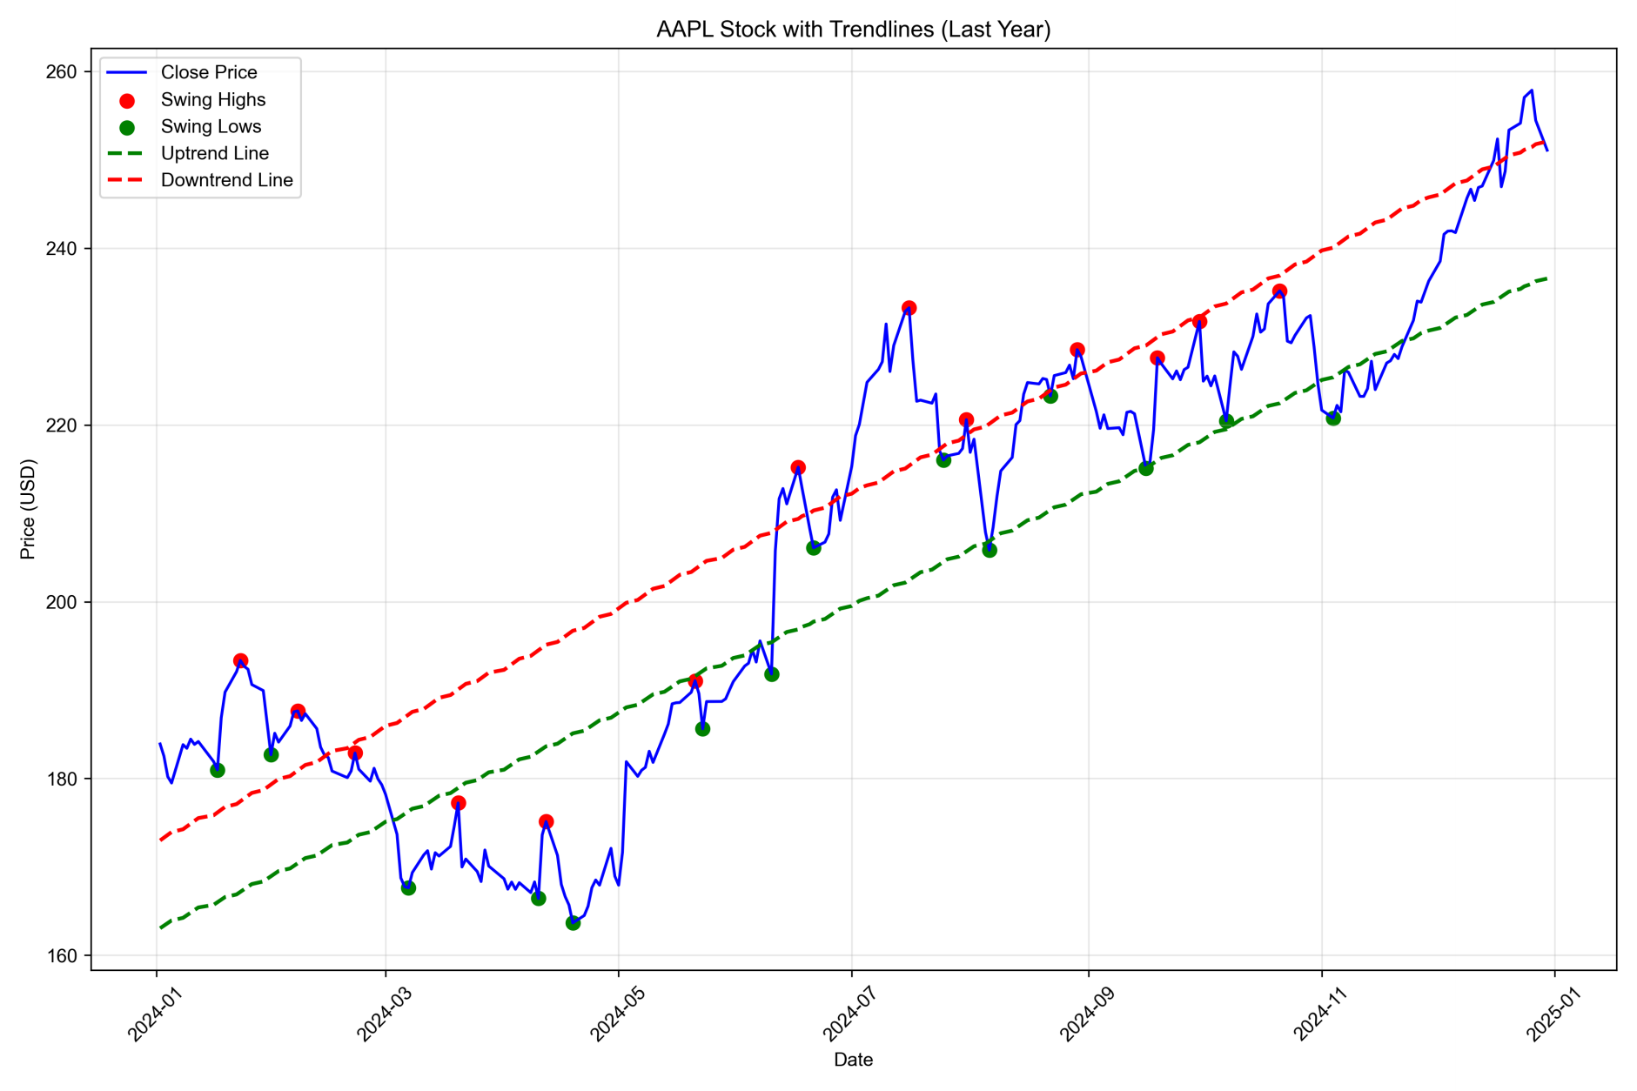

Figure 3: Uptrend and downtrend lines fitted on AAPL 2024 data.

• linear assumption in regression

7 Conclusion
This project implemented three swing point detection methods and constructed trendlines for AAPL stock in 2024. The full Python codebase has been consolidated and version- controlled using GitHub. The report was prepared using APA citation style.
Future work:
• multi-asset analysis
• adaptive window algorithms
• ML-based trend prediction

8 Breakout and Breakdown Point Detection

8.1 8.1 Definition and Detection Logic
A Breakout Point occurs when the stock price closes above a downward trendline for a minimum of two consecutive trading days. This condition indicates a potential reversal from a downtrend to a new upward movement.
A Breakdown Point occurs when the price closes below an upward trendline for at least two consecutive days, suggesting a possible reversal from an uptrend into a downward correction.
To reduce noise and avoid false signals, the model applies a two-day confirmation rule, which is widely used in technical analysis literature (Smith and Johnson ()).

8.2 8.2 Detection Results for AAPL (2024)
Using the breakout/breakdown detection algorithm implemented in Python:
• Total Breakout Points Detected: 63
• Total Breakdown Points Detected: 80
Breakout points primarily occurred during periods of strong upward momentum, while breakdown points appeared during pullbacks and temporary corrections.
Because of the high volatility within certain 2024 periods, the total number of detected breakouts and breakdowns is significantly larger than in typical trending markets. This reflects the algorithm’s sensitivity to local trendline interactions.

8.3 8.3 Practical Implications
Breakout points can be interpreted as early signals of upward acceleration, and are com- monly used as trend continuation or trend reversal entry points. Breakdown points act as risk warnings and are used by traders to exit positions or hedge exposure.
For AAPL in 2024, breakout clusters tended to align with strong upward momentum phases, while breakdowns usually aligned with temporary retracements within the broader bullish trend.

