Physics 2D Report Group 6

Analysis of tau(𝜏)

Kang Min Zhe (1003451), Wilson Koh (1003654), Jordan Tay Jin Jie (1001121), Ng Li Ting (1003828)

Section 1: Introduction

For this Physical World/DW 2D project, my group was tasked to develop a program to predict the temperature of a water bath using an R-pi and a temperature sensor with machine learning.

In our pre-analysis, we were given tau(𝜏), which we are supposed to determine if it is a function of temperature or if it is constant that is independent of temperature.

Based on our results, we are then required to determine if we are to include 𝜏 into our machine learning model.

Section 2: Methods

**2.1: Collection of data**

From our pre-analysis we were given the relation of

$τ=\frac{C_{s}}{λ}$ where $C_{s}$ = heat capacity of sensor and $λ$ = combined thermal conductance (water to sensor)

We first hypothesise that $τ$ is a constant value as both heat capacity and $λ$ are not affected by temperature, since we assumed them to be fixed intrinsic values of the sensor and water bath. Hence, we decided to put our assumption to the test.

We started by recording 12 different sets of data with the sensor and imported it into Excel. We obtained readings from various temperatures of water baths prepared, ranging 10℃ - 60℃, with ambient temperature of 25.3℃ and water

volume of 1.3 litres, both which was kept constant for all experiments.

**2.2: Processing of data**

Next, we cleaned the data by deleting the temperatures at which the sensor is not placed into the water bath yet and mapped out the data for 1 of the 12 temperatures data collected. We observed a logarithmic trend upon plotting the data (Figure: 1). This is the graph for the water temperature of 44℃ (Tw) reading.

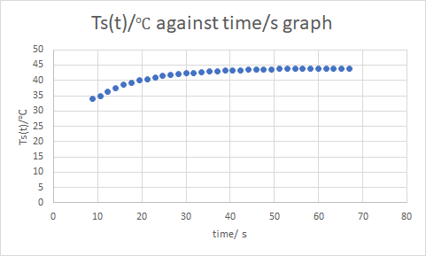

(Figure 1: Graph of temperature sensor Ts(t)/ ℃ against time/s for Tw of 44℃)

However, this logarithmic trend is not useful in telling us the value of tau($τ$), unless converted into a linear relation.

We then fit the data into a linear model by inputting the values of Ts(t) into the equation $\ln\left(\frac{T_{s}\left(t\right)- T_{w}}{T_{amb - T_{w}}}\right)= -\frac{t}{(\frac{C_{s}}{λ})}$ (where $τ=\frac{C_{s}}{λ}$) and plotted the $\ln\left(\frac{T_{s}\left(t\right)- T_{w}}{T_{amb - T_{w}}}\right)$ function against time (Figure: 2). This equation is given in our 2D DW/PW handout.

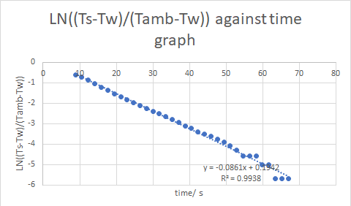

(Figure 2: Graph of LN((Ts-Tw)/(Tamb-Tw)) against time/s)

Where Ts(t) is the temperature of the sensor at time t, Tw is the temperature of the water bath, Tamb is the ambient temperature (which was measured to be at 25.3℃)

From this, we can obtain a linear relationship with the time, t.

**2.3: Graphical analysis**

We obtained the equation of the graph and got a gradient of -0.0861 $s^{-1}$ which is used to calculate tau, by the formula $-\frac{1}{gradient}$

, since gradient = $-\frac{1}{τ}$, (-1/-0.0861) = 11.61s ( $τ$ value). (Refer to 4th data in Figure: 5)

Section 3: Results/Analysis

**3.1: Repeating for the other data sets**

We repeated this process for the rest of the 11 other sets of data that we have collected by obtaining the gradient (Figure: 2) for the other data sets and mapped out the values of $τ$ against the final temperature of water (Tw), which is observed in the graph. (Figure: 3).

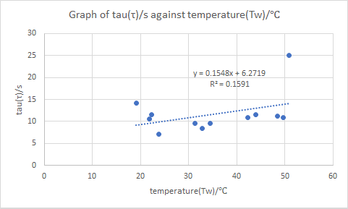

(Figure 3: Graph of tau/s against temperature (Tw)/ ℃)

**3.2: Analysing the graph**

From this graph, there is no clear distinct relationship between the $τ$ and Tw. The points observed were very sporadic which does not have any clear dependence on temperature. However, upon closer inspection, we did notice that most of our experimental plots were at around $τ$ value of 9s to 11s (Figure: 5), that is,

if we were to assume that the extreme plots are outliers.

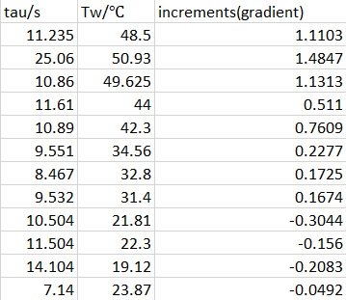

(Figure 5: Raw values of $τ$ (tau) )

However, this assumption is not valid unless we obtain data sets from more varied temperature readings at higher and lower temperature to obtain more $τ$ values.

Moreover, since these values $τ$ happens over a range of values (9-11s, hence this disproved our hypothesis that the $τ$ value is constant as it affected by temperature.

**3.2: Discussion of $τ$**  **value**

From our findings, we concluded that the $τ$ value is not constant and is affected by temperature.

Moreover, if we assume that $τ$ is a constant and we were to rearrange the provided equation $\ln\left(\frac{T_{s}\left(t\right)- T_{w}}{T_{amb - T_{w}}}\right)= -\frac{t}{τ}$ into a different form, $T_{w}=\frac{Ts\left(t\right)-T_{amb}×C}{1- e^{C}}$ where C = $e^{-\frac{t}{τ}}$. We can get the value of Tw by substituting the value of $τ$. However, because $τ$ is not constant as shown in (3.2 Analysing the graph), we further disprove that $τ$ is not constant (Figure: 3) since we cannot find a suitable $τ$ value to substitute in and thus cannot find the value of Tw from the equation. This means that we will not be able to include $τ$ into our machine learning model.

Since $C_{s}$ is defined as $C_{s}= \lim_{∆Q→∞}{\frac{∆Q}{∆T}}$ (Heat capacity, <https://en.wikipedia.org/wiki/Heat_capacity>). This meant Heat capacity is affected by the change in temperature which meant that $τ$ is affected by temperature.

Additionally, we did some research on $C_{s}$ and $λ$ and found out that $C_{s}$ is affected by numerous factors, such as the degree of freedom that are available to the particles in the sensor in space. (Wikipedia,℃ freedom,<https://en.wikipedia.org/wiki/Heat_capacity>)

Moreover, factors such as material porosity will affect the thermal and electrical conductivity of the sensors hence affecting $λ$. (Researchgate, <https://www.researchgate.net/post/How_porosity_and_pore_size_could_affect_thermal_and_electrcal_properties_of_bulk_materials>)

This means that there is a myriad of factors that are affecting how the sensor reads the temperature, hence this means that it is actually very difficult to get any sort of relationship between Tw and $τ$.

The relationship of $τ$ and Tw cannot be used when doing machine learning for temperature prediction as it provides an inaccurate measure of what the outcome will be. Hence, our group took a different approach to the problem and instead measured the gradient of the first few seconds of increments of each data sets which was linear (refer to Figure: 1 time: 10-15s) and plot the increments(gradients) against the Tw (Figure: 4 & 5).

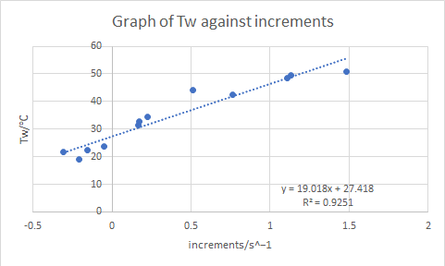

(Figure 5: Graph of temperature (Tw) against increments)

**3.3: Assumptions**

However, our findings of $τ$ not being constant can only be true if we assume that the temperature of the ambient is constant at 25.3℃ and the temperature of water (Tw) is at a steady temperature too.

Section 4: Conclusion

In conclusion, our experimental results show that $τ$ is a function of temperature and is not constant but we are unable to show what kind of relation it has with Tw as the plots were too scattered on the graph.

However, our group also know the fact that there are simply too many factors affecting the $τ$ values, such as the lag between placing the sensor into the bath and the time intervals between each temperature readings (which was about 2-3 seconds). Which might have contributed to the inaccuracies of the data.

Hence, we adopted a different approach to solving this problem by using the increments of Ts(t) in the first few seconds (Figure: 1, time 10-15s) to plot it against the final temperature (In this example it is Tw of 44℃). This was repeated for the rest of our 12 data plots (Figure: 5) and we managed to obtain a fairly accurate predicted temperature reading of +/- 1℃ within 10 seconds.

Section 5: Citations

(Wikipedia, degree of freedom, heat capacity <https://en.wikipedia.org/wiki/Heat_capacity>)

(Researchgate , How does porosity affect thermal conductance <https://www.researchgate.net/post/How_porosity_and_pore_size_could_affect_thermal_and_electrcal_properties_of_bulk_materials>)

Section 5: Appendix



(Figure 1: Graph of temperature sensor Ts(t)/ ℃ against time/s for Tw of 44℃)



(Figure 2: Graph of LN((Ts-Tw)/(Tamb-Tw)) against time/s)



(Figure 3: Graph of tau/s against temperature(Tw)/ ℃)



(Figure 4: Graph of temperature (Tw) against increments)



(Figure 5: Raw values of tau )

