VIETNAM NATIONAL UNIVERSITY HO CHI MINH CITY
UNIVERSITY OF INFORMATION TECHNOLOGY



REPORT LAB 01
SUBJECT: DATA ANALYSIS IN BUSINESS

Lecturer: Nguyễn Đình Thuân
Nguyễn Minh Nhựt
Class: IS403.M22.HTCL
1. Nguyễn Hoàng Tuấn - 18521601
2. Huỳnh Thị Kiều Oanh - 18521224
3. Trương Mỹ Song Dân - 20520424

TASK BOARD
Name | ID Student | Task | Completed evaluation
Nguyễn Hoàng Tuấn | 18521601 | 1a, 1b in R language | 100%
Huỳnh Thị Kiều Oanh | 18521224 | 1a, 1b in Python and Excel | 100%
Trương Mỹ Song Dân | 20520424 | 1c, 2 + report | 100%

1a. Using Data Visualization and Descriptive Statistics to do the following:
According to data on Vietnam's economy at the website:
http://finance.vietstock.vn/du-lieu-vi-mo/Default.htm
- Use MS Excel, Python and R language with data on average GDP of Vietnam, calculate and explain the meaning of the values: Count, Min, Max, Mean, Median, Mode, Quartile, Range, Variance, Standard Deviation, Coefficient of Deviation, Skewness, Kurtosis.
With data file:
GDP binh quan cua VN
Using R language:

//Count
//Min and Max
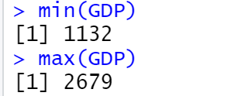
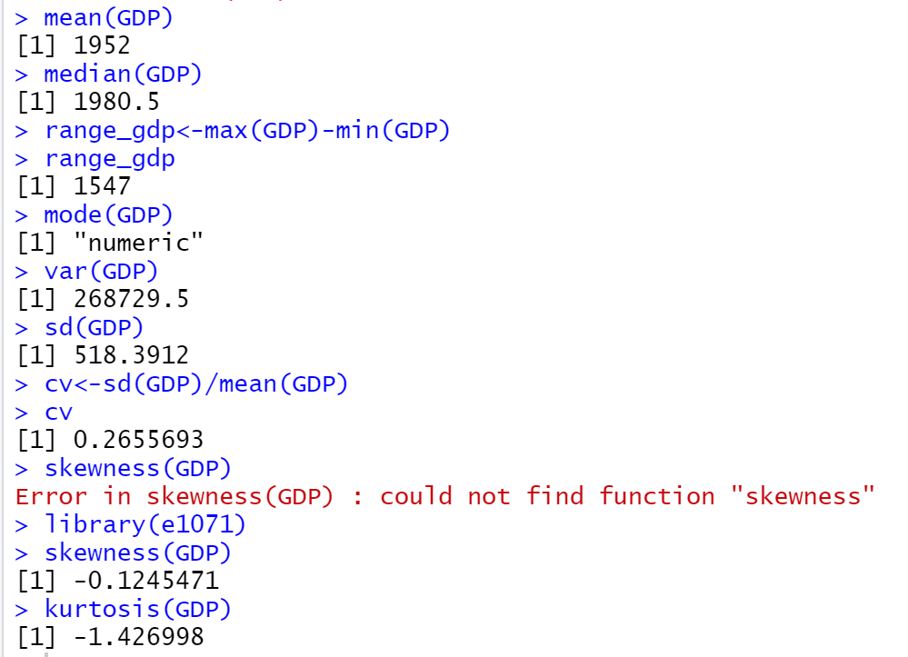
//Mean, Median, Mode, Variance, Standard deviation, Coefficient of variance, Skewness, Kurtosis
Using Excel:
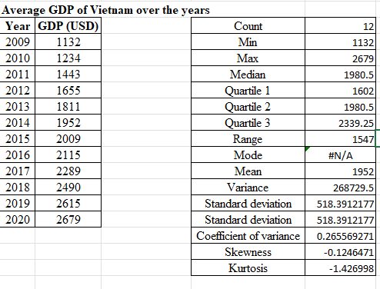

Using Python:
Import library:
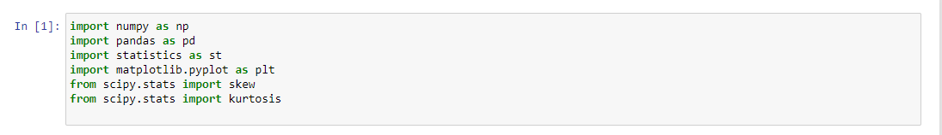

Import data to be analyzed:
GDP_BinhQuan_VD.csv
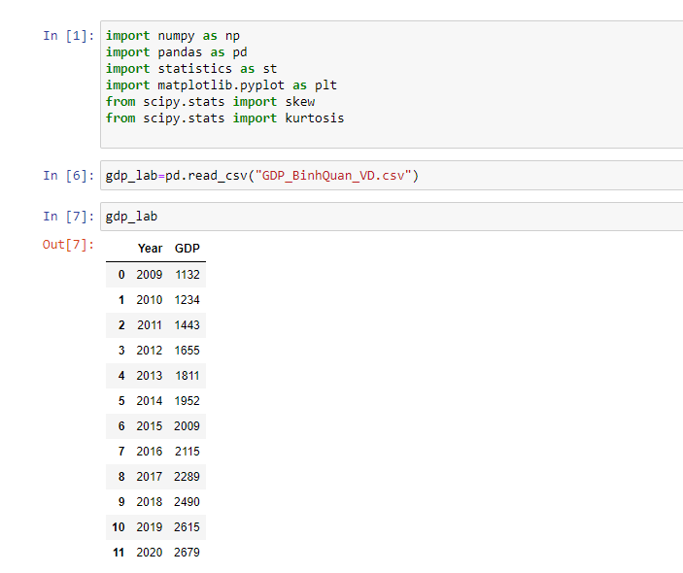
//Count
//Min
//Max
//Mean

//Median


//Variance
// Standard deviation

// Coefficient of variance:
// Skewness:

//Kurtosis:
//Quantile:

2. Use Visualization: Histogram, Box Plot. Please show up these values above:
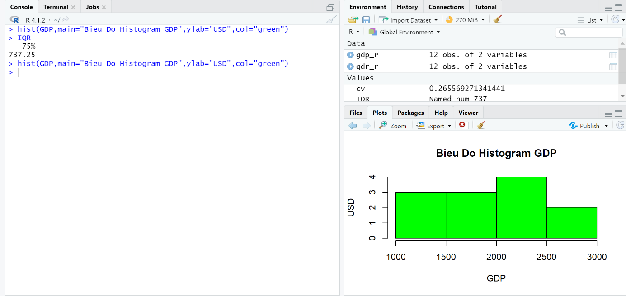
- Using R language:
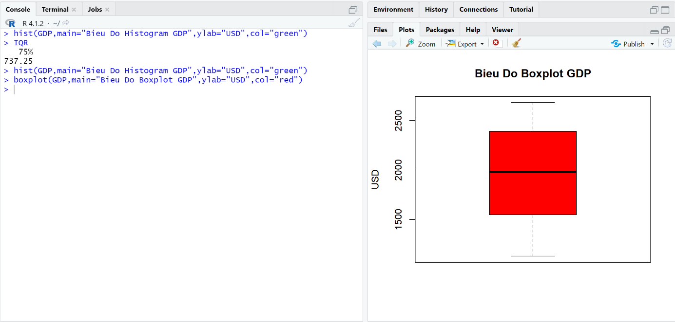
Using Excel:

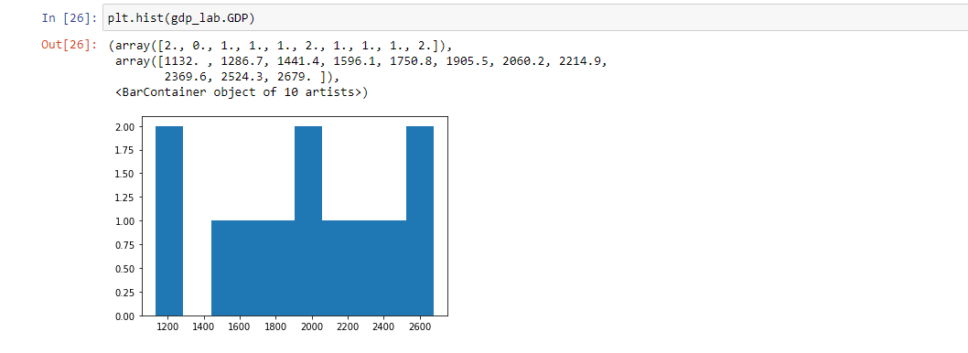
- Using Python:
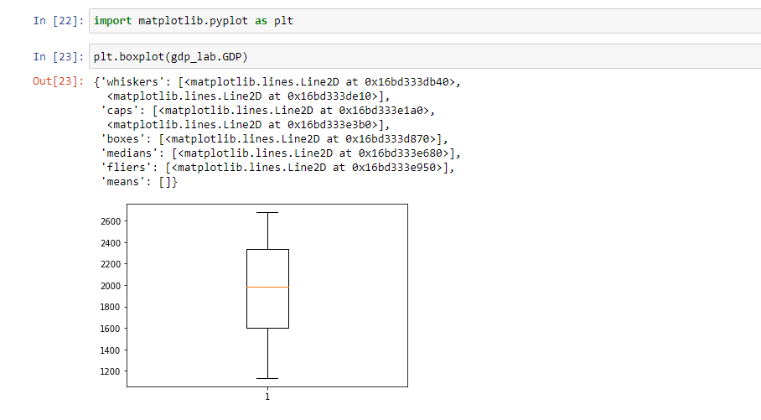

1b. Execute the same requirements as lesson 1a for data files:
Purchase Orders
Using Excel:
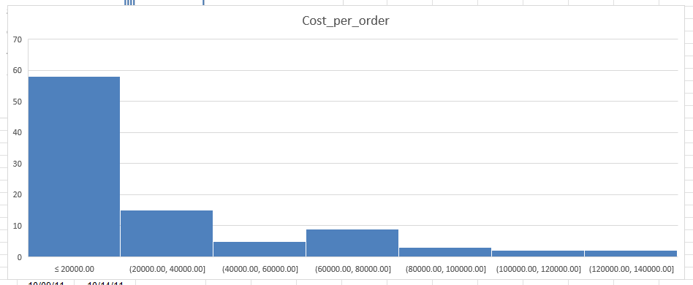
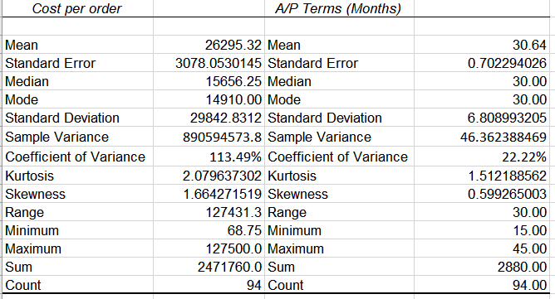

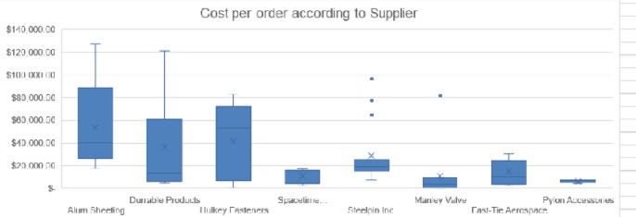
A/P term:

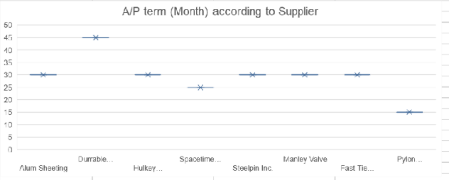

Using R langluage:
Cost per order:
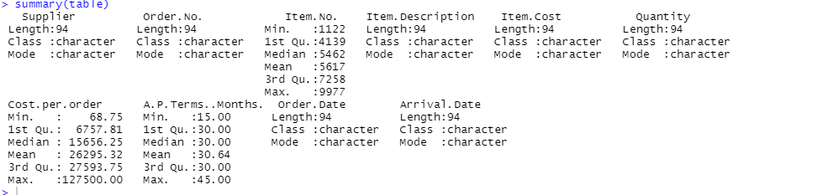

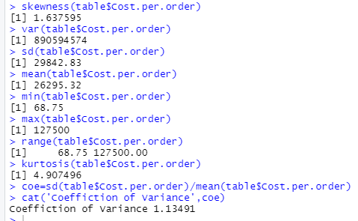

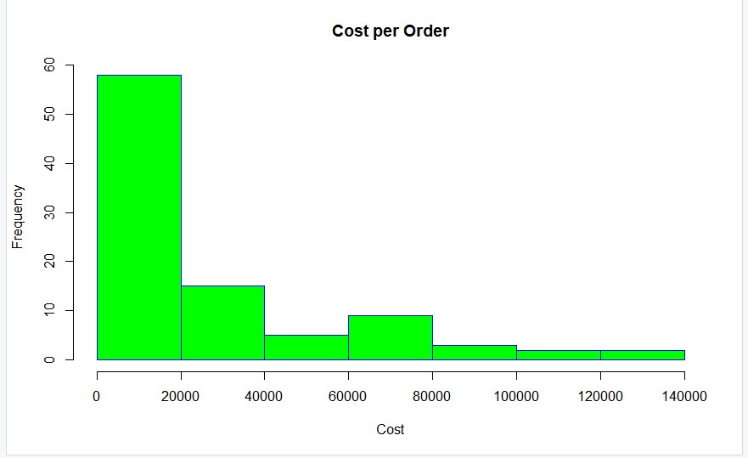

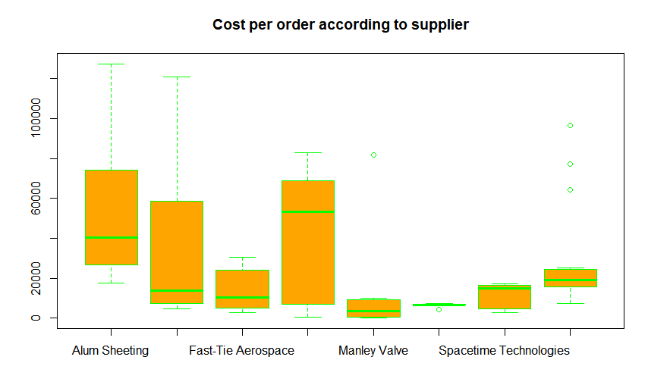

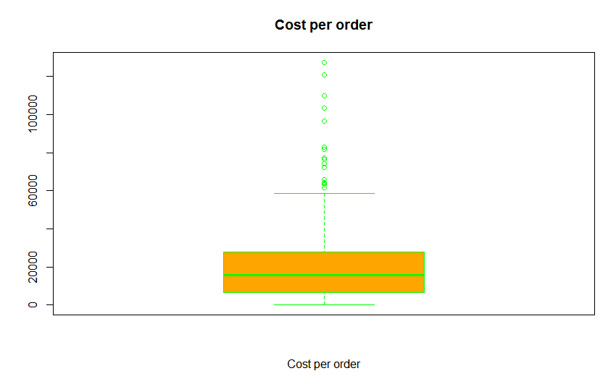
A/P term:
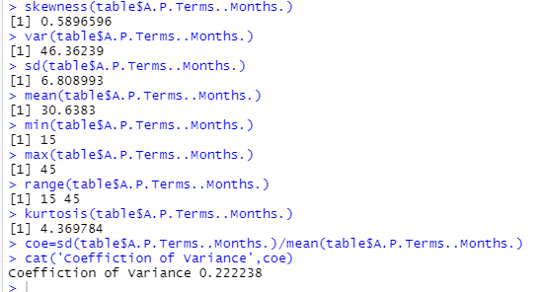

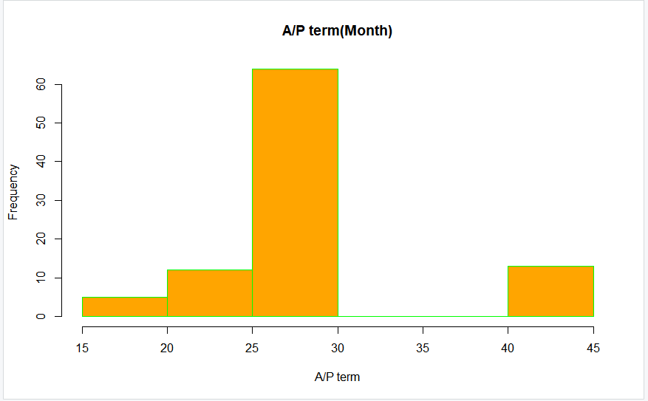

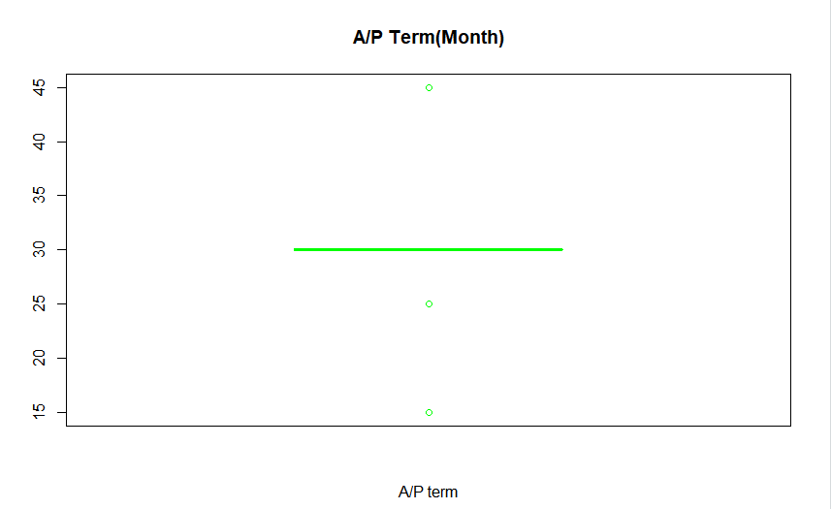

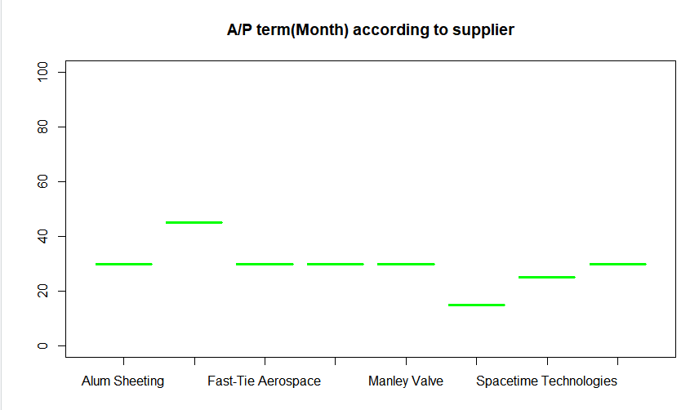

Using Python:
Cost per order:
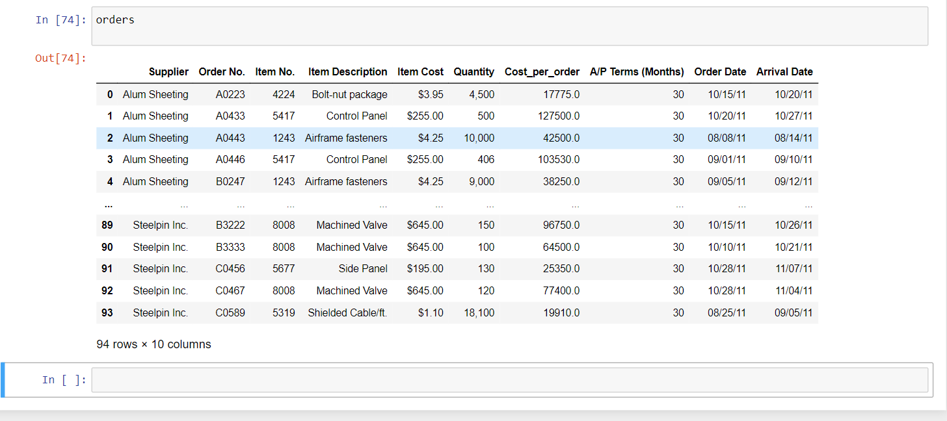







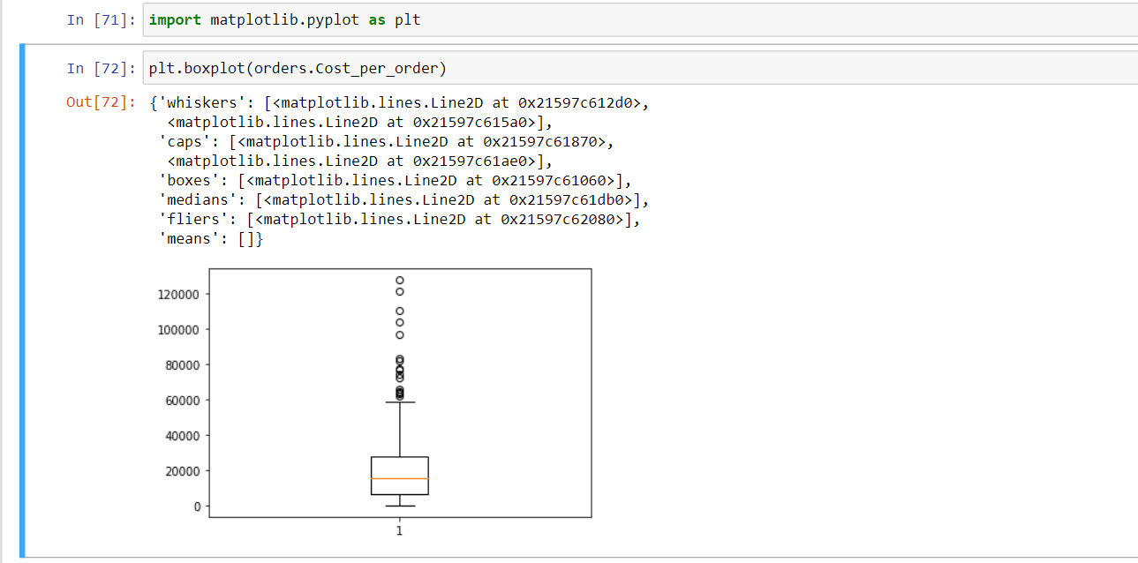
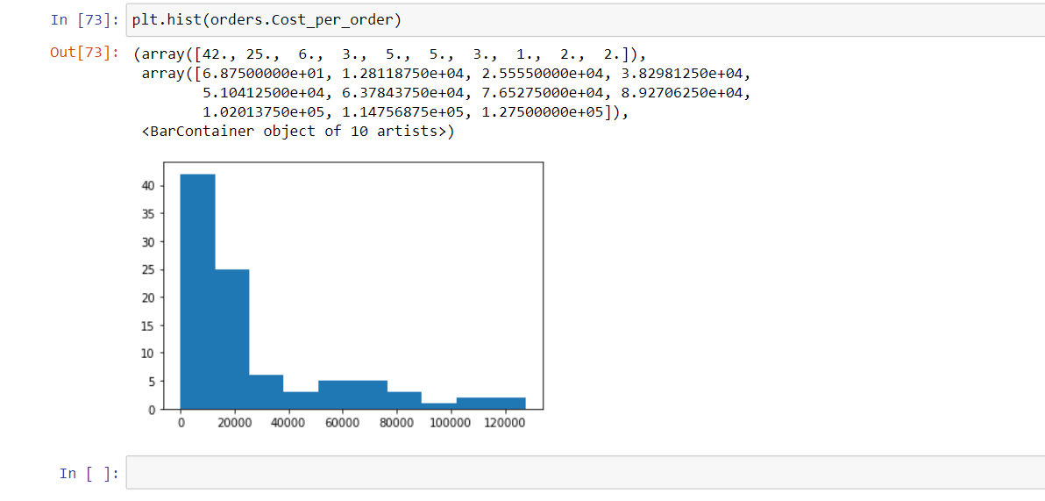
A/P Term:
Import data:

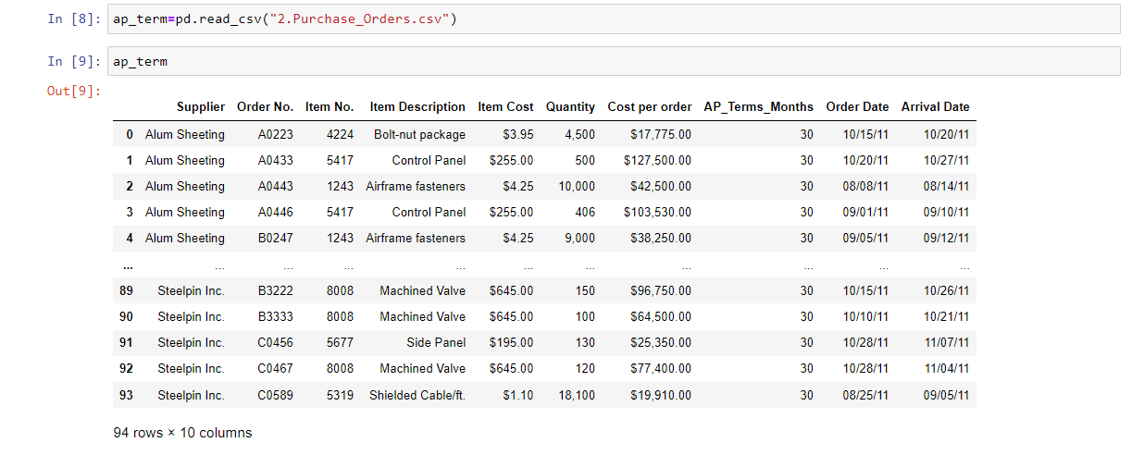







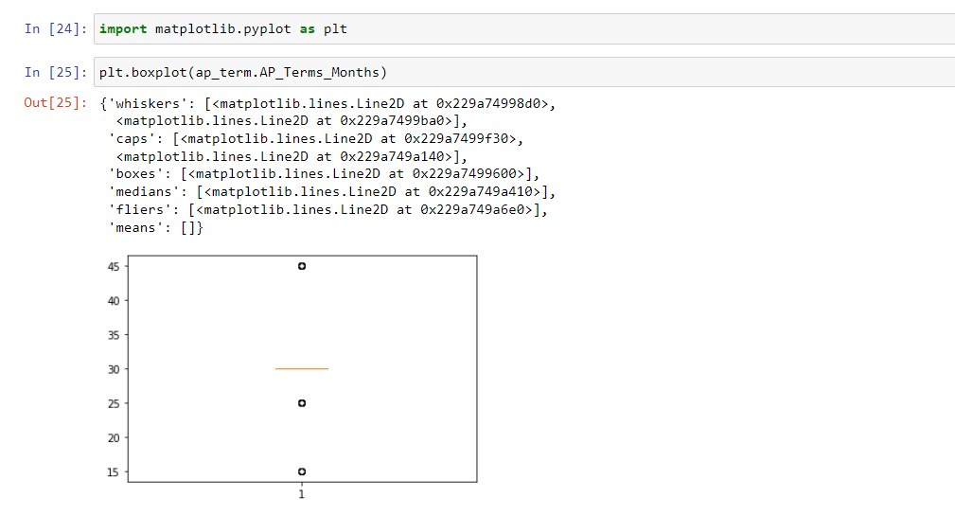

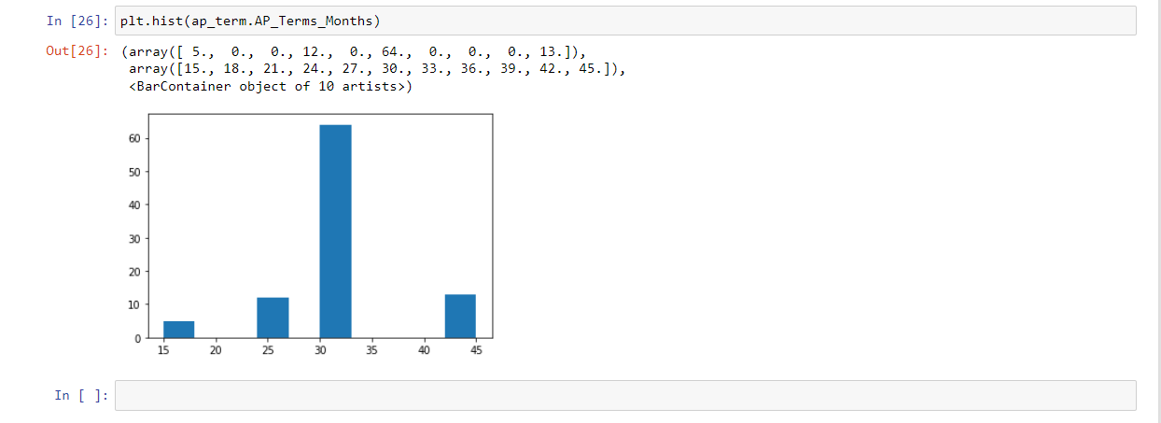
Computer Repair Times:
Using R language:
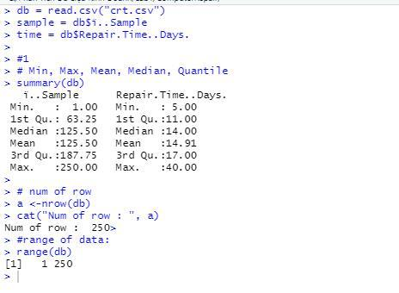

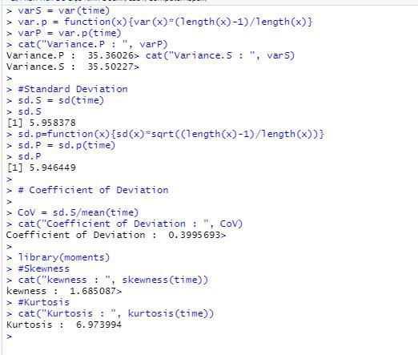

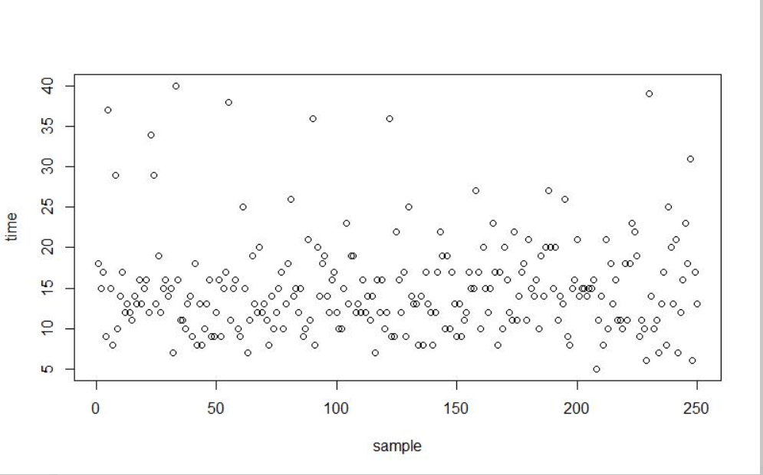

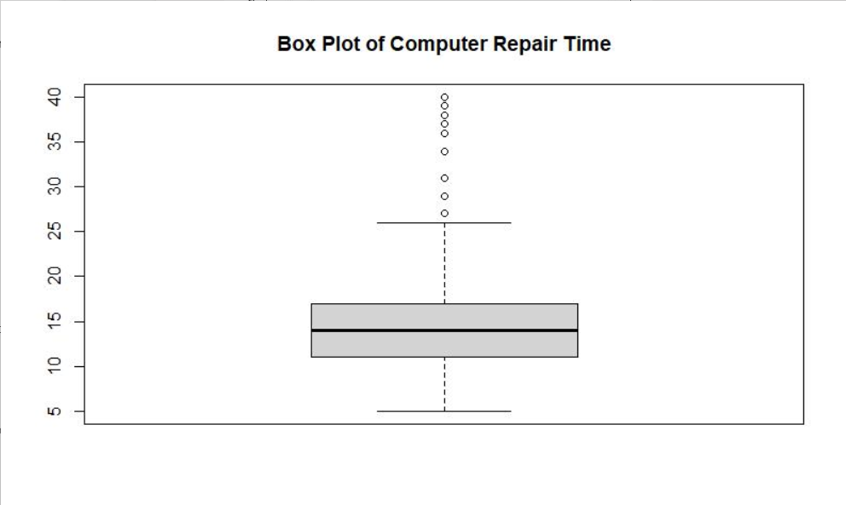
Using Python:

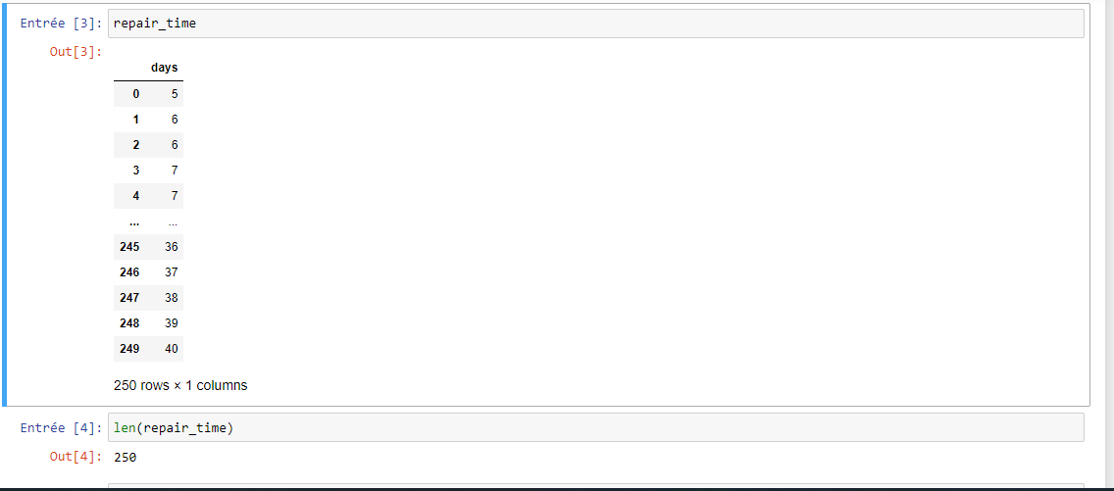
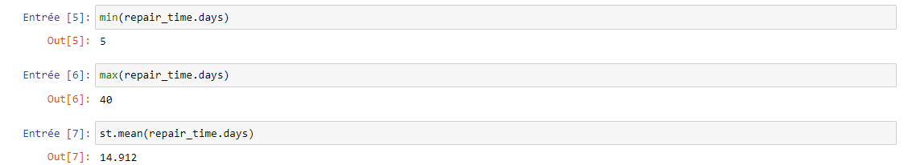
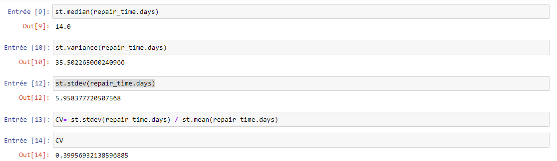
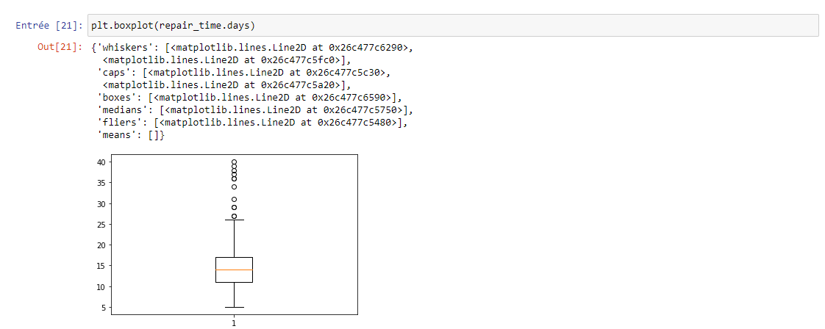
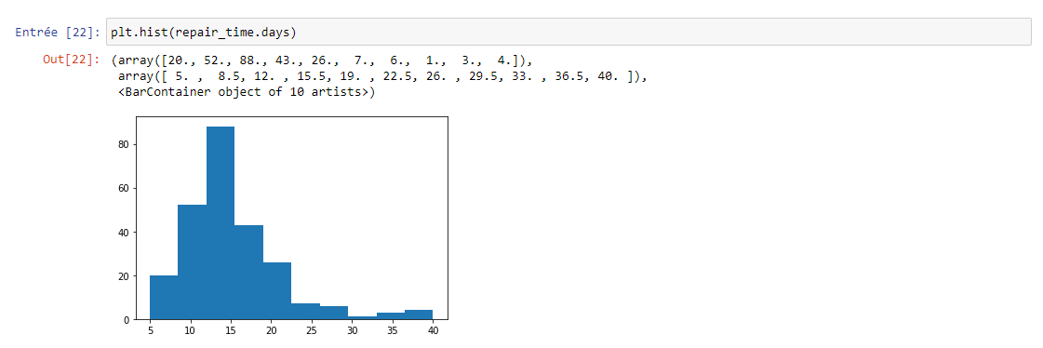

Using Excel:
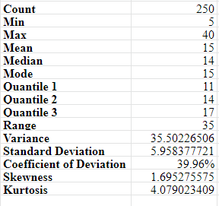

Explanation:
- Count: counts the number of cells that contain numbers, and counts numbers within the list of arguments. Use the Count function to get the number of entries in a number field that is in a range or array of numbers
- Mix: returns the smallest numeric value in the data provided. The Min function ignores empty cells, the logical values True and False and text values, get the smallest value.
- Max: returns the largest numeric value in the data provided. The Max function ignores empty cells, the logical values True and False and text values, get the largest value.
- Mean: find a fair, central number to act as a basis of comparison, rather than comparing individual data points to each other without a standardized basis for comparison.
- Median: returns the median (middle number) in a set of data. The calculation performed by Median varied according to the number of numeric values provided. When the number is odd, Median returns the middle number in the group. When the number is even, Median returns the average of the two numbers in the middle.
- Mode: returns the most frequently occurring number in a set of numeric data. If supplied data does not contain any duplicate numbers, the Mode function returns a #N/A error
- Quantile: returns the quartile of a data set. Quartiles often are used in sales and survey data to divide populations into groups.
- Range: returns the difference between the largest value and the shortest value in a given dataset in mathematical terms.
- Variance: is the measure of variability of a data set that indicates how far different values are spread. Mathematically, it is defined as the average of the squared differences from the mean.
- Standard Deviation: is a statistic that measures the dispersion of a dataset, relative to its mean. It’s calculated as the square root of the variance (the spread of numbers in a dataset). Determining the variation between each data point relative to the mean is valuable for comparing sets of data that may have the same mean but a different range.
- Coefficient of Deviation: is the measure of relative variability. It is the ratio of the standard deviation to the mean.
- Skewness: characterizes the degree of asymmetry of a distribution around its mean. Positive skewness indicates a distribution with an asymmetric tail extending toward more positive values. Negative skewness indicates a distribution with an asymmetric tail extending toward more negative values.
- Kurtosis: characterizes the relative peakedness or flatness of a distribution compared with the normal distribution. Positive kurtosis indicates a relatively peaked distribution. Negative kurtosis indicates a relatively flat distribution.

1c. Difference between:
- Null hypothesis and Alternative hypothesis
- Null hypothesis: A null hypothesis is a statistical hypothesis in which there is no significant difference exist between the set of variables. It is the original or default statement, with no effect, often represented by H₀ (H-zero). It is always the hypothesis that is tested. It denotes the certain value of population parameter such as µ, s, p. A null hypothesis can be rejected, but it cannot be accepted just on the basis of a single test.
- Alternative hypothesis: A statistical hypothesis used in hypothesis testing, which states that there is a significant difference between the set of variables. It is often referred to as the hypothesis other than the null hypothesis, often denoted by H₁ (H-one). It is what the researcher seeks to prove in an indirect way, by using the test. It refers to a certain value of sample statistic, e.g., x¯, s, p. The acceptance of alternative hypothesis depends on the rejection of the null hypothesis i.e. until and unless null hypothesis is rejected, an alternative hypothesis cannot be accepted.

- Comparison Chart:
 | Null hypothesis | Alternative hypothesis
Meaning | A Null hypothesis is a statement, in which there is no relationship between two variables. | An Alternative hypothesis is statement in which there is some statistical significance between two measured phenomenon.
Represent | No observed effect | Some observed effect
What is it? | It is what the researcher tries to disprove | It is what the researcher tries to prove
Acceptance | No changes in opinions or actions | Changes in opinions or actions
Testing | Indirect and implicit | Direct and explicit
Observations | Result of chance | Result of real effect
Denoted by | H₀ | H₁
Mathematical formulation | Equal sign | Unequal sign

- Type I error and Type II error
- Type I error: In statistics, type I error is defined as an error that occurs when the sample results cause the rejection of the null hypothesis, in spite of the fact that it is true. In simple terms, the error of agreeing to the alternative hypothesis, when the results can be ascribed to chance. Also known as the alpha error, it leads the researcher to infer that there is a variation between two observances when they are identical. The likelihood of type I error, is equal to the level of significance, that the researcher sets for his test. Here the level of significance refers to the chances of making type I error.

- Type II error: When on the basis of data, the null hypothesis is accepted, when it is actually false, then this kind of error is known as Type II Error. It arises when the researcher fails to deny the false null hypothesis. It is denoted by Greek letter ‘beta (β)’ and often known as beta error. Type II error is the failure of the researcher in agreeing to an alternative hypothesis, although it is true. It validates a proposition; that ought to be refused. The researcher concludes that the two observances are identical when in fact they are not. The likelihood of making such error is analogous to the power of the test. Here, the power of test alludes to the probability of rejecting of the null hypothesis, which is false and needs to be rejected. As the sample size increases, the power of test also increases, that results in the reduction in risk of making type II error.

- Comparison chart:
 | Type I error | Type II error
Meaning | Type I error refers to non-acceptance of hypothesis which ought to be accepted. | Type II error is the acceptance of hypothesis which ought to be rejected.
Equivalent to | False positive | False negative
What is it? | It is incorrect rejection of true null hypothesis. | It is incorrect rejection of false null hypothesis.
Represents | A false hit | A miss
Probability of committing error | Equals the level of significance | Equals the power of test
Indicated by | Greek letter ‘α’ | Greek letter ‘β’

- α-value and p-value
- α-value: The number alpha is the threshold value that we measure p-values against. It tells us how extreme observed results must be in order to reject the null hypothesis of a significance test.

- p-value: The other number that is part of a test of significance is a p-value. A p-value is also a probability, but it comes from a different source than alpha. Every test statistic has a corresponding probability or p-value. This value is the probability that the observed statistic occurred by chance alone, assuming that the null hypothesis is true

- Difference: To determine if an observed outcome is statistically significant, we compare the values of alpha and the p-value. There are two possibilities that emerge:
- The p-value is less than or equal to alpha. In this case, we reject the null hypothesis. When this happens, we say that the result is statistically significant. In other words, we are reasonably sure that there is something besides chance alone that gave us an observed sample.
- The p-value is greater than alpha. In this case, we fail to reject the null hypothesis. When this happens, we say that the result is not statistically significant. In other words, we are reasonably sure that our observed data can be explained by chance alone.

- a/ Example 7.5: Finding the Critical Value and Drawing a Conclusion. In the CadSoft example, suppose we set α = 0.05.
H₀: response time ≥ 25.
H₁: response time < 25.
n = 44 ; t = -1.05.
- Answer:
α= 0.05 => 1- α = 1 - 0.05 = 0.95
df = n −1 = 43
- Critical value = t_{α/2, n−1} = T.INV (1− α , n −1)
= T.INV (0.95, 43)
= 1.68107
- H₀ means response time ≥ 25 and H₁ means response time < 25
→ Lower one-tailed test
- Compare: | T | ≤ t_{α/2, n−1}
$↔$ | T | ≤ 1.68107
$↔$-1.68107 ≤ T ≤ 1.68107 (1)
We have variable t = -1.05 $→$ (1) is satisfied $→$ Accept the Null Hypothesis.
b/ Example 7.15, 7.16, 7.17
- Answer:
The hypotheses are: α=0.05.
H₀: Gender and brand are independent.
H_{a}: Gender and brand are not independent.
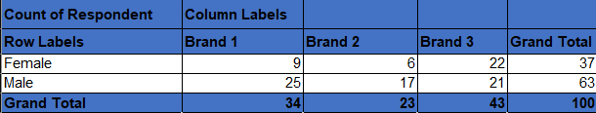
- The data table (Observed table):

- We need to expect the count table so we calculate the expected frequencies using the fomula: Expected Frequency = (Row Total * Column Total) / N.
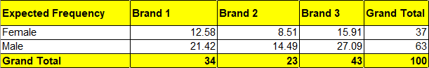
- We have the table below (Expected table):

- The formula for the test statistic is: $x^{2}= Σ\frac{{\left(O-E\right)}^{2}}{E}$
↔ $x^{2}=\frac{{(9-12.58)}^{2}}{12.58}+ \frac{{(6-8.51)}^{2}}{8.51}+\frac{{(22-15.91)}^{2}}{15.91}+\frac{{(25-21.42)}^{2}}{21.42}+\frac{{(17-14.49)}^{2}}{14.49}+ \frac{{(21-27.09)}^{2}}{27.09}=$ 6.492425 (1)
- Degree of freedom: df = (r - 1) x (c - 1) = (2 - 1) x (3 - 1) = 2
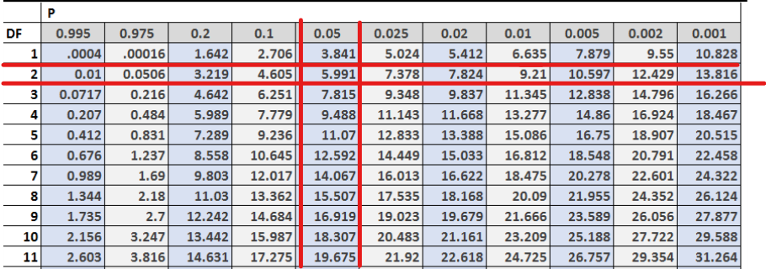
- Critical value: Using Chi-square distribution table to find out the critical value

→ Chi-square critical value is 5.991 (2)
- From (1) and (2) → x² = 6.49 > 5.991
→ Reject the null hypothesis.
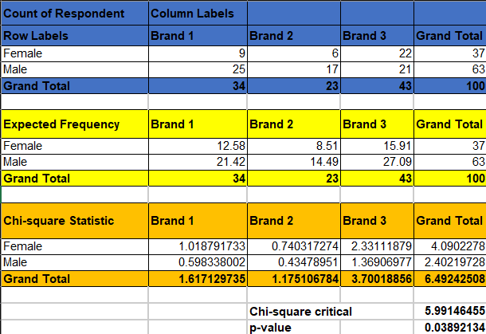
- The p-value is found with degrees of freedom and 5% significance level. Using a table or software, we find the p-value to be 0.038921342.

- With a p-value less than 5%, we reject the null hypothesis. In conclusion, the result is statistically significant.

