# EDA for Customer Segmentation Dataset

## Summary of Dataset

The dataset contains 19 columns and 1907 entries. Key highlights include:  
1. Campaign details such as type, channel, topic, duration, and message counts.  
2. Subject attributes like emojis, discounts, deadlines, etc., used in campaigns.  
3. Missing data is observed in fields like 'topic', 'started_at', 'finished_at', and several other columns.

## EDA Findings

### 1. Campaign Types Distribution

Campaign types are distributed unevenly, with some types (e.g., 'bulk') being more prevalent than others.

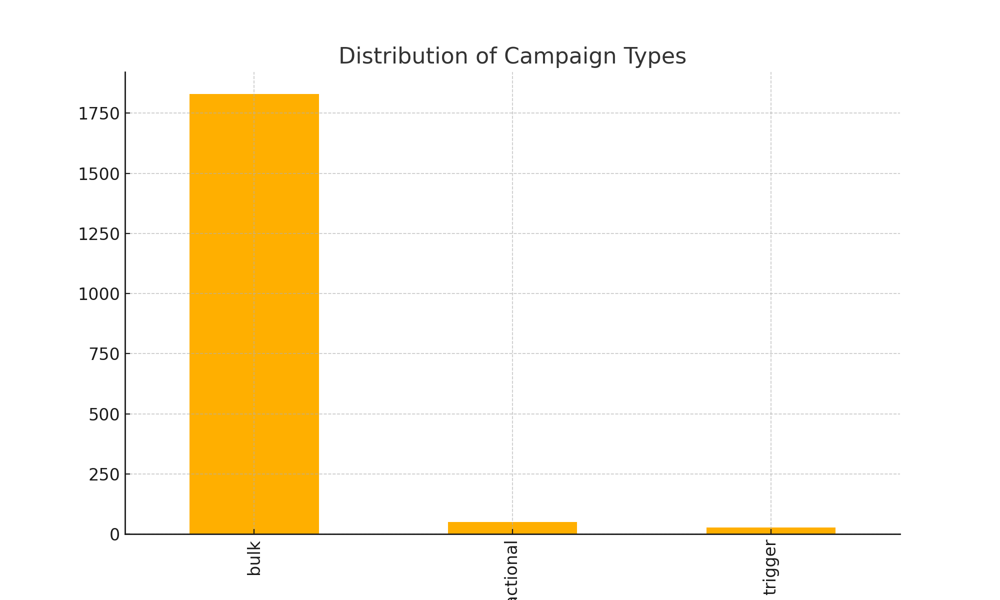

### 2. Channels Distribution

The campaigns are executed across different channels, with a significant concentration on certain channels like 'mobile_push'.

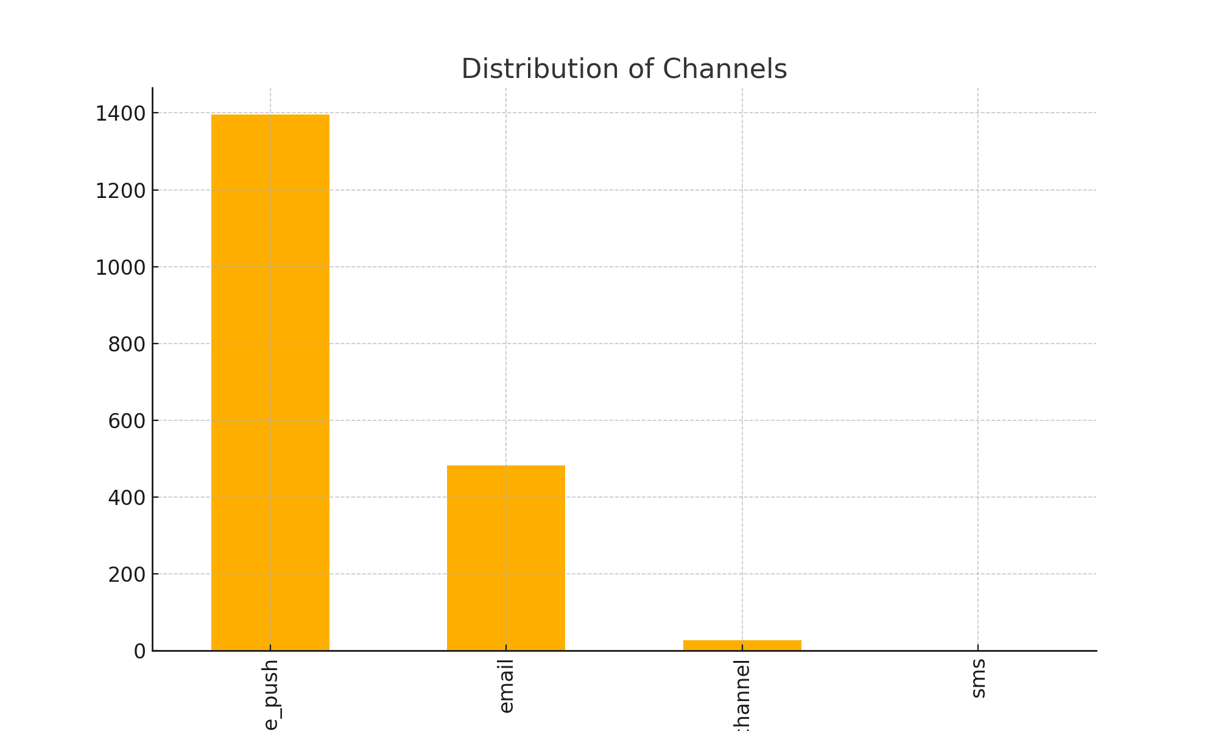

### 3. Messages Sent (total_count)

The number of messages sent per campaign shows a wide range, with the majority sending smaller volumes, but a few campaigns stand out with large message counts.

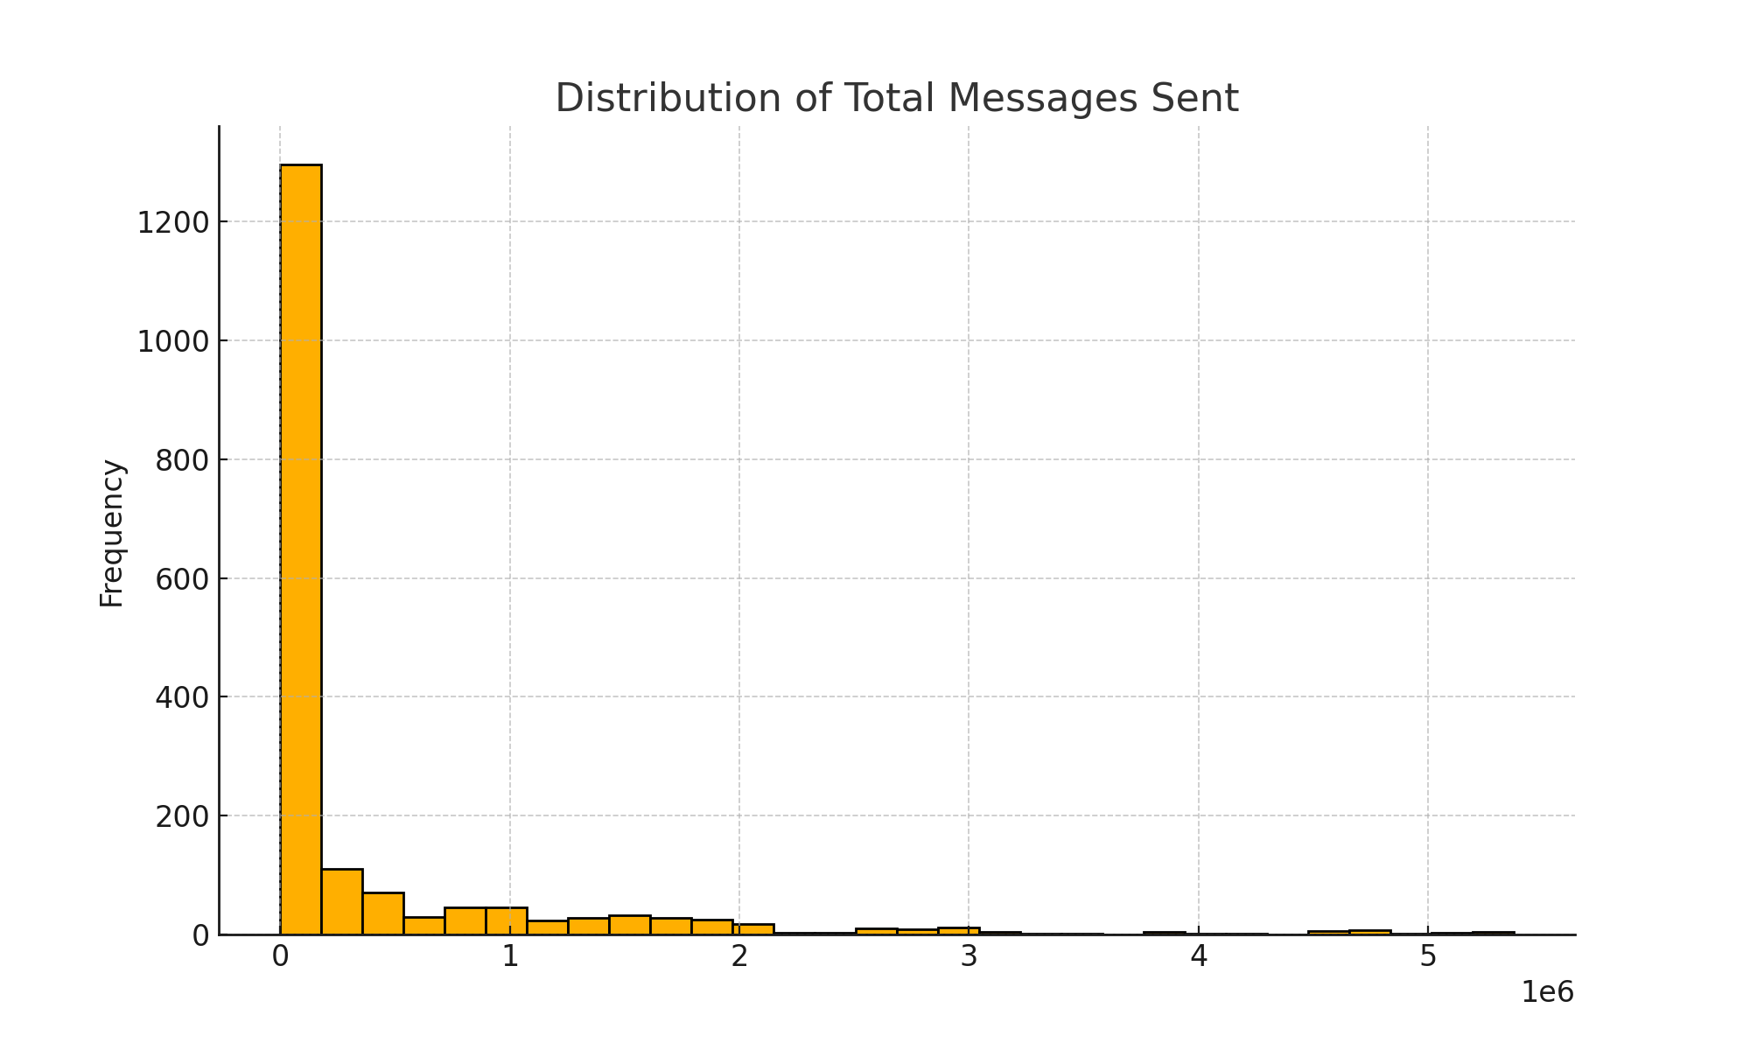

### 4. Subject Attributes Impact

Subject attributes like emojis, discounts, deadlines, and personalization are variably used. The analysis shows their distribution and potential impact.

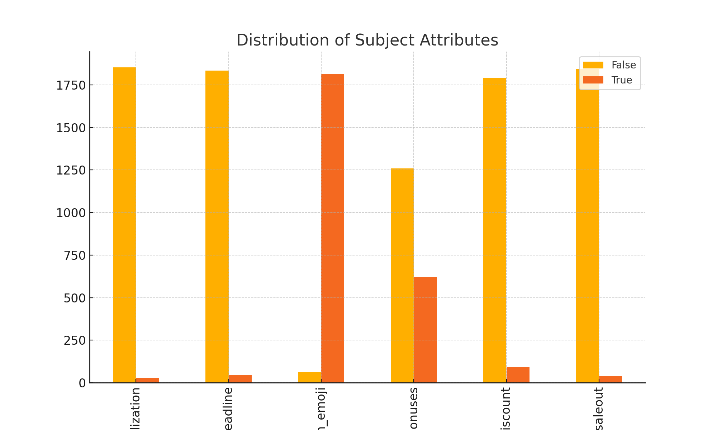

### 5. Campaign Duration

Most campaigns are short-lived, with durations often lasting a few hours.

