# EDA for Customer Segmentation Dataset

## Client First Purchase Data

The client first purchase dataset contains 1,854,736 entries with the following columns:  
- client_id: A unique identifier for each customer.  
- first_purchase_date: The date of the customer's first-ever purchase.

### Distribution of First Purchases

The following visualization shows the monthly distribution of first purchases. This helps identify trends in customer acquisition and seasonality.

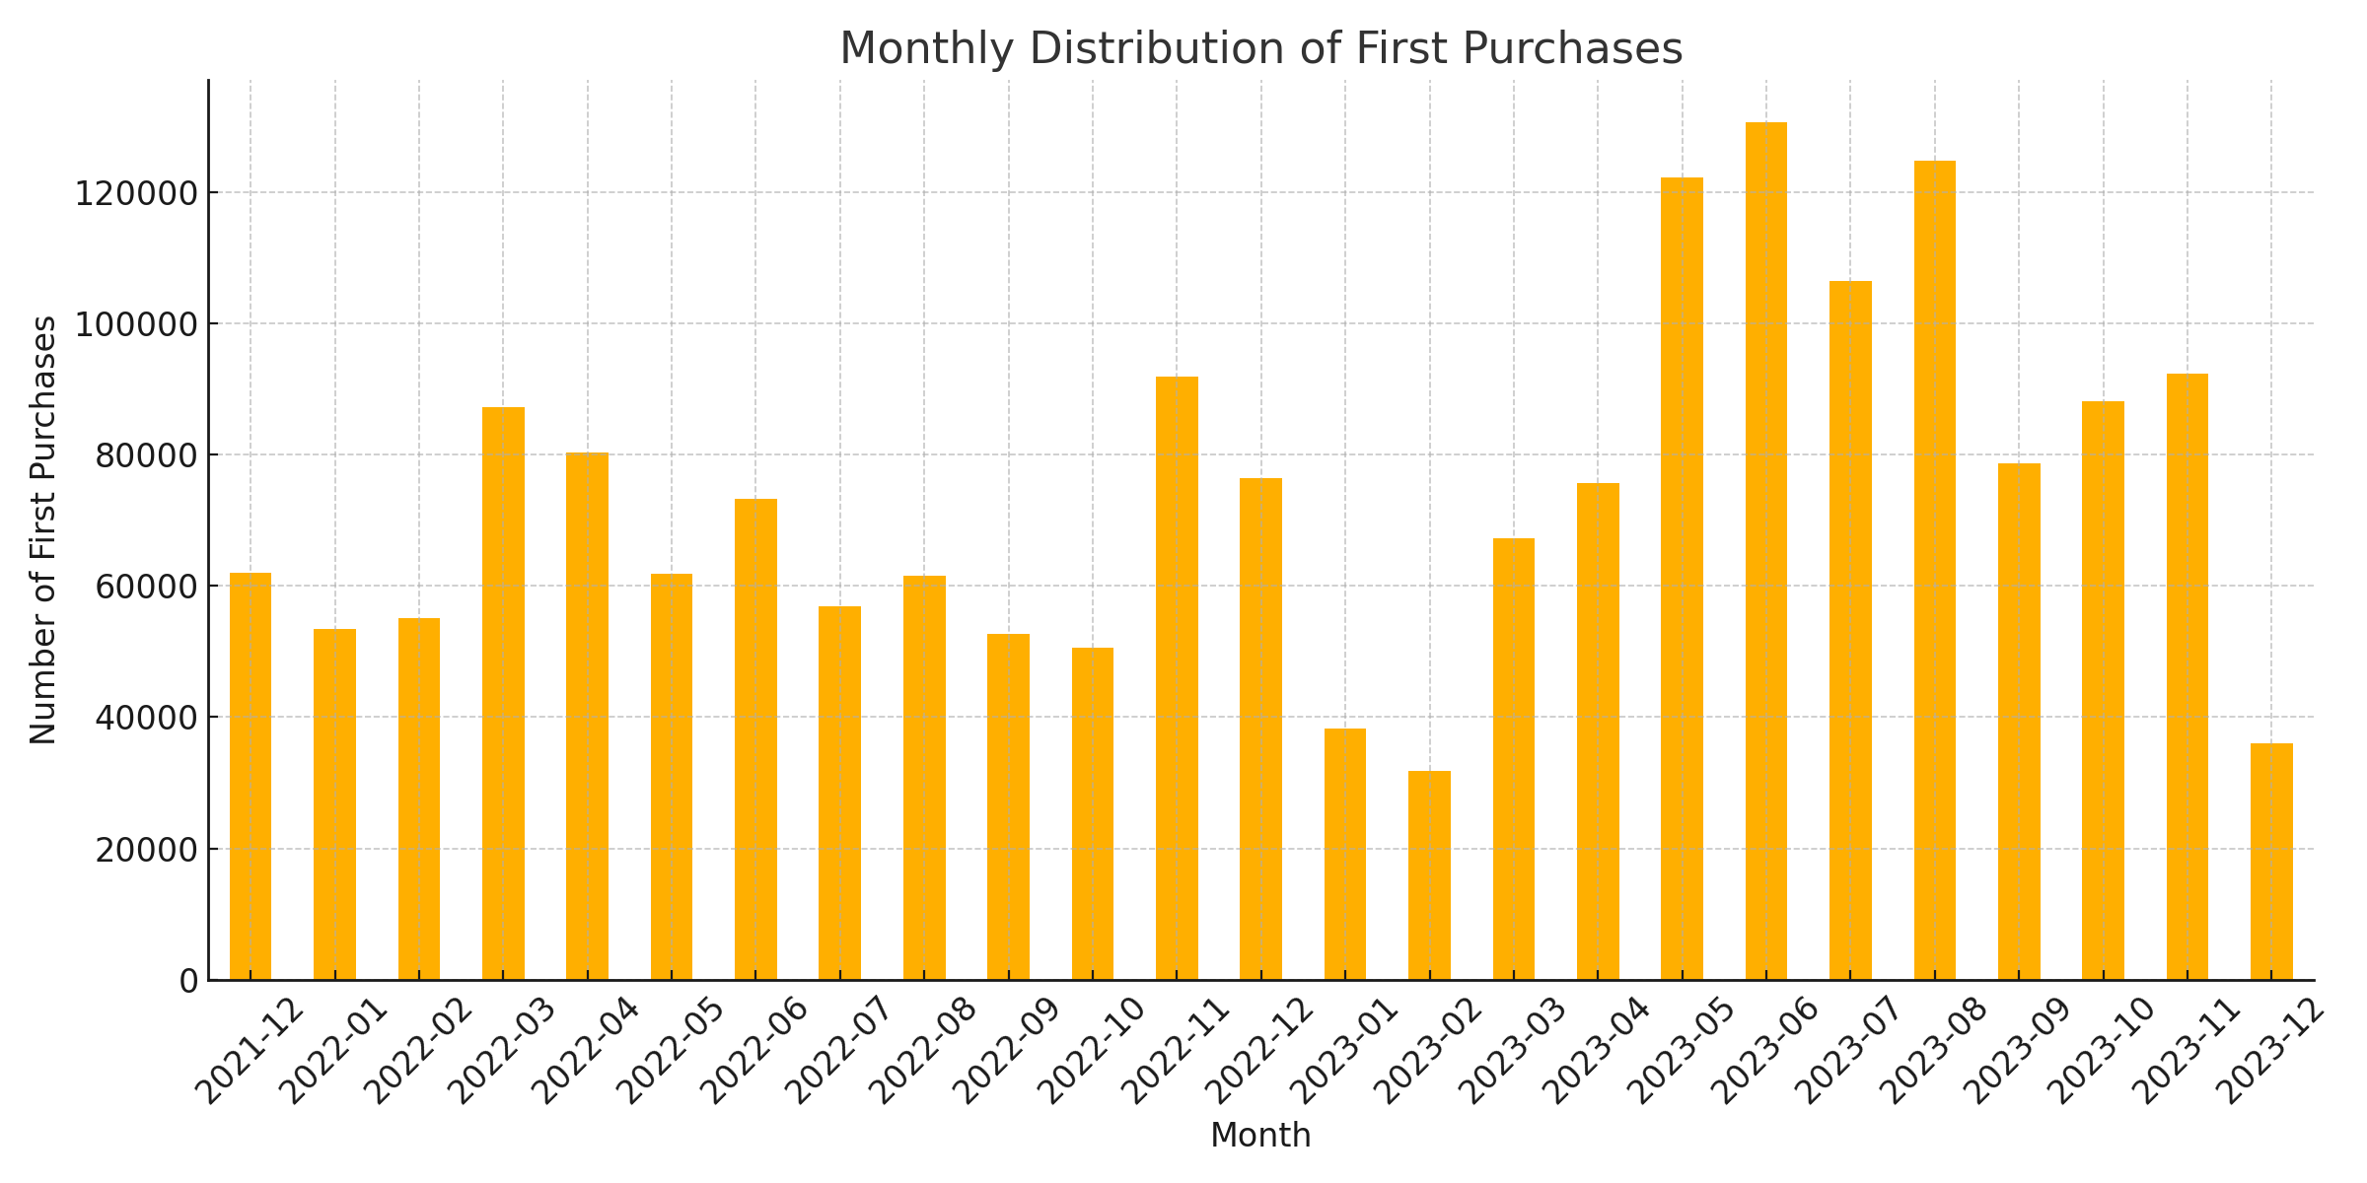

## Campaigns Dataset EDA

### 1. Campaign Types Distribution

Campaign types are distributed unevenly, with some types (e.g., 'bulk') being more prevalent than others.

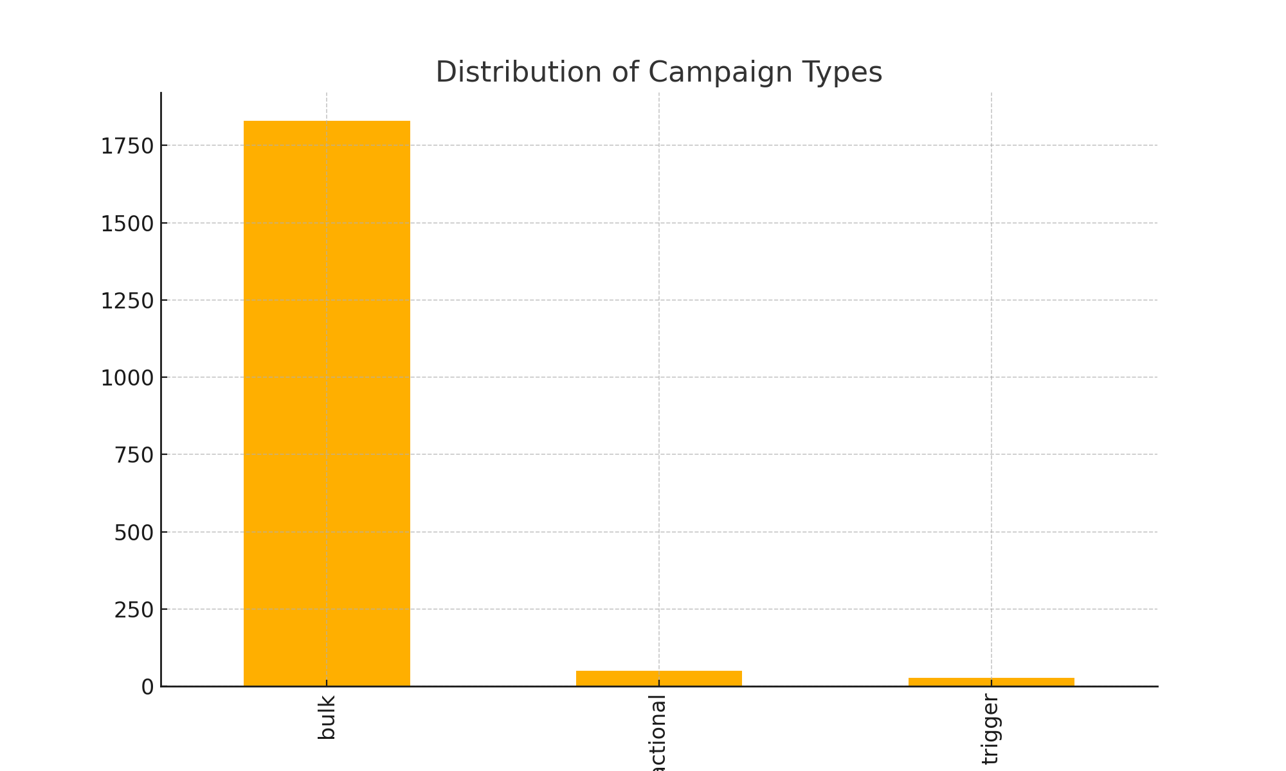

### 2. Channels Distribution

The campaigns are executed across different channels, with a significant concentration on certain channels like 'mobile_push'.

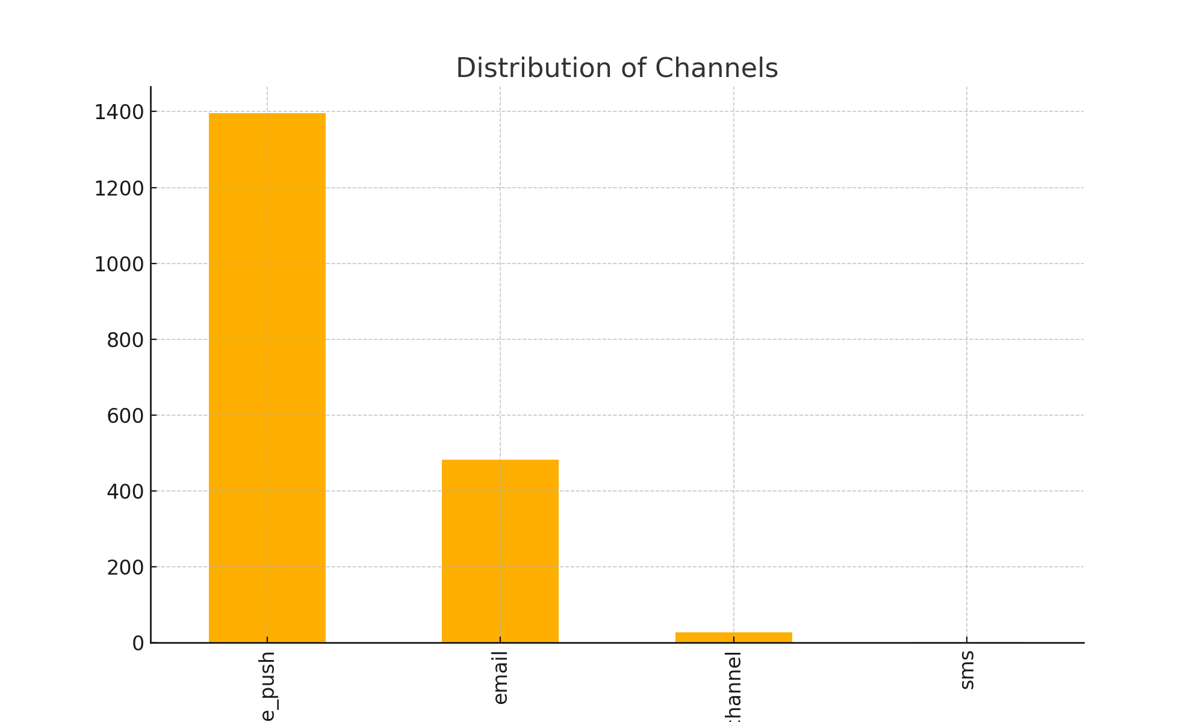

### 3. Messages Sent (total_count)

The number of messages sent per campaign shows a wide range, with the majority sending smaller volumes, but a few campaigns stand out with large message counts.

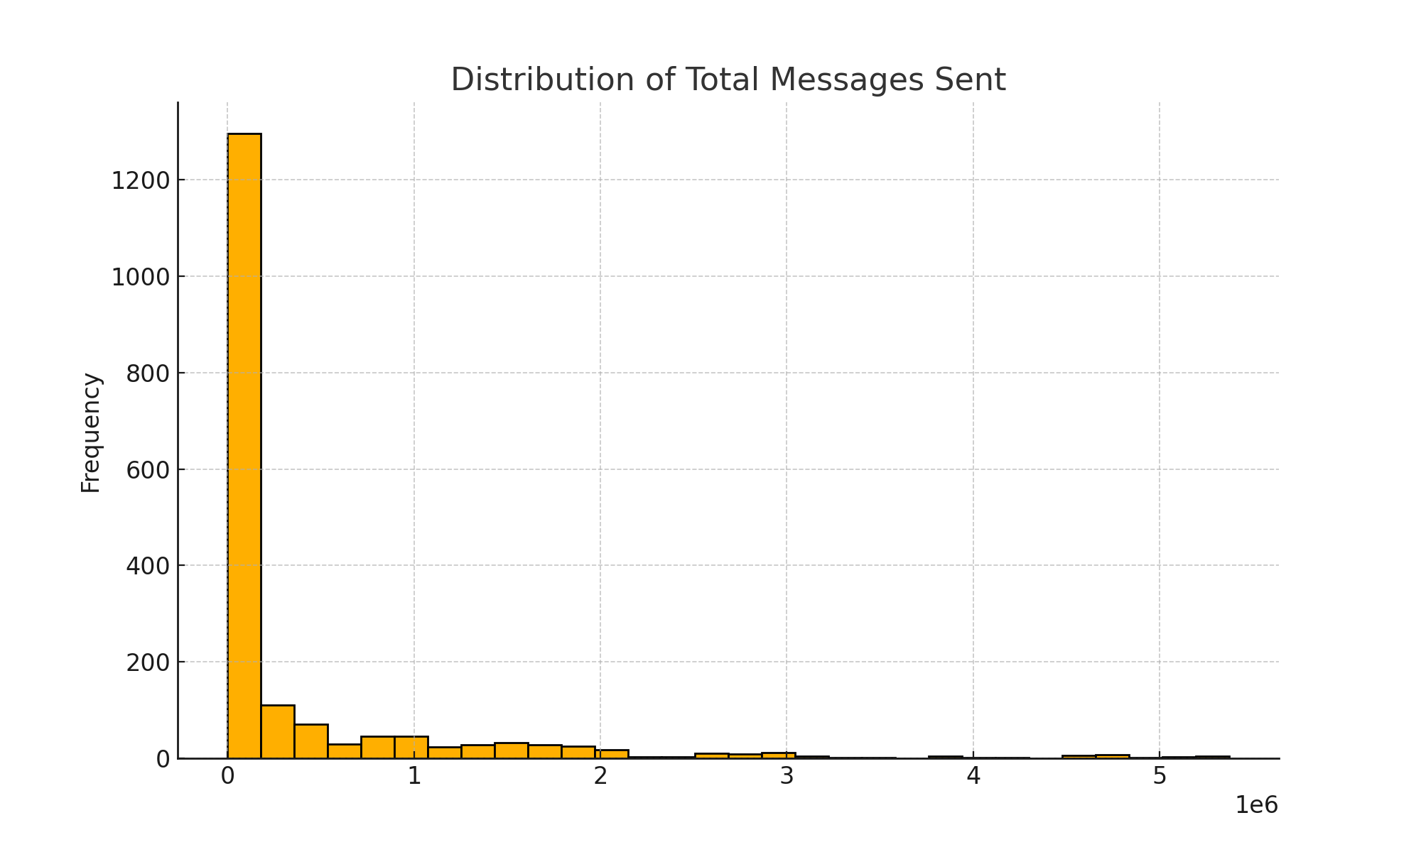

### 4. Subject Attributes Impact

Subject attributes like emojis, discounts, deadlines, and personalization are variably used. The analysis shows their distribution and potential impact.

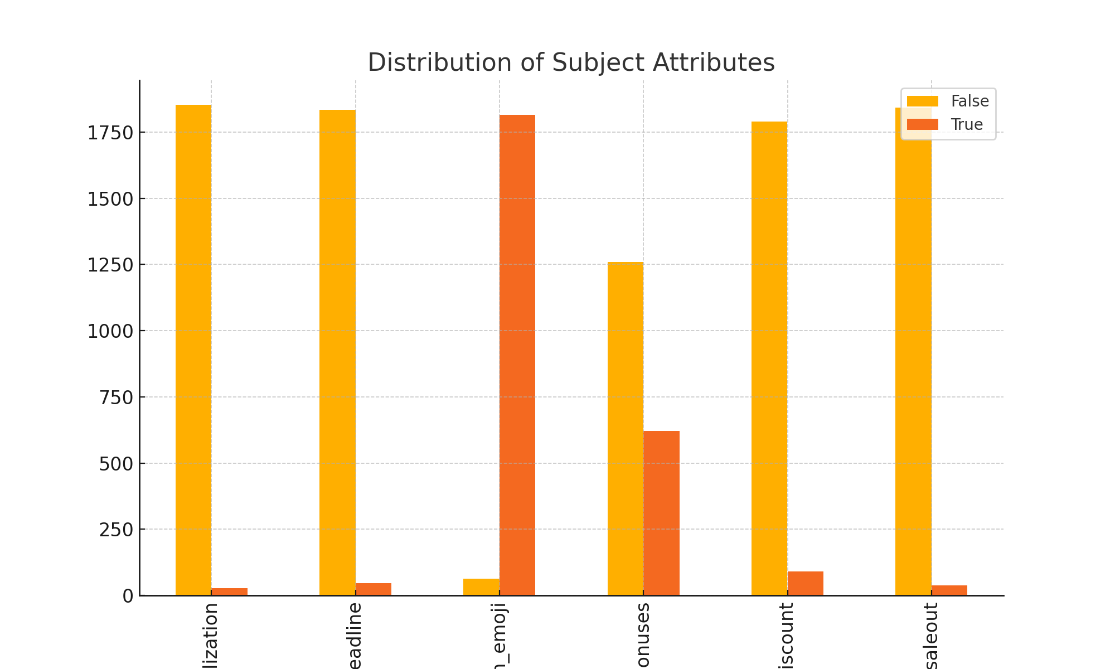

### 5. Campaign Duration

Most campaigns are short-lived, with durations often lasting a few hours.

