# EDA for Customer Segmentation Dataset

## Holidays Data

The holidays dataset contains information about 48 holidays, including their dates and names. This data is crucial for analyzing the impact of holidays on customer behavior and campaign performance.

### Purchase Trends Around Holidays

The analysis explores whether customer acquisitions are influenced by holidays. The following pie chart shows the proportion of purchases made near holidays (within ±3 days).

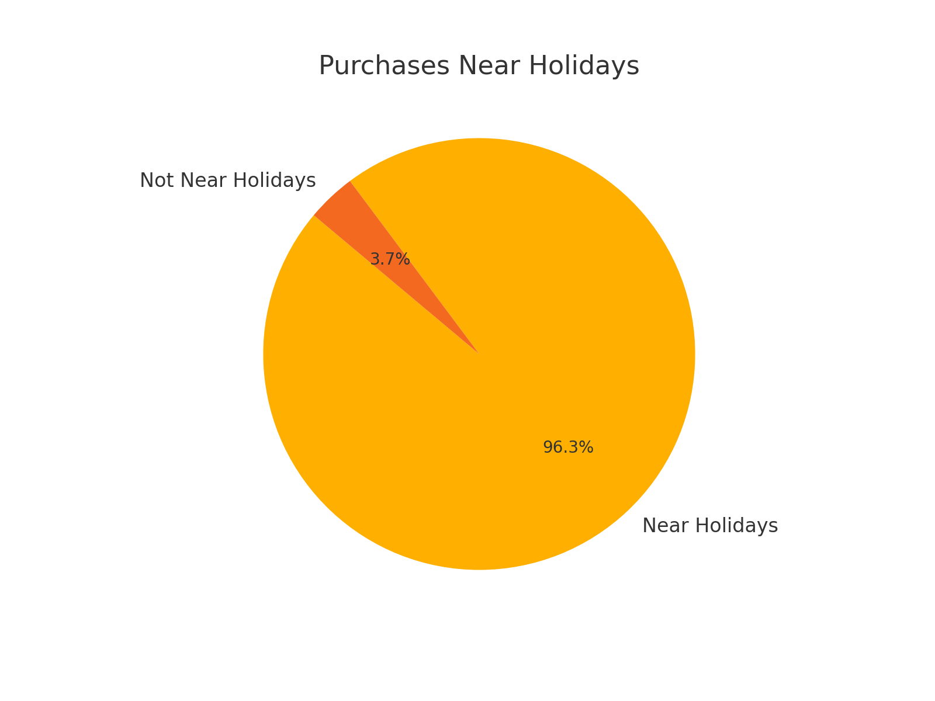

## Campaigns Dataset EDA

### 1. Campaign Types Distribution

Campaign types are distributed unevenly, with some types (e.g., 'bulk') being more prevalent than others.

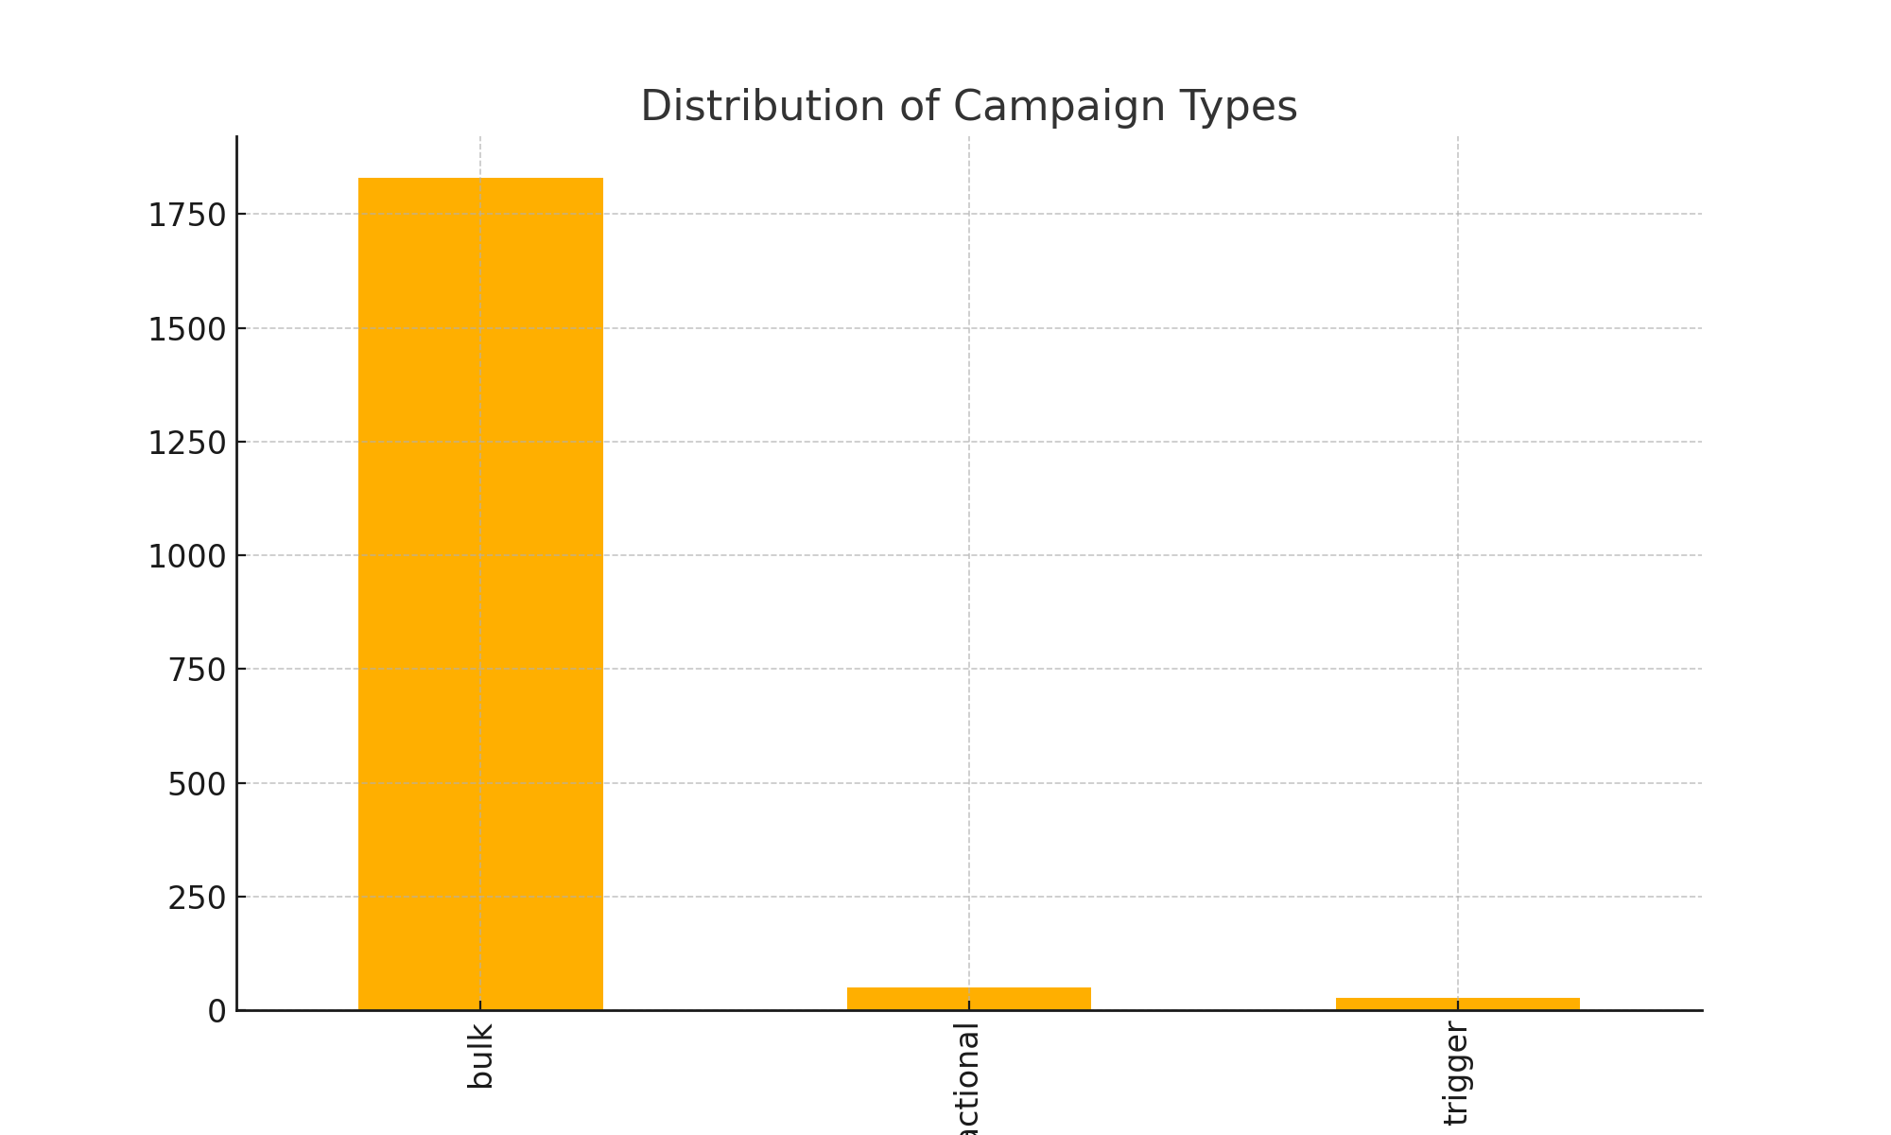

### 2. Channels Distribution

The campaigns are executed across different channels, with a significant concentration on certain channels like 'mobile_push'.

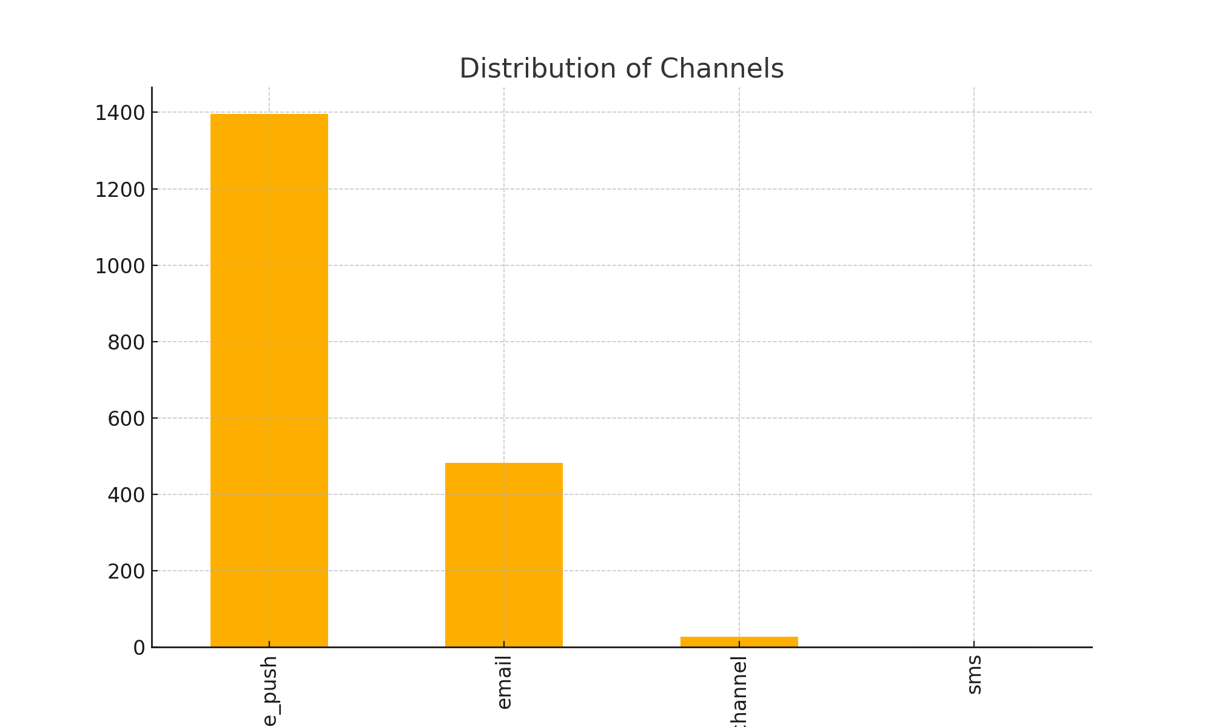

### 3. Messages Sent (total_count)

The number of messages sent per campaign shows a wide range, with the majority sending smaller volumes, but a few campaigns stand out with large message counts.

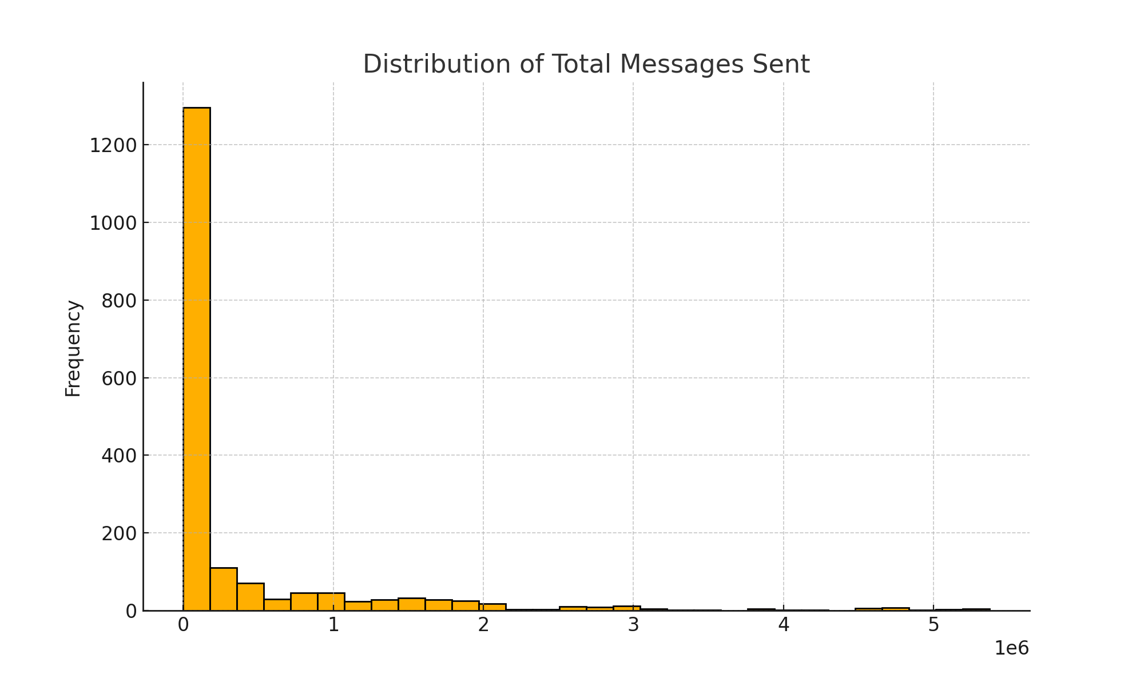

### 4. Subject Attributes Impact

Subject attributes like emojis, discounts, deadlines, and personalization are variably used. The analysis shows their distribution and potential impact.

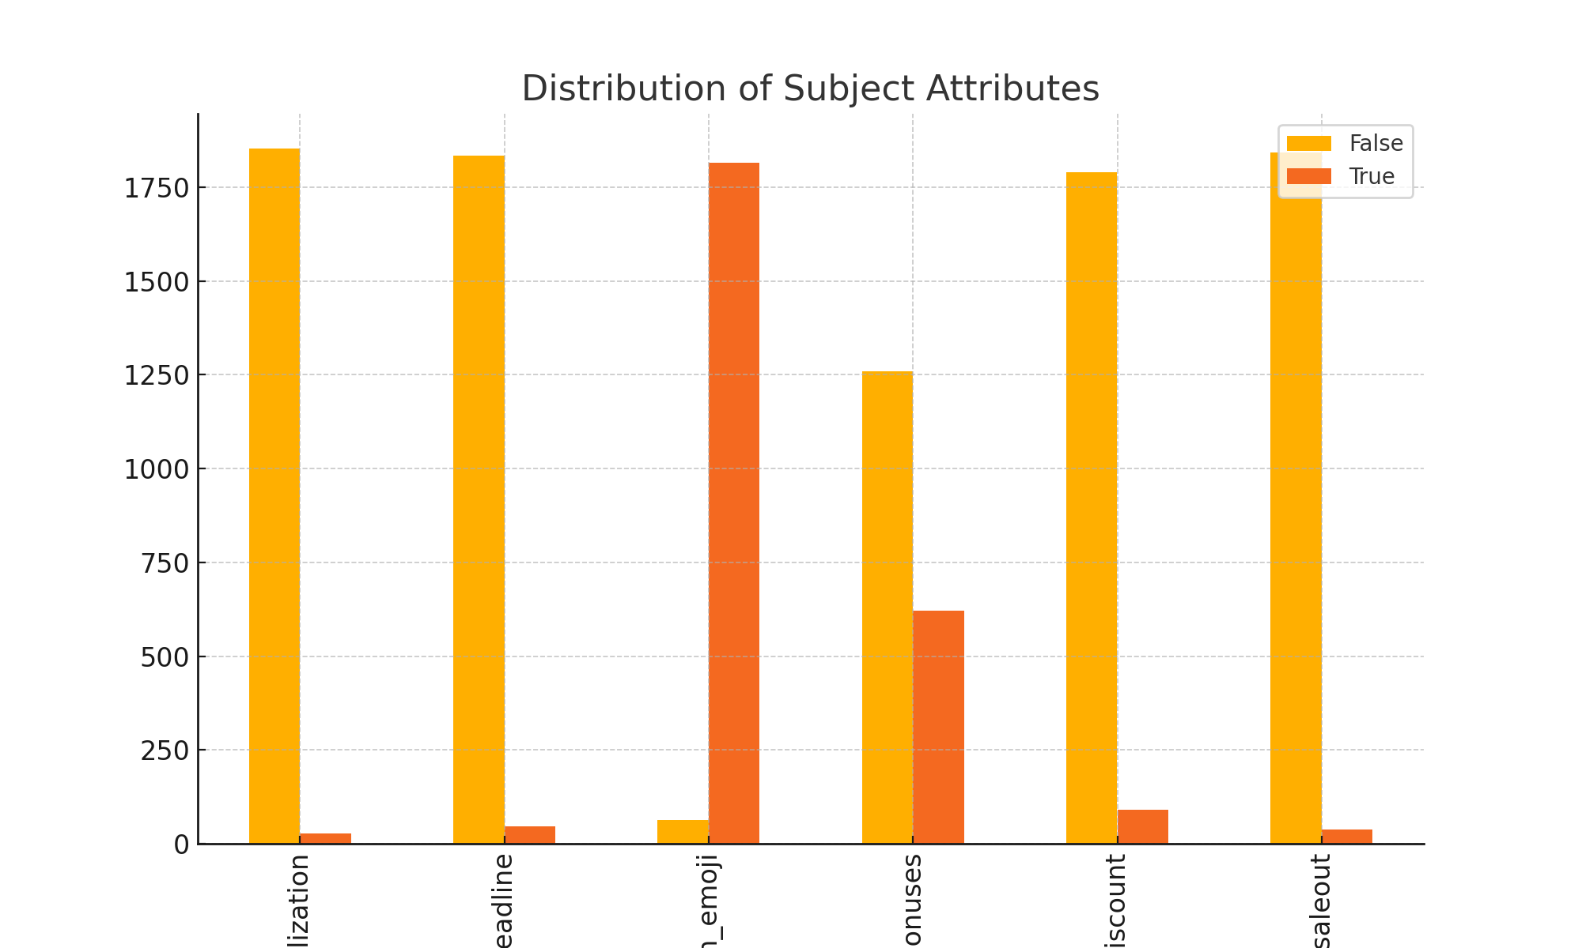

### 5. Campaign Duration

Most campaigns are short-lived, with durations often lasting a few hours.

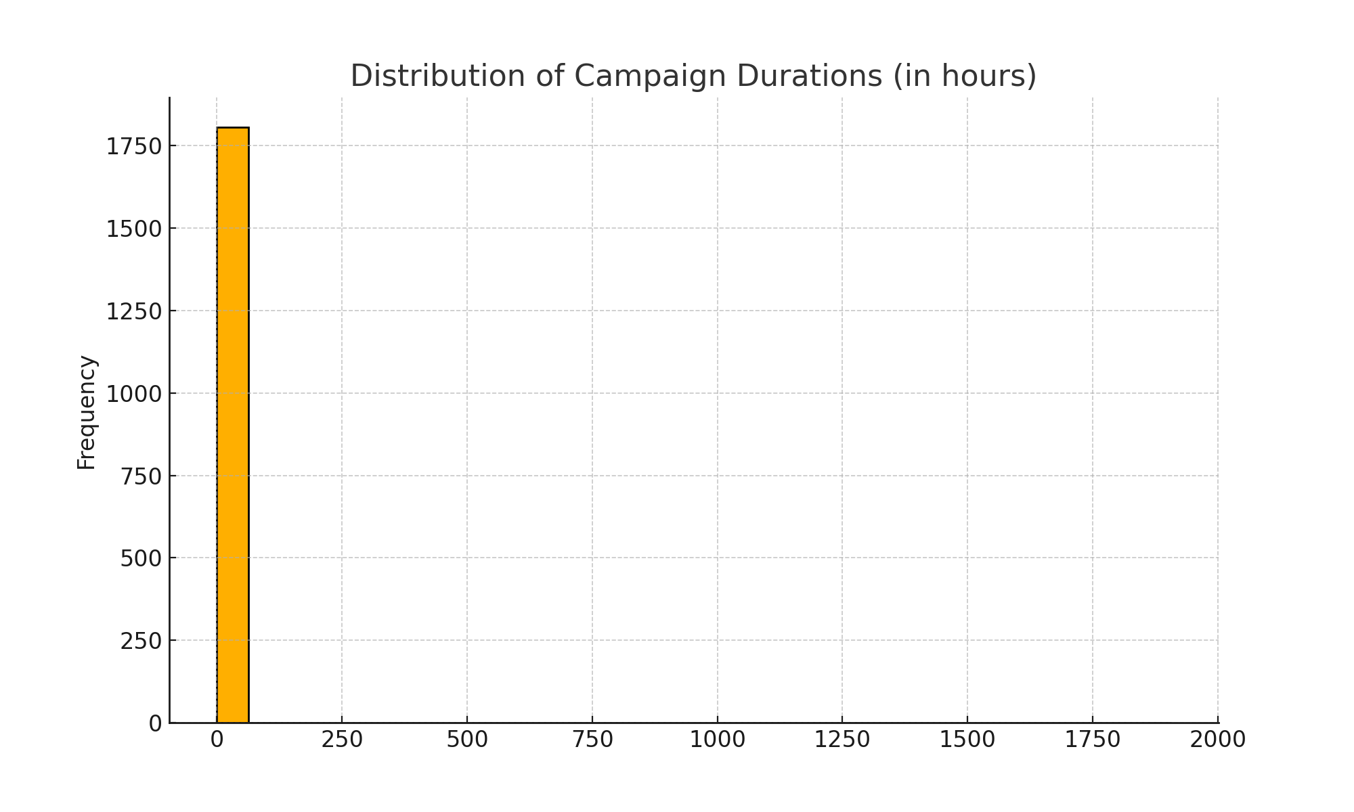

## Client First Purchase Analysis

### Distribution of First Purchases

The following visualization shows the monthly distribution of first purchases. This helps identify trends in customer acquisition and seasonality.

