# EDA for Customer Segmentation Dataset

## Messages Dataset Analysis

The messages dataset contains 10243 entries with details on campaigns, customers, and engagement.  
  
Key Engagement Metrics:  
- Open Rate: 16.13%  
- Click Rate: 16.13%

### Distribution of Campaign Types

The following bar chart shows the distribution of messages across campaign types.

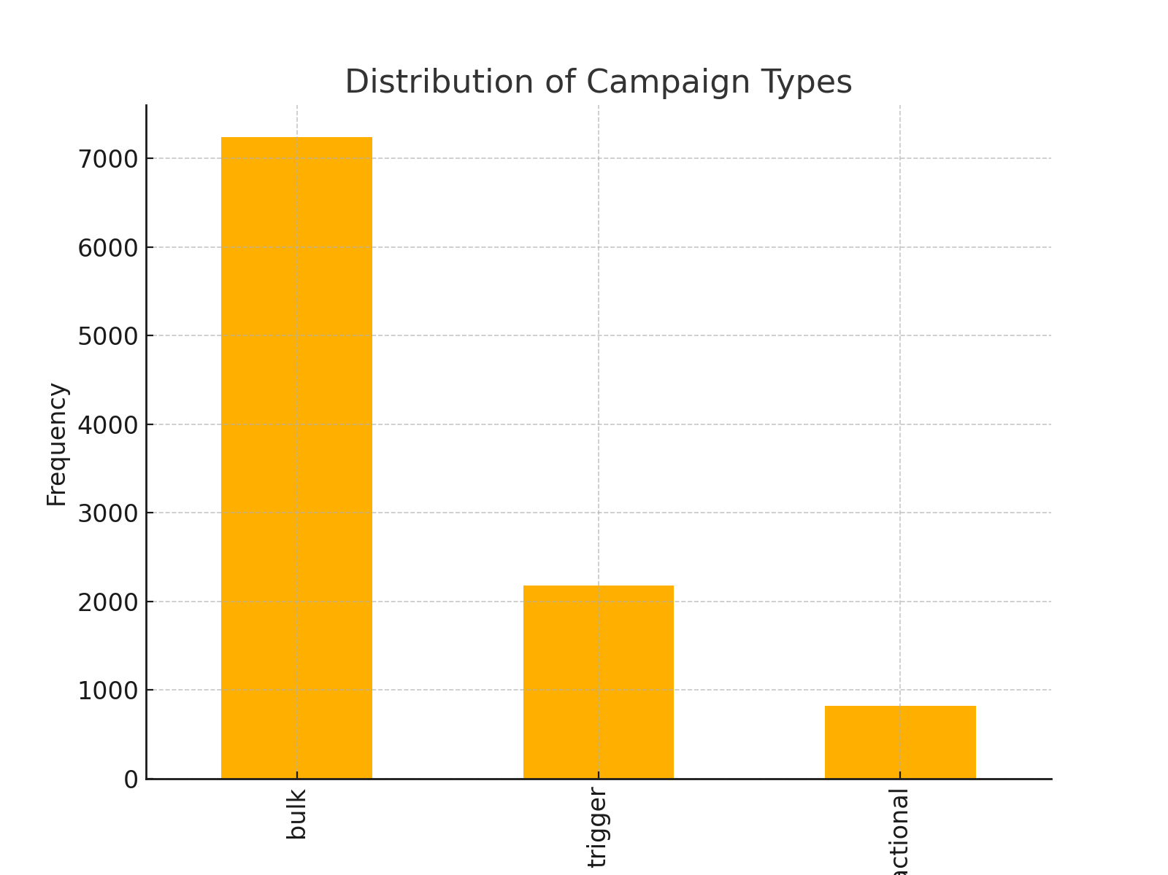

### Distribution of Channels

The following bar chart shows the distribution of messages across channels.

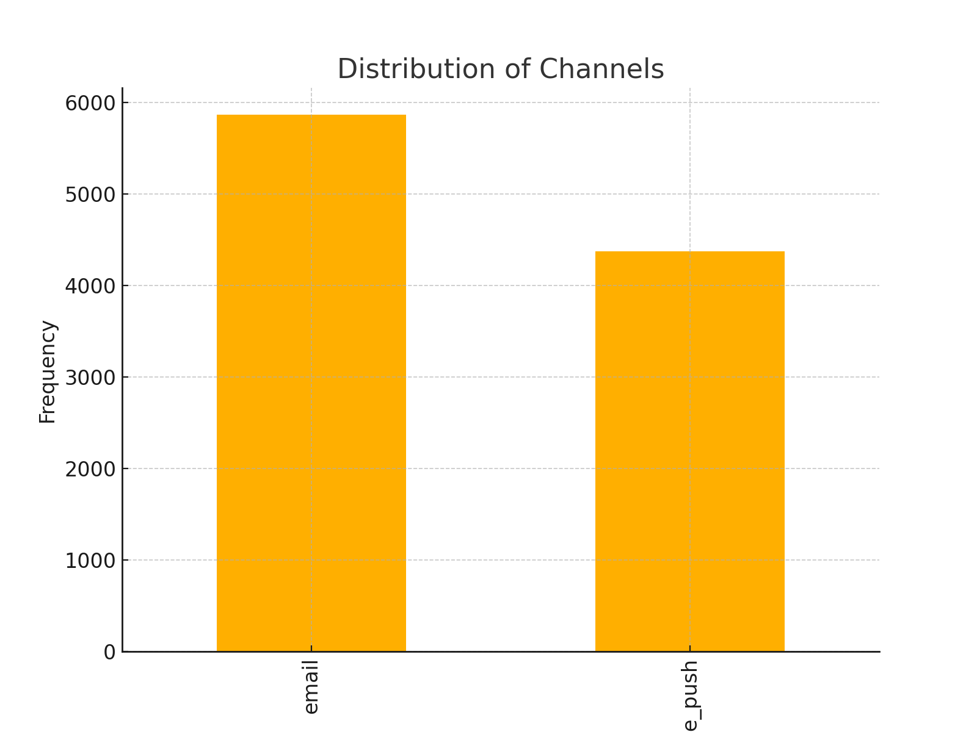

### Engagement Rates

The following bar chart illustrates the open and click rates for the messages.

