BÀI THỰC HÀNH SỐ 2. TẠO DATABASE LINK TRÊN RADMIN MẠNG VPN

Trần Văn Thế, 20520770,

Lưu Vĩnh Phát 20521733,

Đỗ Huỳnh Mỹ Tâm 20520746,

Nguyễn Minh Duy 21522005,

20520770@gm.uit.edu.vn

20521733@gm.uit.edu.vn

20520746@gm.uit.edu.vn

21522005@gm.uit.edu.vn,

tóm tắt nội dung thực hành

Sinh viên tìm hiểu việc thiết lập kết nối giữa các cơ sở dữ liệu Oracle qua sự hướng dẫn của giảng viên thực hành. Trong đó, các kiến thức cần lưu ý bao gồm:

o Database link là gì?

o Các loại database link

o Cú pháp tạo, xóa database link.

Ngoài ra có thể tham khảo thêm chi tiết tại đường dẫn https://docs.oracle.com/cd/B28359_01/server.111/b28310/ds_concepts002.htm hoặc video hướng dẫn thực hiện kết nối tại đường dẫn<https://www.youtube.com/watch?v=N-NShW9cusQ>.

Keywords: Database Link, Oracle, Role, Grant, Connect, …

NỘI DUNG THỰC HÀNH

## Data Definition Language (DDL)

***Tại chi nhánh 1***

ALTER SESSION SET NLS_DATE_FORMAT = 'DD/MM/YY HH24:MI:SS';

CREATE TABLE SACH

(

MaSach VARCHAR2(5) CONSTRAINT PK_SACH PRIMARY KEY,

TenSach VARCHAR2(50),

NgayXB DATE,

TacGia VARCHAR2(50),

GiaTien INT,

NhaXuatBan VARCHAR2(20),

LanIn NUMBER

);

CREATE TABLE CHINHANH

(

MaChiNhanh VARCHAR2(4) CONSTRAINT PK_CHINHANH PRIMARY KEY,

TenChiNhanh VARCHAR2(50),

SoDT VARCHAR2(12)

);

CREATE TABLE KHOSACH_QLKHO

(

MaChiNhanh VARCHAR2(4),

MaSach VARCHAR2(5),

SoLuong NUMBER,

NgayCapNhat DATE,

CONSTRAINT PK_KS_QLK PRIMARY KEY (MaChiNhanh,MaSach)

);

CREATE TABLE KHOSACH_NVBH (

MaChiNhanh VARCHAR(4),

MaSach VARCHAR(5),

TinhTrang VARCHAR (10),

KhuyenMai NUMBER ,

CONSTRAINT PK_KHOSACH_NVBH PRIMARY KEY(MaChiNhanh,MaSach)

);

CREATE TABLE NHANVIEN (

MaNV VARCHAR(4) CONSTRAINT PK_NV PRIMARY KEY,

TenNV VARCHAR(50),

DiaChi VARCHAR(30),

SoDT VARCHAR(20),

Luong NUMBER ,

MaChiNhanh VARCHAR(4)

);

--SACH

INSERT INTO SACH VALUES('Book1', 'SpyxFamily T.6', '29/10/2021', 'Endou Tatsuya', 25000, 'Kim Dong', 1);

INSERT INTO SACH VALUES('Book2', 'S. Family T.6 L', '29/10/2021', 'Endou Tatsuya', 45000, 'Kim Dong', 1);

INSERT INTO SACH VALUES('Book3','Th.L?ng B.H', Null, 'Agatha Christie', 120000, 'Tre', 1);

INSERT INTO SACH VALUES('Book4', 'Black Jack 3', '25/10/2021', 'Osamu Tezuka', 30000, 'Tre', 1);

INSERT INTO SACH VALUES('Book5', 'One Piece 90', '11/10/2021', 'Eiichiro Oda', 19500, 'Kim Dong', 2);

-- CHINHANH

INSERT INTO CHINHANH VALUES('CN01', 'Quan 3, TPHCM', '0939013914');

-- KHOSACH_QLKHO

INSERT INTO KHOSACH_QLKHO VALUES('CN01', 'Book1', 0,'29/10/2021');

INSERT INTO KHOSACH_QLKHO VALUES('CN01', 'Book3', 510,'30/10/2021');

INSERT INTO KHOSACH_QLKHO VALUES('CN01', 'Book5', 100,'30/10/2021');

-- KHOSACH_NVBH

INSERT INTO KHOSACH_NVBH VALUES ('CN01','Book1','Het Hang',0);

INSERT INTO KHOSACH_NVBH VALUES ('CN01','Book3','Con Hang',20);

INSERT INTO KHOSACH_NVBH VALUES ('CN01','Book5','Con Hang',20);

-- NHANVIEN

INSERT INTO NHANVIEN VALUES('NV03','Ho Trong Khang','Binh Dinh','0858595208',5200000,'CN01');

INSERT INTO NHANVIEN VALUES('NV04','Ho Huu Thang','Bien Hoa',Null,5200000,'CN01');

INSERT INTO NHANVIEN VALUES('NV06','Tran Thi Ngoc An ','Binh Dinh','0944052874',5200000,'CN01');

***Tại chi nhánh 2***

ALTER SESSION SET NLS_DATE_FORMAT = 'DD/MM/YY HH24:MI:SS';

CREATE TABLE SACH

(

MaSach VARCHAR2(5) CONSTRAINT PK_SACH PRIMARY KEY,

TenSach VARCHAR2(50),

NgayXB DATE,

TacGia VARCHAR2(50),

GiaTien INT,

NhaXuatBan VARCHAR2(20),

LanIn NUMBER

);

CREATE TABLE CHINHANH

(

MaChiNhanh VARCHAR2(4) CONSTRAINT PK_CHINHANH PRIMARY KEY,

TenChiNhanh VARCHAR2(50),

SoDT VARCHAR2(12)

);

CREATE TABLE KHOSACH_QLKHO

(

MaChiNhanh VARCHAR2(4),

MaSach VARCHAR2(5),

SoLuong NUMBER,

NgayCapNhat DATE,

CONSTRAINT PK_KS_QLK PRIMARY KEY (MaChiNhanh,MaSach)

);

CREATE TABLE KHOSACH_NVBH (

MaChiNhanh VARCHAR(4),

MaSach VARCHAR(5),

TinhTrang VARCHAR (10),

KhuyenMai NUMBER ,

CONSTRAINT PK_KHOSACH_NVBH PRIMARY KEY(MaChiNhanh,MaSach)

);

CREATE TABLE NHANVIEN (

MaNV VARCHAR(4) CONSTRAINT PK_NV PRIMARY KEY,

TenNV VARCHAR(50),

DiaChi VARCHAR(30),

SoDT VARCHAR(20),

Luong NUMBER ,

MaChiNhanh VARCHAR(4)

);

--SACH

INSERT INTO SACH VALUES('Book1', 'SpyxFamily T.6', '29/10/2021', 'Endou Tatsuya', 25000, 'Kim Dong', 1);

INSERT INTO SACH VALUES('Book2', 'S. Family T.6 L', '29/10/2021', 'Endou Tatsuya', 45000, 'Kim Dong', 1);

INSERT INTO SACH VALUES('Book3','Th.L?ng B.H', Null, 'Agatha Christie', 120000, 'Tre', 1);

INSERT INTO SACH VALUES('Book4', 'Black Jack 3', '25/10/2021', 'Osamu Tezuka', 30000, 'Tre', 1);

INSERT INTO SACH VALUES('Book5', 'One Piece 90', '11/10/2021', 'Eiichiro Oda', 19500, 'Kim Dong', 2);

-- CHINHANH

INSERT INTO CHINHANH VALUES('CN02', 'Quan Hoang Kiem, Ha Noi', '0907979815');

-- KHOSACH_QLKHO

INSERT INTO KHOSACH_QLKHO VALUES('CN02', 'Book1', 500,'29/10/2021');

INSERT INTO KHOSACH_QLKHO VALUES('CN02', 'Book2', 0,'29/10/2021');

INSERT INTO KHOSACH_QLKHO VALUES('CN02', 'Book4', 180,'30/10/2021');

INSERT INTO KHOSACH_QLKHO VALUES('CN02', 'Book5', 187,'30/10/2021');

-- KHOSACH_NVBH

INSERT INTO KHOSACH_NVBH VALUES ('CN02','Book1','Con Hang',10);

INSERT INTO KHOSACH_NVBH VALUES ('CN02','Book2','Het Hang',0);

INSERT INTO KHOSACH_NVBH VALUES ('CN02','Book4','Con Hang',10);

INSERT INTO KHOSACH_NVBH VALUES ('CN02','Book5','Con Hang',15);

-- NHANVIEN

INSERT INTO NHANVIEN VALUES('NV01','Nguyen Thi Thuy Nga','Dak Lak','0943058578',4900000, 'CN02');

INSERT INTO NHANVIEN VALUES('NV02','Le Huynh Lan Ha','An Giang','0823664648',4900000,'CN02');

INSERT INTO NHANVIEN VALUES('NV05','Phan Pham Quynh Hoa','Binh Thuan',Null,4900000, 'CN02');

## Six query

***\*Tại chi nhánh 1***

***Database link tại chi nhánh 1***

***Query 1***



***Query 2***

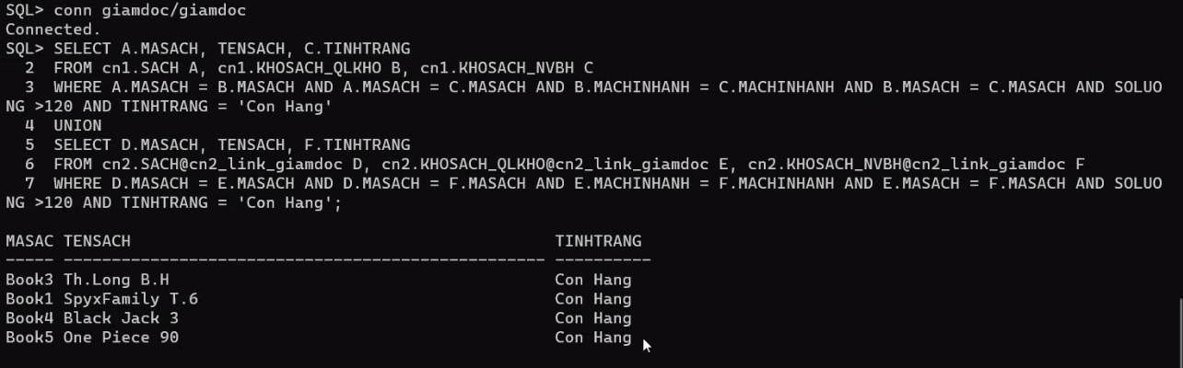

***Query 3***

***Query 4***

***Query 5***

***\*Tại chi nhánh 2***

***Database link tại chi nhánh 2***

***Query 6***

## Kiến thức phân mảnh

***Tại chi nhánh 1:***

* SACH
* CN1.CHINHANH =𝛿(MaChiNhanh = 'CN1')CHINHANH
* CN1.KHOSACH = KHOSACH ⋉MaChiNhanhCN1.CHINHANH
* CN1.KHOSACH tách thành:
  + CN1.KHOSACH_QLKHO (MaChiNhanh, MaSach, SoLuong, NgayCapNhat)
  + CN1.KHOSACH_NVBH (MaChiNhanh, MaSach, TinhTrang, KhuyenMai)
* CN1.NHANVIEN = NHANVIEN⋉MaChiNhanhCN1. CHINHANH

***Tại chi nhánh 2:***

* SACH
* CN2.CHINHANH =𝛿(MaChiNhanh = 'CN2')CHINHANH
* CN2.KHOSACH = KHOSACH ⋉MaChiNhanh CN2.CHINHANH
* CN2.KHOSACH tách thành:
  + CN2.KHOSACH_QLKHO (MaChiNhanh, MaSach, SoLuong, NgayCapNhat)
  + CN2.KHOSACH_NVBH (MaChiNhanh, MaSach, TinhTrang, KhuyenMai)
* CN2.NHANVIEN = NHANVIEN ⋉MaChiNhanh CN2.CHINHANH

## Kiến trúc phân quyền

***\*Tại chi nhánh 1***

User **cn1**

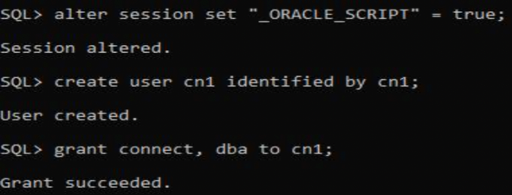

*User* ***GiamDoc***

*User* ***QuanLyKho***

*User* ***NhanVien***

User **cn2**

***\*Tại chi nhánh 2***

User **cn2**

*User* ***GiamDoc***

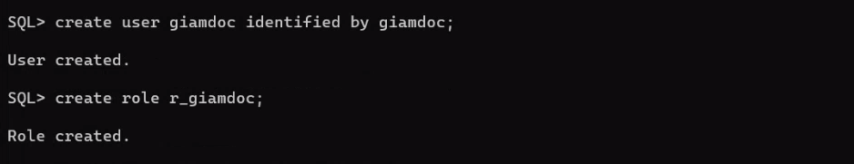

*User* ***QuanLyKho***

*User* ***NhanVien***

User **cn1**

