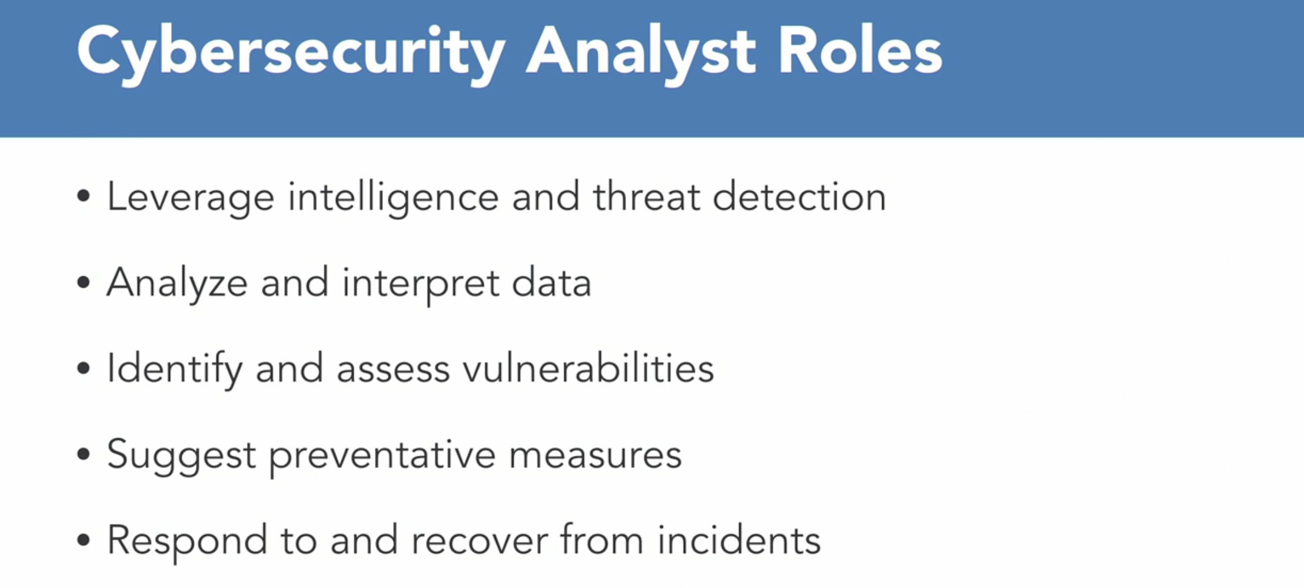

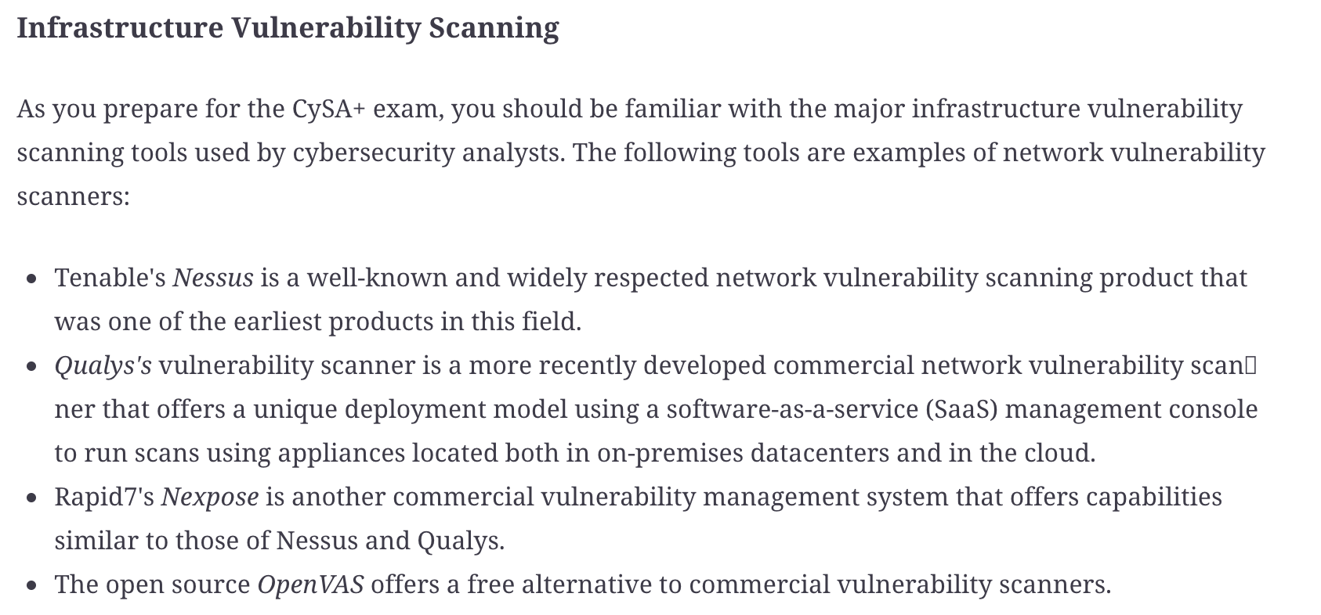

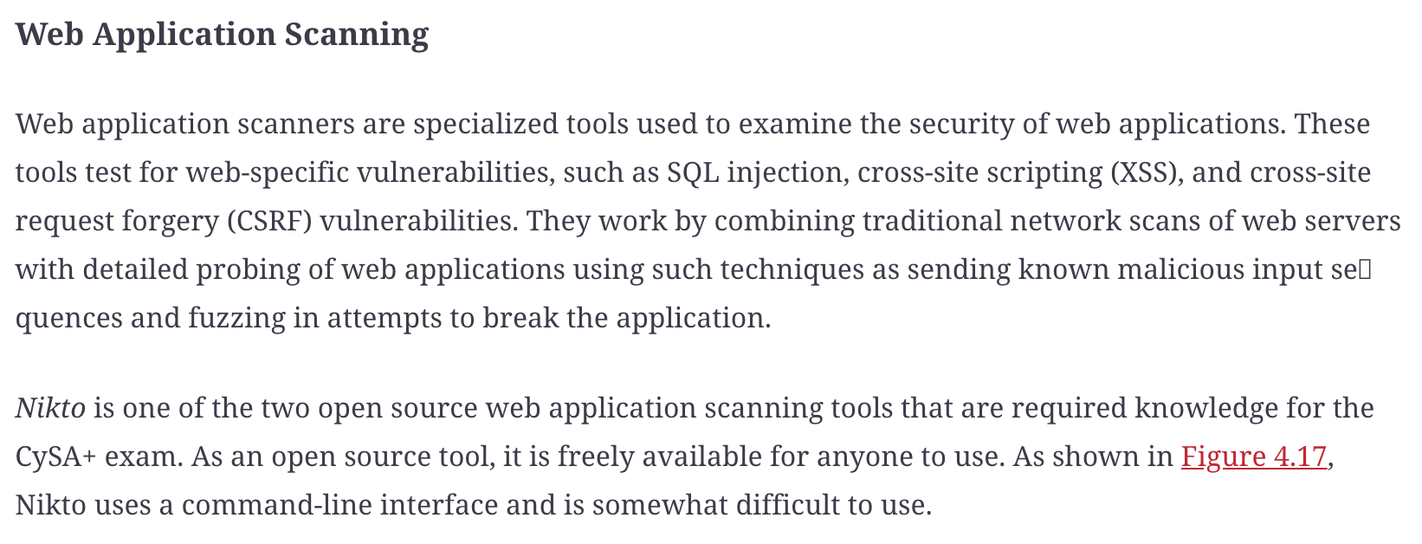

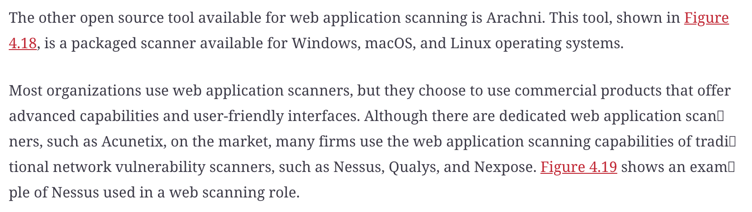

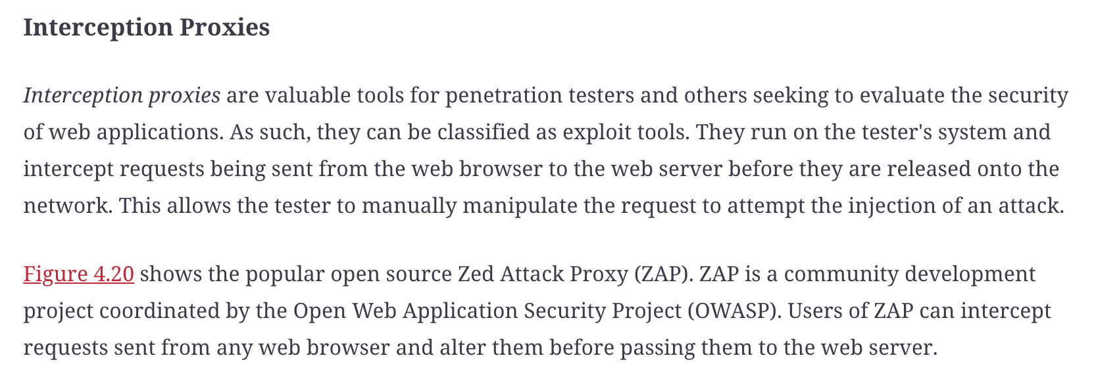

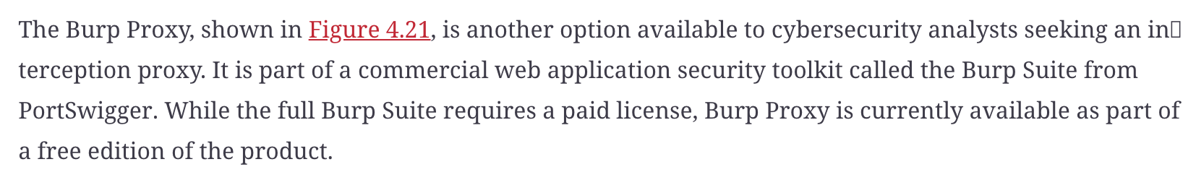

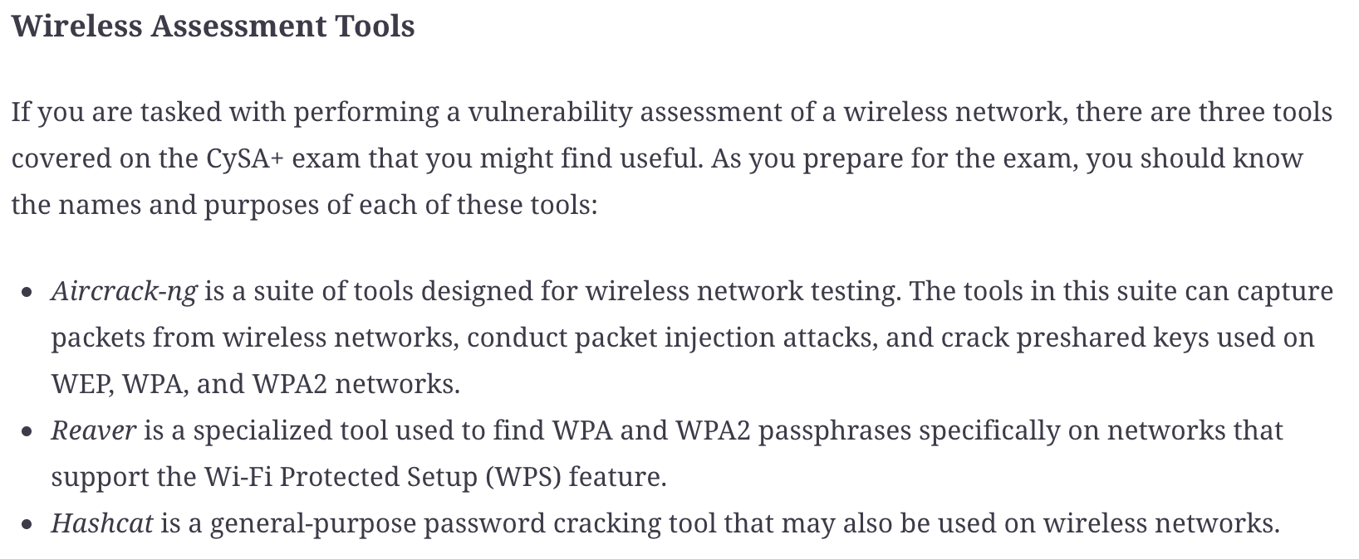

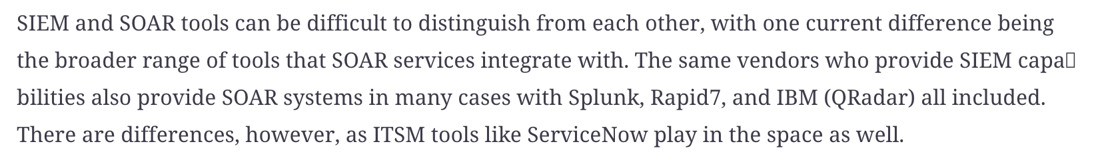

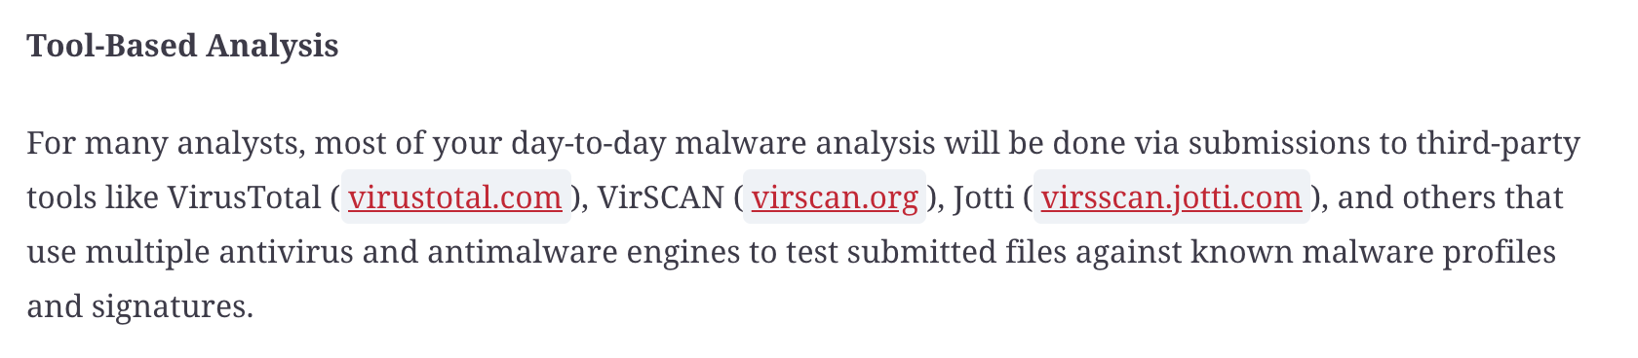

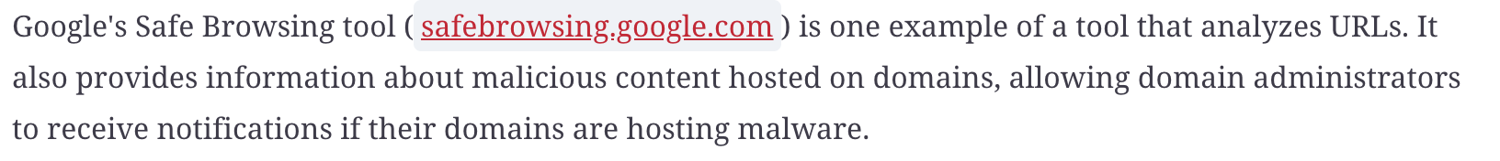

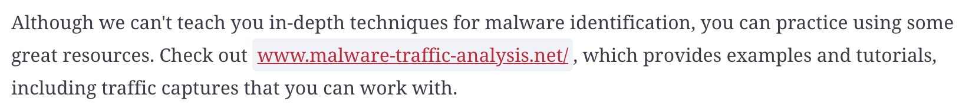

If you're not familiar with the contents of an email header, you can review them at mediatemple.net/community/products/dv/204643950/understanding-an-email-header or https://blog.mailfence.com/email-header/, among many other sites. Email header analysis tools can also be handy, and many sites provide them, including www.whatismyip.com/email-header-analyzer/ and dnschecker.org/email-header-analyzer.php. You won't have access to automated tools like these on the CySA+ exam, so make sure you know how to read a header without help!