COURSE CODE: PRAC101 Section: BSIT - 41014
COURSE TITLE: OJT / PRACTICUM 1
TERM: 1st Semester, SY 2026-2027
PROFESSOR: MR. IAN ERGUIZA
NAME OF STUDENT: CAÑELAS CHRISTIAN D.

OJT NARRATIVE REPORT
A. TOPIC: BSIT MODULES 7 & 8 LECTURE SESSION - FUNDAMENTALS OF WEB APP SECURITY (PART 1)
B. SPEAKER: MR. MARC TONIDO
C. DURATION: 8:00 AM - 9:00 AM
D. DATE: September 16, 2026
E. SCREENSHOT OF DUTY
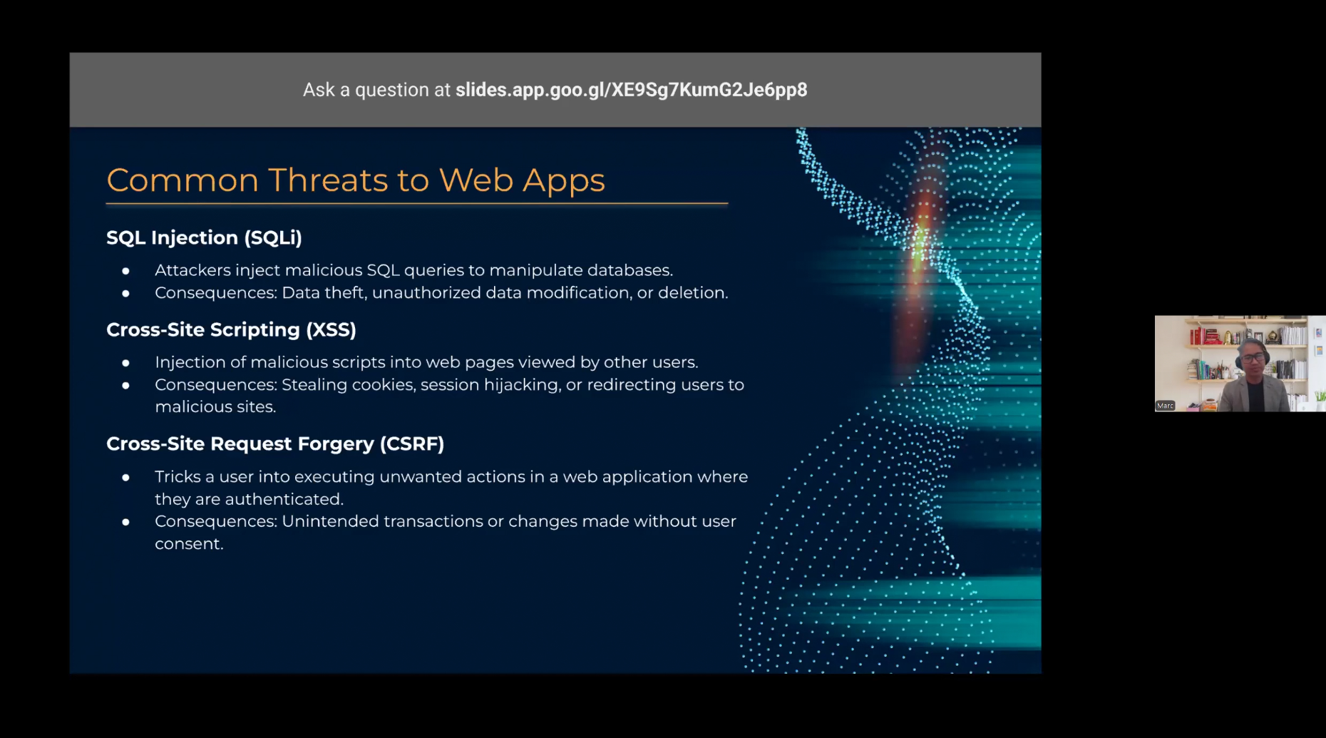

F. REFLECTION
This session opened Modules 7 and 8, which shift the focus specifically to Web App Security, and this first part covered a slide on Common Threats to Web Apps. Mr. Tonido began with SQL Injection, or SQLi, explaining it as a technique where attackers inject malicious SQL queries into input fields to manipulate a database directly, which can lead to consequences like data theft, unauthorized data modification, or outright deletion of records. What stood out to me was how something as ordinary-looking as a login form or search bar can become a serious vulnerability if the backend doesn't properly validate or sanitize what the user types in before running it against the database. It made me think about how easy it is to underestimate small input fields when, in reality, they're often the exact entry point attackers look for first.
Next, he discussed Cross-Site Scripting, or XSS, which involves injecting malicious scripts into web pages that other users end up viewing, and he explained that the consequences can range from stealing cookies to hijacking a session, or even redirecting users to malicious sites without them realizing what happened. This one felt a bit different from SQLi since the target isn't really the database, it's the other people browsing the site, which means the damage spreads to anyone who happens to load that compromised page. It made me realize that a web app doesn't just need to protect its own backend, it also has some responsibility for protecting its users from each other, in a sense, since one attacker's malicious script can end up harming everyone else who visits the same page.
The last threat covered was Cross-Site Request Forgery, or CSRF, which Mr. Tonido described as tricking an already-authenticated user into unknowingly executing actions they never intended, simply by getting them to interact with a malicious link or page while they're still logged into the legitimate site. The consequences mentioned were things like unintended transactions or changes made without the user's actual consent, which sounded genuinely unsettling since the user technically never did anything wrong on their end, their authenticated session was just exploited without their knowledge. This one took me a bit longer to fully wrap my head around compared to the other two, but once I understood that it relies on the trust a site has in an already-logged-in session rather than tricking the user directly, it started to make a lot more sense.
Overall, seeing SQL Injection, XSS, and CSRF laid out together gave me a clearer sense of how differently web apps can be attacked depending on where the trust gap actually is, whether it's the database trusting raw input, other users trusting content on a shared page, or the server trusting a request just because it came from a session that's already logged in. It also made this feel like a natural continuation of the cloud security discussion from the previous module, since a lot of cloud-hosted services are ultimately reached through web applications, so securing the cloud infrastructure itself doesn't mean much if the web app sitting on top of it is still full of these kinds of vulnerabilities. I'm hoping the second part of this module goes into how each of these threats is typically prevented, like input validation, output encoding, or the use of anti-CSRF tokens, since knowing how these attacks work is only useful once we also know how to actually defend against them.

