COURSE CODE: PRAC101 Section: BSIT - 41014
COURSE TITLE: OJT / PRACTICUM 1
TERM: 1st Semester, SY 2026-2027
PROFESSOR: MR. IAN ERGUIZA
NAME OF STUDENT: CAÑELAS CHRISTIAN D.

OJT NARRATIVE REPORT
A. TOPIC: BSIT MODULE 5 LECTURE SESSION - FUNDAMENTALS OF CYBERSECURITY
B. SPEAKER: MR. MARC TONIDO
C. DURATION: 8:00 AM - 9:00 AM
D. DATE: September 2, 2026
E. SCREENSHOT OF DUTY
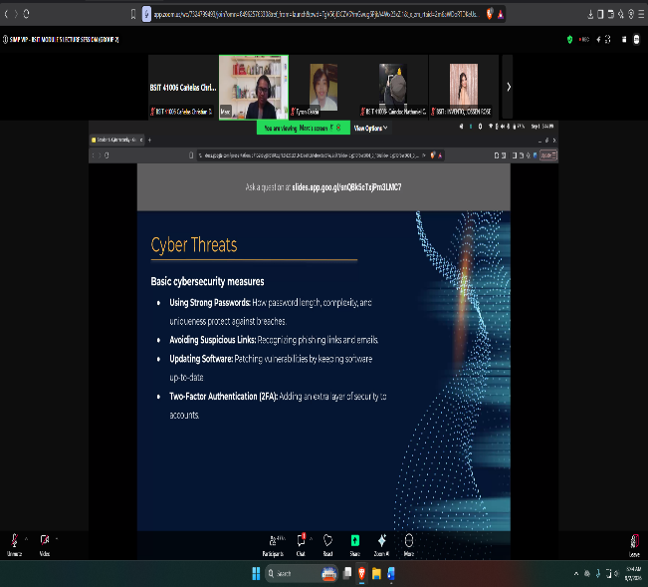
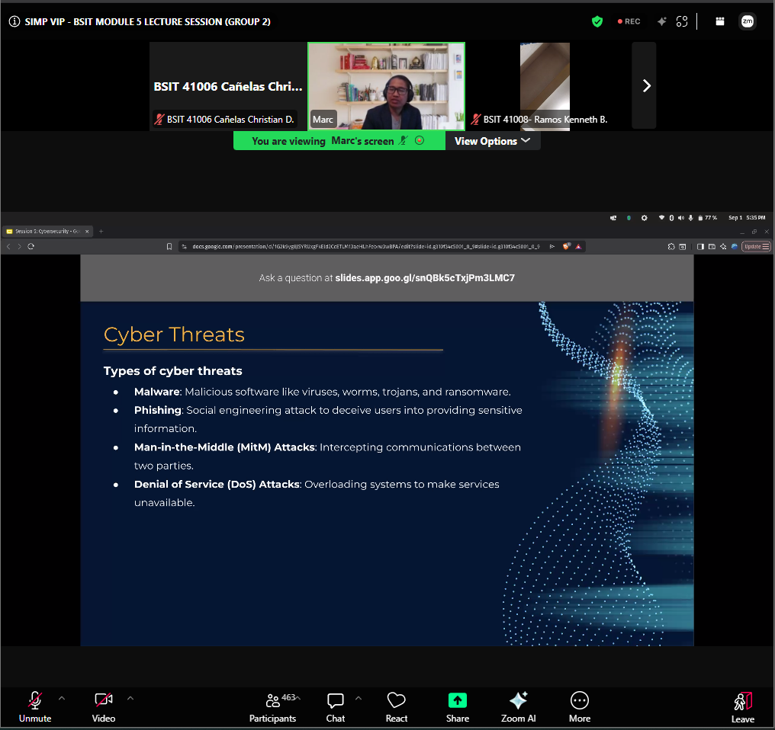

F. REFLECTION
This session shifted gears again, moving from the programming side of Modules 3 and 4 into Module 5, which covers the Fundamentals of Cybersecurity. Mr. Tonido opened with a slide on Cyber Threats, and instead of just listing definitions, he walked through each type in a way that connected them to situations we've probably already encountered without realizing it. The first one he covered was Malware, which he described broadly as malicious software, and he specifically named a few categories under it: viruses, worms, trojans, and ransomware. What stood out to me here was realizing that these terms, which get thrown around pretty loosely in everyday conversation, actually refer to distinct behaviors, like how a worm can spread on its own across a network while a trojan relies on tricking the user into running it by disguising itself as something legitimate.
Next was Phishing, which he framed less as a technical attack and more as a social engineering tactic, since it relies on tricking a person into willingly handing over sensitive information rather than exploiting a flaw in the system itself. This connected pretty well to something we actually discussed in an earlier session, the CIA hacking case, where the attackers didn't break through any firewall but instead manipulated a customer support representative into giving up account access. Mr. Tonido pointed out that phishing works precisely because it targets human trust and urgency rather than a coding vulnerability, which is why even people who are technically savvy can still fall for a convincing fake email or message if they're not paying close attention.
He then moved on to Man-in-the-Middle attacks, or MitM, which he explained as an attacker positioning themselves between two parties to intercept communication without either side realizing it's happening. This was actually the concept I had the hardest time visualizing before this session, but the way he described it, almost like eavesdropping on a private conversation without either speaker knowing someone else is listening in, made it click. It also made me think about how risky it can be to use public Wi-Fi for anything sensitive, since an unsecured network is exactly the kind of environment where this type of interception becomes a lot easier to pull off.
Lastly, he covered Denial of Service, or DoS, attacks, describing them as an attempt to overload a system with traffic or requests until it can no longer respond to legitimate users. He also briefly mentioned that this can scale into a Distributed Denial of Service, where the flood of traffic comes from multiple sources at once instead of a single attacker, making it much harder to block or trace back. I found it interesting that unlike malware or phishing, a DoS attack doesn't necessarily involve stealing data at all, since the entire goal is just to make a service unavailable, which shows that not every cyberattack is about extracting information; sometimes disruption itself is the objective.
Overall, this session gave me a much clearer framework for categorizing threats instead of just thinking of "hacking" as one broad, vague concept. Seeing malware, phishing, MitM, and DoS attacks laid out side by side made it easier to understand that each one exploits a different weakness, whether it's a flaw in software, a gap in human judgment, an unsecured connection, or simply the limits of how much traffic a system can handle. Going into Module 5, I'm hoping we get to explore how each of these threats is typically prevented or mitigated in real practice, since recognizing the threat is really just the first step before actually knowing how to defend against it.

